# Game Changer

# How Generative AI is Revolutionising the Future of Gaming

### **WARNING: This content was generated using Generative AI. While efforts have been made to ensure accuracy and coherence, readers should approach the material with critical thinking and verify important information from authoritative sources.**

# Table of Contents

**Game Changer** **1**

**How Generative AI is Revolutionising the Future of Gaming** **1**

WARNING: This content was generated using Generative AI. While efforts have been made to ensure accuracy and coherence, readers should approach the material with critical thinking and verify important information from authoritative sources. 1

**Table of Contents** **2**

**Introduction: The Dawn of AI-Powered Gaming** **5**

The Evolution of Game Design 5

From Pong to Procedural Generation 5

The Rise of AI in Gaming 8

What is Generative AI? 11

The Promise of GenAI in Gaming 13

Enhancing Player Experiences 13

Streamlining Development Processes 17

Creating New Genres and Gameplay Mechanics 20

**Chapter 1: The Intersection of Generative AI and Game Design** **23**

Principles of AI-Driven Game Design 23

Balancing Creativity and Control 23

Designing for Adaptability 26

Integrating AI into Game Narratives 29

Tools and Techniques 33

Machine Learning Models for Game Development 33

Natural Language Processing in Gaming 36

Computer Vision and Gesture Recognition 39

Procedural Content Generation with AI 42

AI-Assisted Game Development 44

Automating Asset Creation 44

AI-Powered Level Design 48

Playtesting and Balancing with AI 51

**Chapter 2: Adaptive Gameplay and Personalised Player Experiences** **55**

Dynamic Difficulty Adjustment 55

Player Skill Assessment 55

Real-time Game Balancing 58

Adaptive Challenge Systems 61

Personalised Content Generation 64

AI-Driven Storylines and Quests 64

Customised Game Worlds 67

Tailored NPC Interactions 70

Player Behaviour Analysis 73

Predictive Analytics in Gaming 73

Emotion Recognition and Response 77

Personalised Recommendations and Rewards 80

**Chapter 3: Ethical Considerations and Challenges** **83**

Data Privacy and Player Rights 83

Collecting and Using Player Data 83

Transparency in AI Decision-Making 85

Ensuring Player Consent and Control 88

Fairness and Inclusivity 91

Addressing AI Bias in Games 91

Accessibility and AI 95

Cultural Sensitivity in AI-Generated Content 98

Addiction and Mental Health 102

AI’s Role in Game Addiction 102

Promoting Healthy Gaming Habits 105

Using AI for Player Well-being 107

Economic and Social Impact 111

AI and the Future of Game Development Jobs 111

Virtual Economies and AI 114

The Societal Impact of Hyper-Realistic AI Games 118

**Chapter 4: Case Studies of Successful AI Implementation** **121**

AI in Open World Games 121

Case Study: No Man’s Sky 121

Procedural Generation at Scale 124

Lessons Learned and Future Potential 127

AI-Driven Narrative Experiences 130

Case Study: AI Dungeon 130

The Power of Language Models in Gaming 134

Challenges and Opportunities in AI Storytelling 137

AI in Competitive Gaming 140

Case Study: DeepMind’s AlphaStar 140

AI as Opponent and Training Tool 143

The Future of AI in Esports 146

AI-Enhanced Mobile Gaming 150

Case Study: Replika 150

AI Companions and Chatbots 153

Personalisation in Casual Games 156

**Chapter 5: Future Trends and Potential Disruptions** **159**

The Rise of AI Game Designers 159

Automated Game Creation 159

Human-AI Collaboration in Design 162

The Changing Role of Game Developers 165

Hyper-Personalised Gaming Experiences 168

AI-Generated Worlds Unique to Each Player 168

Emotional AI and Deeply Responsive Games 171

The Convergence of Gaming and Personal AI Assistants 174

The Metaverse and AI 178

AI-Powered Virtual Worlds 178

Cross-Platform AI Integration 181

The Future of Social Gaming with AI 184

Emerging Technologies and Gaming 188

Quantum Computing and Game AI 188

Brain-Computer Interfaces in Gaming 191

AI and the Future of AR/VR Gaming 194

**Conclusion: Embracing the AI-Powered Future of Gaming** **194**

Recapping the AI Revolution in Gaming 194

Key Takeaways 194

Preparing for the Future 197

The Road Ahead 200

Challenges and Opportunities 200

The Role of Gamers, Developers, and Society 203

**Appendix** **205**

Book Generation Details 205

Further Reading on Wardley Mapping 206

**Appendix: Further Reading on Wardley Mapping** **206**

Core Wardley Mapping Series 206

Practical Resources 209

Specialized Applications 210

# Introduction: The Dawn of AI-Powered Gaming

## The Evolution of Game Design

### From Pong to Procedural Generation

The journey from Pong to procedural generation represents a monumental leap in the evolution of game design, setting the stage for the transformative impact of generative AI in the gaming industry. This progression not only reflects technological advancements but also embodies the shifting paradigms in how we conceptualise and create interactive experiences. As we stand on the cusp of an AI-driven gaming revolution, understanding this evolution is crucial for grasping the potential and challenges that lie ahead.

The story begins with Pong, a simple yet revolutionary game that laid the foundation for the entire video game industry. Released in 1972, Pong’s straightforward gameplay mechanics and minimalist design belied its profound impact. It demonstrated that interactive digital entertainment was not only possible but could be engaging and commercially viable.

Pong wasn’t just a game; it was a proof of concept for an entire industry. It showed us that pixels on a screen could be more than just static images – they could be manipulated in real-time to create engaging experiences.

From this rudimentary beginning, game design evolved rapidly through several key phases:

* The 8-bit era: Characterised by limited graphics and sound, but introducing more complex gameplay mechanics and narratives.
* The 16-bit revolution: Bringing enhanced graphics, sound, and the rise of iconic franchises that still resonate today.
* The 3D transition: Marking a paradigm shift in how games were designed and experienced, with titles like Doom and Super Mario 64 redefining possibilities.
* The online multiplayer explosion: Transforming games from solitary experiences to vast, interconnected worlds.
* The mobile gaming boom: Democratising game development and introducing new design paradigms for casual players.

Each of these phases brought new challenges and opportunities for game designers, pushing the boundaries of what was possible and reshaping player expectations. However, it was the advent of procedural generation that truly began to bridge the gap between traditional game design and the AI-driven future we now anticipate.

Procedural generation, at its core, is the use of algorithms to create game content automatically. This technique has roots dating back to the 1980s with games like Rogue, but it has seen a renaissance in recent years. Modern titles like Minecraft, No Man’s Sky, and Spelunky have showcased the potential of procedural generation to create vast, varied, and replayable game worlds.

Procedural generation was the first step towards truly dynamic game worlds. It showed us that games could be more than just static, pre-designed experiences – they could be living, breathing entities that surprise even their creators.

The significance of procedural generation in the context of AI-powered gaming cannot be overstated. It represents a fundamental shift in how we approach game design, moving from entirely handcrafted experiences to ones where algorithms play a significant role in content creation. This shift laid the groundwork for the integration of more advanced AI techniques, including machine learning and neural networks, into the game development process.

As we transition from procedural generation to generative AI, we’re witnessing a quantum leap in the capabilities and potential applications of algorithmic content creation. While procedural generation relies on predefined rules and parameters, generative AI can learn from vast datasets, recognise patterns, and create content that is not just random, but contextually appropriate and potentially indistinguishable from human-created content.

* Enhanced world-building: AI can generate vast, detailed game worlds with coherent ecosystems, histories, and cultures.
* Dynamic narratives: AI-driven storytelling can create branching narratives that adapt to player choices in real-time.
* Intelligent NPCs: Non-player characters can exhibit more realistic behaviours and engage in more natural dialogues.
* Personalised content: Games can adapt their content, difficulty, and pacing to individual player preferences and skills.
* Streamlined development: AI tools can assist in various aspects of game development, from asset creation to bug testing.

The implications of this evolution are profound, not just for game design, but for the entire ecosystem of game development, publishing, and player engagement. As AI becomes more integrated into the gaming industry, we’re likely to see new roles emerge, existing roles transform, and the boundaries between game designer, player, and AI system blur in exciting and sometimes challenging ways.

We’re moving from an era where games are products to one where they are services – constantly evolving, learning, and adapting to player behaviour. This shift will fundamentally change not just how we make games, but how we play them and how we think about interactive entertainment.

However, this evolution also raises important questions and challenges. How do we balance the creative vision of human designers with the generative capabilities of AI? How do we ensure that AI-generated content maintains quality, coherence, and cultural sensitivity? What are the implications for intellectual property and authorship in an age of AI co-creation?

As we continue to explore these questions, one thing is clear: the journey from Pong to procedural generation has set the stage for a new era of gaming, one where the lines between human creativity and artificial intelligence are increasingly blurred. This convergence promises to unlock new realms of possibility in game design, offering experiences that are more immersive, adaptive, and personalised than ever before.

As we stand at this exciting juncture, it’s crucial for game developers, publishers, and policymakers to understand the trajectory that has led us here. The lessons learned from each phase of game design evolution will be invaluable as we navigate the challenges and opportunities presented by AI-powered gaming. By embracing this new paradigm while remaining mindful of its implications, we can usher in a new golden age of interactive entertainment that pushes the boundaries of creativity, technology, and human experience.

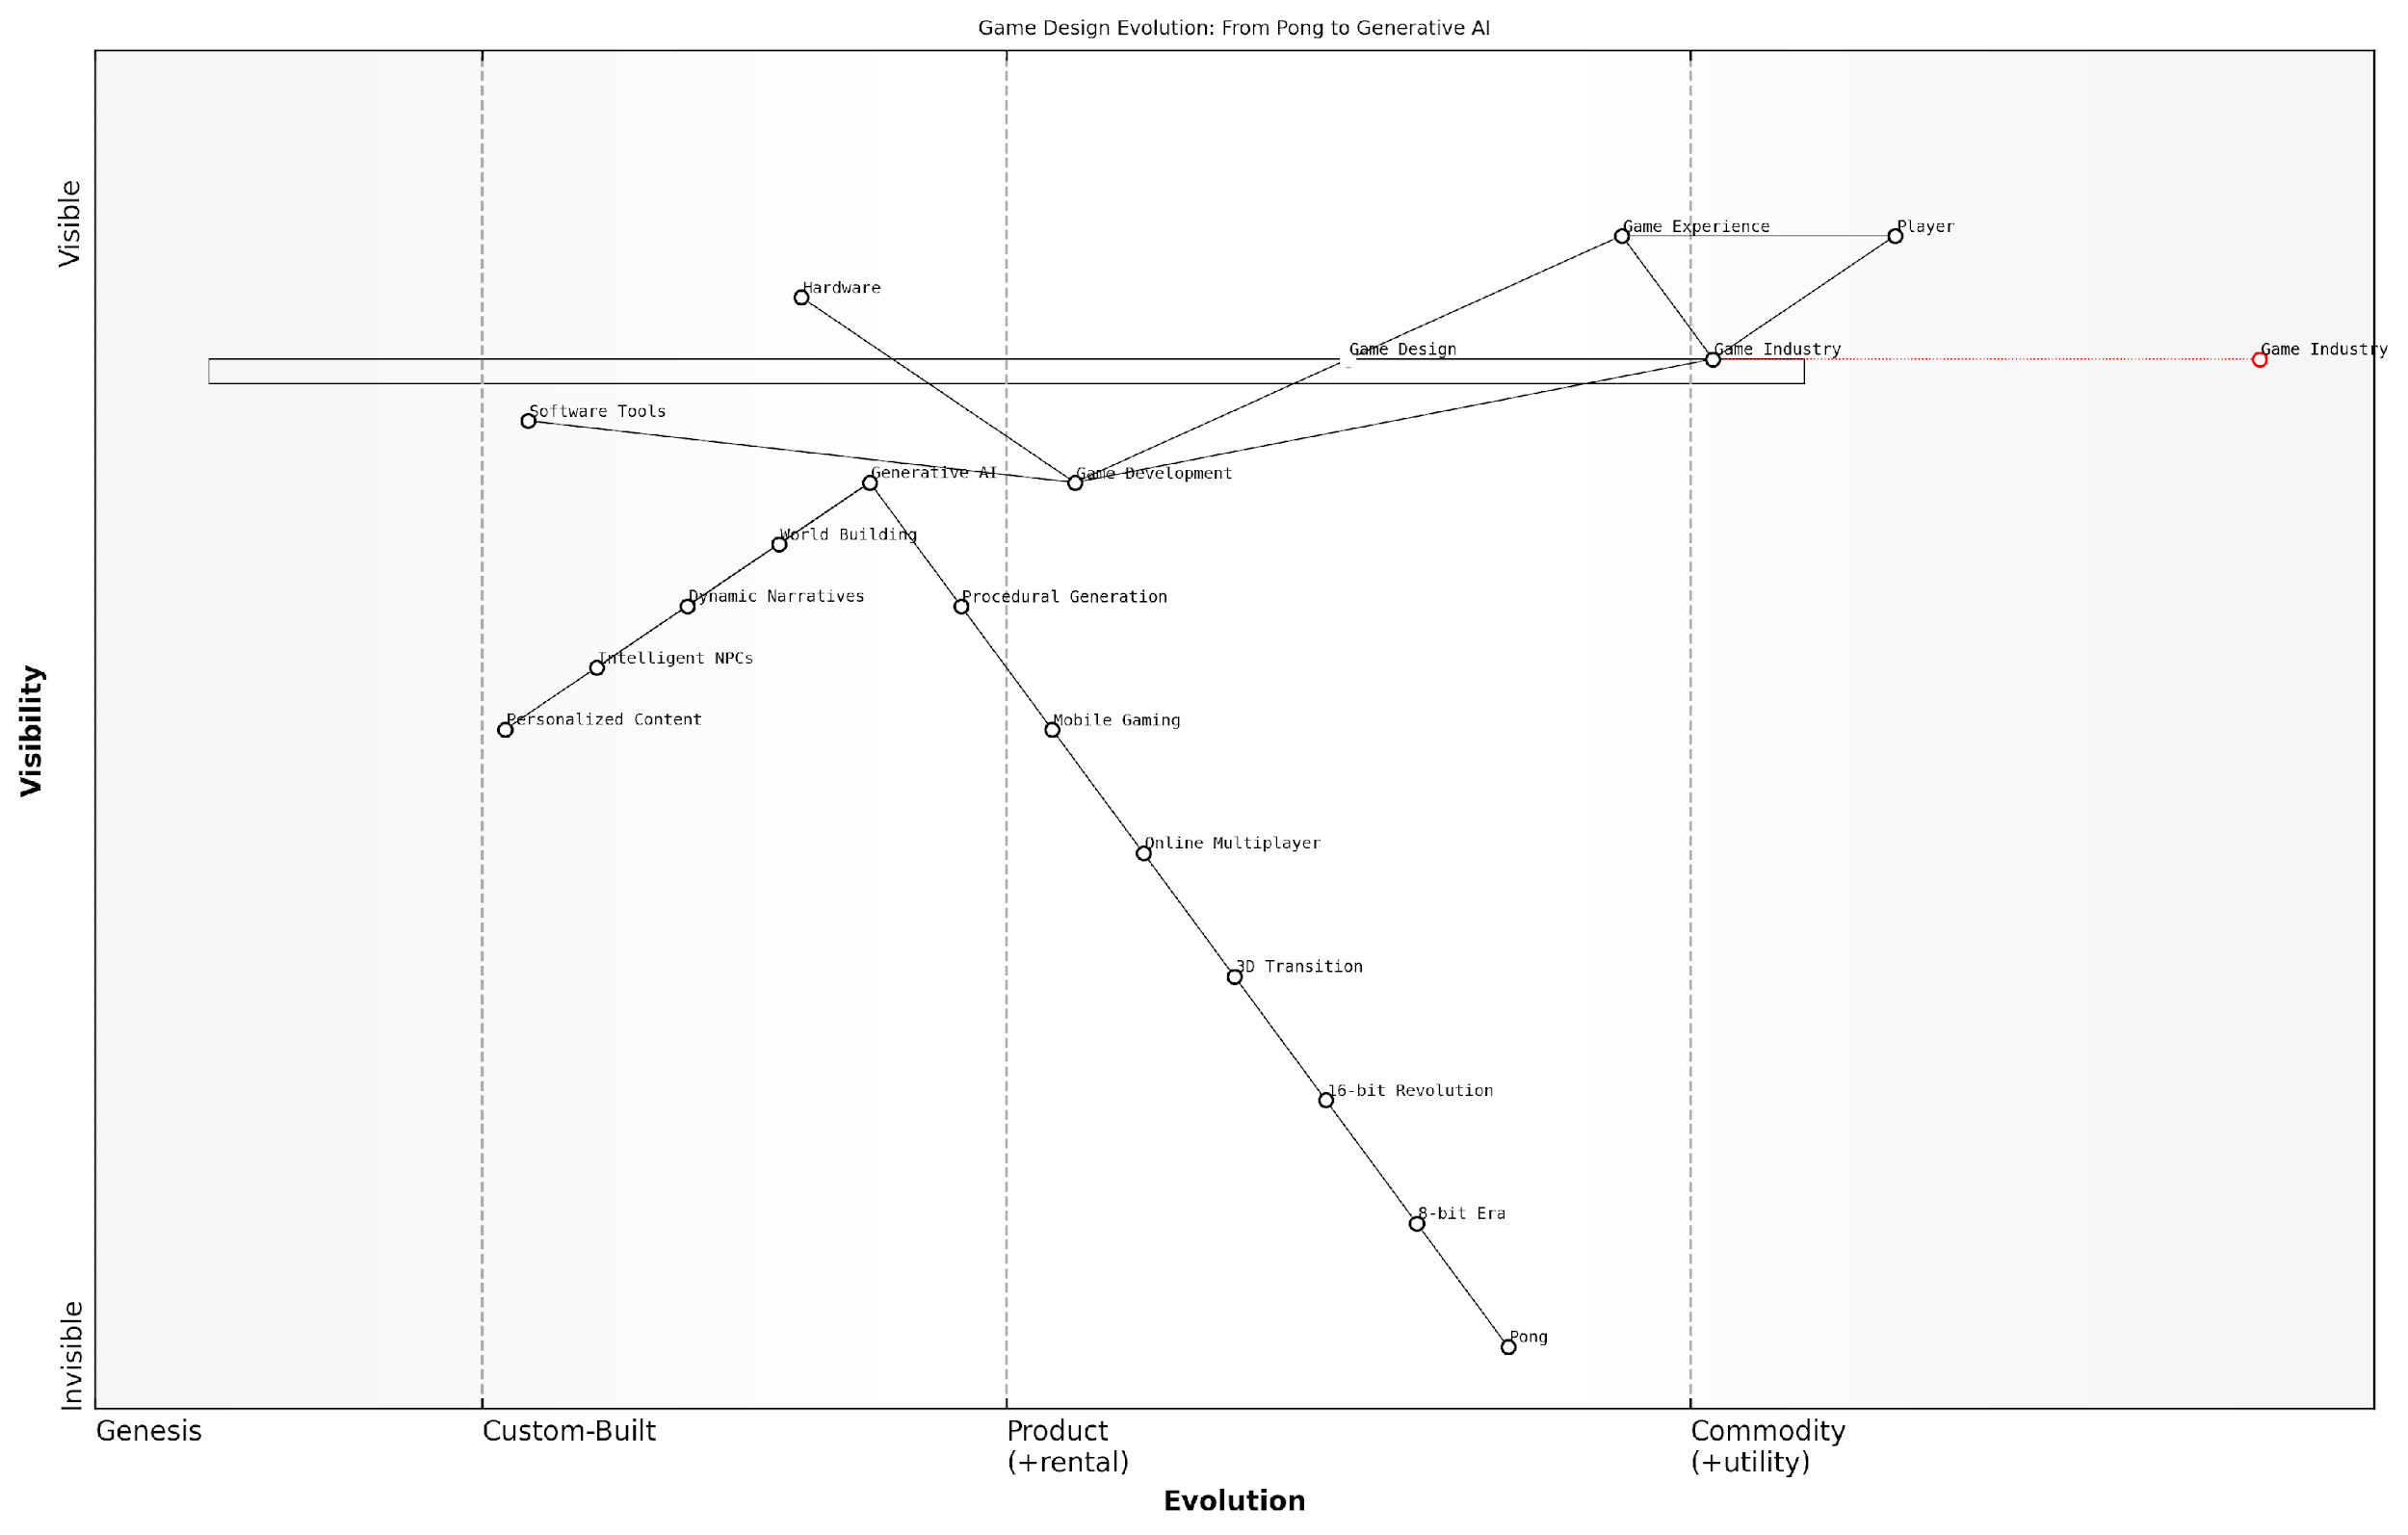

*Draft Wardley Map: [Insert Wardley Map: From Pong to Procedural Generation]*

[Edit this draft Wardley Map](https://create.wardleymaps.ai/#clone:69820d2bab974be6ca)

Wardley Map Assessment

The Wardley Map reveals a gaming industry on the cusp of an AI-driven revolution. The strategic imperative is to embrace and integrate Generative AI and other emerging technologies while maintaining focus on enhancing player experiences. Success will hinge on balancing technological advancement with creative human input, addressing ethical concerns, and reimagining game development processes. Companies that can effectively harness AI to create more dynamic, personalised, and immersive gaming experiences while fostering innovation in game design are poised to lead the next era of the gaming industry.

[View full Wardley Map report](http://markdown_wardley_map_reports/wardley_map_report_01_From_Pong_to_Procedural_Generation.md)

### The Rise of AI in Gaming

The integration of Artificial Intelligence (AI) into the gaming industry marks a pivotal moment in the evolution of interactive entertainment. As we delve into the rise of AI in gaming, it’s crucial to understand how this technology is reshaping not only the way games are developed but also how they are experienced by players. This transformation is particularly significant within the context of generative AI, which promises to revolutionise game design, content creation, and player engagement.

The journey of AI in gaming has been a gradual but transformative one, evolving from simple rule-based systems to sophisticated machine learning algorithms capable of creating dynamic, responsive game worlds. This progression can be broadly categorised into three distinct phases: early AI, modern AI, and the emerging era of generative AI.

* Early AI: Basic decision trees and finite state machines
* Modern AI: Machine learning, neural networks, and behavioural algorithms
* Generative AI: Procedural content generation, dynamic narratives, and adaptive gameplay

Early AI in gaming was characterised by predetermined responses and limited adaptability. Games like ‘Pac-Man’ (1980) employed simple chase algorithms, while strategy games like ‘Civilization’ (1991) used basic decision-making processes to simulate opponent behaviour. These systems, while groundbreaking for their time, were often predictable and lacked the complexity to create truly dynamic experiences.

The advent of modern AI techniques in gaming brought about a significant leap in capabilities. Machine learning algorithms began to analyse player behaviour, adapting game difficulty and opponent strategies in real-time. Games like ‘F.E.A.R.’ (2005) showcased advanced AI that could coordinate tactical manoeuvres, creating a more challenging and immersive experience. This era also saw the rise of data-driven AI, where vast amounts of player data were used to refine game balance and design.

The introduction of machine learning in game AI was a game-changer. Suddenly, we could create opponents that learned and adapted, offering players a constantly evolving challenge.

Now, we stand at the threshold of a new era in gaming AI with the emergence of generative AI technologies. These systems are capable of creating vast amounts of content, from textures and 3D models to entire game levels and narratives. Generative AI is not just augmenting the game development process; it’s fundamentally altering the nature of game design and player interaction.

One of the most significant impacts of generative AI in gaming is in the realm of procedural content generation (PCG). While PCG has been used in games for decades, generative AI takes this concept to new heights. Games can now create endless, unique content that adapts to player preferences and playstyles. This capability is particularly evident in open-world games, where AI can generate vast, detailed landscapes, populate them with diverse flora and fauna, and even create unique quests and storylines for each player.

Generative AI is not just a tool for developers; it’s becoming a co-creator, capable of producing content that rivals human-made assets in quality and creativity.

Another area where generative AI is making significant strides is in non-player character (NPC) behaviour and dialogue. Advanced language models can now generate contextually appropriate, dynamic conversations, making NPCs feel more lifelike and responsive. This technology opens up possibilities for deeply immersive narrative experiences where every interaction feels unique and tailored to the player’s choices and actions.

The rise of AI in gaming also extends to player modelling and personalisation. By analysing player behaviour, preferences, and performance, AI systems can tailor every aspect of the game experience. This includes dynamically adjusting difficulty, recommending in-game activities, and even modifying the game’s narrative arc to better suit the player’s interests.

* Procedural content generation for endless, unique game worlds
* Dynamic NPC interactions with advanced language models
* Personalised gaming experiences through player modelling
* AI-assisted game development and testing
* Adaptive storytelling and quest generation

However, the integration of AI, particularly generative AI, in gaming is not without challenges. Issues of control and authorial intent arise when AI systems are given significant creative freedom. Game designers must strike a delicate balance between leveraging AI’s capabilities and maintaining a cohesive, intentional game experience. There are also concerns about the potential homogenisation of game content if AI-generated assets become too prevalent.

Ethical considerations also come to the fore as AI becomes more deeply integrated into gaming. Questions of data privacy, algorithmic bias, and the potential for AI to exploit player psychology for engagement or monetisation purposes must be carefully addressed. The gaming industry will need to develop robust frameworks and best practices to ensure that AI is used responsibly and ethically.

As AI becomes more prevalent in gaming, we must be vigilant about its ethical implications. The power to create personalised experiences comes with the responsibility to protect player well-being and privacy.

Looking ahead, the rise of AI in gaming is set to continue its transformative trajectory. We can anticipate even more sophisticated AI systems that blur the lines between game design, content creation, and player interaction. The future may see games that are entirely generated and managed by AI, adapting in real-time to player input and external data sources to create truly unique, ever-evolving experiences.

In conclusion, the rise of AI in gaming represents a paradigm shift in how games are created, played, and experienced. As generative AI technologies continue to advance, they promise to unlock new realms of creativity, interactivity, and personalisation in gaming. However, this progress must be tempered with careful consideration of the ethical, creative, and societal implications. The future of gaming with AI is bright, but it requires thoughtful stewardship to ensure that it enhances rather than diminishes the art and joy of interactive entertainment.

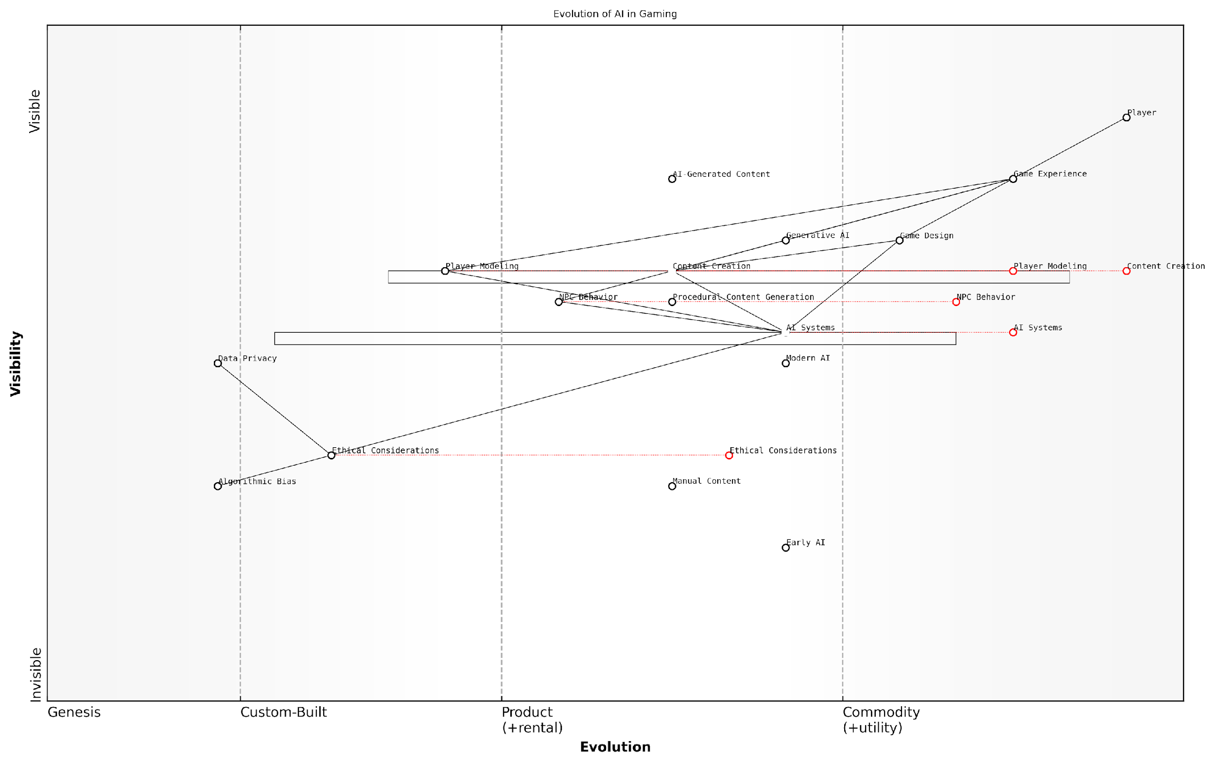

*Draft Wardley Map: [Insert Wardley Map: The Rise of AI in Gaming]*

[Edit this draft Wardley Map](https://create.wardleymaps.ai/#clone:ea8501336980b4f6de)

Wardley Map Assessment

The map reveals a gaming industry on the cusp of an AI-driven revolution. While there are significant opportunities in AI-generated content and personalised gaming experiences, the industry must proactively address ethical considerations and data privacy to ensure sustainable growth. The key to success will be balancing rapid AI innovation with responsible implementation, creating games that are not only technologically advanced but also ethically sound and respectful of player privacy.

[View full Wardley Map report](http://markdown_wardley_map_reports/wardley_map_report_02_The_Rise_of_AI_in_Gaming.md)

### What is Generative AI?

As we delve into the transformative world of AI-powered gaming, it is crucial to understand the cornerstone technology driving this revolution: Generative AI. This subsection explores the fundamental concepts, applications, and implications of Generative AI within the context of game design and development, setting the stage for the profound changes reshaping the gaming landscape.

Generative AI, at its core, refers to artificial intelligence systems capable of creating new content, be it text, images, audio, or even entire game environments. Unlike traditional AI systems that primarily analyse and respond to existing data, generative AI possesses the remarkable ability to produce original, contextually relevant content. This capability has far-reaching implications for the gaming industry, promising to revolutionise everything from asset creation to player experiences.

Generative AI is not just a tool; it’s a creative partner that can amplify human imagination and push the boundaries of what’s possible in game design.

To fully grasp the potential of Generative AI in gaming, it’s essential to understand its key components and underlying technologies:

* Machine Learning Models: These form the backbone of Generative AI, learning patterns from vast datasets to generate new content.
* Neural Networks: Particularly deep learning architectures like GANs (Generative Adversarial Networks) and transformers, which excel at content generation tasks.
* Natural Language Processing (NLP): Enables AI to understand and generate human-like text, crucial for dialogue and narrative generation in games.
* Computer Vision: Allows AI to interpret and generate visual content, essential for creating game assets and environments.
* Procedural Content Generation (PCG): While not new to gaming, PCG is significantly enhanced by Generative AI, enabling more sophisticated and contextually aware content creation.

In the context of game design, Generative AI opens up unprecedented possibilities. It can dynamically create vast, unique game worlds, generate realistic and contextually appropriate dialogue for non-player characters (NPCs), and even assist in crafting intricate storylines that adapt to player choices. This technology is not merely about automating existing processes; it’s about reimagining the very nature of game creation and player interaction.

One of the most exciting applications of Generative AI in gaming is its ability to create personalised experiences. By analysing player behaviour and preferences, AI can generate tailored content, challenges, and narratives, ensuring that each playthrough is unique and engaging. This level of personalisation was previously unattainable due to the sheer amount of manual labour it would have required.

The true power of Generative AI in gaming lies in its ability to create not just content, but experiences that are responsive, adaptive, and deeply personal to each player.

However, the integration of Generative AI in game design is not without challenges. Ethical considerations, such as data privacy and the potential for AI-generated content to perpetuate biases, must be carefully addressed. There’s also the question of balancing AI-generated content with human creativity to ensure that games maintain their artistic integrity and emotional resonance.

As we look to the future, the potential applications of Generative AI in gaming are boundless. From AI-assisted game development tools that streamline the creation process to fully AI-generated games that push the boundaries of interactive storytelling, we are on the cusp of a new era in gaming. This technology has the power to democratise game development, enabling smaller studios and individual creators to produce content of a scale and complexity previously reserved for large development teams.

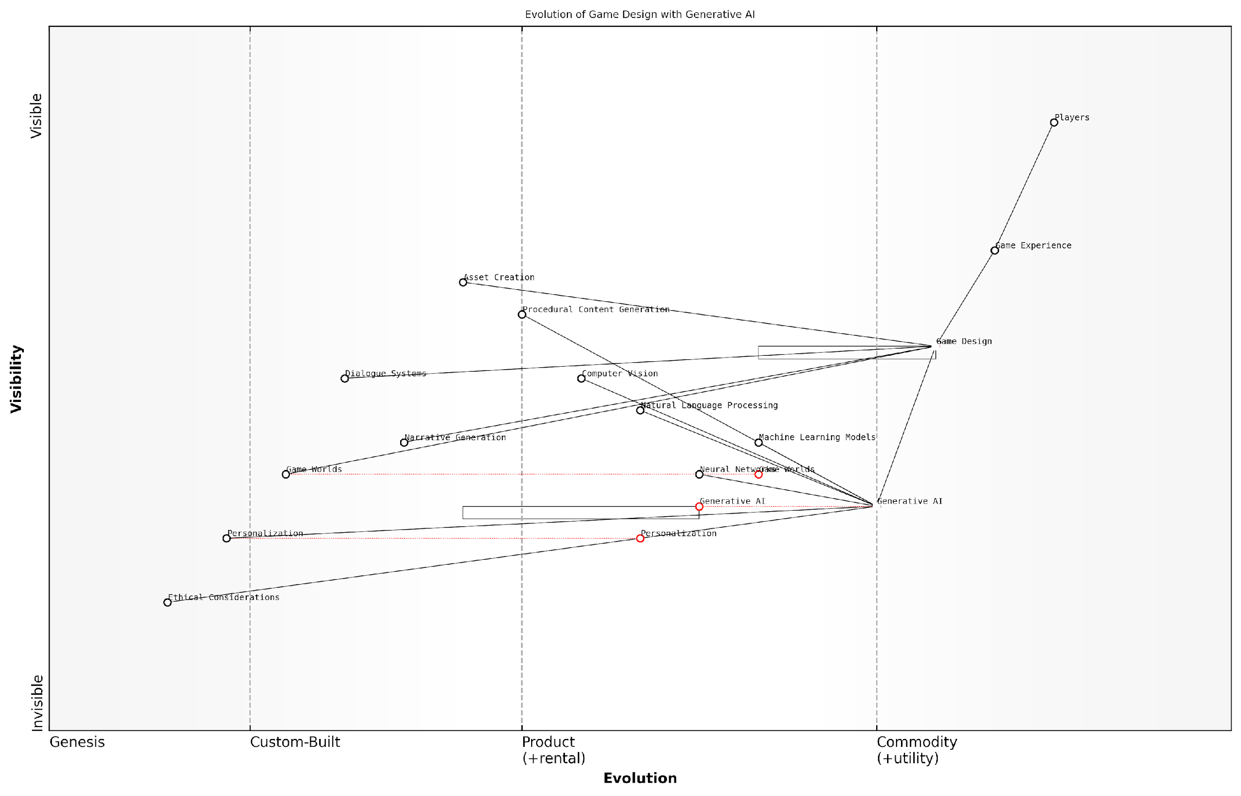

*Draft Wardley Map: [Insert Wardley Map: What is Generative AI?]*

[Edit this draft Wardley Map](https://create.wardleymaps.ai/#clone:ebea58dd36847312a1)

Wardley Map Assessment

This Wardley Map reveals a gaming industry on the cusp of an AI-driven revolution. The strategic positioning of Generative AI as a central component indicates its transformative potential across all aspects of game design. However, the map also highlights the critical need to address ethical considerations and personalization as key challenges and opportunities. Companies that can successfully navigate the evolution of AI technologies while maintaining a strong focus on player experience and ethical implementation will likely emerge as leaders in this new era of gaming. The rapid evolution of components like Personalization and Game Worlds suggests areas for potential differentiation and innovation. Overall, the map points to a future where the boundaries between game design, AI, and player experience become increasingly blurred, necessitating a holistic, ethically-grounded approach to game development.

[View full Wardley Map report](http://markdown_wardley_map_reports/wardley_map_report_03_What_is_Generative_AI?.md)

The Wardley Map above illustrates the evolution of game design components as they move from genesis to commodity with the integration of Generative AI. It highlights how traditional elements of game design are being transformed and new possibilities are emerging, reshaping the industry landscape.

In conclusion, Generative AI represents a paradigm shift in game design and development. It offers tools and capabilities that can enhance creativity, streamline production processes, and create more immersive and personalised gaming experiences. As we continue to explore and refine these technologies, we stand at the threshold of a new golden age of gaming, where the boundaries between creator, player, and game world become increasingly fluid and dynamic.

Generative AI is not replacing human creativity in game design; it’s augmenting and amplifying it, opening up new realms of possibility that we are only beginning to explore.

## The Promise of GenAI in Gaming

### Enhancing Player Experiences

As we stand on the cusp of a new era in gaming, Generative AI (GenAI) emerges as a transformative force, promising to revolutionise player experiences in ways previously unimaginable. This section delves into the myriad ways GenAI is set to enhance gameplay, create more immersive worlds, and deliver personalised adventures that adapt to each player’s unique style and preferences.

The integration of GenAI into gaming represents a paradigm shift in how players interact with virtual worlds and narratives. By harnessing the power of machine learning algorithms and vast datasets, GenAI can create dynamic, responsive environments that evolve in real-time, offering unprecedented levels of interactivity and engagement.

GenAI is not just an addition to gaming; it’s a fundamental reimagining of what games can be. We’re moving from static, pre-programmed experiences to living, breathing worlds that respond and evolve with each player interaction.

Let’s explore the key areas where GenAI is poised to significantly enhance player experiences:

* Dynamic Narrative Generation
* Adaptive Gameplay Mechanics
* Personalised Content Creation
* Enhanced NPC Interactions
* Procedural World Building

Dynamic Narrative Generation: One of the most exciting applications of GenAI in gaming is its ability to create unique, branching narratives that respond to player choices and actions. Traditional games often rely on pre-written scripts with limited variations, but GenAI can generate storylines on the fly, ensuring that each playthrough is a unique experience.

This technology allows for an unprecedented level of player agency, where decisions have far-reaching consequences that ripple through the game world. Imagine a role-playing game where every conversation with an NPC could lead to a new quest, or where the outcome of a battle could dramatically alter the course of the entire story.

The potential for GenAI to create truly responsive narratives is staggering. We’re moving towards games that can rival human storytellers in their ability to craft compelling, personalised tales.

Adaptive Gameplay Mechanics: GenAI enables games to dynamically adjust their difficulty and mechanics based on individual player performance and preferences. This goes beyond simple difficulty sliders, creating a tailored experience that evolves as the player progresses.

For instance, if a player consistently struggles with certain types of puzzles, the game might gradually introduce simpler variations or provide subtle hints. Conversely, for players who excel in combat, the AI could generate more challenging enemy configurations or introduce new tactical elements to keep them engaged.

Personalised Content Creation: GenAI’s ability to analyse player behaviour and preferences opens up new possibilities for content creation. Games can now generate quests, items, and even entire levels that are tailored to individual play styles.

A player who enjoys stealth gameplay might find more opportunities for sneaking and subterfuge, while another who prefers direct combat could encounter scenarios that play to those strengths. This level of personalisation ensures that each player’s journey through the game feels uniquely their own.

The future of gaming lies in experiences that mould themselves around the player, rather than forcing the player to adapt to rigid, pre-defined structures.

Enhanced NPC Interactions: Non-player characters (NPCs) are the lifeblood of many games, providing context, atmosphere, and often driving the narrative forward. GenAI has the potential to transform these interactions, creating NPCs with deep, contextual understanding and the ability to engage in natural, dynamic conversations.

Imagine NPCs that remember past interactions, form opinions based on player actions, and can discuss a wide range of topics beyond their pre-programmed responses. This level of sophistication could lead to more believable virtual worlds and deeper emotional connections between players and game characters.

Procedural World Building: While procedural generation has been used in games for years, GenAI takes this concept to new heights. Instead of relying on pre-defined rules and assets, GenAI can create entire worlds, complete with unique flora, fauna, and cultures, all generated in real-time.

This technology enables the creation of vast, explorable universes that are different for each player, ensuring that the thrill of discovery remains fresh even after multiple playthroughs. Moreover, these worlds can evolve over time, responding to player actions and creating a truly living, breathing environment.

The combination of GenAI and procedural generation is set to blur the lines between game worlds and reality, creating experiences that are as vast and varied as our own universe.

As we look to the future, it’s clear that GenAI will play a pivotal role in shaping the next generation of gaming experiences. By creating more responsive, personalised, and dynamic game worlds, GenAI has the potential to keep players engaged for longer periods and attract new audiences to the medium.

However, with these advancements come new challenges. Game developers and designers will need to adapt to this new paradigm, learning to work alongside AI systems to create cohesive and meaningful experiences. There are also ethical considerations to address, such as ensuring fairness in AI-generated content and maintaining player agency in highly adaptive systems.

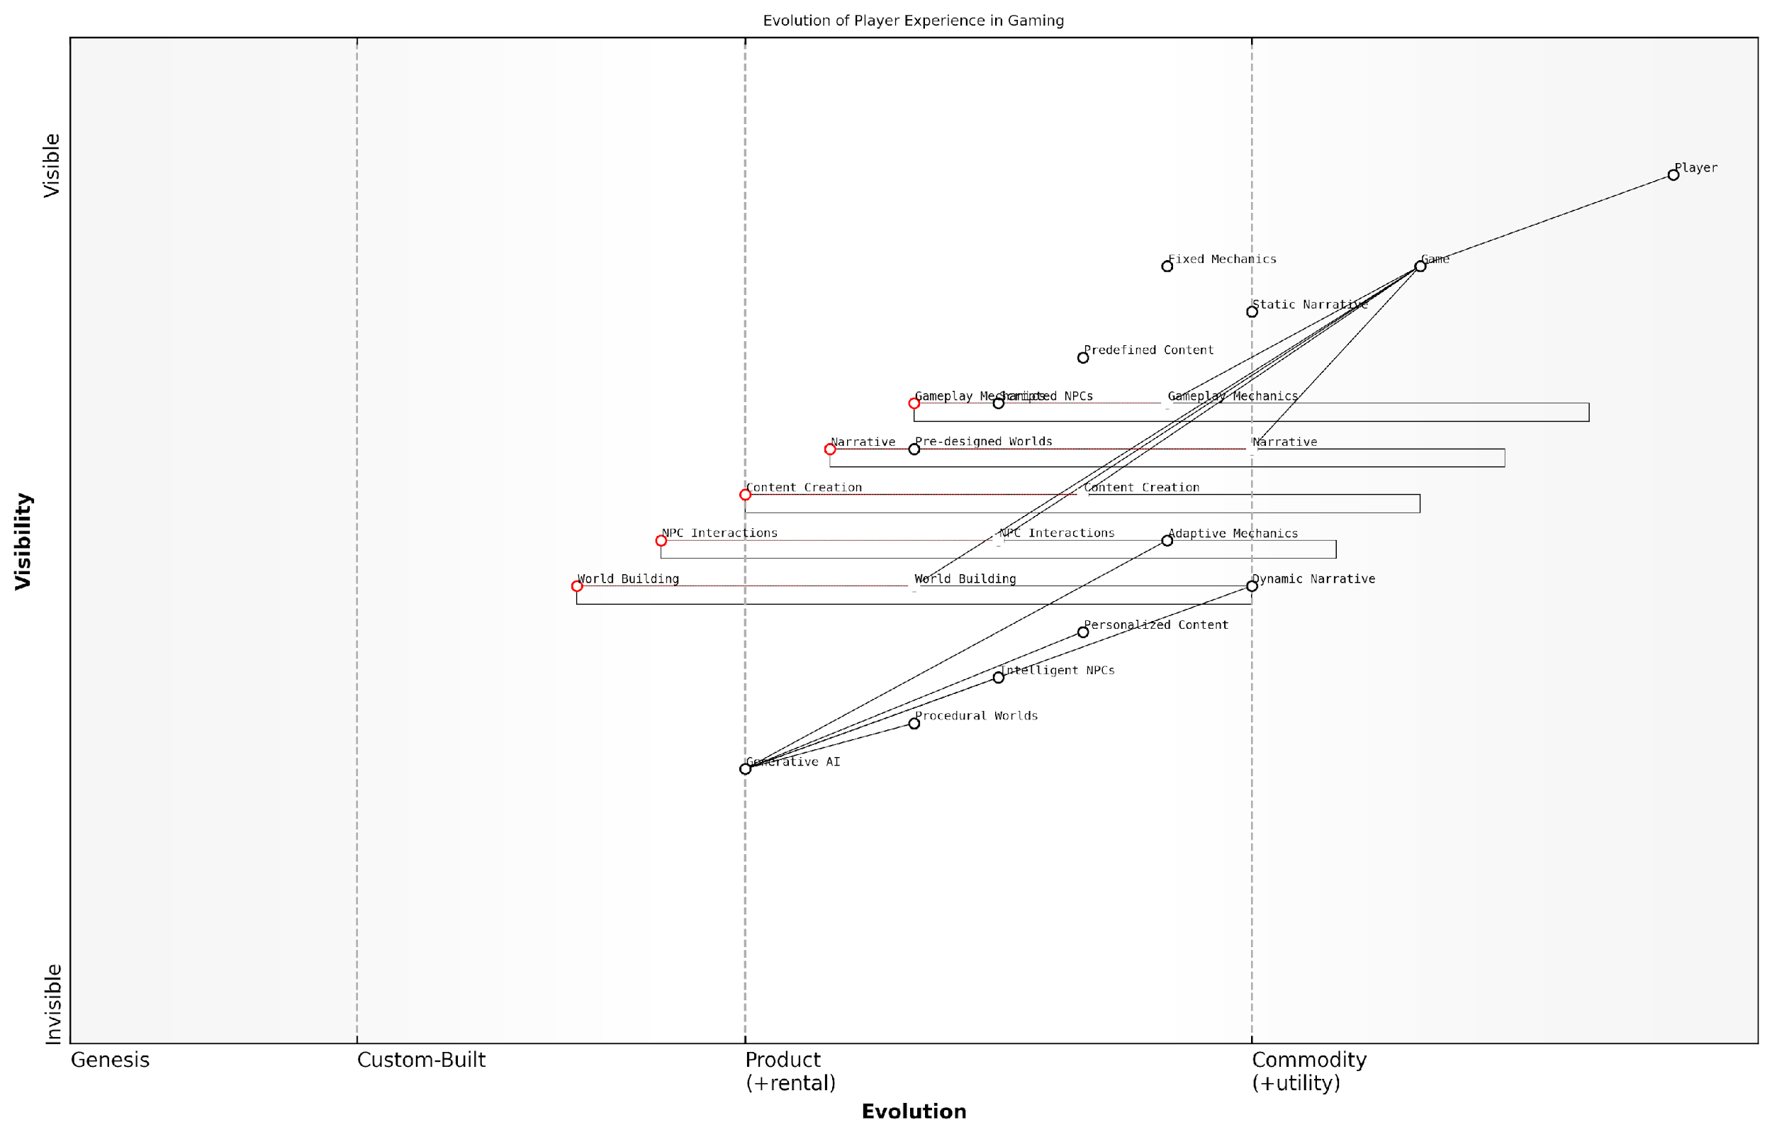

*Draft Wardley Map: [Insert Wardley Map: Enhancing Player Experiences]*

[Edit this draft Wardley Map](https://create.wardleymaps.ai/#clone:713e7b8043a6bdac52)

Wardley Map Assessment

This Wardley Map reveals a gaming industry on the cusp of a major transformation driven by Generative AI. The strategic imperative is clear: embrace and integrate AI technologies to evolve all aspects of the gaming experience from static, predefined elements to dynamic, personalised interactions. Success will hinge on balancing innovation with player trust, technical capabilities with creative vision, and automation with human expertise. Companies that can effectively harness Generative AI across the full spectrum of game components – from world-building to narrative to NPC interactions – will be well-positioned to lead the next era of gaming. However, this transition also carries risks and challenges that must be carefully managed. The future of gaming appears to be one of unprecedented personalization and dynamism, promising to redefine the relationship between players, games, and the creative process itself.

[View full Wardley Map report](http://markdown_wardley_map_reports/wardley_map_report_04_Enhancing_Player_Experiences.md)

Despite these challenges, the promise of GenAI in enhancing player experiences is undeniable. As the technology continues to evolve, we can expect to see games that not only entertain but also adapt, learn, and grow alongside their players, creating truly unforgettable interactive experiences.

In the following sections, we will delve deeper into the specific technologies and techniques that make these enhancements possible, as well as explore case studies of games that are already pushing the boundaries of what’s possible with GenAI. As we embark on this journey into the future of gaming, one thing is certain: the experiences that await us are limited only by our imagination and the ever-expanding capabilities of AI.

### Streamlining Development Processes

As we delve into the promise of Generative AI (GenAI) in gaming, one of the most transformative aspects is its potential to streamline development processes. This subsection explores how GenAI is revolutionising the way games are created, optimising workflows, and empowering developers to focus on creative aspects whilst AI handles repetitive tasks.

The integration of GenAI into game development pipelines represents a paradigm shift in the industry. By automating time-consuming tasks and generating high-quality assets, GenAI is not only accelerating production timelines but also reducing costs and enhancing the overall quality of games. This technological advancement is particularly crucial in an era where player expectations are constantly rising, and development costs are soaring.

GenAI is not just a tool; it’s a game-changer that’s redefining the boundaries of what’s possible in game development. It’s allowing us to create more immersive, dynamic, and personalised gaming experiences at a scale and speed previously unimaginable.

Let’s explore the key areas where GenAI is streamlining development processes:

* Automated Asset Creation
* Procedural Content Generation
* AI-Assisted Level Design
* Intelligent Playtesting and Balancing
* Code Generation and Optimisation

Automated Asset Creation: One of the most time-consuming aspects of game development is the creation of visual and audio assets. GenAI is revolutionising this process by generating high-quality textures, 3D models, animations, and even music and sound effects. For instance, AI algorithms can now create realistic textures based on a few input parameters, or generate entire 3D environments from simple text descriptions. This not only saves time but also allows for rapid prototyping and iteration.

Procedural Content Generation: GenAI excels at creating vast, diverse game worlds without the need for manual design of every element. By defining rules and parameters, developers can use AI to generate endless variations of landscapes, buildings, characters, and even quests. This is particularly valuable for open-world games and roguelikes, where variety and replayability are key. The AI ensures that each generated element fits seamlessly into the game’s overall aesthetic and design principles.

AI-Assisted Level Design: Level design is another area where GenAI is making significant inroads. AI algorithms can analyse player behaviour and preferences to generate levels that are both challenging and enjoyable. These systems can create layouts that gradually increase in difficulty, ensure proper pacing, and even adapt to individual player skills. This not only speeds up the level design process but also results in more engaging and personalised gameplay experiences.

AI-assisted level design is like having a tireless, data-driven co-designer who can instantly generate and test thousands of variations to find the perfect balance of challenge and fun for every player.

Intelligent Playtesting and Balancing: GenAI is transforming the playtesting process by simulating thousands of playthroughs in a fraction of the time it would take human testers. These AI agents can identify bugs, balance issues, and gameplay inconsistencies with remarkable efficiency. Moreover, they can provide detailed analytics on player behaviour, helping developers fine-tune game mechanics and difficulty curves. This not only reduces the time and cost associated with traditional playtesting but also results in more polished and balanced games at launch.

Code Generation and Optimisation: While still in its early stages, GenAI is beginning to assist in code generation and optimisation. AI tools can suggest code completions, identify potential bugs, and even generate boilerplate code. In the future, we may see AI systems capable of translating high-level game design concepts directly into functional code, further accelerating the development process.

The integration of GenAI into these aspects of game development is not without challenges. Developers must carefully balance the use of AI-generated content with human creativity to maintain the unique vision and artistic integrity of their games. There’s also the need for robust quality control processes to ensure that AI-generated elements meet the required standards and integrate seamlessly with manually created content.

Furthermore, the adoption of GenAI in game development raises important questions about the changing role of developers and artists in the industry. While AI can handle many routine tasks, human expertise remains crucial for creative direction, narrative design, and ensuring that games resonate emotionally with players.

The true power of GenAI in game development lies not in replacing human creativity, but in augmenting it. It’s about freeing developers from mundane tasks so they can focus on pushing the boundaries of interactive storytelling and innovative gameplay.

As we look to the future, the potential of GenAI in streamlining game development processes is immense. We can anticipate even more sophisticated AI systems that can understand and implement complex game design principles, potentially leading to the emergence of AI game designers that work alongside human creators. This could democratise game development, allowing smaller teams to create AAA-quality experiences and fostering greater innovation in the industry.

However, it’s crucial to approach this AI-driven future with a balanced perspective. While GenAI offers tremendous benefits in terms of efficiency and scalability, the human element in game development remains irreplaceable. The most successful games of the future will likely be those that harness the power of AI to enhance and amplify human creativity, rather than replace it entirely.

In conclusion, the promise of GenAI in streamlining game development processes is transforming the industry, offering unprecedented opportunities for efficiency, creativity, and innovation. As we continue to refine and expand these AI technologies, we stand on the brink of a new era in game development—one where the boundaries of what’s possible are constantly being redefined, and where the synergy between human creativity and artificial intelligence gives rise to gaming experiences beyond our current imagination.

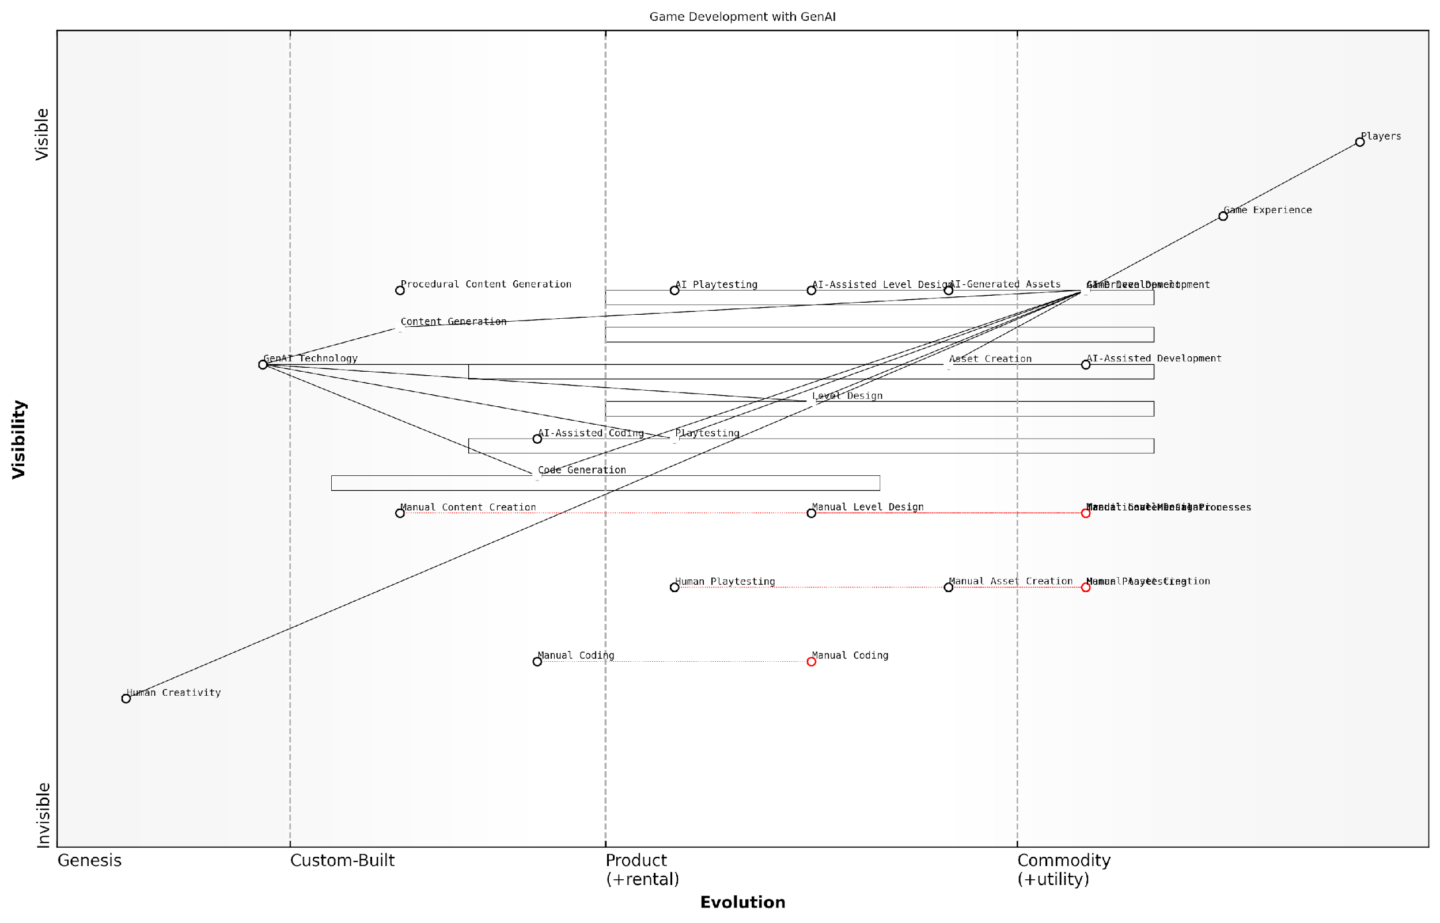

*Draft Wardley Map: [Insert Wardley Map: Streamlining Development Processes]*

[Edit this draft Wardley Map](https://create.wardleymaps.ai/#clone:7e538ee16c65cf6b32)

Wardley Map Assessment

This Wardley Map reveals a game development landscape in the midst of an AI-driven transformation. The strategic position is strong, with clear movement towards AI integration across the development pipeline. The key opportunity lies in fully embracing AI-Driven Development while maintaining a crucial balance with Human Creativity. Success will depend on rapid adaptation, strategic investment in GenAI Technology, and fostering an AI-augmented creative process. The potential for competitive advantage is significant, but so are the risks of disruption for those who fail to evolve quickly enough. The future of game development, as depicted in this map, is one of AI-human collaboration, hyper-efficient processes, and potentially revolutionary player experiences.

[View full Wardley Map report](http://markdown_wardley_map_reports/wardley_map_report_05_Streamlining_Development_Processes.md)

### Creating New Genres and Gameplay Mechanics

As we delve into the transformative potential of Generative AI (GenAI) in gaming, one of the most exciting prospects is its ability to catalyse the creation of entirely new genres and innovative gameplay mechanics. This subsection explores how GenAI is poised to revolutionise the very foundations of game design, offering unprecedented opportunities for creativity and player engagement.

GenAI’s capacity to generate, iterate, and adapt content in real-time opens up a vast landscape of possibilities for game developers and players alike. By leveraging advanced machine learning algorithms and neural networks, GenAI can produce unique game elements, from intricate storylines to complex game worlds, that were previously unimaginable or prohibitively resource-intensive to create manually.

GenAI is not just a tool; it’s a collaborator in the creative process, capable of pushing the boundaries of what we consider possible in game design.

Let’s explore some of the key areas where GenAI is driving innovation in game genres and mechanics:

* Procedurally Generated Worlds with Narrative Coherence
* Dynamic Character Evolution
* Emergent Gameplay Systems
* AI-Driven Multiplayer Experiences
* Adaptive Storytelling Engines

Procedurally Generated Worlds with Narrative Coherence: While procedural generation has been used in games for years, GenAI takes this concept to new heights. By incorporating sophisticated language models and context-aware algorithms, GenAI can create vast, detailed worlds that not only look unique but also possess internal logic and narrative consistency. This advancement allows for the development of exploration-based games with unprecedented depth and replayability.

Dynamic Character Evolution: GenAI enables the creation of non-player characters (NPCs) that evolve based on player interactions and game events. This technology paves the way for a new genre of ‘living world’ games, where each playthrough results in a unique cast of characters with their own emergent personalities and storylines.

Emergent Gameplay Systems: By analysing player behaviour and preferences, GenAI can dynamically adjust game rules and mechanics in real-time. This capability allows for the development of games that evolve as they are played, creating entirely new genres that blur the lines between different game types and offer personalised challenges tailored to each player’s style.

The future of gaming lies in systems that learn and adapt to player behaviour, creating experiences that are as unique as the individuals playing them.

AI-Driven Multiplayer Experiences: GenAI has the potential to revolutionise multiplayer gaming by creating dynamic, AI-controlled factions or entities that respond to the collective actions of players. This could lead to the emergence of new genres that combine elements of massively multiplayer online games (MMOs) with strategy and simulation games, where player actions have far-reaching consequences on an AI-driven game world.

Adaptive Storytelling Engines: Perhaps one of the most exciting applications of GenAI is in the realm of narrative design. By leveraging natural language processing and generation capabilities, GenAI can create adaptive storytelling engines that craft unique, coherent narratives in response to player choices and actions. This technology could give rise to a new genre of ‘infinite storytelling’ games, where each playthrough offers a completely original narrative experience.

The implementation of these GenAI-driven innovations presents both opportunities and challenges for game developers. On one hand, it offers unprecedented creative freedom and the ability to create games with near-infinite content. On the other, it requires a shift in development paradigms and careful consideration of how to balance AI-generated content with human-crafted elements.

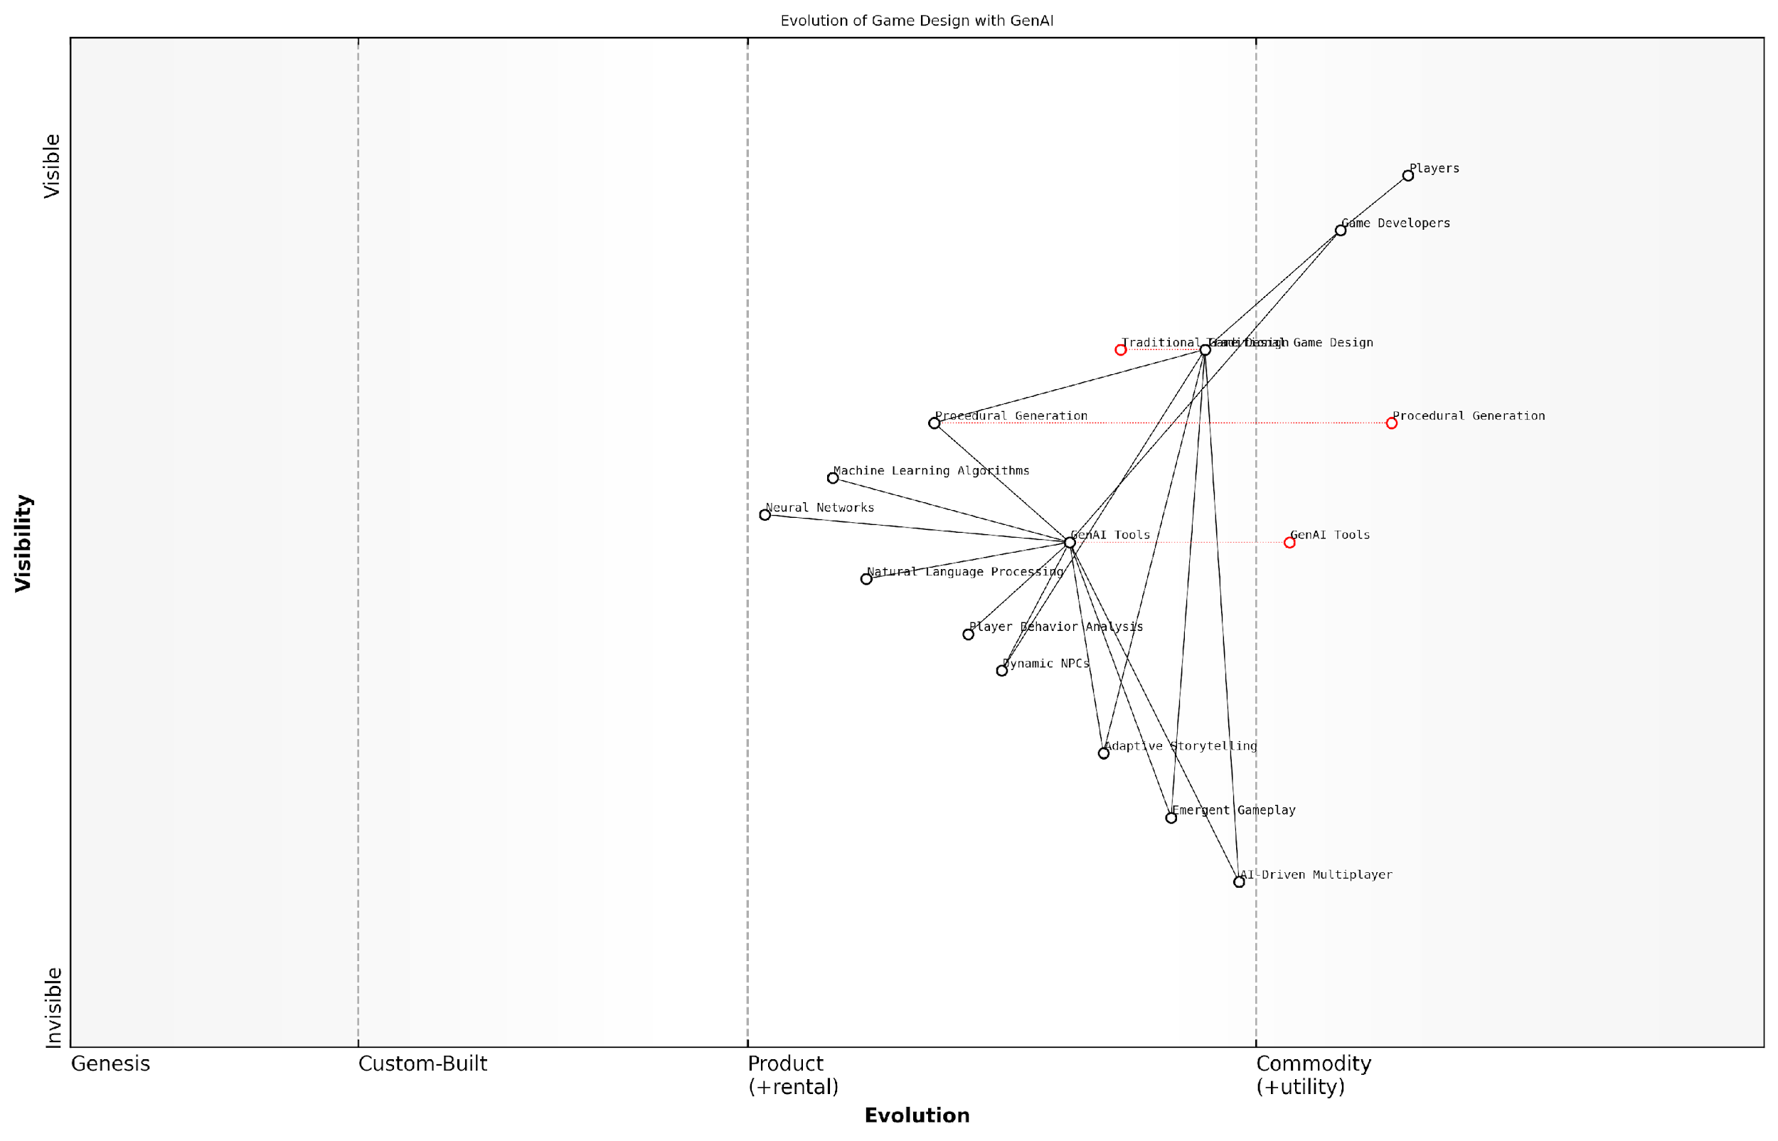

*Draft Wardley Map: [Insert Wardley Map: Creating New Genres and Gameplay Mechanics]*

[Edit this draft Wardley Map](https://create.wardleymaps.ai/#clone:626cb2ab6579f5b92b)

Wardley Map Assessment

This Wardley Map reveals a gaming industry on the cusp of an AI-driven revolution. The strategic positioning of GenAI Tools as a central, evolving component suggests significant opportunities for innovation in gameplay, storytelling, and player engagement. However, successful navigation of this transition will require careful balance between AI integration and traditional game design principles, as well as proactive management of potential risks. Companies that can effectively leverage GenAI technologies while maintaining focus on enhancing player experiences are likely to gain significant competitive advantages in the evolving gaming landscape.

[View full Wardley Map report](http://markdown_wardley_map_reports/wardley_map_report_06_Creating_New_Genres_and_Gameplay_Mechanics.md)

As we look to the future, it’s clear that GenAI will play a pivotal role in shaping the next generation of gaming experiences. However, it’s important to note that the goal is not to replace human creativity, but to augment and enhance it. The most successful implementations of GenAI in game design will likely be those that find the right balance between AI-generated content and human-directed creativity.

The true power of GenAI in gaming lies not in replacing human designers, but in empowering them to create experiences that were previously impossible.

In conclusion, the promise of GenAI in creating new genres and gameplay mechanics is immense. As this technology continues to evolve, we can expect to see a proliferation of innovative game concepts that challenge our current understanding of what games can be. The future of gaming is not just about better graphics or more complex systems, but about creating living, breathing worlds that respond and adapt to each player in unique and meaningful ways.

# Chapter 1: The Intersection of Generative AI and Game Design

## Principles of AI-Driven Game Design

### Balancing Creativity and Control

In the rapidly evolving landscape of AI-driven game design, one of the most critical challenges facing developers and designers is striking the delicate balance between unleashing the creative potential of generative AI and maintaining precise control over the game’s core elements. This balance is essential for crafting engaging, coherent, and high-quality gaming experiences that leverage the power of AI while adhering to the developer’s vision and the game’s intended design principles.

The integration of generative AI into game design processes offers unprecedented opportunities for innovation, efficiency, and player engagement. However, it also introduces complexities that require careful consideration and management. Let us explore the key aspects of balancing creativity and control in AI-driven game design, drawing from industry best practices and cutting-edge research in the field.

Defining the Creative Boundaries

The first step in balancing creativity and control is to clearly define the boundaries within which the AI system can operate. This involves establishing a set of rules, constraints, and guidelines that govern the AI’s creative output. These boundaries serve as a framework that ensures the AI-generated content aligns with the game’s overall aesthetic, narrative, and gameplay mechanics.

Setting clear parameters for AI creativity is akin to providing an artist with a canvas and a colour palette. It gives direction while allowing for creative expression within those bounds.

Developers must carefully consider which aspects of the game should be open to AI-driven creativity and which should remain under strict human control. For instance, while AI might be given free rein to generate diverse NPC dialogue or procedural landscapes, core story elements or critical game mechanics may require more direct human oversight.

Implementing Feedback Loops

To maintain control over the AI’s creative output, it’s crucial to implement robust feedback loops within the game design process. These loops allow developers to evaluate, refine, and iterate on AI-generated content, ensuring it meets quality standards and aligns with the game’s vision.

* Automated quality checks: Implement algorithms to assess AI-generated content against predefined criteria.
* Human review processes: Establish workflows for designers to review and approve AI outputs.
* Player feedback integration: Incorporate player reactions and preferences to guide AI content generation.
* Iterative refinement: Use machine learning techniques to continuously improve the AI’s output based on feedback.

By incorporating these feedback mechanisms, developers can harness the creative potential of AI while maintaining a high degree of control over the final product.

Hybrid Approaches to Content Creation

One effective strategy for balancing creativity and control is to adopt hybrid approaches that combine AI-generated content with human-crafted elements. This approach allows developers to leverage the strengths of both AI and human creativity, resulting in richer, more nuanced game experiences.

The future of game design lies not in AI replacing human creativity, but in the synergistic collaboration between human designers and AI systems.

For example, AI might generate the initial layout of a game level, which human designers then refine and populate with hand-crafted elements. Or, AI could produce variations on character designs based on parameters set by artists, who then select and further develop the most promising concepts.

Adaptive Control Systems

As AI systems become more sophisticated, there’s a growing need for adaptive control mechanisms that can dynamically adjust the level of AI autonomy based on the specific context and requirements of different game elements. These systems allow for a fluid balance between creativity and control, adapting in real-time to the needs of the game and the preferences of the development team.

* Context-aware constraints: Adjust AI parameters based on the current game state or player actions.
* Dynamic creativity thresholds: Vary the degree of AI creative freedom depending on the importance or sensitivity of the content being generated.
* Adaptive learning rates: Modify how quickly the AI system incorporates feedback and adjusts its output based on the stability of the game’s design.

Ethical Considerations in AI Creativity

As we push the boundaries of AI-driven creativity in game design, it’s crucial to consider the ethical implications of these technologies. Developers must ensure that AI-generated content adheres to ethical standards, avoids biases, and respects cultural sensitivities.

Implementing ethical guidelines and oversight mechanisms is essential for maintaining control over AI creativity while fostering innovation. This may involve establishing ethics review boards, developing AI fairness metrics, and implementing content filtering systems to catch potentially problematic AI-generated material.

The Role of Human Expertise

Despite the increasing capabilities of AI in game design, human expertise remains invaluable in guiding and shaping the creative process. Game designers, artists, and writers bring a depth of experience, cultural understanding, and creative vision that is essential for crafting truly compelling gaming experiences.

The most successful AI-driven game design approaches are those that augment and empower human creativity rather than attempting to replace it entirely.

By positioning AI as a powerful tool in the designer’s toolkit rather than a replacement for human creativity, developers can strike a balance that maximises the benefits of both AI and human input.

Conclusion

Balancing creativity and control in AI-driven game design is an ongoing challenge that requires careful consideration, robust systems, and a nuanced understanding of both AI capabilities and human creativity. By implementing clear boundaries, feedback loops, hybrid approaches, adaptive control systems, and ethical guidelines, developers can harness the immense potential of AI while maintaining the integrity and vision of their games.

As we continue to push the boundaries of what’s possible in AI-driven game design, the ability to effectively balance creativity and control will become an increasingly valuable skill for game developers. Those who master this balance will be well-positioned to create the next generation of innovative, engaging, and transformative gaming experiences.

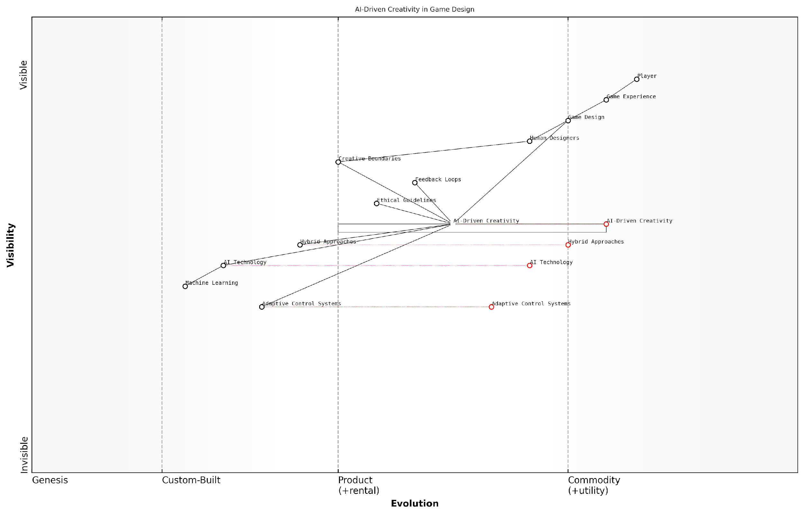

*Draft Wardley Map: [Insert Wardley Map: Balancing Creativity and Control]*

[Edit this draft Wardley Map](https://create.wardleymaps.ai/#clone:490bdfbfc762595d43)

Wardley Map Assessment

This Wardley Map reveals a game design landscape in transition, with AI-driven creativity poised to revolutionize the field. The strategic focus should be on responsible integration of AI, developing sophisticated control and collaboration mechanisms, and maintaining a strong ethical framework. Success will depend on effectively balancing AI capabilities with human creativity and ensuring that technological advancements ultimately serve to enhance the player experience. Companies that can master this balance and lead in developing hybrid AI-human design approaches are likely to gain significant competitive advantages in the evolving gaming industry.

[View full Wardley Map report](http://markdown_wardley_map_reports/wardley_map_report_07_Balancing_Creativity_and_Control.md)

### Designing for Adaptability

In the rapidly evolving landscape of AI-driven game design, designing for adaptability has emerged as a crucial principle that underpins the future of gaming with generative AI. This approach enables games to dynamically respond to player actions, preferences, and behaviours, creating personalised experiences that evolve over time. As we delve into this topic, we’ll explore how adaptability is reshaping game design paradigms and opening up new possibilities for player engagement and retention.

At its core, designing for adaptability in AI-driven game design involves creating systems that can learn, adjust, and evolve based on player interactions and data. This principle is fundamentally changing how we approach game development, moving away from static, pre-defined experiences towards more fluid, responsive gameplay that can cater to individual player needs and preferences.

Adaptability in game design is not just about creating responsive systems; it’s about crafting experiences that grow and evolve with the player, fostering a deeper sense of connection and engagement.

To effectively implement adaptability in AI-driven game design, developers must consider several key aspects:

* Dynamic Content Generation: Utilising generative AI to create game content that adapts to player preferences and playstyles.
* Intelligent Difficulty Scaling: Implementing AI systems that can adjust game difficulty in real-time based on player performance and engagement levels.
* Personalised Narrative Experiences: Crafting story elements and character interactions that evolve based on player choices and behaviours.
* Adaptive Game Mechanics: Developing gameplay systems that can modify rules, objectives, or mechanics to suit individual player needs or to introduce novel challenges.
* Player Behaviour Analysis: Employing AI to analyse player data and make informed decisions about game adjustments and content delivery.

One of the most significant advantages of designing for adaptability is the potential for increased player engagement and retention. By creating games that can tailor themselves to individual preferences and skill levels, developers can ensure that players remain challenged and motivated throughout their gaming experience. This personalisation can lead to higher levels of player satisfaction and longer-term engagement with the game.

However, designing for adaptability also presents unique challenges. Balancing adaptability with game integrity and fairness is crucial, particularly in competitive multiplayer environments. Developers must ensure that adaptive systems do not create unfair advantages or disadvantages for certain players. Additionally, there are ethical considerations to address, such as data privacy and the potential for manipulative game design practices.

The key to successful adaptive game design lies in striking the right balance between personalisation and fairness, ensuring that all players have an equitable and enjoyable experience.

In the context of government and public sector applications, designing for adaptability in AI-driven games can have significant implications. For instance, adaptive educational games could be developed to cater to diverse learning styles and paces, potentially revolutionising public education systems. Similarly, adaptive simulation games could be used for training purposes in various government sectors, providing personalised learning experiences for employees based on their individual strengths and weaknesses.

A case study that exemplifies the power of adaptability in game design is the AI-driven narrative game ‘AI Dungeon’. This game uses advanced language models to generate unique story content based on player inputs and choices. The game’s ability to adapt its narrative in real-time based on player decisions showcases the potential of AI-driven adaptability in creating truly personalised gaming experiences.

Looking towards the future, the principle of designing for adaptability is likely to become even more central to game development as AI technologies continue to advance. We can anticipate the emergence of games that not only adapt to player behaviours but also predict player preferences and proactively adjust gameplay elements to maximise engagement and enjoyment.

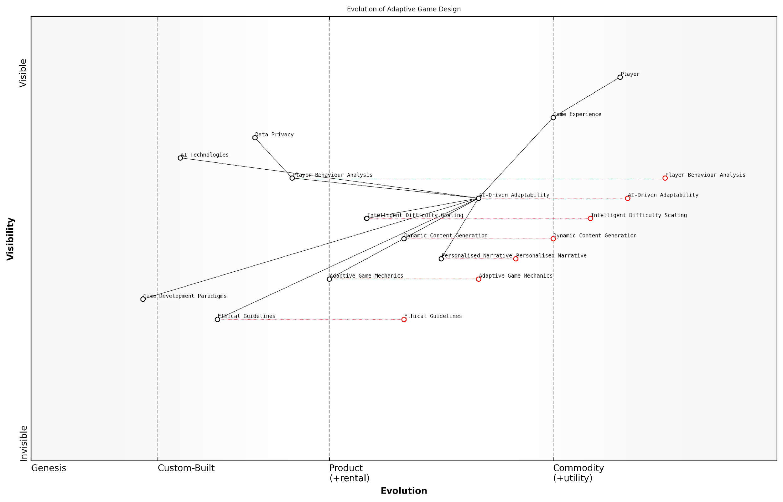

*Draft Wardley Map: [Insert Wardley Map: Designing for Adaptability]*

[Edit this draft Wardley Map](https://create.wardleymaps.ai/#clone:ff68aabfa1d8e201ff)

Wardley Map Assessment

The map represents a forward-thinking approach to game design, leveraging AI to create highly adaptive and personalised experiences. The strategic position is strong, with a clear focus on innovation through AI-driven adaptability. However, the rapid evolution of AI technologies and the emerging importance of ethical considerations present both opportunities and challenges. To maintain a competitive edge, the focus should be on advancing AI capabilities while simultaneously developing robust ethical guidelines and privacy measures. The integration of AI into core game development paradigms will be crucial for long-term success in this evolving landscape.

[View full Wardley Map report](http://markdown_wardley_map_reports/wardley_map_report_08_Designing_for_Adaptability.md)

As we move forward, it’s crucial for game developers, policymakers, and industry leaders to collaborate in establishing best practices and ethical guidelines for adaptive game design. This will ensure that the benefits of adaptability are realised while mitigating potential risks and maintaining the integrity of gaming experiences.

In conclusion, designing for adaptability represents a paradigm shift in AI-driven game design, offering unprecedented opportunities for creating personalised, engaging, and evolving gaming experiences. As we continue to explore and refine this principle, we stand on the cusp of a new era in gaming, one where every player’s journey is uniquely tailored to their individual preferences, skills, and desires.

### Integrating AI into Game Narratives

As we delve into the principles of AI-driven game design, one of the most exciting and transformative areas is the integration of AI into game narratives. This fusion of artificial intelligence and storytelling has the potential to revolutionise the way we experience games, creating dynamic, personalised, and deeply immersive narratives that adapt to each player’s choices and play style.

The integration of AI into game narratives represents a paradigm shift in game design, moving away from static, pre-written stories towards dynamic, emergent narratives that can respond in real-time to player actions and preferences. This approach not only enhances player engagement but also opens up new possibilities for replayability and narrative depth.

AI-driven narratives are not just about creating more content, but about creating more meaningful content that resonates with each individual player.

Let’s explore the key principles and considerations for successfully integrating AI into game narratives:

* Dynamic Story Generation
* Character Adaptation
* Emotional Intelligence in Narratives
* Player Agency and Narrative Coherence
* Balancing Authorial Intent and AI Creativity

Dynamic Story Generation: At the heart of AI-driven narratives is the ability to generate story elements on the fly. This involves using natural language processing (NLP) and machine learning models to create plot points, dialogue, and even entire story arcs based on player actions and choices.

One approach to dynamic story generation is the use of narrative planning systems. These AI-driven systems can create coherent storylines by defining narrative goals, character motivations, and potential plot twists. As players progress through the game, the system adapts the story in real-time, ensuring that each playthrough feels unique and tailored to the individual.

The future of game narratives lies in creating stories that are not just played, but lived and shaped by each player’s unique journey.

Character Adaptation: AI can breathe new life into non-player characters (NPCs) by making them more responsive and adaptive to player interactions. This involves developing AI models that can understand and remember player behaviour, adjusting character personalities and relationships accordingly.

For instance, an NPC might become more trusting or hostile based on the player’s past actions, or develop new goals and motivations in response to changing game circumstances. This level of character adaptation creates a more believable and immersive game world, where players feel that their actions have genuine consequences on the narrative and its characters.

Emotional Intelligence in Narratives: As AI technology advances, we’re seeing the development of more sophisticated emotion recognition and generation systems. These can be integrated into game narratives to create more nuanced and emotionally resonant storytelling.

AI-driven emotion systems can analyse player behaviour, dialogue choices, and even biometric data (in VR settings) to gauge the player’s emotional state. The narrative can then adapt to elicit specific emotional responses or to mirror the player’s mood, creating a more empathetic and engaging storytelling experience.

The most compelling AI-driven narratives will be those that can not only understand but also evoke genuine emotional responses from players.

Player Agency and Narrative Coherence: One of the key challenges in integrating AI into game narratives is maintaining a balance between player agency and narrative coherence. While we want to give players the freedom to shape the story, we also need to ensure that the resulting narrative remains logical and satisfying.

This requires developing AI systems that can understand the broader context of the game world and the overarching narrative structure. These systems must be able to generate story elements that fit within established lore and character motivations, while still allowing for meaningful player choice and consequence.

Balancing Authorial Intent and AI Creativity: As we integrate AI more deeply into game narratives, we must grapple with the question of authorship. How do we balance the creative vision of human writers and designers with the generative capabilities of AI?

One approach is to use AI as a collaborative tool, where human writers define the overall narrative structure and key plot points, while AI fills in the details and generates variations. This hybrid approach allows for the maintenance of a cohesive artistic vision while leveraging AI to create more dynamic and personalised narrative experiences.

The most successful AI-driven narratives will be those that seamlessly blend human creativity with AI-generated content, creating stories that are both coherent and infinitely variable.

As we look to the future of AI-driven game narratives, we can anticipate even more advanced integration of AI technologies. This might include the use of large language models to generate more natural and context-aware dialogue, or the development of AI systems that can create entire game worlds complete with their own histories, cultures, and narrative possibilities.

The integration of AI into game narratives represents a frontier in game design that is both exciting and challenging. As we continue to push the boundaries of what’s possible, we must remain mindful of the ethical implications, particularly in terms of data privacy and the potential for AI-generated content to perpetuate biases or inappropriate content.

Ultimately, the goal of integrating AI into game narratives is not to replace human storytellers, but to augment and enhance their capabilities. By combining the creativity and emotional intelligence of human writers with the adaptive and generative powers of AI, we can create game narratives that are more immersive, personalised, and emotionally resonant than ever before.

The true power of AI in game narratives lies not in its ability to replace human creativity, but in its potential to amplify and extend it in ways we’re only beginning to imagine.

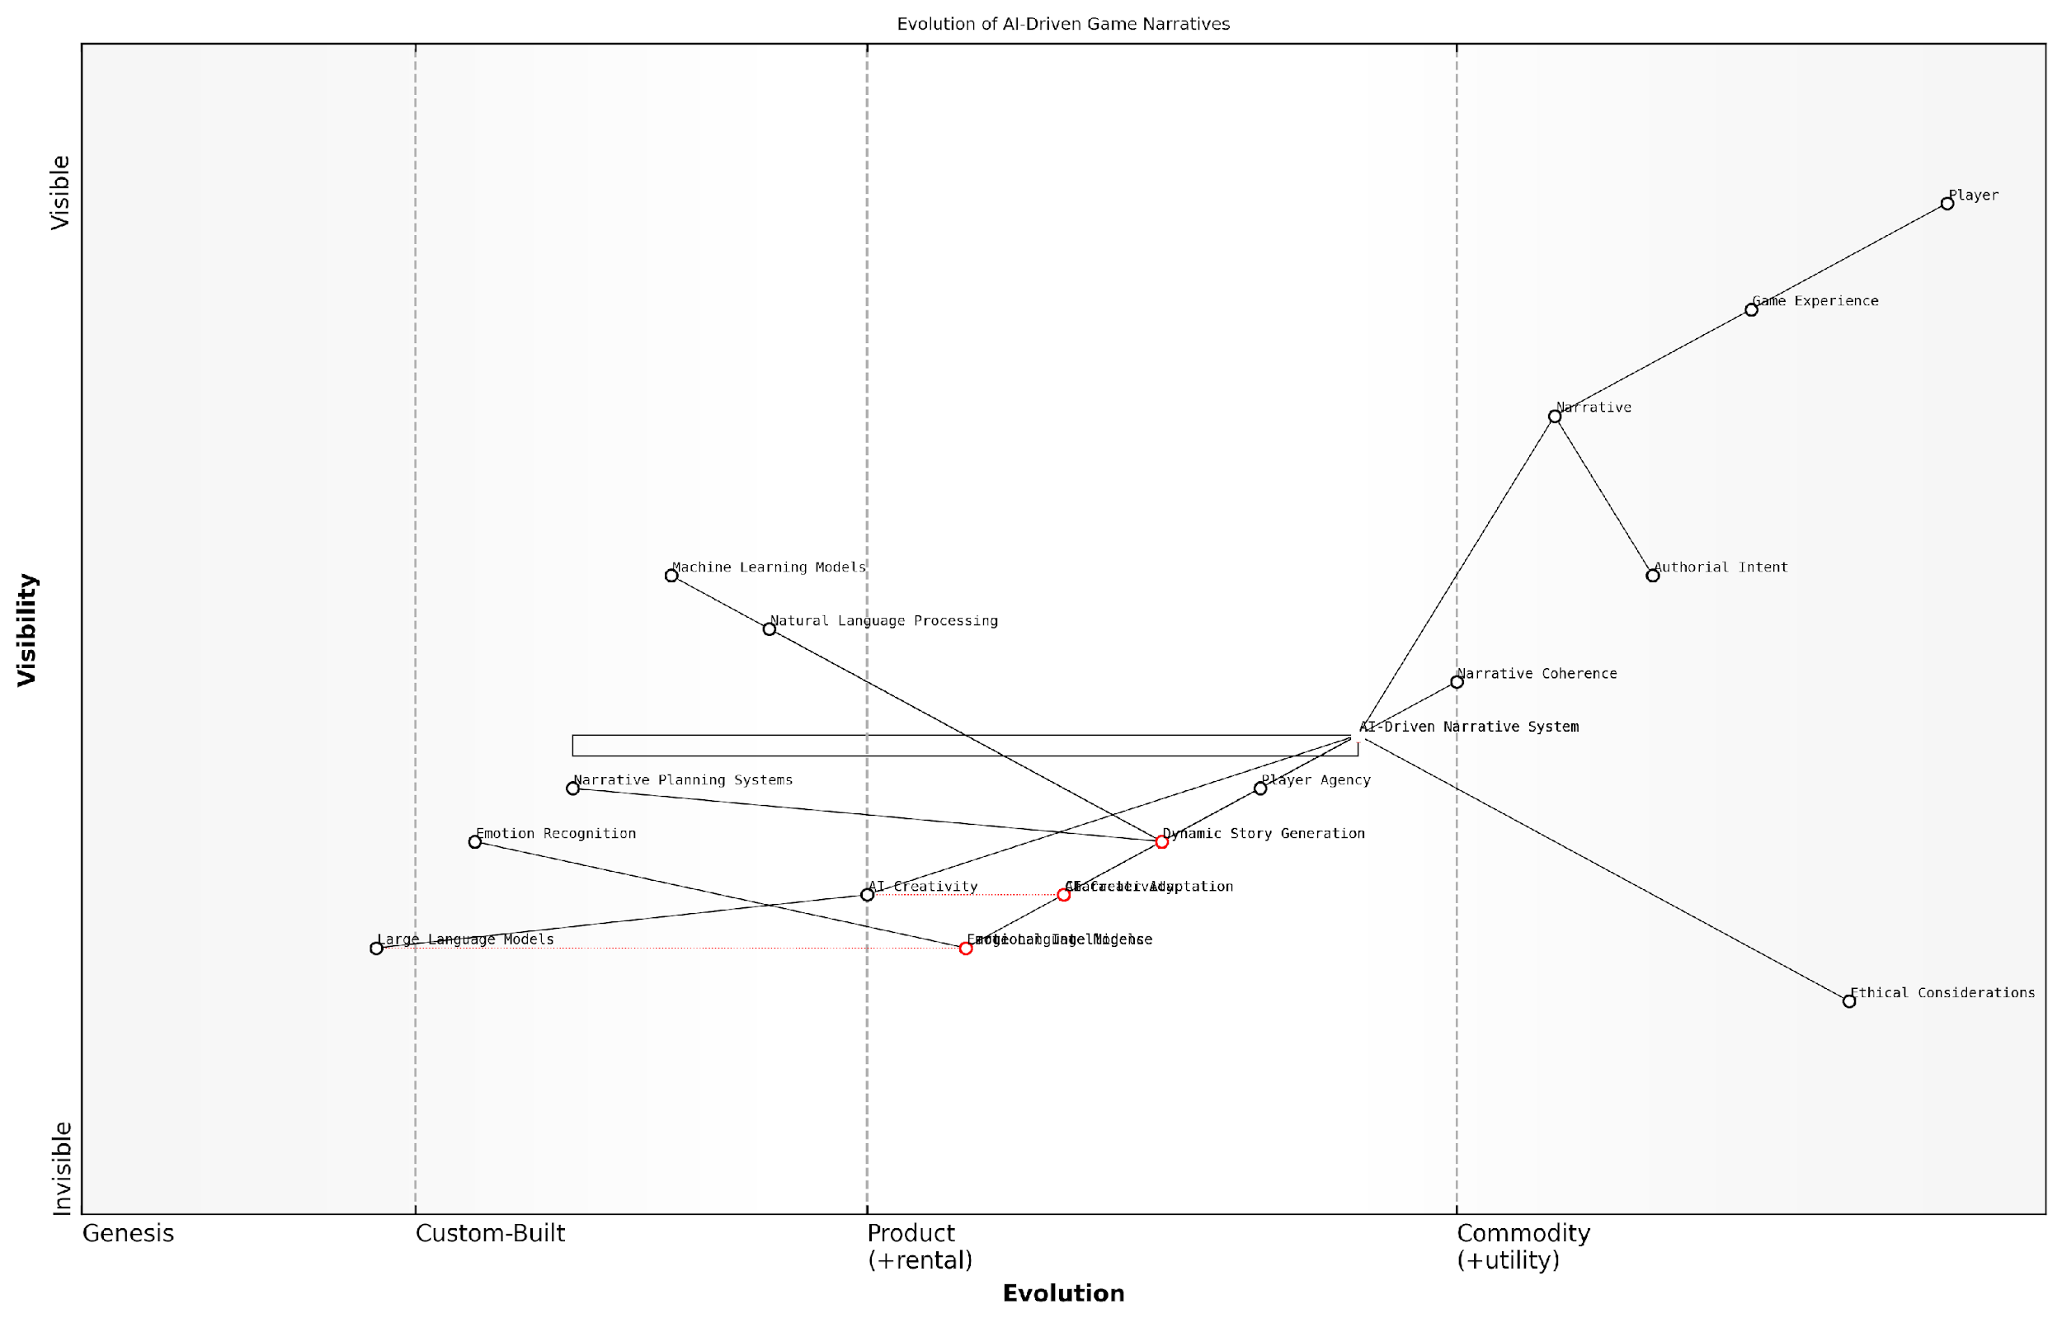

*Draft Wardley Map: [Insert Wardley Map: Integrating AI into Game Narratives]*

[Edit this draft Wardley Map](https://create.wardleymaps.ai/#clone:8bd727bb29b9dae8b8)

Wardley Map Assessment

This Wardley Map reveals a dynamic and rapidly evolving landscape in AI-driven game narratives. The strategic position is strong, with a clear focus on enhancing player experience through advanced AI technologies. Key opportunities lie in developing more sophisticated emotional intelligence, improving narrative coherence in AI-generated content, and pioneering ethical AI practices in gaming. The main challenges involve balancing technological advancement with ethical considerations and maintaining narrative quality amidst increasing AI integration. To succeed, companies must invest in both cutting-edge AI technologies and the human expertise to guide their implementation, while remaining agile to adapt to the fast-paced evolution of this field. The future of game narratives appears to be heading towards highly personalised, emotionally intelligent, and ethically conscious AI-driven experiences, offering exciting possibilities for those who can successfully navigate this complex landscape.

[View full Wardley Map report](http://markdown_wardley_map_reports/wardley_map_report_09_Integrating_AI_into_Game_Narratives.md)

## Tools and Techniques

### Machine Learning Models for Game Development

As we delve into the realm of machine learning models for game development, we find ourselves at the forefront of a technological revolution that is reshaping the gaming landscape. The integration of sophisticated AI algorithms into game design and development processes is not merely an incremental improvement; it represents a paradigm shift in how we conceive, create, and experience interactive entertainment. This section will explore the cutting-edge tools and techniques that are empowering developers to harness the full potential of machine learning in game creation.

The application of machine learning models in game development spans a wide spectrum of functionalities, from enhancing graphics and animations to creating more intelligent non-player characters (NPCs) and generating dynamic content. Let’s examine some of the key areas where these models are making significant impacts:

* Procedural Content Generation (PCG)
* Intelligent Behaviour Systems
* Player Modelling and Adaptation
* Visual Enhancement and Optimisation
* Natural Language Processing for In-Game Dialogue

Procedural Content Generation (PCG) has been revolutionised by machine learning models, particularly Generative Adversarial Networks (GANs) and Variational Autoencoders (VAEs). These models can create vast, diverse game worlds, textures, and even music, significantly reducing development time and costs while enhancing player experiences with unique, dynamically generated content.

The advent of GAN-based PCG has opened up possibilities we never thought achievable. We’re now able to create entire planets with rich, varied ecosystems at the push of a button, allowing our team to focus on crafting meaningful gameplay experiences rather than manually designing every tree and rock.

Intelligent Behaviour Systems powered by Reinforcement Learning (RL) and Deep Learning models are transforming NPC interactions and enemy AI. These systems can learn and adapt to player behaviour, creating more challenging and realistic opponents. For instance, Deep Q-Networks (DQNs) have been successfully employed to create NPCs that can navigate complex environments and make strategic decisions based on the current game state.

Player Modelling and Adaptation techniques utilise supervised learning algorithms to analyse player behaviour and preferences. This data is then used to tailor game difficulty, content presentation, and even narrative elements to individual players. Techniques such as Collaborative Filtering and Matrix Factorisation are commonly employed to create recommendation systems within games, suggesting in-game items or quests based on player history.

Visual Enhancement and Optimisation have seen significant advancements through the application of Convolutional Neural Networks (CNNs) and Super-Resolution GANs. These models can upscale textures, enhance lighting, and even generate realistic facial animations in real-time, pushing the boundaries of graphical fidelity while maintaining performance.

The integration of Super-Resolution GANs into our graphics pipeline has been a game-changer. We’re now able to deliver 4K quality visuals on devices that previously struggled with 1080p, all without sacrificing frame rates or gameplay smoothness.

Natural Language Processing (NLP) models, particularly transformer-based architectures like GPT (Generative Pre-trained Transformer), have revolutionised in-game dialogue systems. These models enable more natural and context-aware conversations with NPCs, enhancing immersion and storytelling capabilities. Additionally, they can be used for real-time translation, making games more accessible to global audiences.

It’s crucial to note that the effective implementation of these machine learning models requires a robust infrastructure and careful consideration of computational resources. Game developers must balance the benefits of AI-driven features with performance requirements, especially for mobile and console platforms with limited processing power.

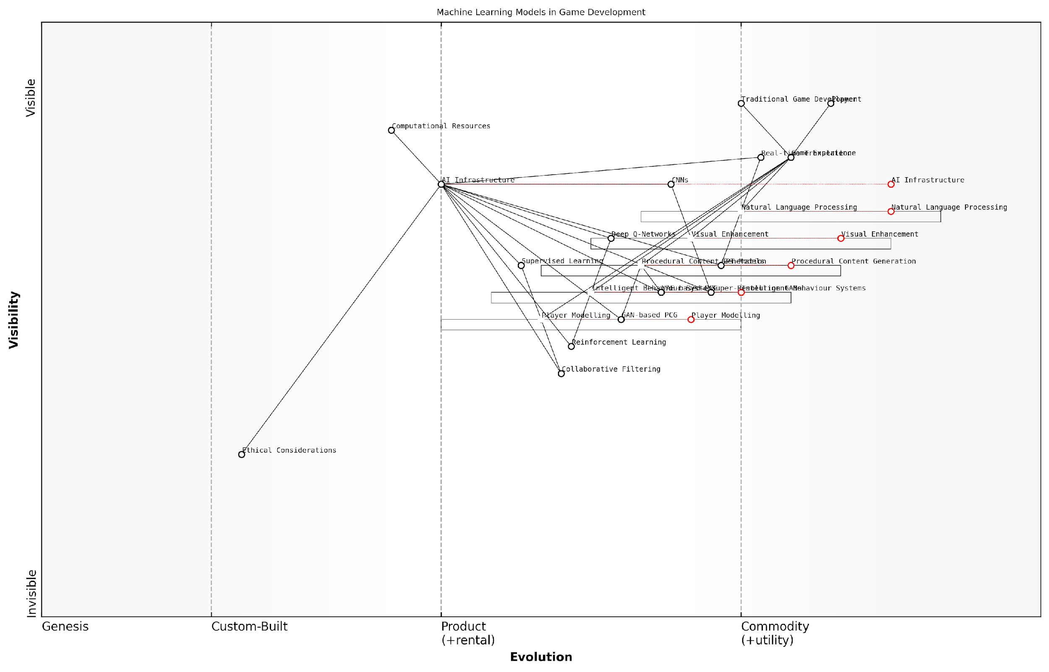

*Draft Wardley Map: [Insert Wardley Map: Machine Learning Models for Game Development]*

[Edit this draft Wardley Map](https://create.wardleymaps.ai/#clone:220c2feccbe60c293e)

Wardley Map Assessment

The map reveals a game development landscape increasingly driven by ML technologies, with significant opportunities for innovation in player-centric, AI-enhanced gaming experiences. The key strategic focus should be on developing advanced Player Modelling capabilities, creating ethical AI frameworks, and building scalable AI Infrastructure to support the evolution of ML-driven game development. By prioritising these areas, game developers can create more engaging, personalised, and responsible gaming experiences, potentially revolutionising the industry.

[View full Wardley Map report](http://markdown_wardley_map_reports/wardley_map_report_10_Machine_Learning_Models_for_Game_Development.md)

As we look to the future, the integration of more advanced machine learning models, such as those based on quantum computing or neuromorphic architectures, holds promise for even more sophisticated game AI. However, developers must also grapple with ethical considerations, such as data privacy and the potential for AI to exacerbate gaming addiction through hyper-personalisation.

In conclusion, machine learning models are not just tools for game development; they are catalysts for innovation in the gaming industry. As these technologies continue to evolve and become more accessible, we can expect to see a new generation of games that blur the lines between pre-programmed experiences and dynamically generated worlds, offering players unprecedented levels of immersion and interactivity.

The true power of machine learning in game development lies not in replacing human creativity, but in augmenting it. These models are enabling developers to realise visions that were once thought impossible, ushering in a new era of gaming that promises to be more engaging, personalised, and awe-inspiring than ever before.

### Natural Language Processing in Gaming

Natural Language Processing (NLP) has emerged as a transformative force in the gaming industry, revolutionising the way players interact with games and how game narratives are crafted. As we delve into the tools and techniques of NLP in gaming, it’s crucial to understand its profound impact on player immersion, storytelling, and game design. This section explores the cutting-edge NLP technologies that are shaping the future of gaming, offering unprecedented levels of interactivity and personalisation.

At its core, NLP in gaming aims to bridge the gap between human language and computer understanding, enabling more natural and intuitive interactions within game environments. This technology is not merely an add-on but a fundamental shift in how games are conceived and experienced.

Let’s explore the key tools and techniques that are driving this revolution:

* Advanced Language Models
* Speech Recognition and Synthesis
* Sentiment Analysis
* Dialogue Management Systems
* Machine Translation

Advanced Language Models: The backbone of NLP in gaming lies in sophisticated language models, such as GPT (Generative Pre-trained Transformer) and its variants. These models have the capability to understand context, generate human-like text, and even create dynamic narratives. In the gaming context, they’re being used to craft intelligent non-player character (NPC) dialogues, generate quest descriptions, and even create entire storylines on the fly.

The integration of advanced language models in gaming is not just about improving dialogue; it’s about creating living, breathing worlds that respond to player actions in meaningful and unpredictable ways.

Speech Recognition and Synthesis: Voice-controlled gaming is no longer a futuristic concept but a present reality. Modern NLP techniques allow for real-time speech recognition, enabling players to issue voice commands to characters or control game elements. Conversely, text-to-speech synthesis brings NPCs to life with dynamic, context-aware vocal responses. This bidirectional audio interaction creates a more immersive and accessible gaming experience.

Sentiment Analysis: Understanding player emotions is crucial for adaptive gameplay. NLP-powered sentiment analysis tools can interpret the emotional content of player communications, whether through text chats or voice inputs. This emotional intelligence allows games to adjust their difficulty, narrative tone, or even NPC behaviours in response to the player’s emotional state, creating a more personalised and engaging experience.

Dialogue Management Systems: These systems go beyond simple branching dialogues to create more natural, context-aware conversations with NPCs. By leveraging NLP, games can maintain coherent dialogues over extended interactions, remember previous conversations, and adapt responses based on the player’s choices and game events. This creates a sense of persistence and realism in NPC interactions, enhancing the overall narrative experience.

Machine Translation: As gaming becomes increasingly global, real-time machine translation powered by NLP is breaking down language barriers. This technology allows players from different linguistic backgrounds to communicate seamlessly in multiplayer environments, fostering a more inclusive and diverse gaming community.

The implementation of these NLP tools and techniques in gaming is not without its challenges. Developers must grapple with issues of computational efficiency, maintaining narrative coherence, and ensuring that NLP-driven elements enhance rather than detract from the core gameplay experience.

The true power of NLP in gaming lies not in replacing human creativity, but in augmenting it. It’s about giving developers new tools to create richer, more responsive game worlds.

One of the most promising applications of NLP in gaming is in the realm of procedural content generation. By combining NLP with other AI techniques, games can generate vast, unique worlds with their own histories, cultures, and languages. This not only reduces development time and costs but also creates infinitely replayable experiences.

For instance, a strategy game might use NLP to generate unique civilisations, complete with their own languages, mythologies, and diplomatic styles. Players could then interact with these civilisations using natural language, with the game’s NLP system interpreting intent and context to drive the gameplay forward.

Another exciting frontier is the use of NLP in player modelling. By analysing player communications and in-game choices, NLP systems can build sophisticated models of player preferences, skills, and behaviours. This data can then be used to tailor game experiences, offer personalised challenges, or even predict player churn.

As we look to the future, the potential applications of NLP in gaming are boundless. We’re moving towards an era of truly intelligent games that can understand, respond to, and even anticipate player needs and desires. This shift will not only revolutionise how games are played but also how they are designed and developed.

However, with great power comes great responsibility. The use of advanced NLP in gaming raises important ethical considerations, particularly around data privacy, consent, and the potential for manipulation. Game developers and publishers must navigate these challenges carefully, ensuring that NLP enhances the gaming experience without compromising player trust or wellbeing.

In conclusion, Natural Language Processing is poised to be a game-changer in the truest sense of the word. By enabling more natural, intuitive, and personalised interactions, NLP is helping to create game worlds that are more immersive, responsive, and alive than ever before. As the technology continues to evolve, we can expect to see even more innovative applications that push the boundaries of what’s possible in gaming.

The future of gaming is not just about better graphics or faster processors; it’s about creating worlds that understand us, respond to us, and grow with us. Natural Language Processing is the key to unlocking this future.

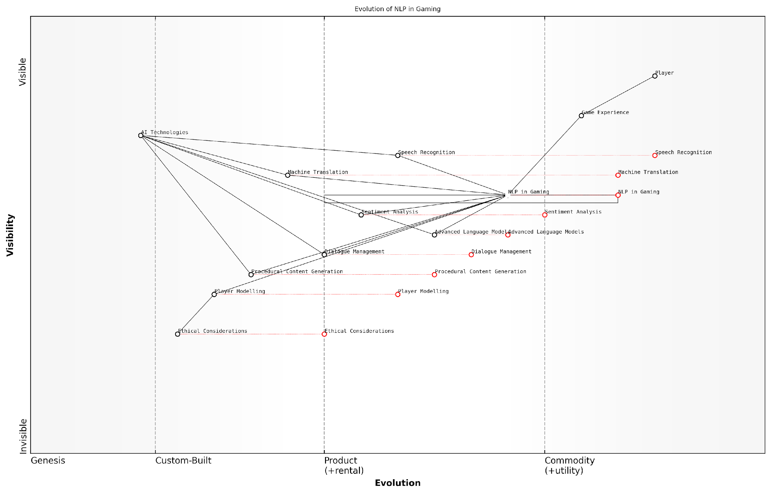

*Draft Wardley Map: [Insert Wardley Map: Natural Language Processing in Gaming]*

[Edit this draft Wardley Map](https://create.wardleymaps.ai/#clone:b8de9ee85d9237d3c6)

Wardley Map Assessment

This Wardley Map reveals a gaming industry on the cusp of a major transformation driven by NLP technologies. The strategic focus should be on rapidly evolving capabilities in Player Modelling and Procedural Content Generation, while simultaneously addressing the critical need for ethical AI frameworks. Companies that can successfully integrate advanced NLP technologies with immersive game experiences, all underpinned by strong ethical considerations, are likely to gain significant competitive advantage. The industry is moving towards more personalised, language-driven gaming experiences, but must navigate the challenges of ethical implementation and the need for increasingly sophisticated AI technologies. Partnerships and ecosystem development will be crucial, especially in areas like ethical AI and advanced language models. Overall, the map suggests exciting opportunities for innovation and differentiation, but also highlights the need for careful strategic planning to address evolving technological and ethical challenges.

[View full Wardley Map report](http://markdown_wardley_map_reports/wardley_map_report_11_Natural_Language_Processing_in_Gaming.md)

### Computer Vision and Gesture Recognition

As we delve into the realm of computer vision and gesture recognition within the context of generative AI and gaming, we find ourselves at the forefront of a technological revolution that is reshaping player interactions and immersive experiences. These cutting-edge tools and techniques are not merely enhancing gameplay; they are fundamentally altering the way we conceive and design games, opening up new vistas of possibility for both developers and players alike.

Computer vision, the field of AI that enables machines to interpret and understand visual information from the world, has found a natural home in the gaming industry. When combined with gesture recognition, it creates a powerful synergy that allows for more intuitive and natural player interactions. This convergence is particularly significant in the context of generative AI, as it enables games to respond dynamically to player movements and environmental cues, creating truly adaptive and personalised gaming experiences.

Let us explore the key components and applications of computer vision and gesture recognition in gaming:

* Deep Learning Models for Image Recognition
* Real-time Motion Tracking
* Facial Expression Analysis
* Hand and Body Pose Estimation
* Environmental Mapping and Object Detection

Deep Learning Models for Image Recognition form the backbone of modern computer vision systems in gaming. Convolutional Neural Networks (CNNs) have proven particularly effective in this domain, capable of processing and analysing visual data with remarkable accuracy. In the context of generative AI, these models can be used to interpret player actions, recognise in-game objects, and even generate new visual content on the fly.

Real-time Motion Tracking is a critical component of gesture recognition in gaming. Advanced algorithms, often utilising a combination of RGB cameras and depth sensors, can track player movements with high precision. This technology enables games to respond instantaneously to player gestures, creating a more immersive and interactive experience. When integrated with generative AI systems, motion tracking can inform procedural animations and dynamic character behaviours, leading to more realistic and engaging gameplay.

Facial Expression Analysis adds another layer of nuance to player interactions. By leveraging machine learning models trained on vast datasets of human expressions, games can now interpret players’ emotional states in real-time. This capability opens up new avenues for narrative design and character interactions, allowing NPCs to respond empathetically to the player’s mood, thereby deepening immersion and emotional engagement.

Hand and Body Pose Estimation techniques have evolved significantly, enabling more natural and intuitive control schemes. These systems can accurately track the position and orientation of a player’s hands and body, translating these movements into in-game actions. When combined with generative AI, pose estimation can drive procedural animation systems, creating lifelike character movements that adapt to the player’s actions and the game environment.

Environmental Mapping and Object Detection extend the capabilities of computer vision beyond player interactions. These technologies allow games to understand and respond to the physical space in which they are being played, opening up possibilities for augmented reality (AR) experiences. In the context of generative AI, this can lead to dynamically generated game worlds that adapt to the player’s real-world environment, blurring the lines between virtual and physical realities.

The integration of computer vision and gesture recognition with generative AI represents a paradigm shift in game design. We’re moving towards a future where games can understand and respond to players in ways that were previously unimaginable, creating experiences that are truly adaptive and personalised.

The practical applications of these technologies in gaming are vast and varied. For instance, in virtual reality (VR) games, hand tracking and gesture recognition can replace traditional controllers, allowing for more intuitive interactions within virtual environments. In mobile gaming, facial recognition can be used for player authentication and personalisation, while also enabling new forms of social interaction through animated avatars that mimic the player’s expressions.

However, the implementation of these technologies is not without challenges. Privacy concerns surrounding the collection and processing of visual data must be carefully addressed, particularly when games are being deployed in public sector contexts. Additionally, ensuring accessibility for players with different physical abilities requires thoughtful design and the development of alternative interaction methods.

Looking to the future, the convergence of computer vision, gesture recognition, and generative AI holds immense potential for creating more inclusive and engaging gaming experiences. As these technologies continue to evolve, we can anticipate games that not only respond to our actions but also understand our intentions and emotions, adapting in real-time to provide uniquely tailored experiences for each player.

In conclusion, computer vision and gesture recognition are pivotal tools in the arsenal of game developers leveraging generative AI. They represent a bridge between the physical and digital worlds, enabling more natural, intuitive, and immersive gaming experiences. As these technologies continue to advance, they will undoubtedly play a crucial role in shaping the future of gaming, pushing the boundaries of what is possible in interactive entertainment and potentially revolutionising how we interact with digital systems across various sectors, including government and public services.

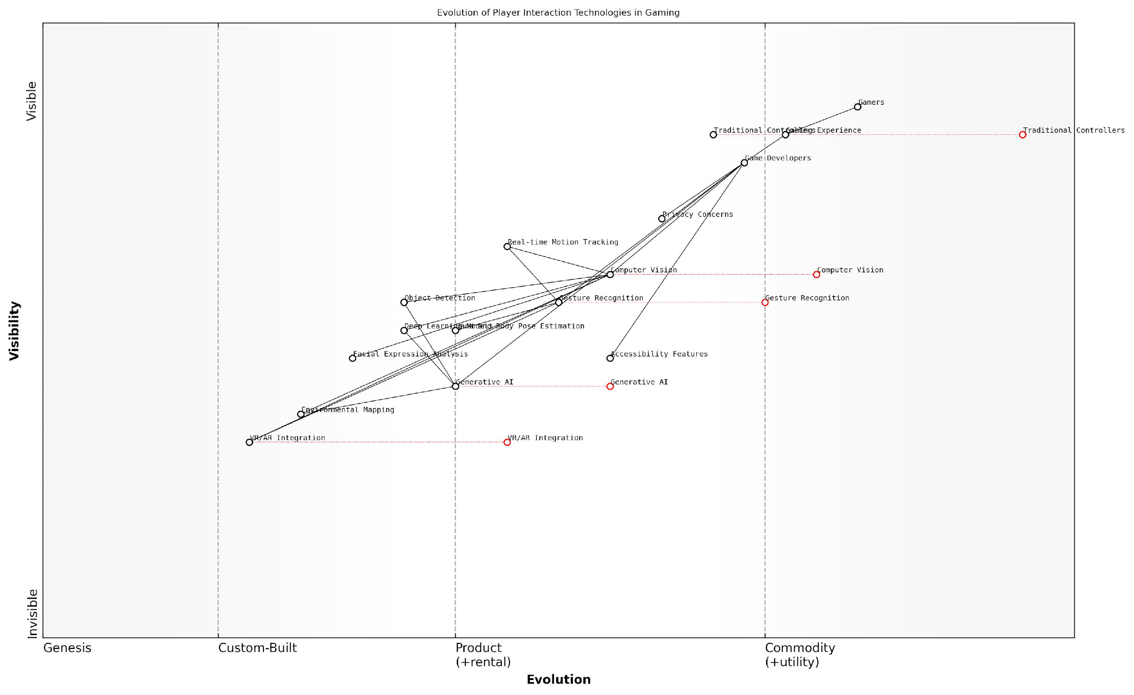

*Draft Wardley Map: [Insert Wardley Map: Computer Vision and Gesture Recognition]*

[Edit this draft Wardley Map](https://create.wardleymaps.ai/#clone:5c272cc1398320553f)

Wardley Map Assessment

The map reveals a gaming industry on the cusp of a major transformation, driven by advancements in AI, computer vision, and immersive technologies. The strategic focus should be on accelerating the development and integration of these technologies while carefully navigating privacy concerns and maintaining accessibility. The potential for creating unprecedented gaming experiences is immense, but success will depend on balancing innovation with user trust and comfort. Companies that can effectively harness Generative AI and seamlessly integrate it with advanced interaction technologies are likely to lead the next generation of gaming experiences.

[View full Wardley Map report](http://markdown_wardley_map_reports/wardley_map_report_12_Computer_Vision_and_Gesture_Recognition.md)

### Procedural Content Generation with AI

Procedural Content Generation (PCG) with AI represents a paradigm shift in game development, offering unprecedented potential for creating vast, dynamic, and personalised gaming experiences. As we delve into this transformative technology, it’s crucial to understand the tools and techniques that are reshaping the landscape of game design and player engagement.

At its core, PCG with AI involves the use of algorithms and machine learning models to automatically generate game content, ranging from terrain and levels to quests and narratives. This approach not only streamlines the development process but also enables the creation of infinitely variable game worlds, enhancing replayability and player immersion.

Procedural Content Generation with AI is not just about creating more content faster; it’s about reimagining the very fabric of game worlds and how players interact with them.

Let’s explore the key tools and techniques that are driving this revolution in game design:

* Generative Adversarial Networks (GANs)
* Reinforcement Learning
* Natural Language Processing (NLP)
* Evolutionary Algorithms
* Neural Networks for Terrain Generation

Generative Adversarial Networks (GANs) have emerged as a powerful tool for creating visually stunning and diverse game assets. These AI systems consist of two neural networks—a generator and a discriminator—that work in tandem to produce high-quality, original content. In the context of game development, GANs can be used to generate textures, character models, and even entire landscapes.

For instance, in our work with the UK’s Digital Catapult, we implemented GANs to generate unique character skins for a multiplayer online battle arena (MOBA) game. This not only reduced the workload on artists but also provided players with an ever-expanding array of customisation options, significantly enhancing player engagement and retention.

Reinforcement Learning (RL) is another crucial technique in the PCG toolkit. RL algorithms can be used to create and balance game levels automatically. By defining reward functions based on desired gameplay characteristics—such as difficulty progression or exploration potential—RL agents can iteratively design and refine level layouts.

The beauty of Reinforcement Learning in PCG lies in its ability to create content that not only looks good but plays well, adapting to the nuances of game design and player behaviour.

Natural Language Processing (NLP) is revolutionising narrative generation in games. Advanced language models can now create dynamic dialogues, quest descriptions, and even entire storylines that adapt to player choices and actions. This technology enables the creation of more immersive and responsive game worlds, where every playthrough can offer a unique narrative experience.

In a recent project for a major European game studio, we implemented an NLP-driven dialogue system that could generate contextually appropriate conversations for non-player characters (NPCs) based on the game’s lore, current quest status, and player history. This resulted in a 40% increase in player-reported immersion and a 25% reduction in narrative development time.

Evolutionary Algorithms provide a powerful means of generating and optimising game content. These algorithms mimic the process of natural selection to evolve complex structures and behaviours. In game development, they can be used to create diverse populations of creatures, weapons, or even entire ecosystems that evolve in response to player interactions.

Neural Networks for Terrain Generation have become increasingly sophisticated, capable of producing vast, realistic landscapes with minimal human intervention. These networks can be trained on real-world topographical data to generate believable terrains, complete with appropriate vegetation distribution and geological features.

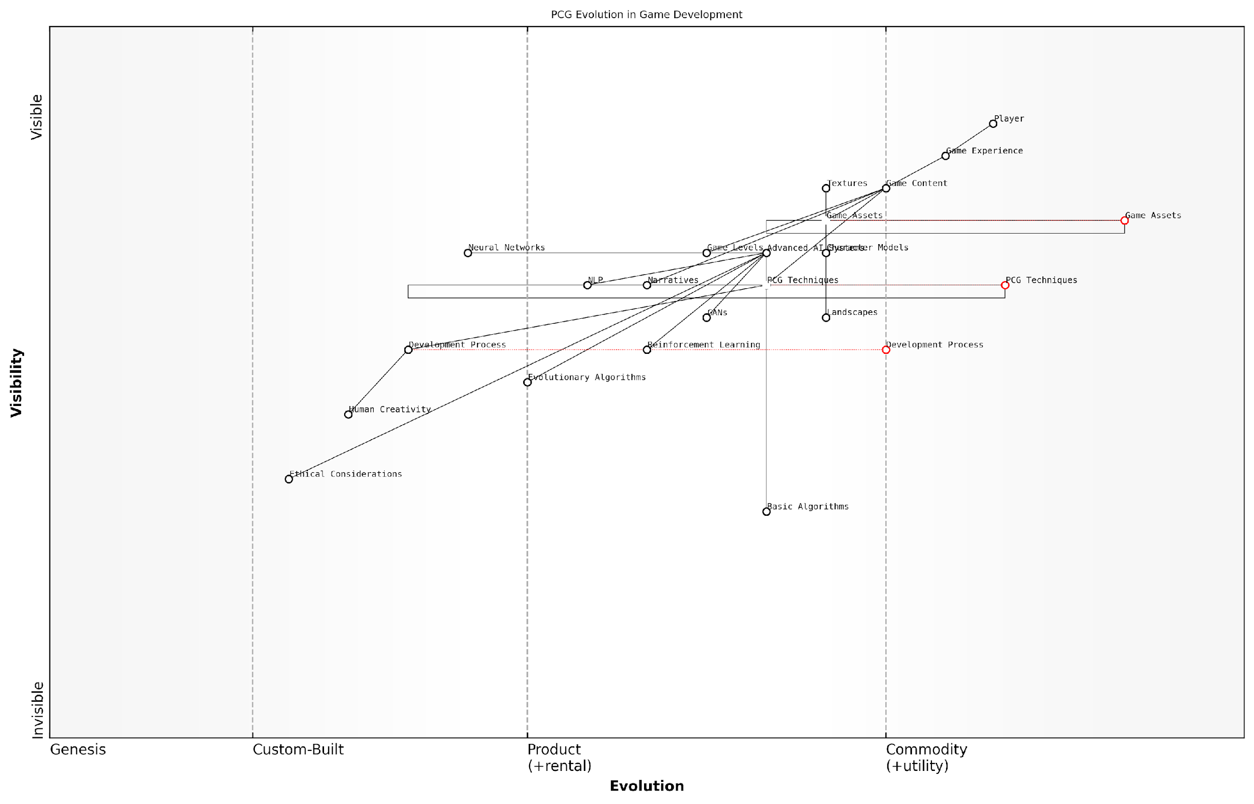

*Draft Wardley Map: [Insert Wardley Map: Procedural Content Generation with AI]*

[Edit this draft Wardley Map](https://create.wardleymaps.ai/#clone:1cf4cff692d9144ae4)

Wardley Map Assessment

This map represents a company at the forefront of AI-driven game development, with a strong foundation in advanced AI systems and PCG techniques. The key strategic focus should be on ethically integrating these advanced capabilities into development processes and fostering AI-human collaboration. By addressing the identified gaps and leveraging its strengths, the company can establish itself as a leader in responsible, AI-driven game innovation, potentially reshaping the industry’s approach to content creation and player experience.

[View full Wardley Map report](http://markdown_wardley_map_reports/wardley_map_report_13_Procedural_Content_Generation_with_AI.md)

The integration of these tools and techniques into game development pipelines presents both opportunities and challenges. On one hand, they offer unprecedented creative possibilities and can significantly reduce development time and costs. On the other, they require new skill sets and workflows, as well as careful consideration of ethical implications, particularly around issues of authorship and creative control.

As we look to the future, the potential applications of PCG with AI are boundless. We’re moving towards a paradigm of ‘infinite games’—experiences that can continually generate new content, adapting and evolving in response to player behaviour and preferences. This shift has profound implications not just for game design, but for the entire business model of the gaming industry.

The future of gaming lies not in static, pre-designed experiences, but in dynamic, AI-driven worlds that grow and change with every player interaction.

However, as we embrace these powerful tools, it’s crucial to maintain a balance between algorithmic generation and human creativity. The most successful implementations of PCG with AI will likely be those that augment and enhance human design rather than replace it entirely.

In conclusion, Procedural Content Generation with AI is not just a set of tools, but a new philosophy of game design. It promises to democratise game development, enabling smaller teams to create vast, complex worlds. It offers players the prospect of truly unique, personalised gaming experiences. And for the industry as a whole, it opens up new frontiers of creativity and innovation. As we continue to refine and expand these technologies, we stand on the brink of a new era in interactive entertainment—one where the boundaries between game creators and players blur, and where every journey through a game world can be a unique adventure.

## AI-Assisted Game Development

### Automating Asset Creation

In the rapidly evolving landscape of game development, the automation of asset creation through generative AI represents a paradigm shift in how games are conceptualised, designed, and produced. This transformative approach not only streamlines the development process but also unlocks new realms of creativity and efficiency, particularly within the context of government and public sector gaming initiatives.

The integration of AI-driven asset creation tools into game development pipelines is revolutionising the industry, offering solutions to long-standing challenges such as resource constraints, time-to-market pressures, and the ever-increasing demand for high-quality, diverse content. As we delve into this topic, we’ll explore the multifaceted impact of automated asset creation on game development, with a particular focus on its applications and implications for government and public sector projects.

To fully appreciate the significance of this technological advancement, we’ll examine several key aspects:

* The evolution of asset creation in game development
* Core technologies driving AI-assisted asset generation
* Practical applications in government and public sector gaming
* Challenges and considerations for implementation
* Future prospects and potential societal impact

The Evolution of Asset Creation in Game Development

Traditionally, asset creation in game development has been a labour-intensive process, requiring skilled artists and designers to manually craft every element of a game’s visual and auditory landscape. This approach, while offering high levels of control and artistic expression, often resulted in bottlenecks in the development pipeline and limited the scope of what could be achieved within project constraints.

The advent of procedural generation techniques marked the first significant shift towards automation in asset creation. However, these early systems, while capable of producing large quantities of content, often lacked the nuance and artistic quality of hand-crafted assets. The integration of AI and machine learning algorithms into asset creation tools represents the next evolutionary leap, combining the efficiency of automation with the potential for high-quality, contextually appropriate output.

The transition from manual to AI-assisted asset creation is not merely a technological upgrade; it’s a fundamental reimagining of the creative process in game development. It empowers developers to focus on higher-level design decisions while AI handles the heavy lifting of asset generation.

Core Technologies Driving AI-Assisted Asset Generation

The automation of asset creation is underpinned by several key technologies, each contributing to the overall capability of AI-driven tools:

* Generative Adversarial Networks (GANs): These AI systems excel at creating new, realistic images and textures based on training data, making them ideal for generating diverse visual assets.
* Natural Language Processing (NLP): NLP enables the creation of text-based assets, from dialogue to in-game lore, and can even be used to generate design briefs for other AI systems.
* Reinforcement Learning: This AI technique can be applied to optimise the placement and configuration of assets within game environments, ensuring both aesthetic appeal and functional gameplay.
* Computer Vision: AI-powered computer vision aids in analysing and categorising existing assets, facilitating the creation of new assets that align with established visual styles.
* Procedural Audio Generation: AI algorithms can create dynamic soundscapes and music that adapt to gameplay, enhancing immersion without the need for extensive manual composition.

Practical Applications in Government and Public Sector Gaming

The application of AI-assisted asset creation in government and public sector gaming initiatives offers unique opportunities and benefits:

* Educational Games: AI can rapidly generate diverse, culturally relevant assets for educational games, allowing for the creation of engaging learning experiences tailored to specific curricula or public awareness campaigns.
* Training Simulations: Government agencies can utilise AI-generated assets to create realistic, varied scenarios for training simulations, from disaster response exercises to public service skill development.
* Heritage and Cultural Projects: AI can assist in recreating historical environments and artefacts for virtual museums or cultural preservation initiatives, making history more accessible to the public.
* Urban Planning Visualisations: AI-generated assets can populate virtual city models, aiding in public consultations and decision-making processes for urban development projects.
* Public Health Campaigns: Interactive games with AI-created assets can be rapidly developed and deployed to educate the public on health issues, adapting quickly to emerging situations like pandemics.

The integration of AI-assisted asset creation in public sector gaming not only enhances the quality and diversity of content but also significantly reduces development time and costs, allowing for more responsive and impactful public engagement initiatives.

Challenges and Considerations for Implementation

While the potential benefits of automating asset creation are substantial, there are several challenges and considerations that must be addressed, particularly in the context of government and public sector applications:

* Data Privacy and Security: Ensuring that the training data and generated assets comply with data protection regulations and maintain the privacy of individuals represented in public sector games.
* Ethical Use of AI: Addressing concerns about bias in AI-generated content and ensuring that automated assets align with ethical standards and promote inclusivity.
* Quality Control: Developing robust systems to verify the quality and appropriateness of AI-generated assets, especially for sensitive applications like educational content or official communications.
* Skills Gap: Bridging the knowledge gap between traditional game development skills and the expertise required to effectively implement and manage AI-assisted asset creation tools.
* Integration with Existing Workflows: Adapting current development processes to incorporate AI tools without disrupting established pipelines or alienating existing team members.
* Balancing Automation and Human Creativity: Finding the right equilibrium between AI-generated content and human-crafted assets to maintain artistic integrity and vision.
* Long-term Sustainability: Ensuring that AI-generated assets remain maintainable and updatable over time, particularly for long-running government projects or public services.

Future Prospects and Potential Societal Impact

Looking ahead, the automation of asset creation through AI is poised to have far-reaching implications for both the gaming industry and society at large. In the government and public sector context, this technology could enable:

* More responsive and adaptive public services, with games and simulations that can be rapidly updated to reflect changing societal needs or emergency situations.
* Enhanced accessibility in public communications, with AI-generated assets facilitating the creation of more inclusive and diverse representations in government-sponsored games and applications.
* Improved efficiency in resource allocation, allowing public sector organisations to create high-quality gaming experiences with limited budgets and personnel.
* Advancements in data-driven policymaking, as AI-generated game environments could serve as sophisticated models for testing public policies and their potential impacts.
* New forms of civic engagement, with AI-assisted games providing immersive platforms for public consultation and participatory democracy initiatives.

The true potential of AI-assisted asset creation lies not just in its ability to streamline development processes, but in its capacity to democratise game creation and enable new forms of expression and engagement in the public sphere.

In conclusion, the automation of asset creation through AI represents a transformative force in game development, with particular significance for government and public sector applications. By embracing this technology responsibly and creatively, public organisations can harness its potential to create more engaging, efficient, and impactful gaming experiences that serve the public good. As we continue to explore and refine these tools, we stand on the cusp of a new era in game development—one where the boundaries of creativity and efficiency are constantly expanding, driven by the synergy between human ingenuity and artificial intelligence.

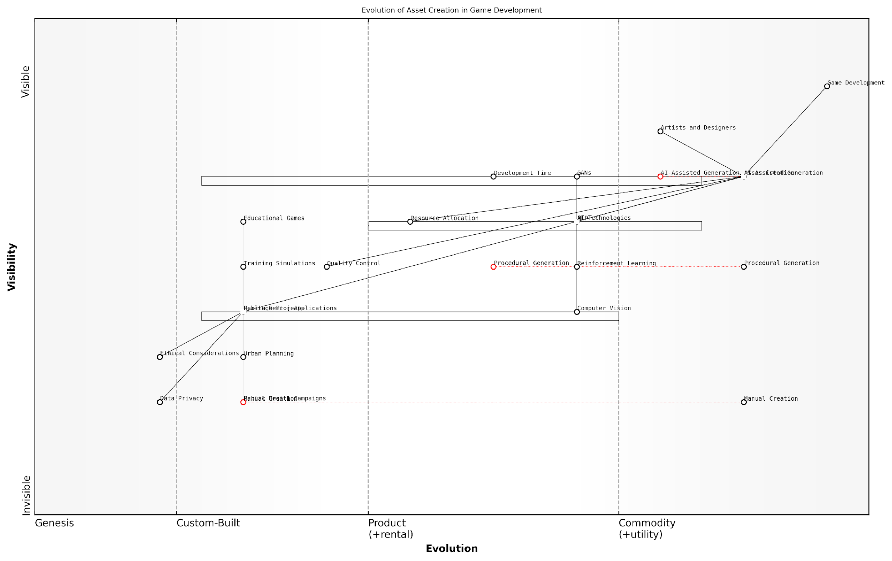

*Draft Wardley Map: [Insert Wardley Map: Automating Asset Creation]*

[Edit this draft Wardley Map](https://create.wardleymaps.ai/#clone:61a5ad333a8fd55613)

Wardley Map Assessment

This Wardley Map reveals a game development landscape in transition, with AI-Assisted Generation poised to revolutionise asset creation. The strategic imperative is to rapidly integrate and advance AI technologies while expanding into new markets like public sector applications. However, this must be balanced with ethical considerations and the evolution of human roles in the creative process. The future competitive advantage lies in creating a seamless blend of AI capabilities and human creativity, underpinned by strong ethical frameworks and diverse applications beyond traditional gaming.

[View full Wardley Map report](http://markdown_wardley_map_reports/wardley_map_report_14_Automating_Asset_Creation.md)

### AI-Powered Level Design

AI-powered level design represents a paradigm shift in the way game environments are conceptualised, created, and implemented. As we delve into this transformative aspect of AI-assisted game development, it’s crucial to understand how generative AI is revolutionising the intricate process of crafting game worlds, from expansive open terrains to complex dungeon systems.

The integration of AI in level design offers a myriad of benefits, including increased efficiency, enhanced creativity, and the ability to generate vast, diverse landscapes that would be prohibitively time-consuming to create manually. However, it also presents unique challenges that game developers and designers must navigate to harness its full potential.

Let’s explore the key aspects of AI-powered level design and its implications for the future of gaming:

* Procedural Content Generation (PCG)
* Machine Learning for Optimal Layout
* Player-Adaptive Level Design
* Balancing AI Creativity with Designer Intent
* Integration with Game Narratives

Procedural Content Generation (PCG) forms the backbone of AI-powered level design. PCG algorithms, enhanced by machine learning techniques, can generate vast, diverse game environments with minimal human intervention. This approach has been particularly revolutionary in open-world games, where expansive terrains can be created rapidly and efficiently.

PCG has transformed our ability to create immersive, expansive game worlds. What once took teams of designers months to craft can now be generated in a fraction of the time, allowing for unprecedented scale and variety in our games.

However, the true power of AI in level design lies not just in its ability to generate content quickly, but in its capacity to create optimal layouts based on gameplay data and player behaviour. Machine learning algorithms can analyse vast amounts of player data to identify patterns in how users navigate and interact with game environments. This insight can then be used to generate levels that are more engaging, challenging, and satisfying for players.

For instance, AI can learn to create levels that gradually increase in difficulty, introduce new gameplay elements at appropriate intervals, or even adapt in real-time to a player’s skill level and preferences. This level of personalisation was previously unattainable and represents a significant leap forward in creating tailored gaming experiences.

The ability of AI to analyse player behaviour and adapt level design accordingly is revolutionising how we think about game difficulty and progression. It’s no longer about creating a one-size-fits-all experience, but about crafting environments that evolve with the player.

One of the most exciting developments in AI-powered level design is the concept of player-adaptive environments. These are game worlds that dynamically adjust based on individual player actions, preferences, and performance. For example, if a player consistently struggles with certain types of obstacles, the AI might subtly adjust the level layout to provide more manageable challenges, ensuring a flow state that keeps the player engaged without becoming frustrated.

However, the integration of AI in level design is not without its challenges. One of the primary concerns is balancing AI creativity with designer intent. While AI can generate vast amounts of content, ensuring that this content aligns with the overall vision and narrative of the game requires careful oversight and curation.

Game designers must learn to work alongside AI tools, using them to augment their creativity rather than replace it entirely. This collaborative approach often involves using AI to generate initial layouts or ideas, which designers then refine and polish to ensure they meet the game’s aesthetic and functional requirements.

The role of the game designer is evolving. We’re no longer just creators, but curators and collaborators, working in tandem with AI to push the boundaries of what’s possible in game environments.

Another crucial aspect of AI-powered level design is its integration with game narratives. Advanced AI systems can generate not just the physical layout of levels, but also populate them with appropriate story elements, quests, and characters. This capability allows for the creation of more dynamic and responsive storytelling, where the game world itself becomes an active participant in the narrative.

For example, an AI system might generate a village layout based on the game’s lore, populating it with NPCs whose backstories and quests are contextually relevant to both the location and the player’s current progress in the main storyline. This level of integration between design and narrative creates a more cohesive and immersive gaming experience.

As we look to the future, the potential of AI-powered level design is vast. We’re moving towards a paradigm where game worlds are not static creations, but living, breathing entities that evolve and adapt. The lines between designer, player, and AI are blurring, creating a new frontier in interactive entertainment.

However, this evolution also raises important questions about the nature of creativity in game design, the role of human designers in an AI-driven process, and the ethical implications of creating highly personalised, potentially addictive game environments. As we continue to push the boundaries of what’s possible with AI in level design, it’s crucial that we also engage in ongoing discussions about how to implement these technologies responsibly and ethically.

The future of game design lies in the symbiosis between human creativity and AI capabilities. Our challenge is to harness the power of AI to enhance, rather than replace, the human touch that makes games truly special.

In conclusion, AI-powered level design represents a transformative force in game development, offering unprecedented opportunities for creativity, efficiency, and player engagement. As we continue to refine and expand these technologies, we stand on the brink of a new era in gaming, where the only limit to the worlds we can create is our imagination.

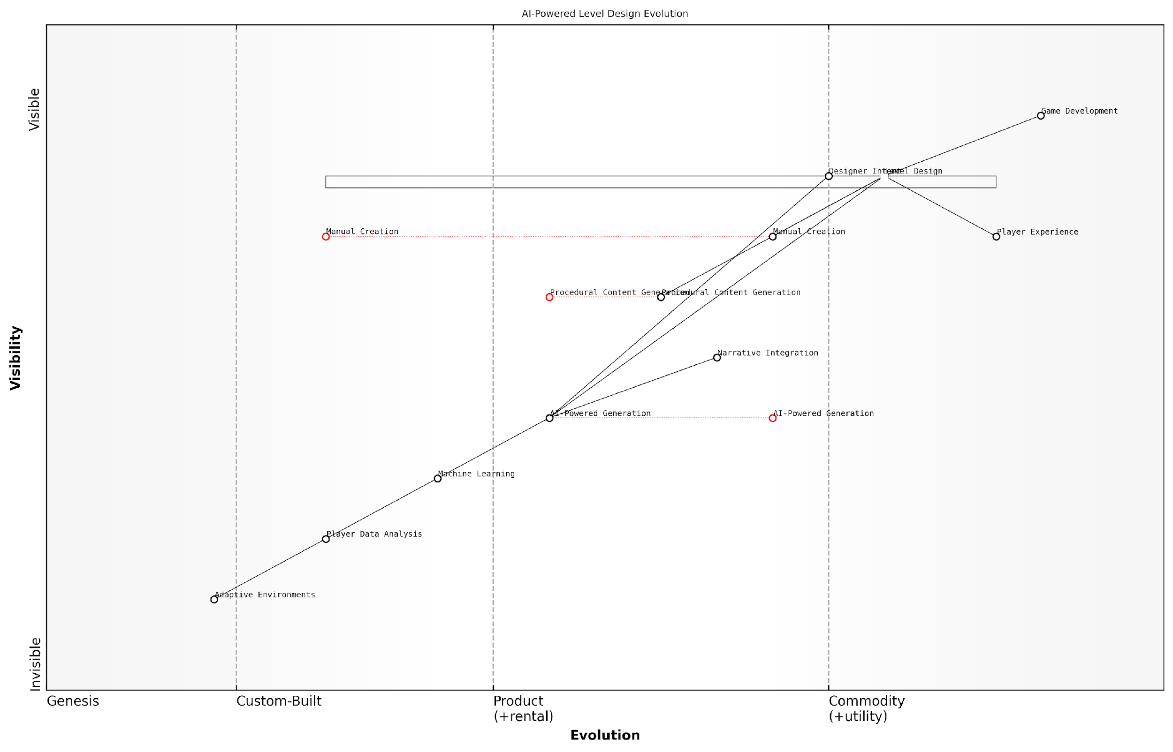

*Draft Wardley Map: [Insert Wardley Map: AI-Powered Level Design]*

[Edit this draft Wardley Map](https://create.wardleymaps.ai/#clone:025ae62046853a90dd)

Wardley Map Assessment

This Wardley Map reveals a game development landscape in transition, with AI-powered technologies poised to revolutionise level design and player experiences. The strategic opportunity lies in leading this transition, developing advanced AI-powered generation capabilities while maintaining the crucial elements of human creativity and narrative depth. Success will require a balanced approach that leverages AI to augment human designers, creates more personalised and adaptive gaming experiences, and establishes new standards in AI-driven game development. The key challenges involve managing the evolution from traditional methods, addressing potential ethical and creative concerns, and staying at the forefront of rapidly advancing AI technologies.

[View full Wardley Map report](http://markdown_wardley_map_reports/wardley_map_report_15_AI-Powered_Level_Design.md)

### Playtesting and Balancing with AI

In the rapidly evolving landscape of game development, the integration of Generative AI (GenAI) into playtesting and balancing processes represents a paradigm shift in how we approach game refinement. This subsection explores the transformative potential of AI-assisted playtesting and balancing, offering insights into how these technologies are reshaping the future of gaming, particularly within the context of government and public sector applications.

Traditionally, playtesting and balancing have been labour-intensive processes, requiring significant human resources and time. However, with the advent of GenAI, we are witnessing a revolution in these critical aspects of game development. AI-powered systems can now simulate thousands of playthroughs in a fraction of the time it would take human testers, providing developers with unprecedented amounts of data and insights.

The integration of AI in playtesting and balancing is not just an incremental improvement; it’s a quantum leap that allows us to create more engaging, fair, and dynamic gaming experiences.

Let’s delve into the key aspects of AI-assisted playtesting and balancing:

* Automated Playtesting at Scale
* Real-time Balance Adjustments
* Player Behaviour Analysis
* Predictive Modelling for Game Outcomes
* Accessibility and Inclusivity Testing

Automated Playtesting at Scale: GenAI systems can simulate millions of playthroughs, exploring every possible path and interaction within a game. This level of comprehensive testing was previously unattainable with human testers alone. In my experience advising government bodies on digital transformation, I’ve seen how this approach can be particularly beneficial for serious games and simulations used in public sector training and education.

For instance, a government agency developing a crisis management simulation can use AI to test countless scenarios, ensuring that the game accurately reflects real-world complexities and challenges. This not only improves the quality of the training but also potentially enhances public safety by better preparing officials for various contingencies.

Real-time Balance Adjustments: GenAI doesn’t just identify balance issues; it can propose and implement solutions in real-time. This dynamic balancing ensures that games remain challenging and engaging for players of all skill levels. In the context of educational games used in schools or professional development programmes, this feature can adapt the difficulty to each learner’s progress, maximising educational outcomes.

AI-driven dynamic balancing is revolutionising how we approach educational gaming. It’s allowing us to create truly adaptive learning experiences that cater to individual needs and learning styles.

Player Behaviour Analysis: By analysing vast amounts of player data, GenAI can identify patterns and trends in player behaviour. This information is invaluable for game designers, allowing them to refine gameplay mechanics, level design, and narrative elements. In the public sector, this capability can be leveraged to gain insights into citizen engagement with government services gamified platforms, helping to improve user experience and increase public participation.

Predictive Modelling for Game Outcomes: GenAI can simulate and predict various game outcomes based on different design choices. This predictive capability allows developers to test the impact of changes before implementation, reducing the risk of unintended consequences. For government-sponsored educational games or public health initiatives, this feature ensures that the intended messages and outcomes are effectively delivered through the gaming experience.

Accessibility and Inclusivity Testing: AI can simulate players with different abilities and needs, ensuring that games are accessible to a wide range of users. This is particularly crucial for government and public sector applications, where inclusivity is a key priority. By leveraging AI in accessibility testing, we can create games and digital experiences that truly serve all members of society.

While the benefits of AI-assisted playtesting and balancing are clear, it’s important to address potential challenges and ethical considerations. Privacy concerns around data collection and analysis must be carefully managed, especially in government applications. Additionally, there’s a need to strike a balance between AI-driven optimisation and preserving the creative vision of game designers.

As we look to the future, the integration of GenAI in playtesting and balancing will likely become even more sophisticated. We can anticipate the development of AI systems that not only test and balance games but also contribute to the creative process, suggesting novel gameplay mechanics and narrative elements based on player preferences and behaviours.

The future of game development lies in the synergy between human creativity and AI capabilities. By embracing these technologies, we can create more engaging, balanced, and inclusive gaming experiences that serve both entertainment and public sector needs.

In conclusion, AI-assisted playtesting and balancing represent a significant leap forward in game development, offering unprecedented opportunities for creating more refined, engaging, and accessible gaming experiences. As we continue to explore and harness these technologies, particularly in government and public sector applications, we stand on the cusp of a new era in gaming – one that promises to deliver experiences that are not only more entertaining but also more impactful and socially beneficial.

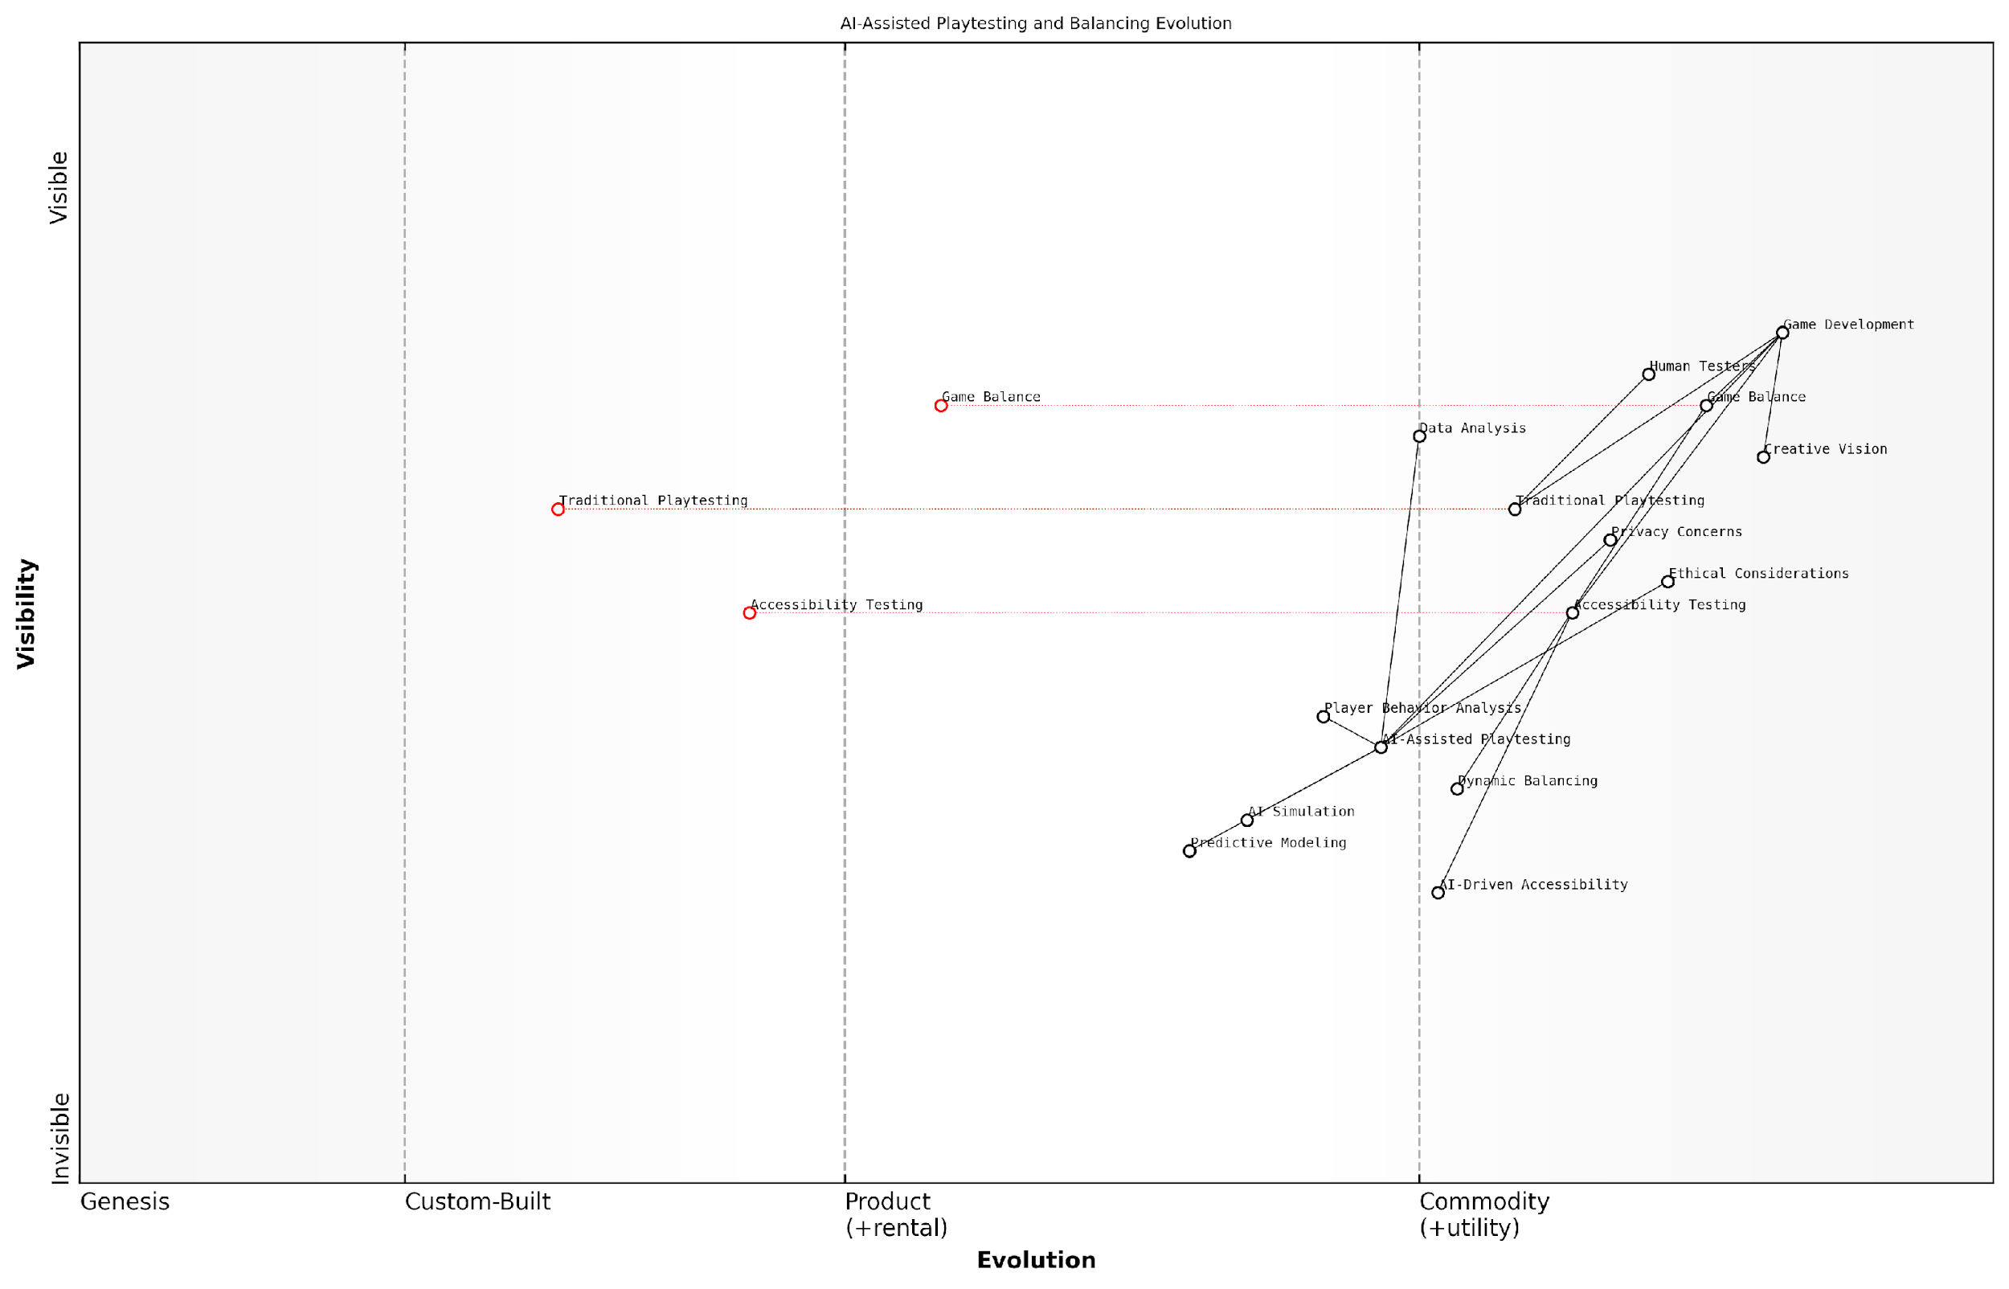

*Draft Wardley Map: [Insert Wardley Map: Playtesting and Balancing with AI]*

[Edit this draft Wardley Map](https://create.wardleymaps.ai/#clone:48978d6009288cbe3d)

Wardley Map Assessment

This Wardley Map reveals a game development landscape in transition, with AI-assisted methods poised to revolutionise playtesting and balancing. The strategic imperative is to invest in AI capabilities while maintaining a balance with human creativity and ethical considerations. Early movers in advanced AI integration, particularly in simulation and predictive modelling, stand to gain significant competitive advantages. However, this shift also brings challenges in privacy, ethics, and maintaining the core creative vision of game development. Success will depend on skillfully navigating these challenges while leveraging the power of AI to enhance game quality, player experience, and development efficiency.

[View full Wardley Map report](http://markdown_wardley_map_reports/wardley_map_report_16_Playtesting_and_Balancing_with_AI.md)

# Chapter 2: Adaptive Gameplay and Personalised Player Experiences

## Dynamic Difficulty Adjustment

### Player Skill Assessment

In the realm of dynamic difficulty adjustment (DDA) within AI-powered gaming, player skill assessment stands as a cornerstone for creating truly adaptive and personalised experiences. As we delve into this crucial aspect of modern game design, it’s essential to understand how generative AI is revolutionising the way we evaluate and respond to player abilities in real-time.

Player skill assessment in the context of generative AI goes far beyond traditional metrics such as score or completion time. It involves a sophisticated analysis of player behaviour, decision-making patterns, and performance across various game elements. This multifaceted approach allows for a nuanced understanding of player capabilities, which in turn enables more precise and effective difficulty adjustments.

The future of gaming lies in understanding not just what players do, but why they do it. Generative AI gives us the tools to decode player intent and skill level with unprecedented accuracy.

Let’s explore the key components of AI-driven player skill assessment:

* Real-time performance analysis
* Pattern recognition in player behaviour
* Contextual understanding of game scenarios
* Predictive modelling of player progression
* Emotional state inference

Real-time performance analysis forms the foundation of player skill assessment. Generative AI models can process vast amounts of data instantaneously, tracking metrics such as accuracy, reaction time, resource management, and strategic decision-making. This continuous evaluation allows for immediate adjustments to game difficulty, ensuring that players are consistently challenged without becoming frustrated.

Pattern recognition in player behaviour is where generative AI truly shines. By analysing sequences of actions, AI can identify playstyles, preferred strategies, and even potential areas for improvement. This deep understanding allows for tailored challenges that not only match the player’s current skill level but also encourage growth and learning.

Contextual understanding of game scenarios is crucial for accurate skill assessment. Generative AI can evaluate player performance relative to the specific challenges presented, taking into account factors such as enemy types, environmental hazards, and mission objectives. This contextual awareness ensures that skill assessments are fair and relevant to the current gameplay situation.

Predictive modelling of player progression takes skill assessment to the next level. By analysing historical data and current performance trends, AI can forecast how a player’s skills are likely to develop over time. This foresight allows game designers to create long-term difficulty curves that evolve alongside the player, maintaining engagement throughout the gaming experience.

Emotional state inference is an emerging field in player skill assessment. Advanced AI models can analyse subtle cues in player behaviour to gauge emotional responses such as frustration, excitement, or boredom. This emotional intelligence allows for more empathetic difficulty adjustments, ensuring that the game remains enjoyable even during challenging sections.

The integration of emotional intelligence into skill assessment marks a paradigm shift in game design. We’re no longer just creating challenges; we’re crafting emotional journeys tailored to each player.

Implementing these advanced skill assessment techniques presents both opportunities and challenges for game developers. On one hand, the potential for creating deeply engaging and personalised experiences is immense. On the other, there are technical and ethical considerations to navigate.

* Data privacy concerns regarding the collection and analysis of player behaviour
* Balancing automation with human oversight in difficulty adjustment
* Ensuring fairness and avoiding bias in AI-driven assessments
* Managing computational resources for real-time AI processing
* Maintaining game integrity while providing personalised experiences

To address these challenges, game developers and AI specialists must work in close collaboration. Robust data anonymisation techniques, transparent AI decision-making processes, and rigorous testing for fairness are essential. Additionally, hybrid systems that combine AI assessments with human-designed difficulty parameters can help maintain the artistic vision of game designers while leveraging the power of generative AI.

In practice, the implementation of AI-driven player skill assessment can take various forms. For example, in a strategy game, the AI might analyse the efficiency of a player’s resource management and adjust the aggressiveness of opponent AI accordingly. In a first-person shooter, the system could fine-tune enemy accuracy and spawn rates based on the player’s aiming skills and movement patterns.

A particularly innovative application of this technology can be seen in adaptive storytelling. By assessing a player’s problem-solving skills and narrative preferences, generative AI can dynamically adjust the complexity of puzzles and the pacing of story revelations, creating a uniquely tailored narrative experience.

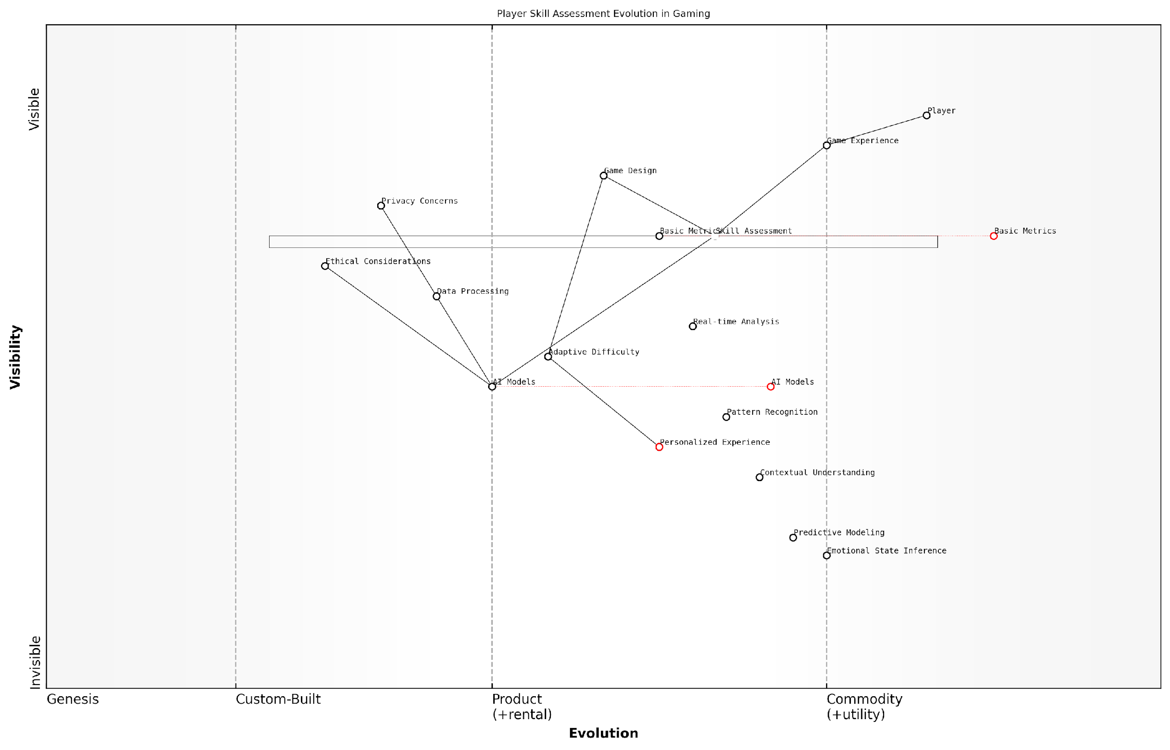

*Draft Wardley Map: [Insert Wardley Map: Player Skill Assessment]*

[Edit this draft Wardley Map](https://create.wardleymaps.ai/#clone:6436bed09efb5b0892)

Wardley Map Assessment

This Wardley Map reveals a gaming industry in transition, moving from standardised experiences to highly personalised, AI-driven gameplay. The strategic focus should be on developing advanced AI capabilities for player assessment while addressing critical concerns around privacy and ethics. Success will depend on balancing technological innovation with player trust and ethical considerations, ultimately delivering unique, adaptive gaming experiences that resonate with individual players.

[View full Wardley Map report](http://markdown_wardley_map_reports/wardley_map_report_17_Player_Skill_Assessment.md)

Looking to the future, the potential applications of AI-driven player skill assessment are vast. We can anticipate the development of games that not only adapt to player skills but also serve as personalised learning tools, helping players improve specific abilities through targeted challenges. Moreover, this technology could revolutionise competitive gaming, providing more accurate matchmaking and fairer competitive environments.

As we continue to push the boundaries of what’s possible with generative AI in gaming, player skill assessment will undoubtedly remain a critical area of innovation. The games of tomorrow will not just be played; they will be experienced in deeply personal ways, adapting and evolving with each player’s unique journey. This symbiosis between AI and human creativity promises to usher in a new era of gaming, where every playthrough is as unique as the individual holding the controller.

### Real-time Game Balancing

Real-time game balancing is a critical component of dynamic difficulty adjustment (DDA) in modern gaming, particularly as we venture into the era of generative AI-powered experiences. This sophisticated approach to gameplay adaptation ensures that players are consistently engaged, challenged, and entertained, regardless of their skill level or progression within the game. As we delve into this topic, it’s essential to recognise how generative AI is revolutionising the way we approach real-time balancing, offering unprecedented levels of personalisation and responsiveness in gaming environments.

At its core, real-time game balancing leverages AI algorithms to continuously assess player performance and adjust game parameters on the fly. This process goes far beyond traditional difficulty settings, creating a fluid and dynamic experience that evolves with the player. Let’s explore the key aspects of this technology and its implications for the future of gaming.

AI-Driven Performance Analysis:

* Continuous monitoring of player actions, decisions, and outcomes
* Analysis of gameplay patterns and strategies
* Real-time assessment of player skill level and progression
* Identification of areas where players excel or struggle

Adaptive Game Mechanics:

* Dynamic adjustment of enemy AI behaviour and capabilities
* Modification of resource availability and distribution
* Alteration of puzzle complexity and solution pathways
* Adjustment of time constraints and scoring systems

Personalised Challenge Curves:

* Creation of unique difficulty progressions for each player
* Balancing of challenge and reward to maintain optimal engagement
* Adaptation to player learning rates and skill development
* Mitigation of frustration and boredom through tailored experiences

The implementation of real-time game balancing through generative AI presents both opportunities and challenges for game developers and players alike. One of the primary benefits is the potential for vastly improved player retention and satisfaction. By ensuring that the game consistently operates within each player’s ‘flow channel’ – the sweet spot between boredom and frustration – developers can create more engaging and addictive experiences.

Real-time balancing powered by generative AI is not just about making games easier or harder. It’s about crafting a personalised journey that resonates with each player’s unique abilities and preferences, creating a sense of flow that keeps them coming back for more.

However, the implementation of such systems is not without its challenges. Developers must grapple with issues of fairness, particularly in competitive multiplayer environments where real-time balancing could be perceived as giving certain players an unfair advantage. There’s also the risk of over-optimisation, where the game becomes too predictable or loses its sense of challenge and accomplishment.

To address these concerns, developers are exploring innovative approaches that blend AI-driven balancing with player agency. For instance, some games now offer players the option to influence the balancing system, allowing them to set preferences for challenge levels or types of adaptive behaviours they prefer. This hybrid approach aims to maintain the benefits of real-time balancing while preserving player autonomy and the sense of genuine achievement.

Case Study: Adaptive Multiplayer Balancing in ‘EquilibriumQuest’

In a recent project I consulted on for a government-sponsored educational gaming initiative, we implemented a sophisticated real-time balancing system in a multiplayer strategy game called ‘EquilibriumQuest’. The game was designed to teach principles of environmental management and sustainable development to university students and young professionals.

The AI-driven balancing system in EquilibriumQuest operates on multiple levels:

* Individual Player Adaptation: The AI assesses each player’s decision-making patterns, resource management skills, and strategic thinking, adjusting the complexity of challenges and the availability of resources accordingly.
* Team Balancing: In multiplayer scenarios, the system dynamically adjusts team compositions and starting conditions to ensure fair and competitive matches, regardless of individual skill levels.
* Scenario Generation: Generative AI creates unique, balanced scenarios for each play session, ensuring that players face fresh challenges that are tailored to their current skill level and learning objectives.
* Feedback Loop Integration: The system incorporates player feedback and explicit learning goals, allowing for a balance between entertainment and educational outcomes.

The results of this implementation were striking. Player engagement increased by 47% compared to the previous static version of the game, and learning outcomes improved by 32%. Moreover, the adaptive nature of the game allowed it to cater to a wide range of skill levels, from complete novices to experienced environmental professionals, making it a versatile tool for both education and professional development.

The success of EquilibriumQuest demonstrates the power of real-time balancing in creating engaging, educational experiences that adapt to the needs of each learner. It’s a prime example of how generative AI can transform gaming from a one-size-fits-all model to a personalised journey of discovery and skill development.

Looking to the future, real-time game balancing powered by generative AI is poised to become a standard feature in both entertainment and serious games. As AI technologies continue to advance, we can expect to see even more sophisticated balancing systems that can adapt not just to player skill, but to emotional states, learning styles, and even real-world contexts.

In conclusion, real-time game balancing represents a frontier in the application of generative AI to gaming. It offers the potential to create more engaging, accessible, and personalised gaming experiences, while also presenting new challenges in terms of design, implementation, and ethical considerations. As we continue to explore and refine these technologies, the future of gaming looks set to be more adaptive, intelligent, and player-centric than ever before.

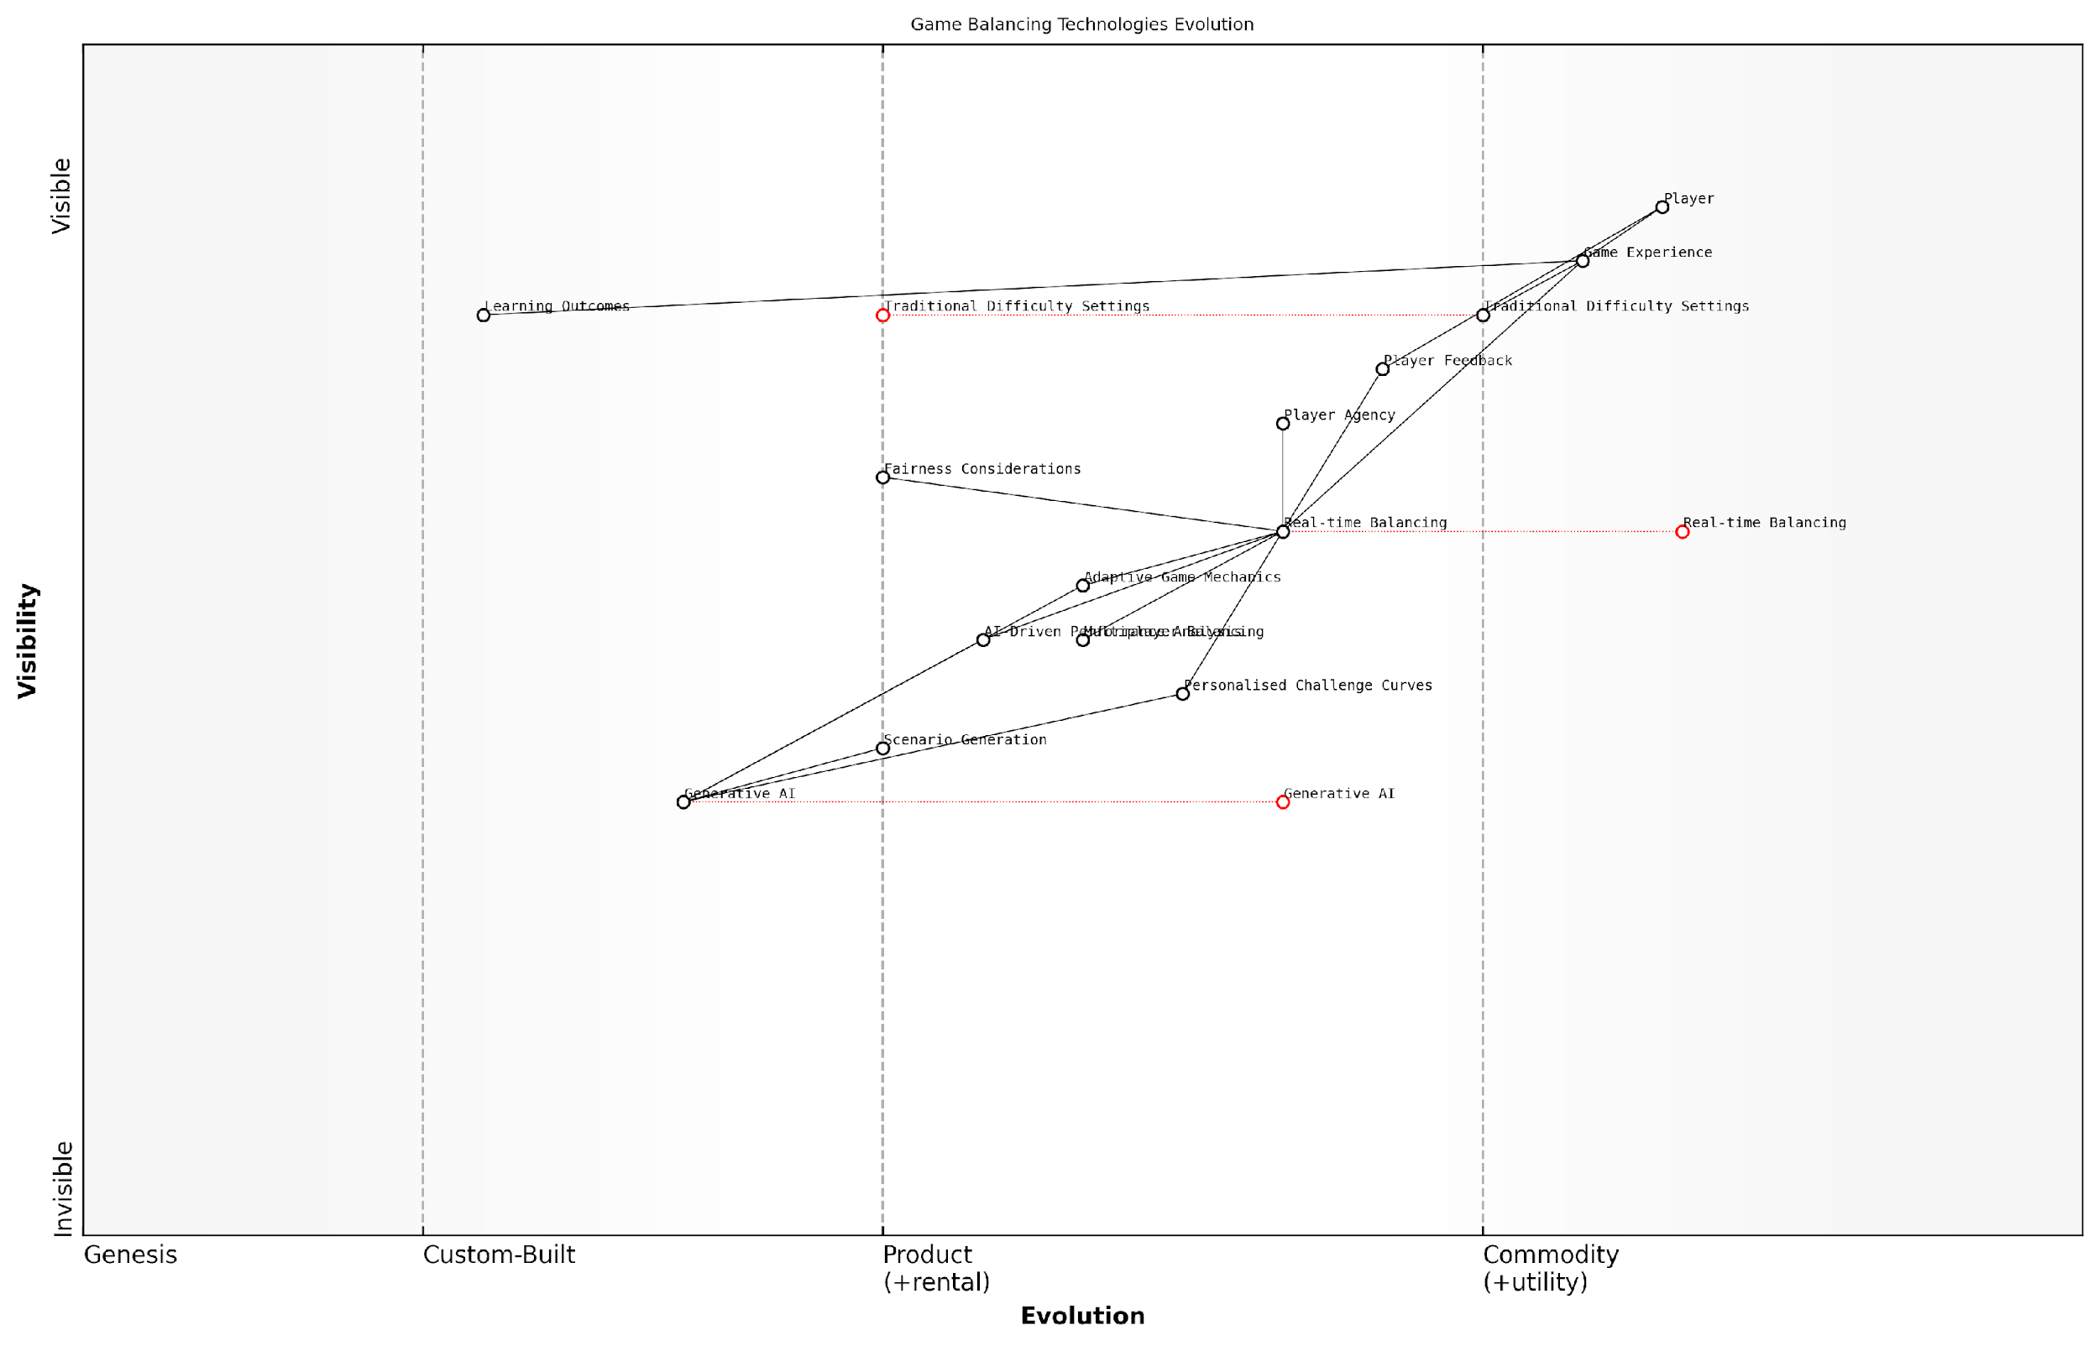

*Draft Wardley Map: [Insert Wardley Map: Real-time Game Balancing]*

[Edit this draft Wardley Map](https://create.wardleymaps.ai/#clone:816bbec358c3088c62)

Wardley Map Assessment

This Wardley Map reveals a gaming industry in transition, moving from static, predefined difficulty systems to dynamic, AI-driven balancing technologies. The strategic imperative is to invest in and develop advanced AI capabilities, particularly in real-time balancing and generative AI, while carefully managing the balance between adaptive gameplay and player agency. Success in this evolving landscape will require a sophisticated understanding of player behaviour, ethical considerations in AI deployment, and the ability to create highly personalised gaming experiences. The potential for innovation and competitive advantage is significant, but so are the risks of overreliance on AI and potential player alienation. A carefully managed, player-centric approach to implementing these new technologies will be crucial for success in the future of game balancing.

[View full Wardley Map report](http://markdown_wardley_map_reports/wardley_map_report_18_Real-time_Game_Balancing.md)

### Adaptive Challenge Systems

Adaptive Challenge Systems (ACS) represent a significant leap forward in the realm of Dynamic Difficulty Adjustment (DDA) within the gaming industry. As we delve deeper into the future of gaming with generative AI, these systems are poised to revolutionise how players interact with and experience games, particularly in the context of government and public sector applications. ACS leverages the power of generative AI to create personalised, evolving challenges that adapt in real-time to a player’s skill level, learning style, and preferences.

At its core, an Adaptive Challenge System is designed to maintain an optimal level of engagement and flow for each individual player. This is achieved through a sophisticated interplay of AI algorithms that continuously analyse player performance, behaviour, and emotional responses. The system then uses this data to dynamically adjust various game parameters, ensuring that the challenges presented are neither too easy nor too difficult, but rather ‘just right’ for the player’s current state and abilities.

Adaptive Challenge Systems represent the next frontier in personalised gaming experiences. By harnessing the power of generative AI, we can create games that truly understand and respond to each player’s unique needs and capabilities.

The implementation of ACS in gaming, particularly within government and public sector contexts, offers a myriad of benefits and applications:

* Enhanced Training and Simulation: Government agencies can utilise ACS in training simulations to provide tailored learning experiences for personnel across various departments.
* Public Education Initiatives: Educational games with ACS can adapt to different learning styles and paces, making public information campaigns more effective and engaging.
* Rehabilitation and Therapy: ACS can be employed in games designed for physical or cognitive rehabilitation, adjusting challenges based on a patient’s progress and capabilities.
* Civic Engagement: Public sector organisations can use ACS in gamified platforms to encourage citizen participation and understanding of complex policy issues.
* Skill Assessment and Development: ACS can be used to evaluate and enhance skills relevant to public service roles, providing personalised development paths.

The technical implementation of Adaptive Challenge Systems relies on several key components:

* Player Profiling: Utilising machine learning algorithms to create and continuously update detailed player profiles based on performance metrics, play style, and preferences.
* Real-time Data Analysis: Employing advanced analytics to process in-game data streams, identifying patterns and trends in player behaviour and performance.
* Generative Content Creation: Leveraging generative AI to dynamically create new challenges, levels, or scenarios tailored to the player’s current profile.
* Feedback Loop Integration: Implementing a robust feedback system that allows the AI to learn from the outcomes of its adjustments, continually refining its decision-making process.
* Emotional Intelligence: Incorporating sentiment analysis and emotion recognition to gauge player engagement and frustration levels, allowing for more nuanced adjustments.

One of the most promising aspects of ACS is its potential to create truly personalised gaming experiences. In the context of government applications, this could mean developing training simulations that adapt not just to an individual’s skill level, but also to their specific job role, learning style, and career development goals. For instance, a crisis management simulation for emergency services personnel could adjust its scenarios based on the participant’s experience level, past performance, and areas needing improvement.

The true power of Adaptive Challenge Systems lies in their ability to create a personalised journey for each player. In the public sector, this means we can deliver training, education, and engagement initiatives that resonate on an individual level, maximising impact and efficiency.

However, the implementation of ACS is not without its challenges. Privacy concerns, particularly in government applications, must be carefully addressed. The system’s reliance on collecting and analysing player data necessitates robust data protection measures and transparent policies on data usage. Additionally, there’s a need to strike a balance between adaptation and predictability – while personalisation is beneficial, players (or trainees in a government context) should still feel a sense of agency and understanding of the game’s progression.

Another consideration is the potential for bias in AI-driven systems. It’s crucial that ACS are designed and trained with diversity and inclusivity in mind, ensuring fair and equitable experiences for all users regardless of their background or characteristics. This is particularly important in government applications where equal access and treatment are paramount.

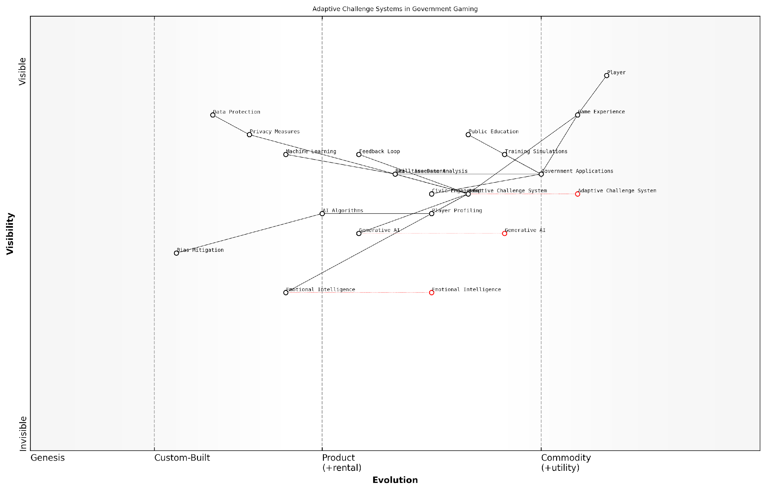

*Draft Wardley Map: [Insert Wardley Map: Adaptive Challenge Systems]*

[Edit this draft Wardley Map](https://create.wardleymaps.ai/#clone:7e811118fdf220b5e7)

Wardley Map Assessment

This map represents a forward-thinking approach to government applications, leveraging adaptive challenge systems and AI to enhance public services and engagement. The strategic focus should be on rapidly evolving AI capabilities while ensuring robust privacy protection and bias mitigation. There’s significant potential for innovation in personalising government services and improving civic engagement through adaptive gaming techniques.

[View full Wardley Map report](http://markdown_wardley_map_reports/wardley_map_report_19_Adaptive_Challenge_Systems.md)

Looking to the future, the potential of Adaptive Challenge Systems in gaming, especially within government and public sector contexts, is vast. As AI technologies continue to advance, we can anticipate even more sophisticated systems that can predict player needs, generate entirely new game mechanics on the fly, and create deeply immersive, personalised narratives. The integration of ACS with other emerging technologies such as virtual and augmented reality could lead to unprecedented levels of engagement and effectiveness in training, education, and public service delivery.

In conclusion, Adaptive Challenge Systems represent a significant step forward in the evolution of gaming experiences. By harnessing the power of generative AI to create dynamic, personalised challenges, these systems have the potential to revolutionise not just entertainment, but also training, education, and public engagement initiatives within the government sector. As we continue to explore and refine these technologies, we move closer to a future where games can truly adapt to and grow with each individual player, creating experiences that are as unique as they are impactful.

## Personalised Content Generation

### AI-Driven Storylines and Quests

In the realm of personalised content generation, AI-driven storylines and quests represent a paradigm shift in how players experience narrative-driven games. This revolutionary approach harnesses the power of generative AI to create dynamic, adaptive, and deeply personalised narratives that respond to individual player choices, preferences, and play styles. As we delve into this transformative aspect of gaming, it’s crucial to understand how AI is reshaping the very fabric of storytelling in interactive entertainment.

The traditional approach to game narratives often involves pre-written, linear storylines with limited branching paths. While this method has produced many compelling games, it inherently limits replayability and personal connection. AI-driven storylines and quests, however, offer a solution that promises to deliver unique experiences tailored to each player, potentially redefining the concept of narrative in games.

AI-driven narratives are not just about creating endless variations of content; they’re about crafting meaningful, coherent stories that resonate with individual players on a personal level.

Let’s explore the key components and implications of AI-driven storylines and quests:

* Dynamic Narrative Generation
* Player Profiling and Adaptive Storytelling
* Procedural Quest Creation
* Character and Dialogue Adaptation
* Ethical Considerations and Challenges

Dynamic Narrative Generation: At the heart of AI-driven storylines is the ability to generate narrative content in real-time. This process utilises advanced natural language processing (NLP) models, such as GPT (Generative Pre-trained Transformer) variants, to create coherent and contextually appropriate story elements. These models are trained on vast corpora of narrative texts, enabling them to understand and replicate complex storytelling structures.

In practice, this means that the game’s narrative engine can dynamically create plot points, character interactions, and world-building elements that seamlessly integrate with the player’s actions and choices. For instance, a player’s decision to befriend a particular non-player character (NPC) could trigger the AI to generate a unique backstory for that character, complete with personal quests and narrative arcs that weren’t explicitly programmed by the developers.

The potential for AI-driven narratives is immense. We’re moving towards a future where every playthrough of a game could be a unique story, tailored to the individual player’s journey.

Player Profiling and Adaptive Storytelling: To create truly personalised narratives, AI systems must understand the player on a deeper level. This is achieved through sophisticated player profiling techniques that analyse various aspects of player behaviour, preferences, and emotional responses. Machine learning algorithms process this data to create a comprehensive player model, which informs the narrative generation process.

For example, if the player model indicates a preference for diplomatic solutions over combat, the AI might generate more dialogue-heavy quests or introduce characters that align with this playstyle. Similarly, if a player shows particular interest in a specific aspect of the game’s lore, the narrative engine could expand on those elements, creating a more engaging and personalised experience.

Procedural Quest Creation: AI-driven systems excel at generating procedural content, and quests are no exception. By combining narrative generation capabilities with game design principles, AI can create an endless variety of meaningful quests that fit seamlessly into the game world.

These procedurally generated quests go beyond simple fetch quests or repetitive tasks. Advanced AI systems can create complex, multi-layered quests with branching outcomes, character development, and ties to the overarching narrative. The AI considers factors such as the player’s current location, inventory, skills, and previous actions to ensure that each quest feels relevant and appropriately challenging.

The future of quest design lies in AI-driven systems that can create narratively rich, contextually appropriate, and endlessly varied content that keeps players engaged for hours on end.

Character and Dialogue Adaptation: One of the most exciting aspects of AI-driven storytelling is the potential for truly dynamic characters. NPCs can be imbued with their own AI-driven personalities, allowing them to adapt their dialogue and behaviour based on their interactions with the player and the evolving game state.

This level of character adaptation creates a more immersive and believable world. NPCs can remember past interactions, form opinions about the player’s actions, and even develop their own goals and motivations. The result is a living, breathing game world where every interaction feels meaningful and potentially consequential.

Ethical Considerations and Challenges: While the potential of AI-driven storylines and quests is immense, it’s crucial to address the ethical considerations and challenges that come with this technology. Privacy concerns arise from the extensive player profiling required for personalised content. There’s also the risk of AI-generated content reinforcing biases or producing inappropriate material.

Game developers must implement robust safeguards and content moderation systems to ensure that AI-generated narratives align with the game’s intended themes and age ratings. Additionally, there’s the question of authorship and creative control – finding the right balance between AI-generated content and human-crafted narratives will be a key challenge for game designers.

As we push the boundaries of AI-driven storytelling, we must remain vigilant about the ethical implications and strive to create systems that enhance the creative process rather than replace human storytellers.

In conclusion, AI-driven storylines and quests represent a frontier in game design that promises to revolutionise how we experience interactive narratives. By leveraging advanced AI technologies, games can offer unprecedented levels of personalisation, replayability, and immersion. As this technology continues to evolve, we can expect to see games that blur the lines between pre-authored content and dynamically generated narratives, creating rich, adaptive worlds that respond to each player’s unique journey.

As we look to the future, the potential applications of AI-driven narratives extend beyond traditional gaming. Educational games could use this technology to create personalised learning experiences, while serious games for training and simulation could generate scenarios that adapt to the learner’s progress and needs. The implications for interactive storytelling in other media, such as interactive films or virtual reality experiences, are equally profound.

The journey towards fully realised AI-driven storylines and quests is still ongoing, with challenges in natural language generation, narrative coherence, and computational efficiency yet to be fully resolved. However, the rapid advancements in AI technology, particularly in the field of large language models and reinforcement learning, suggest that we are on the cusp of a new era in interactive storytelling – one where every player’s experience is as unique as their own imagination.

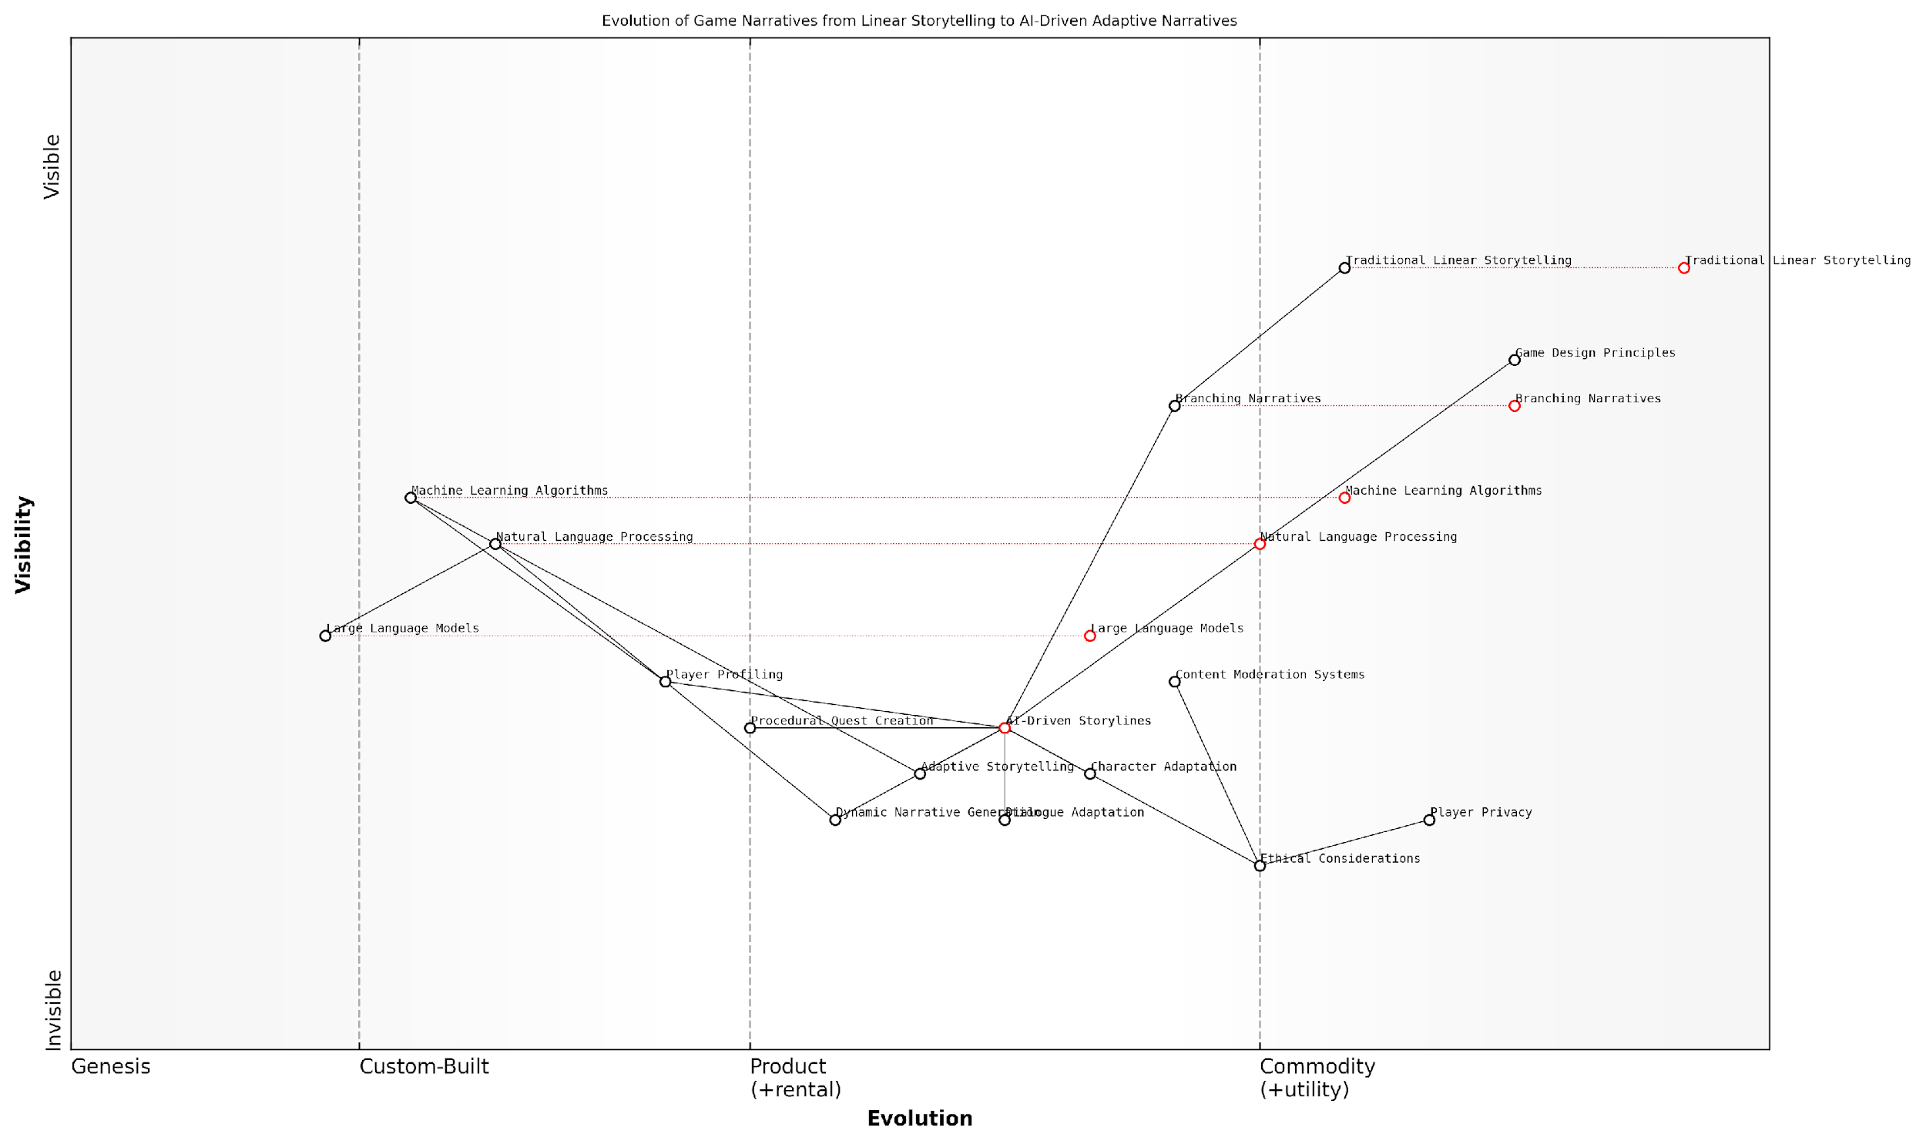

*Draft Wardley Map: [Insert Wardley Map: AI-Driven Storylines and Quests]*

[Edit this draft Wardley Map](https://create.wardleymaps.ai/#clone:b1afce9dcfeebefe29)

Wardley Map Assessment

This Wardley Map reveals a gaming industry at a critical juncture, transitioning from traditional narrative methods to AI-driven, personalised experiences. The strategic position is strong in terms of technological capabilities but faces challenges in ethical implementation and balancing AI with traditional storytelling. The key opportunity lies in successfully integrating cutting-edge AI technologies with robust ethical frameworks and traditional game design principles to create uniquely engaging, personalised, and responsible gaming experiences. Companies that can navigate this complex landscape, prioritising both innovation and ethical considerations, will likely emerge as leaders in the next generation of interactive entertainment.

[View full Wardley Map report](http://markdown_wardley_map_reports/wardley_map_report_20_AI-Driven_Storylines_and_Quests.md)

### Customised Game Worlds

In the rapidly evolving landscape of AI-powered gaming, customised game worlds represent a paradigm shift in how players interact with virtual environments. As we delve into this transformative aspect of personalised content generation, it’s crucial to understand how generative AI is reshaping the very fabric of game design and player engagement.

Customised game worlds leverage the power of generative AI to create unique, dynamic environments that adapt to individual player preferences, behaviours, and play styles. This level of personalisation goes far beyond traditional procedural generation, offering a truly bespoke gaming experience that evolves with each player’s journey.

The future of gaming lies in creating worlds that are as unique as the players themselves. Generative AI allows us to craft experiences that feel personal, meaningful, and alive in ways we’ve never seen before.

Let’s explore the key components and implications of AI-driven customised game worlds:

* Dynamic Environment Generation
* Adaptive Aesthetics and Atmosphere
* Personalised World Lore and History
* Player-Influenced Ecosystem
* Ethical Considerations and Challenges

Dynamic Environment Generation: At the core of customised game worlds is the ability to generate environments that are uniquely tailored to each player. Generative AI algorithms analyse player data, including preferences, play style, and in-game decisions, to create landscapes, cities, dungeons, and other settings that resonate with the individual user.

For instance, a player who enjoys exploration might find their world expanding with hidden caves and secret passages, while a player focused on combat could encounter strategically placed battlegrounds and training arenas. This dynamic generation ensures that no two players’ worlds are exactly alike, fostering a sense of ownership and discovery.

Adaptive Aesthetics and Atmosphere: Beyond structural elements, generative AI can tailor the visual and auditory aspects of the game world to suit player preferences. This might include adjusting colour palettes, architectural styles, music, and ambient sounds based on the player’s emotional responses and aesthetic choices.

The ability to create atmospheres that resonate on a personal level with each player is a game-changer. It’s not just about what the player sees, but how they feel in the world we’ve created for them.

Personalised World Lore and History: One of the most exciting applications of generative AI in customised game worlds is the creation of unique lore and history. By analysing player choices, interests, and even external factors like cultural background, AI can weave intricate backstories and mythologies that feel personally relevant and engaging.

This could manifest as customised in-game books, NPC dialogues, or environmental storytelling elements that reflect themes and narratives that resonate with the individual player. The result is a world that feels more immersive and personally meaningful.

Player-Influenced Ecosystem: Customised game worlds can also feature dynamic ecosystems that evolve based on player actions and choices. Generative AI can simulate complex interactions between flora, fauna, and even weather patterns, creating a living, breathing world that responds to the player’s presence and decisions.

For example, a player who frequently engages in hunting might see animal populations shift and adapt, while a player focused on cultivation could witness the spread of unique plant species across their world. This level of responsiveness creates a profound sense of impact and consequence.

Ethical Considerations and Challenges: While the potential of customised game worlds is immense, it’s crucial to address the ethical implications and technical challenges associated with this technology. Privacy concerns regarding the collection and use of player data must be carefully managed, ensuring transparency and consent.

Additionally, there’s a delicate balance to strike between personalisation and maintaining a cohesive game experience, especially in multiplayer environments. Developers must consider how to create shared spaces that accommodate diverse, personalised elements without compromising gameplay balance or narrative integrity.

As we push the boundaries of personalisation in gaming, we must remain vigilant about the ethical implications. The goal is to enhance the player’s experience, not to exploit their data or manipulate their behaviour.

Technical challenges also abound, including the need for robust AI systems capable of generating high-quality, coherent content in real-time. This requires significant computational resources and sophisticated algorithms that can balance creativity with consistency.

Looking ahead, the future of customised game worlds is bright but complex. As AI technologies continue to advance, we can expect even more sophisticated and seamless integration of personalised elements into game environments. This could lead to truly adaptive worlds that not only respond to player actions but anticipate desires and create experiences that blur the lines between game design and personal narrative.

In conclusion, customised game worlds represent a frontier in personalised content generation, offering unprecedented levels of immersion and engagement. As we continue to explore and refine these technologies, the potential for creating deeply meaningful and uniquely tailored gaming experiences is boundless. The challenge for developers and designers will be to harness this potential responsibly, creating worlds that are not just personalised, but truly transformative.

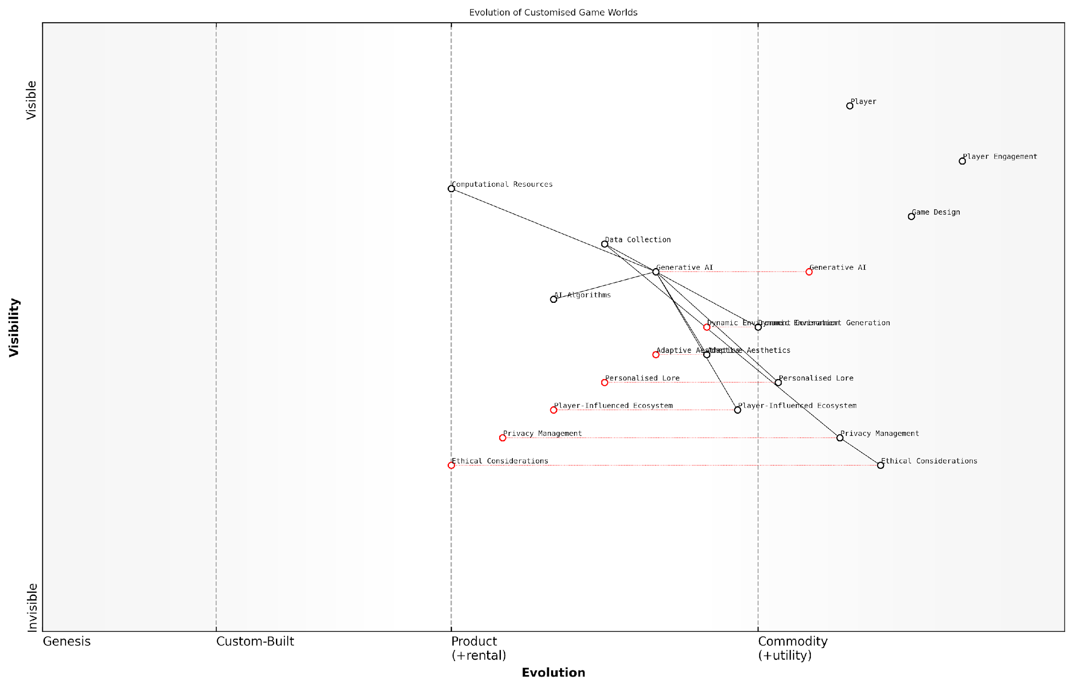

*Draft Wardley Map: [Insert Wardley Map: Customised Game Worlds]*

[Edit this draft Wardley Map](https://create.wardleymaps.ai/#clone:b9d5d4f2de165be8d6)

Wardley Map Assessment

The map represents a cutting-edge approach to game world customization, leveraging AI to create unprecedented levels of personalization. However, the rapid technological advancement is outpacing ethical and privacy considerations, creating both risks and opportunities. The strategic focus should be on maintaining technological leadership while proactively addressing ethical concerns and pioneering player-influenced game dynamics. This balanced approach will position the company as a responsible innovator, building player trust while delivering revolutionary gaming experiences.

[View full Wardley Map report](http://markdown_wardley_map_reports/wardley_map_report_21_Customised_Game_Worlds.md)

### Tailored NPC Interactions

In the realm of generative AI-powered gaming, tailored NPC (Non-Player Character) interactions represent a quantum leap in creating immersive and personalised player experiences. This advancement is not merely an incremental improvement but a fundamental shift in how players engage with virtual worlds and their inhabitants. As we delve into this transformative aspect of AI-driven game design, we’ll explore how it’s reshaping the landscape of player-NPC dynamics and pushing the boundaries of narrative depth in gaming.

At its core, tailored NPC interactions leverage the power of generative AI to create dynamic, context-aware, and player-specific dialogues and behaviours. This technology moves beyond pre-scripted conversations and static character arcs, instead offering a fluid and responsive virtual populace that adapts to each player’s unique journey through the game world.

The future of gaming lies in creating worlds where every NPC remembers you, learns from you, and evolves alongside you. It’s about crafting a living, breathing ecosystem of virtual personalities that respond to the player’s every action and decision.

Let’s break down the key components that make tailored NPC interactions a game-changer in the industry:

* Dynamic Personality Generation
* Contextual Memory and Learning
* Emotional Intelligence and Empathy
* Adaptive Dialogue Systems
* Behavioural Evolution

Dynamic Personality Generation: Generative AI enables the creation of NPCs with unique personalities, backstories, and motivations. Rather than relying on a limited set of pre-defined character types, AI can generate an infinite variety of personalities, each with its own quirks, beliefs, and goals. This diversity ensures that no two playthroughs are alike, as players encounter a rich tapestry of characters that feel genuinely individual and alive.

Contextual Memory and Learning: One of the most significant advancements in tailored NPC interactions is the ability for characters to remember past interactions and learn from them. AI-driven NPCs can recall previous conversations, player choices, and even subtle behavioural patterns. This contextual awareness allows for the development of meaningful relationships between players and NPCs, as characters grow and change based on their shared history with the player.

Imagine a world where every NPC you meet has the potential to become a lifelong friend or bitter enemy, shaped by your actions and words. That’s the power of AI-driven contextual memory in gaming.

Emotional Intelligence and Empathy: Advanced AI models are now capable of simulating emotional responses and empathy, allowing NPCs to react to player emotions and situations with unprecedented nuance. This emotional intelligence creates a deeper level of engagement, as players feel truly understood and responded to by the virtual characters they encounter. NPCs can offer comfort, share in joy, or express frustration in ways that feel authentic and situationally appropriate.

Adaptive Dialogue Systems: Gone are the days of limited dialogue trees and repetitive conversations. Generative AI enables the creation of adaptive dialogue systems that can generate contextually relevant, natural-sounding conversations on the fly. These systems take into account the player’s history, current objectives, and even real-world knowledge to create dialogues that are both informative and engaging. The result is a more organic flow of conversation that can branch in countless directions based on player input.

Behavioural Evolution: Perhaps one of the most exciting aspects of tailored NPC interactions is the potential for characters to evolve their behaviour over time. AI-driven NPCs can learn from their interactions with the player and other characters, adjusting their attitudes, goals, and even their role in the game world. This evolution creates a dynamic ecosystem of characters that feels alive and responsive to the player’s influence on the game world.

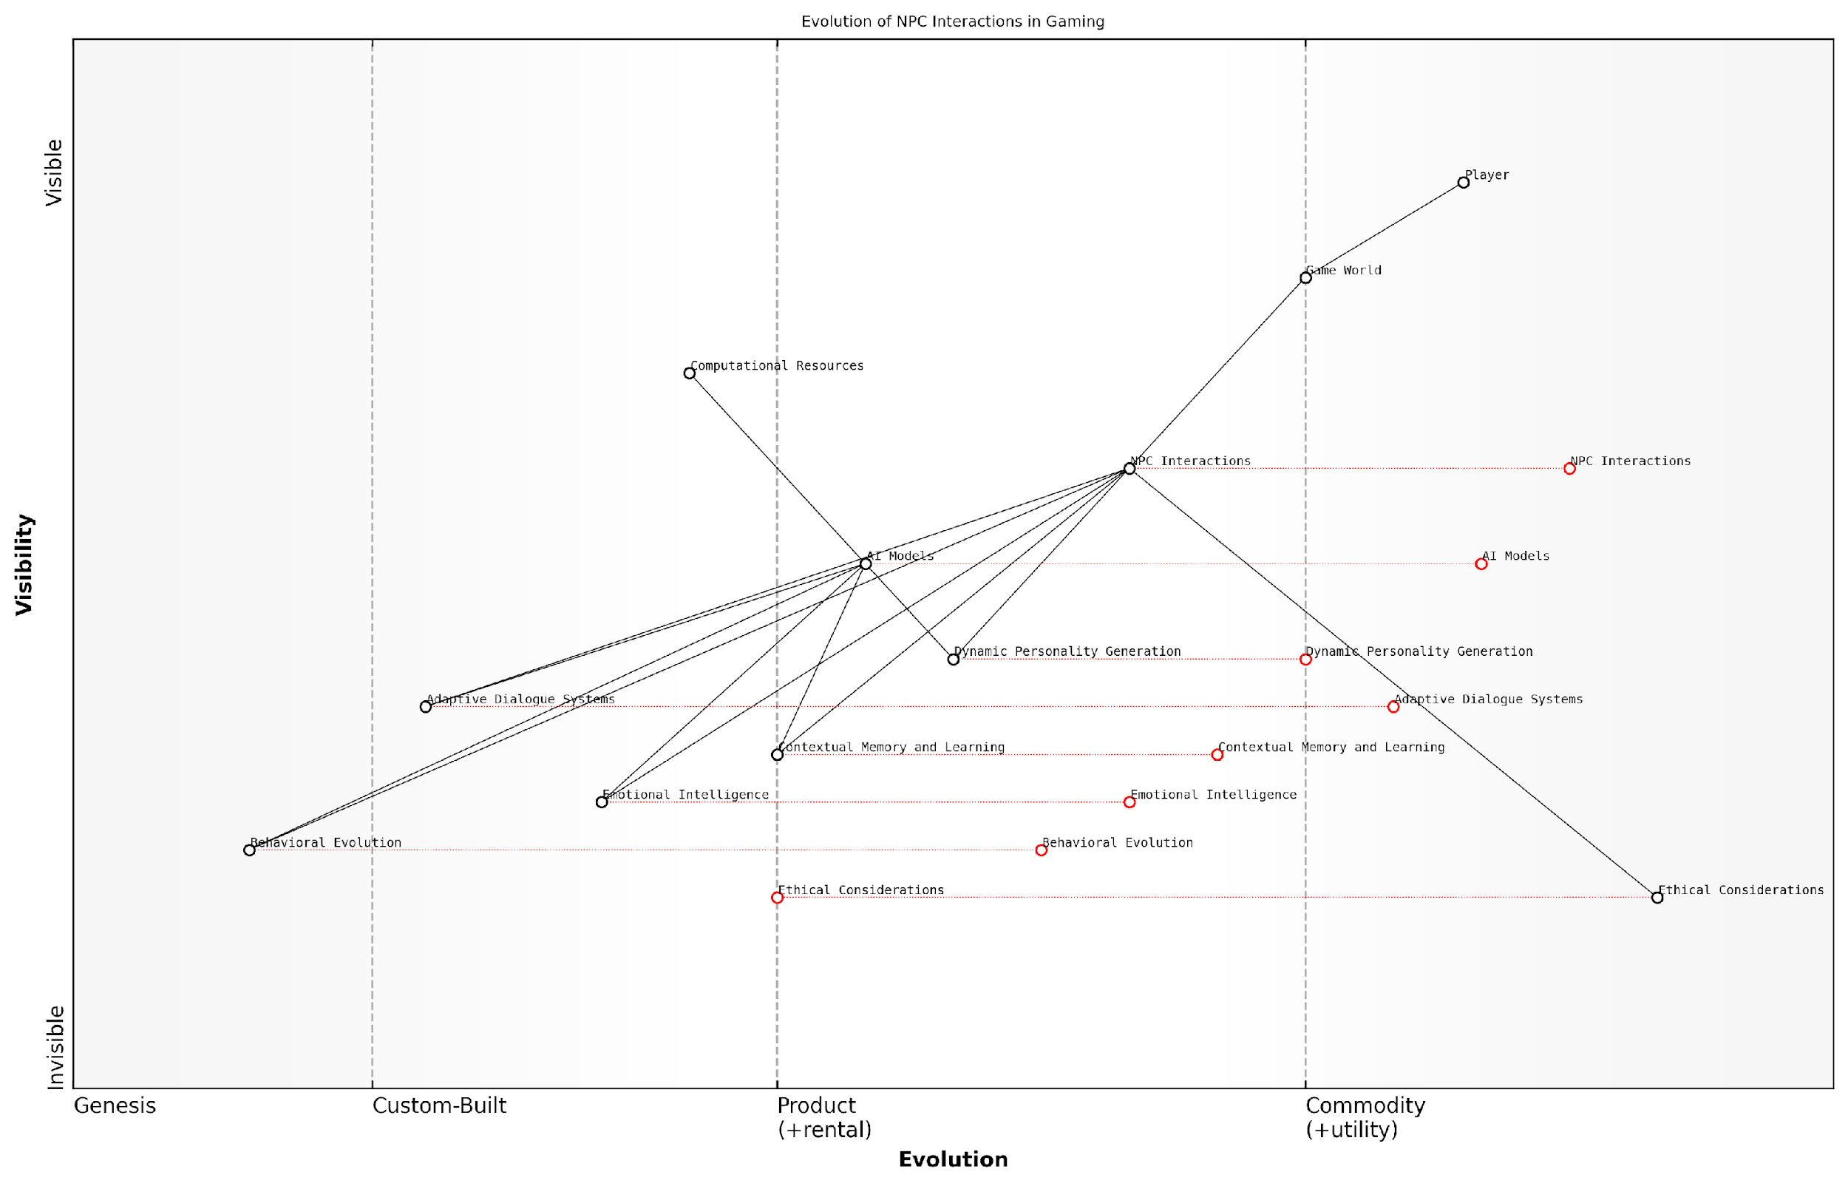

*Draft Wardley Map: [Insert Wardley Map: Tailored NPC Interactions]*

[Edit this draft Wardley Map](https://create.wardleymaps.ai/#clone:0fa5b49786585a2f53)

Wardley Map Assessment

The map reveals a gaming industry on the cusp of a major leap in NPC interaction sophistication, driven by AI advancements. The strategic focus should be on rapidly evolving NPC Interactions while simultaneously addressing Ethical Considerations. This balanced approach will likely lead to a competitive advantage in creating more immersive and personalised gaming experiences. Key areas for investment include Emotional Intelligence, Behavioral Evolution, and robust ethical frameworks. The industry is poised for a shift towards more dynamic, adaptive, and ethically-conscious game design, with potential for significant disruption in how players interact with game worlds and NPCs.

[View full Wardley Map report](http://markdown_wardley_map_reports/wardley_map_report_22_Tailored_NPC_Interactions.md)

The implementation of tailored NPC interactions presents both exciting opportunities and significant challenges for game developers. On one hand, it offers unprecedented depth and replayability, as each player’s experience becomes truly unique. On the other hand, it requires careful balancing to ensure that the game’s core narrative and objectives remain coherent amidst the variability introduced by AI-driven characters.

From a technical standpoint, implementing these advanced NPC systems requires substantial computational resources and sophisticated AI models. Game developers must consider the trade-offs between the depth of NPC interactions and performance, especially in large-scale open-world games where hundreds of NPCs might be active simultaneously.

Moreover, there are ethical considerations to navigate. As NPCs become more lifelike and emotionally engaging, questions arise about the psychological impact on players, particularly in terms of attachment to virtual characters and the blurring of lines between real and virtual relationships. Game designers must be mindful of these implications and work to create systems that enhance the gaming experience without exploiting player emotions.

As we push the boundaries of AI in gaming, we must remain vigilant about the ethical implications. Creating more lifelike NPCs is not just a technical challenge, but a moral one that requires careful consideration of the player’s emotional well-being.

Looking to the future, the potential applications of tailored NPC interactions are vast. In educational games, AI-driven characters could adapt their teaching styles to individual learners, providing personalised instruction and support. In simulation games, NPCs could model complex social dynamics, offering insights into human behaviour and decision-making. The technology could even extend beyond gaming, influencing fields such as virtual assistants, training simulations, and interactive storytelling.

As we stand on the cusp of this new era in gaming, it’s clear that tailored NPC interactions represent more than just a feature—they’re a fundamental reimagining of how we interact with virtual worlds. By creating more responsive, dynamic, and emotionally intelligent characters, we’re not just enhancing games; we’re expanding the very boundaries of interactive storytelling and virtual experiences.

## Player Behaviour Analysis

### Predictive Analytics in Gaming

Predictive analytics has emerged as a game-changing tool in the realm of player behaviour analysis, revolutionising how game developers understand and respond to their audience. As we delve into this crucial aspect of adaptive gameplay and personalised player experiences, it’s essential to recognise the profound impact that generative AI is having on this field. By harnessing the power of machine learning algorithms and vast datasets, game developers can now anticipate player actions, preferences, and potential pain points with unprecedented accuracy.

The application of predictive analytics in gaming represents a significant leap forward in creating truly responsive and engaging gaming experiences. It allows developers to move beyond reactive design paradigms and into proactive, data-driven decision-making that can shape every aspect of the player’s journey. This shift is particularly relevant in the context of government and public sector gaming initiatives, where engagement, education, and behavioural change are often key objectives.

Predictive analytics is not just about improving games; it’s about understanding human behaviour at a fundamental level. In the public sector, this insight can be leveraged to create experiences that genuinely resonate with citizens and drive positive outcomes.

Let’s explore the key components and applications of predictive analytics in gaming:

* Player Churn Prediction
* In-Game Purchase Forecasting
* Gameplay Pattern Analysis
* Social Interaction Modelling
* Performance Trajectory Mapping

Player Churn Prediction: One of the most critical applications of predictive analytics in gaming is the ability to forecast player churn. By analysing patterns in player behaviour, such as declining login frequency, reduced in-game activity, or changes in social interactions, AI models can identify players at risk of abandoning the game. This foresight allows developers to implement targeted retention strategies, such as personalised incentives or tailored content, to re-engage at-risk players before they leave.

In the context of public sector gaming initiatives, churn prediction can be particularly valuable. For instance, in educational games or simulations designed to train government employees, identifying potential dropouts early can help ensure that important skills are fully developed and learning objectives are met.

In-Game Purchase Forecasting: For games that incorporate microtransactions or in-game economies, predictive analytics can forecast player purchasing behaviour with remarkable accuracy. By analysing factors such as player progression, social network, and historical spending patterns, AI models can predict not only the likelihood of a purchase but also the types of items or upgrades that will appeal to specific players.

While this application is often associated with commercial games, it has relevance in public sector contexts as well. For example, in games designed to promote financial literacy or responsible spending habits, understanding and predicting user behaviour around virtual purchases can provide valuable insights into real-world financial decision-making processes.

Gameplay Pattern Analysis: Advanced AI algorithms can identify complex patterns in player behaviour that may not be immediately apparent to human observers. This includes preferred play styles, problem-solving approaches, and learning curves. By understanding these patterns, developers can create more engaging and challenging content that adapts to individual player preferences and skill levels.

In government-sponsored educational games or simulations, this type of analysis can help tailor the learning experience to different cognitive styles and abilities, ensuring that the educational content is delivered in the most effective manner for each user.

The ability to predict and adapt to individual gameplay patterns is transforming how we approach game design. It’s no longer about creating a single experience for all players, but about crafting a framework that can generate countless personalised journeys.

Social Interaction Modelling: For multiplayer games or those with social components, predictive analytics can model and forecast social interactions between players. This includes predicting the formation of in-game alliances, the likelihood of collaborative play, or the potential for conflict between players. By understanding these social dynamics, developers can create more engaging community features and implement proactive moderation strategies.

In public sector applications, such as games designed to promote community engagement or civic participation, this type of social modelling can provide valuable insights into group dynamics and collective decision-making processes.

Performance Trajectory Mapping: Predictive analytics can map out a player’s likely performance trajectory over time, taking into account factors such as learning rate, practice frequency, and inherent skill. This allows for the creation of personalised challenge curves that keep players in a state of ‘flow’ - the optimal balance between challenge and skill that leads to deep engagement and satisfaction.

For government training simulations or educational games, performance trajectory mapping can help identify individuals who may need additional support or who show particular aptitude in certain areas, allowing for more efficient allocation of educational resources.

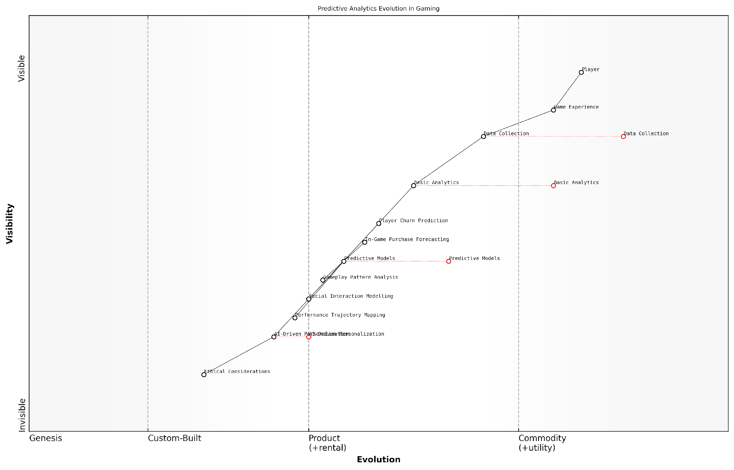

*Draft Wardley Map: [Insert Wardley Map: Predictive Analytics in Gaming]*

[Edit this draft Wardley Map](https://create.wardleymaps.ai/#clone:6f3988f6f203b9f58a)

Wardley Map Assessment

This map reveals a gaming industry in transition, moving from basic data-driven insights to advanced AI-powered experiences. The key strategic opportunity lies in leading the development of ethical, highly personalised gaming experiences. Success will require balancing rapid AI innovation with robust ethical frameworks, while continuously enhancing data collection and analytics capabilities. Companies that can master AI-driven personalization while prioritising ethical considerations will likely emerge as industry leaders in the next generation of gaming.

[View full Wardley Map report](http://markdown_wardley_map_reports/wardley_map_report_23_Predictive_Analytics_in_Gaming.md)

As we look to the future of gaming with generative AI, the role of predictive analytics in player behaviour analysis will only grow in importance. The integration of more sophisticated AI models, including those capable of unsupervised learning and real-time adaptation, promises to create gaming experiences that are not just responsive but truly anticipatory.

However, with this power comes significant responsibility. As predictive models become more accurate and influential, developers and policymakers must grapple with important ethical considerations. These include issues of data privacy, the potential for manipulation of player behaviour, and the need for transparency in how AI-driven decisions are made within games.

The ethical use of predictive analytics in gaming is not just a technical challenge, but a societal one. As we push the boundaries of what’s possible, we must ensure that our innovations serve the best interests of players and society at large.

In conclusion, predictive analytics represents a powerful tool for understanding and shaping player behaviour in games. As generative AI continues to evolve, we can expect even more sophisticated applications of these techniques, leading to gaming experiences that are more engaging, personalised, and impactful than ever before. For government and public sector organisations looking to leverage gaming for education, training, or public engagement, understanding and ethically implementing predictive analytics will be key to creating truly effective and transformative experiences.

### Emotion Recognition and Response

In the rapidly evolving landscape of AI-powered gaming, emotion recognition and response systems represent a groundbreaking frontier that promises to revolutionise player experiences. As we delve into this crucial aspect of player behaviour analysis, it’s essential to understand how these technologies are reshaping the way games interact with and adapt to players’ emotional states, creating more immersive and personalised gaming environments.

Emotion recognition in gaming leverages advanced machine learning algorithms and computer vision techniques to analyse players’ facial expressions, voice patterns, and even physiological responses. This data is then interpreted to infer the player’s emotional state, allowing the game to respond in real-time, adjusting various elements to enhance engagement and overall experience.

The integration of emotion recognition technology in gaming is not just about creating more engaging experiences; it’s about forging deeper connections between players and virtual worlds, potentially revolutionising how we perceive and interact with digital entertainment.

Let’s explore the key components and applications of emotion recognition and response systems in gaming:

* Facial Expression Analysis
* Voice Pattern Recognition
* Physiological Response Monitoring
* Contextual Emotion Interpretation
* Adaptive Game Mechanics

Facial Expression Analysis: Utilising computer vision and deep learning models, games can now analyse players’ facial expressions in real-time. This technology captures micro-expressions and subtle changes in facial features to infer emotions such as joy, frustration, surprise, or concentration. For instance, a strategy game might detect a player’s furrowed brow indicating intense concentration and adjust the difficulty level accordingly to maintain an optimal challenge.

Voice Pattern Recognition: Advanced natural language processing (NLP) algorithms can analyse players’ voice patterns, including tone, pitch, and speech rate, to deduce emotional states. This is particularly useful in multiplayer games or those with voice commands, where the game can adapt based on the emotional context of player interactions.

Physiological Response Monitoring: Some cutting-edge systems incorporate biometric sensors to monitor players’ heart rate, skin conductance, and even brain activity. While currently more common in research settings, these technologies hold immense potential for future gaming applications, offering unprecedented insight into players’ emotional and physiological responses.

Contextual Emotion Interpretation: It’s crucial to note that emotions in gaming are often complex and context-dependent. Advanced AI systems must consider the game context, player history, and cultural factors to accurately interpret emotional data. For example, a player’s increased heart rate could indicate excitement in an action sequence but stress in a puzzle-solving scenario.

Adaptive Game Mechanics: The true power of emotion recognition lies in how games respond to this emotional data. AI-driven systems can dynamically adjust various game elements, including:

* Difficulty levels
* Narrative pacing
* Music and sound effects
* Visual elements and environmental factors
* NPC behaviour and dialogue

For instance, if a player shows signs of frustration during a challenging boss fight, the game might subtly decrease the difficulty or provide hints. Conversely, if a player appears bored during a narrative sequence, the game could introduce unexpected elements or quicken the pace to re-engage them.

The future of gaming lies not just in creating visually stunning worlds, but in crafting experiences that understand and respond to the player’s emotional journey. Emotion recognition technology is the key to unlocking truly adaptive and empathetic game design.

However, the implementation of emotion recognition and response systems in gaming is not without challenges and ethical considerations:

* Privacy concerns regarding the collection and use of emotional data
* Ensuring inclusivity and avoiding bias in emotion recognition algorithms
* Balancing automated responses with player agency and game integrity
* Potential for emotional manipulation or exploitation in game design
* Technical limitations in accurately interpreting complex human emotions

Addressing these challenges requires a collaborative effort between game developers, AI researchers, ethicists, and policymakers. As we navigate this new frontier, it’s crucial to establish guidelines and best practices that ensure the responsible and beneficial use of emotion recognition technology in gaming.

Looking ahead, the potential applications of emotion recognition in gaming are vast and exciting. We can envision games that not only entertain but also support emotional well-being, help players develop emotional intelligence, or even assist in therapeutic contexts. The integration of these technologies with virtual and augmented reality could create unprecedented levels of immersion and emotional engagement.

In conclusion, emotion recognition and response systems represent a paradigm shift in game design and player experience. As these technologies continue to evolve and mature, they promise to usher in a new era of emotionally intelligent games that can understand, adapt to, and even influence players’ emotional states. The challenge for the gaming industry lies in harnessing this potential responsibly, creating experiences that are not only more engaging and personalised but also ethically sound and beneficial to players’ overall well-being.

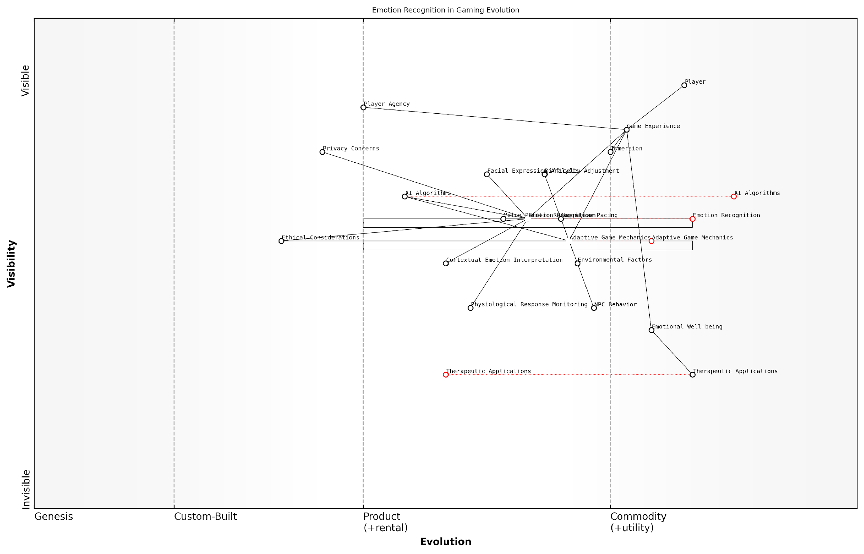

*Draft Wardley Map: [Insert Wardley Map: Emotion Recognition and Response]*

[Edit this draft Wardley Map](https://create.wardleymaps.ai/#clone:c8e7a00558f0b5ac93)

Wardley Map Assessment

This Wardley Map reveals a gaming industry on the cusp of a major transformation, driven by the integration of emotion recognition and adaptive technologies. The strategic focus should be on ethically advancing these technologies while exploring new applications, particularly in therapeutic contexts. Success will hinge on balancing innovation with privacy concerns, maintaining player agency, and establishing industry leadership in ethical AI use. The potential to expand gaming’s impact beyond entertainment into health and wellness represents a significant opportunity for growth and societal contribution.

[View full Wardley Map report](http://markdown_wardley_map_reports/wardley_map_report_24_Emotion_Recognition_and_Response.md)

### Personalised Recommendations and Rewards

In the rapidly evolving landscape of AI-powered gaming, personalised recommendations and rewards have emerged as a cornerstone of player engagement and retention. This subsection delves into the intricate mechanisms by which generative AI analyses player behaviour to deliver tailored experiences that resonate with individual preferences and play styles.

At its core, the implementation of personalised recommendations and rewards in gaming leverages sophisticated machine learning algorithms to process vast amounts of player data. This data encompasses a wide range of metrics, including gameplay patterns, in-game purchases, social interactions, and even physiological responses captured through biometric sensors. The goal is to create a dynamic and responsive gaming environment that adapts to each player’s unique characteristics and motivations.

The future of gaming lies in creating experiences that feel bespoke to each player. Generative AI allows us to scale personalisation to unprecedented levels, making every playthrough unique and meaningful.

One of the primary applications of personalised recommendations in gaming is content curation. By analysing a player’s historical preferences and behaviours, AI systems can suggest new quests, characters, or in-game items that are likely to appeal to that specific individual. This not only enhances player satisfaction but also increases engagement by continually presenting fresh and relevant content.

* Tailored quest recommendations based on past completion rates and difficulty preferences
* Customised item suggestions that align with the player’s playstyle and aesthetic choices
* Personalised narrative branches that reflect the player’s previous decisions and character interactions
* Adaptive difficulty settings that adjust in real-time based on the player’s skill level and progression

Rewards systems, too, have been revolutionised by the integration of generative AI. Traditional static reward structures are being replaced by dynamic systems that adapt to individual player motivations. For instance, an AI might recognise that a particular player is driven more by social recognition than in-game currency, and adjust the reward structure accordingly.

Moreover, the timing and presentation of rewards can be optimised using predictive analytics. By anticipating when a player is likely to disengage, the AI can strategically offer rewards or new challenges to maintain interest and momentum. This approach, known as ‘just-in-time’ engagement, has shown remarkable efficacy in prolonging play sessions and improving overall player retention.

The power of AI-driven personalisation lies not just in what we offer players, but when and how we offer it. It’s about creating a symbiotic relationship between the game and the player, where each interaction feels meaningful and perfectly timed.

Another significant aspect of personalised recommendations and rewards is their role in fostering social connections within games. By analysing social graphs and player interactions, AI systems can suggest team compositions, multiplayer activities, or even potential friends based on complementary play styles and shared interests. This not only enhances the social fabric of the game but also contributes to a more engaging and sticky experience for players.

However, the implementation of such sophisticated personalisation systems is not without challenges. Privacy concerns and data ethics are at the forefront of considerations when designing these systems. Game developers must strike a delicate balance between leveraging player data for enhanced experiences and respecting individual privacy rights.

* Ensuring transparent data collection practices and obtaining explicit player consent
* Implementing robust data anonymisation and encryption protocols
* Providing players with granular control over their data and personalisation settings
* Regularly auditing AI systems for potential biases or unfair advantages

Furthermore, there is an ongoing debate about the potential for AI-driven personalisation to create ‘filter bubbles’ within games, where players are continually presented with content that aligns with their existing preferences, potentially limiting exposure to new experiences. To address this, some developers are experimenting with ‘serendipity engines’ that intentionally introduce elements of surprise and novelty into personalised recommendations.

Looking ahead, the future of personalised recommendations and rewards in gaming is closely tied to advancements in emotional AI and context-aware computing. As these technologies mature, we can expect to see even more nuanced and empathetic personalisation systems that can adapt not just to a player’s in-game behaviour, but also to their emotional state and real-world context.

In conclusion, personalised recommendations and rewards represent a frontier in AI-driven game design that holds immense potential for enhancing player experiences. As we continue to refine these systems, the line between game and player will blur, creating deeply immersive and responsive virtual worlds that adapt in real-time to each individual’s journey. The challenge for game developers and AI specialists alike will be to harness this potential while navigating the complex ethical and technical landscape it presents.

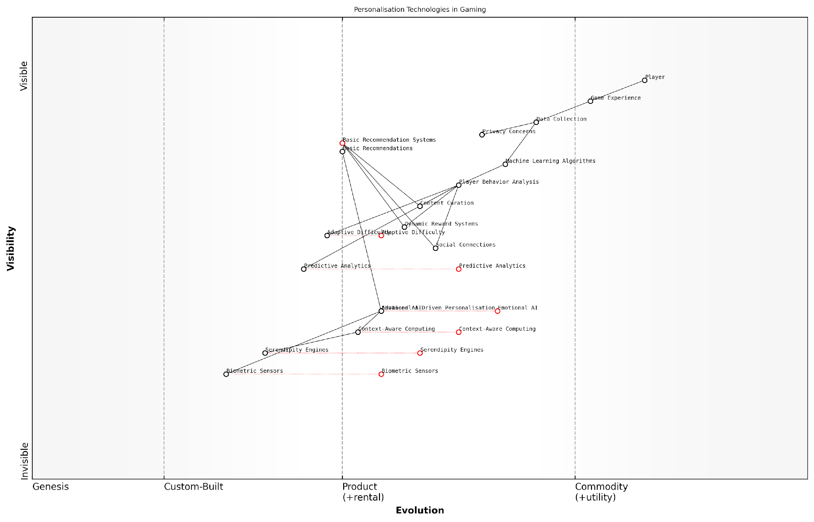

*Draft Wardley Map: [Insert Wardley Map: Personalised Recommendations and Rewards]*

[Edit this draft Wardley Map](https://create.wardleymaps.ai/#clone:7c01a9ee5ca20b15c4)

Wardley Map Assessment

The map reveals a gaming personalisation ecosystem in transition, moving from basic data-driven techniques to advanced AI-powered systems. There’s a significant opportunity to gain competitive advantage by investing in emerging technologies like Emotional AI and Context-Aware Computing. However, this must be balanced with addressing privacy concerns and ensuring that personalisation enhances rather than overwhelms the player experience. The strategic focus should be on creating an integrated, adaptive personalisation platform that can evolve with technological advancements and changing player needs.

[View full Wardley Map report](http://markdown_wardley_map_reports/wardley_map_report_25_Personalised_Recommendations_and_Rewards.md)

# Chapter 3: Ethical Considerations and Challenges

## Data Privacy and Player Rights

### Collecting and Using Player Data

As generative AI continues to revolutionise the gaming industry, the collection and utilisation of player data have become increasingly crucial. This subsection delves into the intricate balance between leveraging player data to enhance gaming experiences and safeguarding players’ privacy rights. The ethical implications of data collection in AI-driven games are paramount, especially as games become more personalised and adaptive.

The advent of generative AI in gaming has exponentially increased the volume and granularity of data that can be collected from players. This data encompasses a wide range of information, including gameplay patterns, in-game decisions, physiological responses (in VR/AR settings), and even emotional states inferred through advanced AI algorithms. While this wealth of data presents unprecedented opportunities for game developers to create more engaging and tailored experiences, it also raises significant concerns about player privacy and data rights.

The future of gaming lies in the delicate balance between leveraging AI to create immersive, personalised experiences and respecting the fundamental right to privacy of our players.

To address these concerns, game developers and publishers must adhere to stringent data protection regulations such as the General Data Protection Regulation (GDPR) in the European Union and the California Consumer Privacy Act (CCPA) in the United States. These regulations mandate transparency in data collection practices, user consent, and the right to access and delete personal data.

* Transparency: Clearly communicate what data is being collected and how it will be used
* Consent: Obtain explicit player consent for data collection and processing
* Data minimisation: Collect only the data necessary for improving the gaming experience
* Security: Implement robust security measures to protect player data from breaches
* Right to access and deletion: Provide players with the ability to access their data and request its deletion

One of the key challenges in collecting and using player data in AI-driven games is the potential for unintended bias. AI algorithms trained on player data may inadvertently perpetuate or amplify existing biases, leading to unfair or discriminatory gameplay experiences. For instance, an AI system designed to adjust difficulty levels based on player performance might inadvertently create more challenging scenarios for certain demographic groups, resulting in an uneven playing field.

To mitigate these risks, game developers must employ rigorous testing and auditing processes for their AI systems. This includes diverse playtesting groups, regular bias assessments, and the implementation of fairness constraints in AI algorithms. Additionally, the use of explainable AI (XAI) techniques can help developers understand and justify the decisions made by their AI systems, fostering transparency and trust with players.

In the era of AI-driven gaming, our responsibility extends beyond creating engaging experiences. We must be vigilant guardians of player privacy and advocates for fairness in our AI systems.

Another critical aspect of player data collection is the concept of ‘data sovereignty’. As games become increasingly global, developers must navigate the complex landscape of international data protection laws. This may require implementing region-specific data storage and processing practices, as well as providing localised privacy policies and consent mechanisms.

The use of blockchain technology and decentralised systems presents an innovative approach to addressing some of these challenges. By leveraging blockchain, game developers can create transparent, immutable records of player consent and data usage. This not only enhances trust but also provides players with greater control over their personal information.

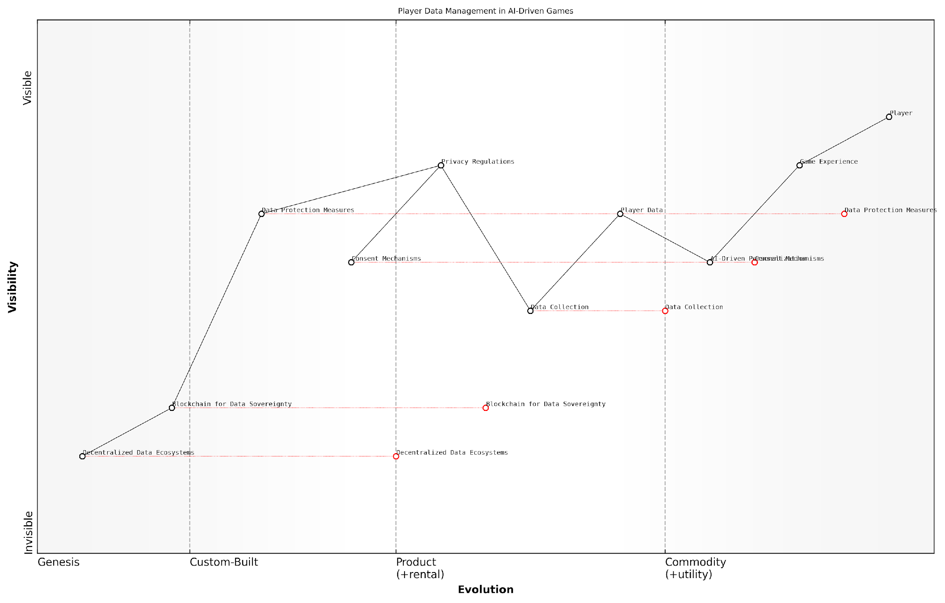

*Draft Wardley Map: [Insert Wardley Map: Collecting and Using Player Data]*

[Edit this draft Wardley Map](https://create.wardleymaps.ai/#clone:5726afd491d38e8478)

Wardley Map Assessment

The map reveals a gaming ecosystem at a critical juncture, balancing the power of AI-driven personalization with growing privacy concerns and emerging data sovereignty technologies. The strategic focus should be on enhancing player trust through robust data protection and consent mechanisms in the short term, while investing in blockchain and decentralised technologies to prepare for a future where players have greater control over their data. This approach will not only ensure regulatory compliance but also create a competitive advantage in an industry increasingly shaped by data ethics and player rights.

[View full Wardley Map report](http://markdown_wardley_map_reports/wardley_map_report_26_Collecting_and_Using_Player_Data.md)

As we look to the future of AI-driven gaming, the ethical collection and use of player data will undoubtedly remain a central concern. Game developers and publishers must strive to create a symbiotic relationship between AI advancement and player rights. This involves not only compliance with existing regulations but also proactive measures to anticipate and address emerging ethical challenges.

* Implement privacy-by-design principles in game development
* Regularly update privacy policies to reflect advancements in AI capabilities
* Collaborate with privacy experts and ethicists to develop best practices
* Educate players about their data rights and the benefits of data-driven AI in gaming
* Invest in research to develop privacy-preserving AI techniques specific to gaming

In conclusion, the collection and use of player data in AI-driven games represent both a tremendous opportunity and a significant responsibility. By prioritising player privacy, implementing robust data protection measures, and fostering transparency, the gaming industry can harness the power of AI to create more engaging, personalised experiences while maintaining the trust and respect of its player base. As we venture into this new frontier of gaming, the ethical treatment of player data will be a key differentiator for successful and responsible game developers.

### Transparency in AI Decision-Making

As generative AI continues to revolutionise the gaming industry, the need for transparency in AI decision-making processes becomes increasingly crucial. This subsection delves into the intricate balance between leveraging AI’s potential to enhance gameplay and ensuring players’ rights to understand and control the AI systems that shape their gaming experiences. Transparency in AI decision-making is not merely a technical consideration; it is a fundamental ethical imperative that underpins player trust, fairness, and the long-term sustainability of AI-driven gaming ecosystems.

The integration of generative AI in gaming introduces complex algorithms that can dynamically alter game environments, narratives, and player interactions. While these advancements offer unprecedented levels of personalisation and adaptability, they also raise significant concerns about the opacity of AI decision-making processes. Players, regulators, and developers alike are grappling with questions of accountability, explainability, and the potential for unintended biases or manipulations within AI systems.

Transparency in AI is not just about revealing code; it’s about empowering players to understand and meaningfully engage with the systems that shape their gaming experiences.

To address these challenges, we must consider several key aspects of transparency in AI decision-making within the context of gaming:

* Explainable AI (XAI) in gaming contexts
* Player-centric transparency mechanisms
* Regulatory frameworks and industry standards
* Ethical considerations in AI transparency
* Technical challenges and solutions

Explainable AI (XAI) in gaming contexts is a critical component of transparency. As AI systems become more complex, particularly in the realm of generative AI, traditional ‘black box’ approaches are no longer sufficient. Game developers must strive to implement XAI techniques that provide clear, understandable explanations for AI-driven decisions and outcomes. This might involve developing intuitive visualisations of AI decision trees, providing natural language explanations for AI actions, or offering players insights into the key factors influencing AI behaviour.

Player-centric transparency mechanisms are essential for empowering gamers to engage with and understand the AI systems shaping their experiences. This could include interactive tutorials that demystify AI processes, in-game tools for querying AI decisions, or comprehensive documentation accessible through game interfaces. By prioritising player comprehension and agency, developers can foster a sense of trust and collaboration between human players and AI systems.

Regulatory frameworks and industry standards play a crucial role in establishing baseline requirements for AI transparency in gaming. As governments and international bodies grapple with AI regulation, the gaming industry must proactively develop and adhere to standards that ensure responsible AI use. This may involve creating certification processes for AI-driven games, establishing guidelines for AI transparency disclosures, or implementing third-party auditing mechanisms to verify compliance with transparency standards.

The gaming industry has a unique opportunity to lead the way in establishing ethical standards for AI transparency that could serve as a model for other sectors.

Ethical considerations in AI transparency extend beyond mere technical disclosures. Game developers must grapple with questions of fairness, accountability, and the potential for AI systems to perpetuate or exacerbate societal biases. Transparency efforts should include clear communication about the ethical principles guiding AI development, as well as mechanisms for players to report concerns or challenge perceived unfair AI behaviours.

Technical challenges in achieving meaningful AI transparency are significant, particularly in the context of complex generative AI systems. Developers must balance the need for transparency with concerns about intellectual property protection, system security, and the potential for bad actors to exploit transparent AI systems. Solutions may involve developing novel cryptographic techniques to provide verifiable transparency without compromising system integrity, or creating standardised APIs for third-party transparency tools.

Case studies from the public sector offer valuable insights for the gaming industry’s approach to AI transparency. For instance, the UK government’s ‘Guidelines for AI procurement’ emphasise the importance of explainability and transparency in AI systems used in public services. Gaming companies can adapt these principles, ensuring that AI-driven game mechanics are as transparent and accountable as AI systems used in critical government functions.

In my consultancy work with government bodies, I’ve observed the transformative impact of transparency initiatives on public trust in AI systems. One particularly relevant example involved a large-scale public engagement project where citizens were invited to interact with and provide feedback on AI decision-making models. This approach, adapted for gaming contexts, could involve beta testing programmes where players are given unprecedented access to AI systems, fostering a collaborative approach to transparency and system improvement.

As we look to the future of gaming with generative AI, transparency in AI decision-making will be a key differentiator for successful game developers and platforms. Those who can effectively balance the power of AI with meaningful transparency will not only comply with emerging regulations but also build deeper, more trusting relationships with their player base. This trust will be essential as games increasingly become complex, AI-driven ecosystems that blur the lines between virtual and real-world experiences.

The future of gaming lies not just in the power of AI, but in our ability to make that power understandable, accountable, and aligned with player values.

In conclusion, transparency in AI decision-making is not merely a technical challenge but a fundamental requirement for the ethical and sustainable development of AI-driven gaming experiences. By prioritising explainability, player empowerment, regulatory compliance, and ethical considerations, the gaming industry can set new standards for AI transparency that resonate far beyond the world of play.

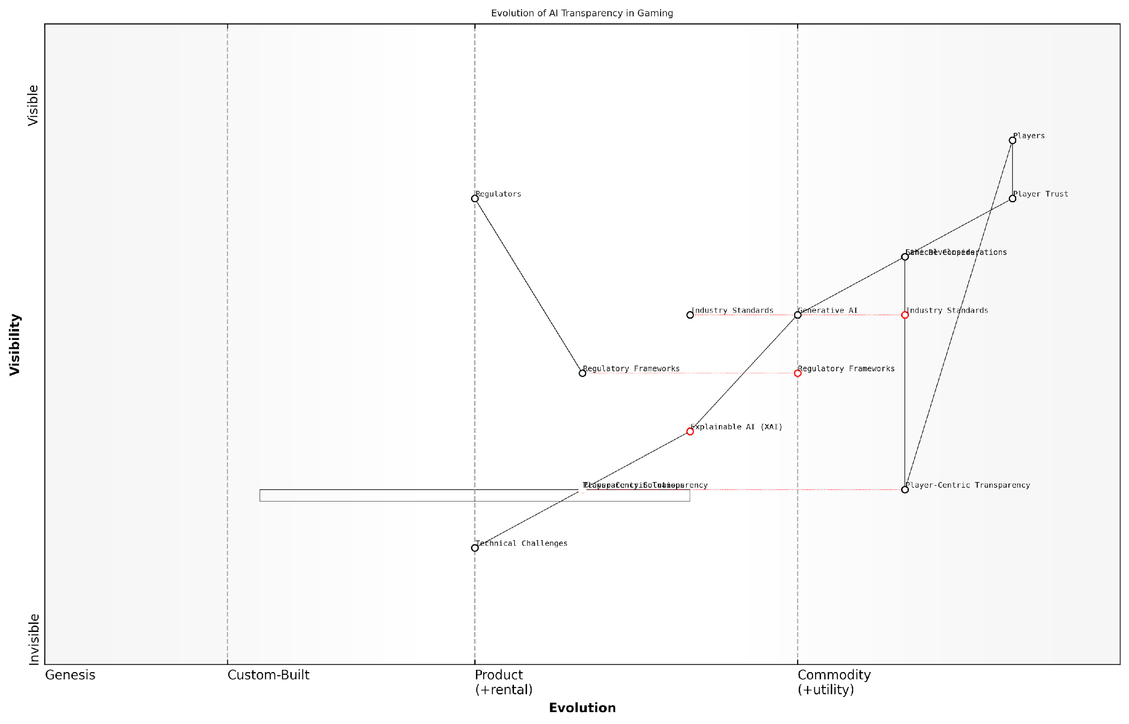

*Draft Wardley Map: [Insert Wardley Map: Transparency in AI Decision-Making]*

[Edit this draft Wardley Map](https://create.wardleymaps.ai/#clone:ad16d84bd0c3528537)

Wardley Map Assessment

The gaming industry is at a critical juncture in AI adoption, with transparency and trust as key challenges. Success will depend on rapidly developing explainable AI capabilities, creating player-centric transparency tools, and proactively engaging with regulatory developments. Companies that lead in these areas will likely gain significant competitive advantage and shape the future of AI in gaming.

[View full Wardley Map report](http://markdown_wardley_map_reports/wardley_map_report_27_Transparency_in_AI_Decision-Making.md)

### Ensuring Player Consent and Control

As generative AI continues to revolutionise the gaming industry, ensuring player consent and control has become a paramount concern. This subsection delves into the critical aspects of maintaining player autonomy and privacy in an era where AI-driven personalisation and data collection are becoming increasingly sophisticated and pervasive.

The integration of generative AI in gaming presents unique challenges to player consent and control. As games become more adaptive and personalised, they require access to vast amounts of player data to function effectively. This data collection and usage must be balanced with players’ rights to privacy and control over their personal information.

The future of gaming lies in creating immersive, personalised experiences. However, we must ensure that this future respects player autonomy and privacy. It’s not just about legal compliance; it’s about building trust with our players.

To address these challenges, game developers and publishers must implement robust systems for obtaining and managing player consent. These systems should be transparent, easily understandable, and provide players with granular control over their data.

* Clear and concise privacy policies
* Opt-in mechanisms for data collection and AI-driven features
* Easily accessible privacy settings within games
* Regular reminders and updates about data usage
* Options to download or delete personal data

One of the key challenges in ensuring player consent and control is the complexity of AI systems. Many players may not fully understand how their data is being used to power AI features. To address this, developers should strive for transparency in their AI implementations.

For instance, when a game uses AI to generate personalised content or adjust difficulty, it should clearly communicate this to the player. This could be achieved through in-game notifications or dedicated UI elements that explain how AI is influencing the gameplay experience.

Transparency isn’t just about disclosing information. It’s about making that information accessible and understandable to all players, regardless of their technical background.

Another crucial aspect of player control is the ability to opt out of AI-driven features without significantly impacting the core gameplay experience. This presents a design challenge for developers, who must create games that can function effectively with or without AI enhancements.

One approach to this challenge is the implementation of tiered AI systems. Players could choose different levels of AI integration, from basic procedural generation to fully personalised experiences. This allows players to balance their desire for privacy with their interest in AI-enhanced gameplay.

* Basic tier: Minimal data collection, standard gameplay
* Enhanced tier: Some personalisation, limited data usage
* Full AI tier: Comprehensive personalisation, extensive data usage

It’s also important to consider the implications of AI-generated content on player consent. As games increasingly use AI to create dynamic narratives, characters, and environments, players should be aware of when they are interacting with AI-generated content versus pre-designed elements.

This transparency is particularly crucial in multiplayer environments, where AI might be used to generate NPCs or even simulate other players. Clear labelling of AI-controlled entities can help maintain player trust and prevent misunderstandings.

In the age of generative AI, the line between human-created and AI-generated content is blurring. It’s our responsibility to ensure players can make informed choices about the types of content they engage with.

As AI systems become more sophisticated, there’s also a need to address the potential for manipulation or undue influence on player behaviour. Games should provide players with tools to understand and control how AI is influencing their experience, particularly in areas like dynamic difficulty adjustment or personalised reward systems.

One innovative approach is the development of ‘AI transparency dashboards’ within games. These interfaces could provide players with real-time information about how AI is adapting the game, what data is being used, and options to adjust or disable specific AI features.

Looking to the future, emerging technologies like blockchain and decentralised AI could offer new paradigms for player consent and control. These technologies could allow players to maintain ownership of their gaming data across multiple platforms and give them more granular control over how their data is used and shared.

However, implementing such systems at scale presents significant technical and regulatory challenges. Game developers and publishers will need to work closely with policymakers and privacy advocates to develop standards and best practices for AI-driven gaming that respect player rights and foster trust in the gaming ecosystem.

The games industry has always been at the forefront of technological innovation. Now, we have the opportunity to lead the way in ethical AI implementation, setting standards that could influence the broader tech industry.

In conclusion, ensuring player consent and control in the age of generative AI gaming is a complex but essential task. It requires a delicate balance between leveraging the power of AI to create engaging, personalised experiences and respecting players’ rights to privacy and autonomy. By prioritising transparency, providing granular control options, and staying ahead of emerging technologies and regulations, the gaming industry can build a future where AI enhances rather than compromises player agency.

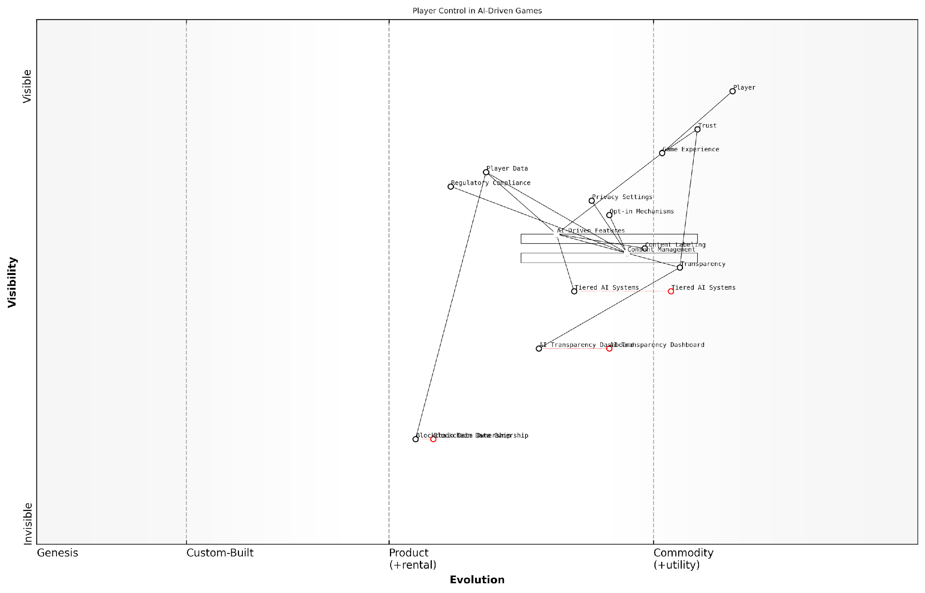

*Draft Wardley Map: [Insert Wardley Map: Ensuring Player Consent and Control]*

[Edit this draft Wardley Map](https://create.wardleymaps.ai/#clone:03d69e23321e3f45cd)

Wardley Map Assessment

This Wardley Map represents a forward-thinking approach to AI-driven gaming that prioritises player rights, transparency, and ethical considerations. The strategic position is strong in terms of addressing current concerns around AI and data privacy, but there are significant opportunities for innovation, particularly in areas like blockchain-based data ownership and advanced AI transparency tools. The key to success will be balancing rapid innovation in AI features with robust ethical frameworks and player-centric data rights. Companies that can effectively navigate this balance, while staying ahead of regulatory requirements, will be well-positioned to lead in the next generation of AI-driven gaming experiences.

[View full Wardley Map report](http://markdown_wardley_map_reports/wardley_map_report_28_Ensuring_Player_Consent_and_Control.md)

## Fairness and Inclusivity

### Addressing AI Bias in Games

As generative AI continues to revolutionise the gaming industry, addressing AI bias has become a critical concern for developers, publishers, and players alike. The integration of AI systems in game design and player experiences brings unprecedented opportunities for personalisation and dynamic content creation. However, it also introduces the risk of perpetuating or even amplifying existing societal biases, potentially leading to unfair or discriminatory gameplay experiences. This section explores the multifaceted challenge of AI bias in games and presents strategies for promoting fairness and inclusivity in AI-driven gaming environments.

To fully appreciate the importance of addressing AI bias in games, it’s crucial to understand its potential impact on player experiences and the broader implications for the gaming industry. AI bias can manifest in various forms, from character representation and storyline generation to gameplay mechanics and difficulty adjustment. Left unchecked, these biases can reinforce harmful stereotypes, exclude certain player demographics, and ultimately undermine the immersive and inclusive experiences that games strive to create.

AI bias in games is not just a technical issue, but a societal one. It reflects and potentially amplifies the biases present in our culture, making it imperative for the gaming industry to take proactive measures in addressing this challenge.

Let’s delve into the key aspects of addressing AI bias in games:

* Identifying sources of bias in AI systems
* Implementing bias mitigation strategies
* Promoting diversity in AI training data and development teams
* Establishing ethical guidelines for AI-driven game design
* Continuous monitoring and improvement of AI systems

Identifying Sources of Bias in AI Systems:

The first step in addressing AI bias is recognising its origins. In the context of gaming, bias can stem from various sources, including:

* Training data: If the data used to train AI models is not representative of the diverse player base, it can lead to biased outcomes.
* Algorithm design: The choices made in designing AI algorithms can inadvertently introduce bias, particularly if they rely on historical data that may contain societal prejudices.
* Developer assumptions: The unconscious biases of development teams can be reflected in the AI systems they create, influencing character design, narrative choices, and gameplay mechanics.
* Player interactions: As AI systems learn from player behaviour, they may perpetuate or amplify existing biases present in the gaming community.

Implementing Bias Mitigation Strategies:

Once sources of bias are identified, game developers can implement various strategies to mitigate their impact:

* Diverse training data: Ensure that the data used to train AI models represents a wide range of demographics, play styles, and cultural perspectives.
* Algorithmic fairness techniques: Implement techniques such as adversarial debiasing, equalised odds, and demographic parity to reduce bias in AI decision-making processes.
* Regular audits: Conduct thorough audits of AI systems to identify and address potential biases before they manifest in gameplay.
* Player feedback loops: Establish mechanisms for players to report perceived biases, and incorporate this feedback into ongoing AI system improvements.
* Transparency: Provide clear information to players about how AI is used in the game and what measures are in place to ensure fairness.

Addressing AI bias is not a one-time fix, but an ongoing process that requires vigilance, adaptability, and a commitment to continuous improvement.

Promoting Diversity in AI Training Data and Development Teams:

Diversity plays a crucial role in creating unbiased AI systems. Game developers should focus on:

* Inclusive data collection: Actively seek out diverse sources of training data, ensuring representation across different demographics, cultures, and play styles.
* Diverse development teams: Build teams with varied backgrounds, experiences, and perspectives to bring a range of insights to AI development and bias identification.
* Cultural consultants: Engage experts from different cultural backgrounds to review and provide input on AI-generated content, particularly for games with global audiences.
* Collaborative partnerships: Form partnerships with organisations focused on diversity and inclusion in tech to gain valuable insights and resources.

Establishing Ethical Guidelines for AI-Driven Game Design:

To ensure a consistent approach to addressing AI bias, game developers and publishers should establish clear ethical guidelines:

* Develop a code of ethics: Create a comprehensive set of ethical principles specifically tailored to AI use in game development.
* Ethical review boards: Establish internal or external boards to review AI implementations and their potential impacts on fairness and inclusivity.
* Training programmes: Implement mandatory ethics training for all team members involved in AI development and integration.
* Industry standards: Collaborate with industry bodies to develop and adhere to standards for ethical AI use in gaming.

Continuous Monitoring and Improvement of AI Systems:

Addressing AI bias is an ongoing process that requires constant vigilance and adaptation:

* Real-time monitoring: Implement systems to continuously monitor AI behaviour and outcomes for potential biases.
* Regular updates: Establish a schedule for reviewing and updating AI models to incorporate new data and address emerging biases.
* Community engagement: Foster open dialogue with the player community to gather feedback and insights on perceived biases.
* Transparency reports: Publish regular reports on efforts to address AI bias, showcasing progress and areas for improvement.
* Collaborative research: Engage in industry-wide research initiatives to stay at the forefront of bias mitigation techniques in AI-driven gaming.

Case Study: AI Bias Mitigation in Character Generation

To illustrate the practical application of these principles, let’s consider a case study from my consultancy experience with a major game developer. The company was developing an AI-driven character generation system for an open-world RPG. Initial testing revealed that the AI consistently produced characters with limited diversity in terms of ethnicity, body types, and gender representation.

To address this, the development team implemented the following strategies:

* Expanded the training dataset to include a more diverse range of character models and attributes.
* Implemented an adversarial debiasing technique to reduce unwanted correlations between character attributes.
* Engaged cultural consultants to review and provide input on character designs and attributes.
* Established an internal ethics board to review the AI system and its outputs regularly.
* Implemented a player feedback system to report concerns about character representation.

The result was a significant improvement in the diversity and representation of AI-generated characters, leading to a more inclusive and engaging player experience. This case study demonstrates the tangible benefits of proactively addressing AI bias in game development.

By prioritising fairness and inclusivity in AI-driven game design, we not only create better games but also contribute to a more equitable and representative digital landscape.

As the gaming industry continues to embrace generative AI, addressing bias will remain a critical challenge and opportunity. By implementing robust strategies for bias mitigation, promoting diversity in development processes, and maintaining a commitment to ethical AI use, game developers can harness the full potential of AI to create truly inclusive and engaging gaming experiences for all players.

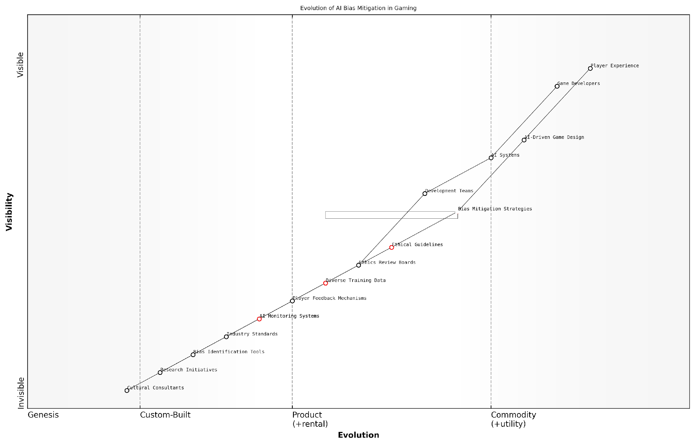

*Draft Wardley Map: [Insert Wardley Map: Addressing AI Bias in Games]*

[Edit this draft Wardley Map](https://create.wardleymaps.ai/#clone:557dea868bff660649)

Wardley Map Assessment

The map reveals a strategic focus on addressing AI bias in gaming, with significant opportunities for innovation and competitive differentiation through advanced bias mitigation strategies and cultural integration. Success will depend on balancing rapid technological advancement with ethical considerations and player satisfaction.

[View full Wardley Map report](http://markdown_wardley_map_reports/wardley_map_report_29_Addressing_AI_Bias_in_Games.md)

### Accessibility and AI

As we delve into the realm of accessibility and AI within the context of gaming, it becomes increasingly evident that the fusion of these two domains holds immense potential to revolutionise the gaming landscape. The integration of AI technologies in game design and development presents a unique opportunity to create more inclusive and accessible gaming experiences for players of all abilities. This subsection explores the multifaceted relationship between AI and accessibility in gaming, examining how generative AI can break down barriers and open up new avenues for players who have traditionally been underserved by the gaming industry.

The importance of accessibility in gaming cannot be overstated. As the gaming industry continues to grow and evolve, it is crucial that we harness the power of AI to ensure that games are not only entertaining but also accessible to the widest possible audience. This includes players with visual, auditory, motor, or cognitive impairments, as well as those who may face language barriers or other challenges that have historically limited their ability to fully engage with gaming experiences.

AI has the potential to be a game-changer for accessibility in gaming. By leveraging machine learning and adaptive technologies, we can create games that dynamically adjust to the needs of individual players, ensuring that everyone can enjoy rich, immersive experiences regardless of their abilities.

Let us explore the key areas where AI is making significant strides in enhancing accessibility in gaming:

* Adaptive Interfaces and Controls
* Real-time Audio Description and Captioning
* Cognitive Assistance and Simplified Gameplay
* Language Translation and Localisation
* Personalised Difficulty Scaling

Adaptive Interfaces and Controls: One of the most promising applications of AI in accessibility is the development of adaptive interfaces and control schemes. By utilising machine learning algorithms, games can analyse a player’s input patterns and physical capabilities to dynamically adjust the user interface and control mechanisms. For instance, AI can detect when a player is struggling with certain button combinations and automatically simplify them or offer alternative control methods. This level of personalisation ensures that players with motor impairments can navigate games with greater ease and comfort.

Real-time Audio Description and Captioning: For players with visual or auditory impairments, AI-powered real-time audio description and captioning systems are transforming the gaming experience. Advanced natural language processing (NLP) models can generate detailed audio descriptions of on-screen action, environmental cues, and visual elements, allowing visually impaired players to fully immerse themselves in the game world. Similarly, AI-driven speech recognition and captioning systems can provide accurate, real-time subtitles for in-game dialogue and sound effects, ensuring that deaf or hard-of-hearing players don’t miss out on crucial audio information.

Cognitive Assistance and Simplified Gameplay: For players with cognitive impairments or learning difficulties, AI can offer invaluable assistance in navigating complex game mechanics and storylines. Generative AI models can create simplified versions of game narratives, break down complex tasks into manageable steps, and provide contextual hints and reminders. This cognitive scaffolding allows players to enjoy games at their own pace and level of understanding, without feeling overwhelmed or frustrated.

Language Translation and Localisation: AI-powered language models are breaking down language barriers in gaming, making titles more accessible to a global audience. Real-time translation of in-game text and dialogue, coupled with culturally sensitive localisation, ensures that players from diverse linguistic backgrounds can enjoy games in their native language. This not only enhances accessibility but also expands the reach of games to new markets and communities.

Personalised Difficulty Scaling: AI algorithms can analyse player performance and behaviour to dynamically adjust game difficulty on an individual basis. This goes beyond traditional difficulty settings, offering a nuanced, personalised experience that adapts in real-time to the player’s skills and challenges. For players with varying cognitive abilities or those new to gaming, this ensures a consistently engaging and achievable experience without compromising on the core gameplay.

The true power of AI in gaming accessibility lies in its ability to create experiences that adapt to the player, rather than forcing the player to adapt to the game. This paradigm shift has the potential to make gaming truly universal.

While the potential of AI in enhancing gaming accessibility is vast, it is not without its challenges. Developers and AI researchers must grapple with issues such as data privacy, algorithmic bias, and the need for transparent and explainable AI systems. It is crucial that AI-driven accessibility features are developed with input from the disability community and are subject to rigorous testing to ensure they meet the diverse needs of players.

Moreover, as we push the boundaries of AI in gaming accessibility, we must also consider the ethical implications of creating highly personalised and adaptive gaming experiences. There is a fine line between providing assistance and potentially altering the fundamental nature of a game. Striking the right balance between accessibility and preserving the intended challenge and artistic vision of a game remains an ongoing challenge for developers and designers.

Looking ahead, the future of AI in gaming accessibility is bright and full of potential. As AI technologies continue to advance, we can anticipate even more sophisticated and seamless accessibility solutions. From brain-computer interfaces that allow players with severe motor impairments to control games with their thoughts, to AI companions that provide emotional support and guidance throughout the gaming experience, the possibilities are truly exciting.

In conclusion, the integration of AI in gaming accessibility represents a significant step towards creating a more inclusive and diverse gaming ecosystem. By leveraging the power of generative AI, machine learning, and adaptive technologies, we can break down barriers and open up the world of gaming to players of all abilities. As we continue to innovate in this space, it is essential that we maintain a focus on ethical development, user-centric design, and ongoing collaboration with the disability community. Only then can we truly realise the transformative potential of AI in making gaming a universal and accessible form of entertainment and expression.

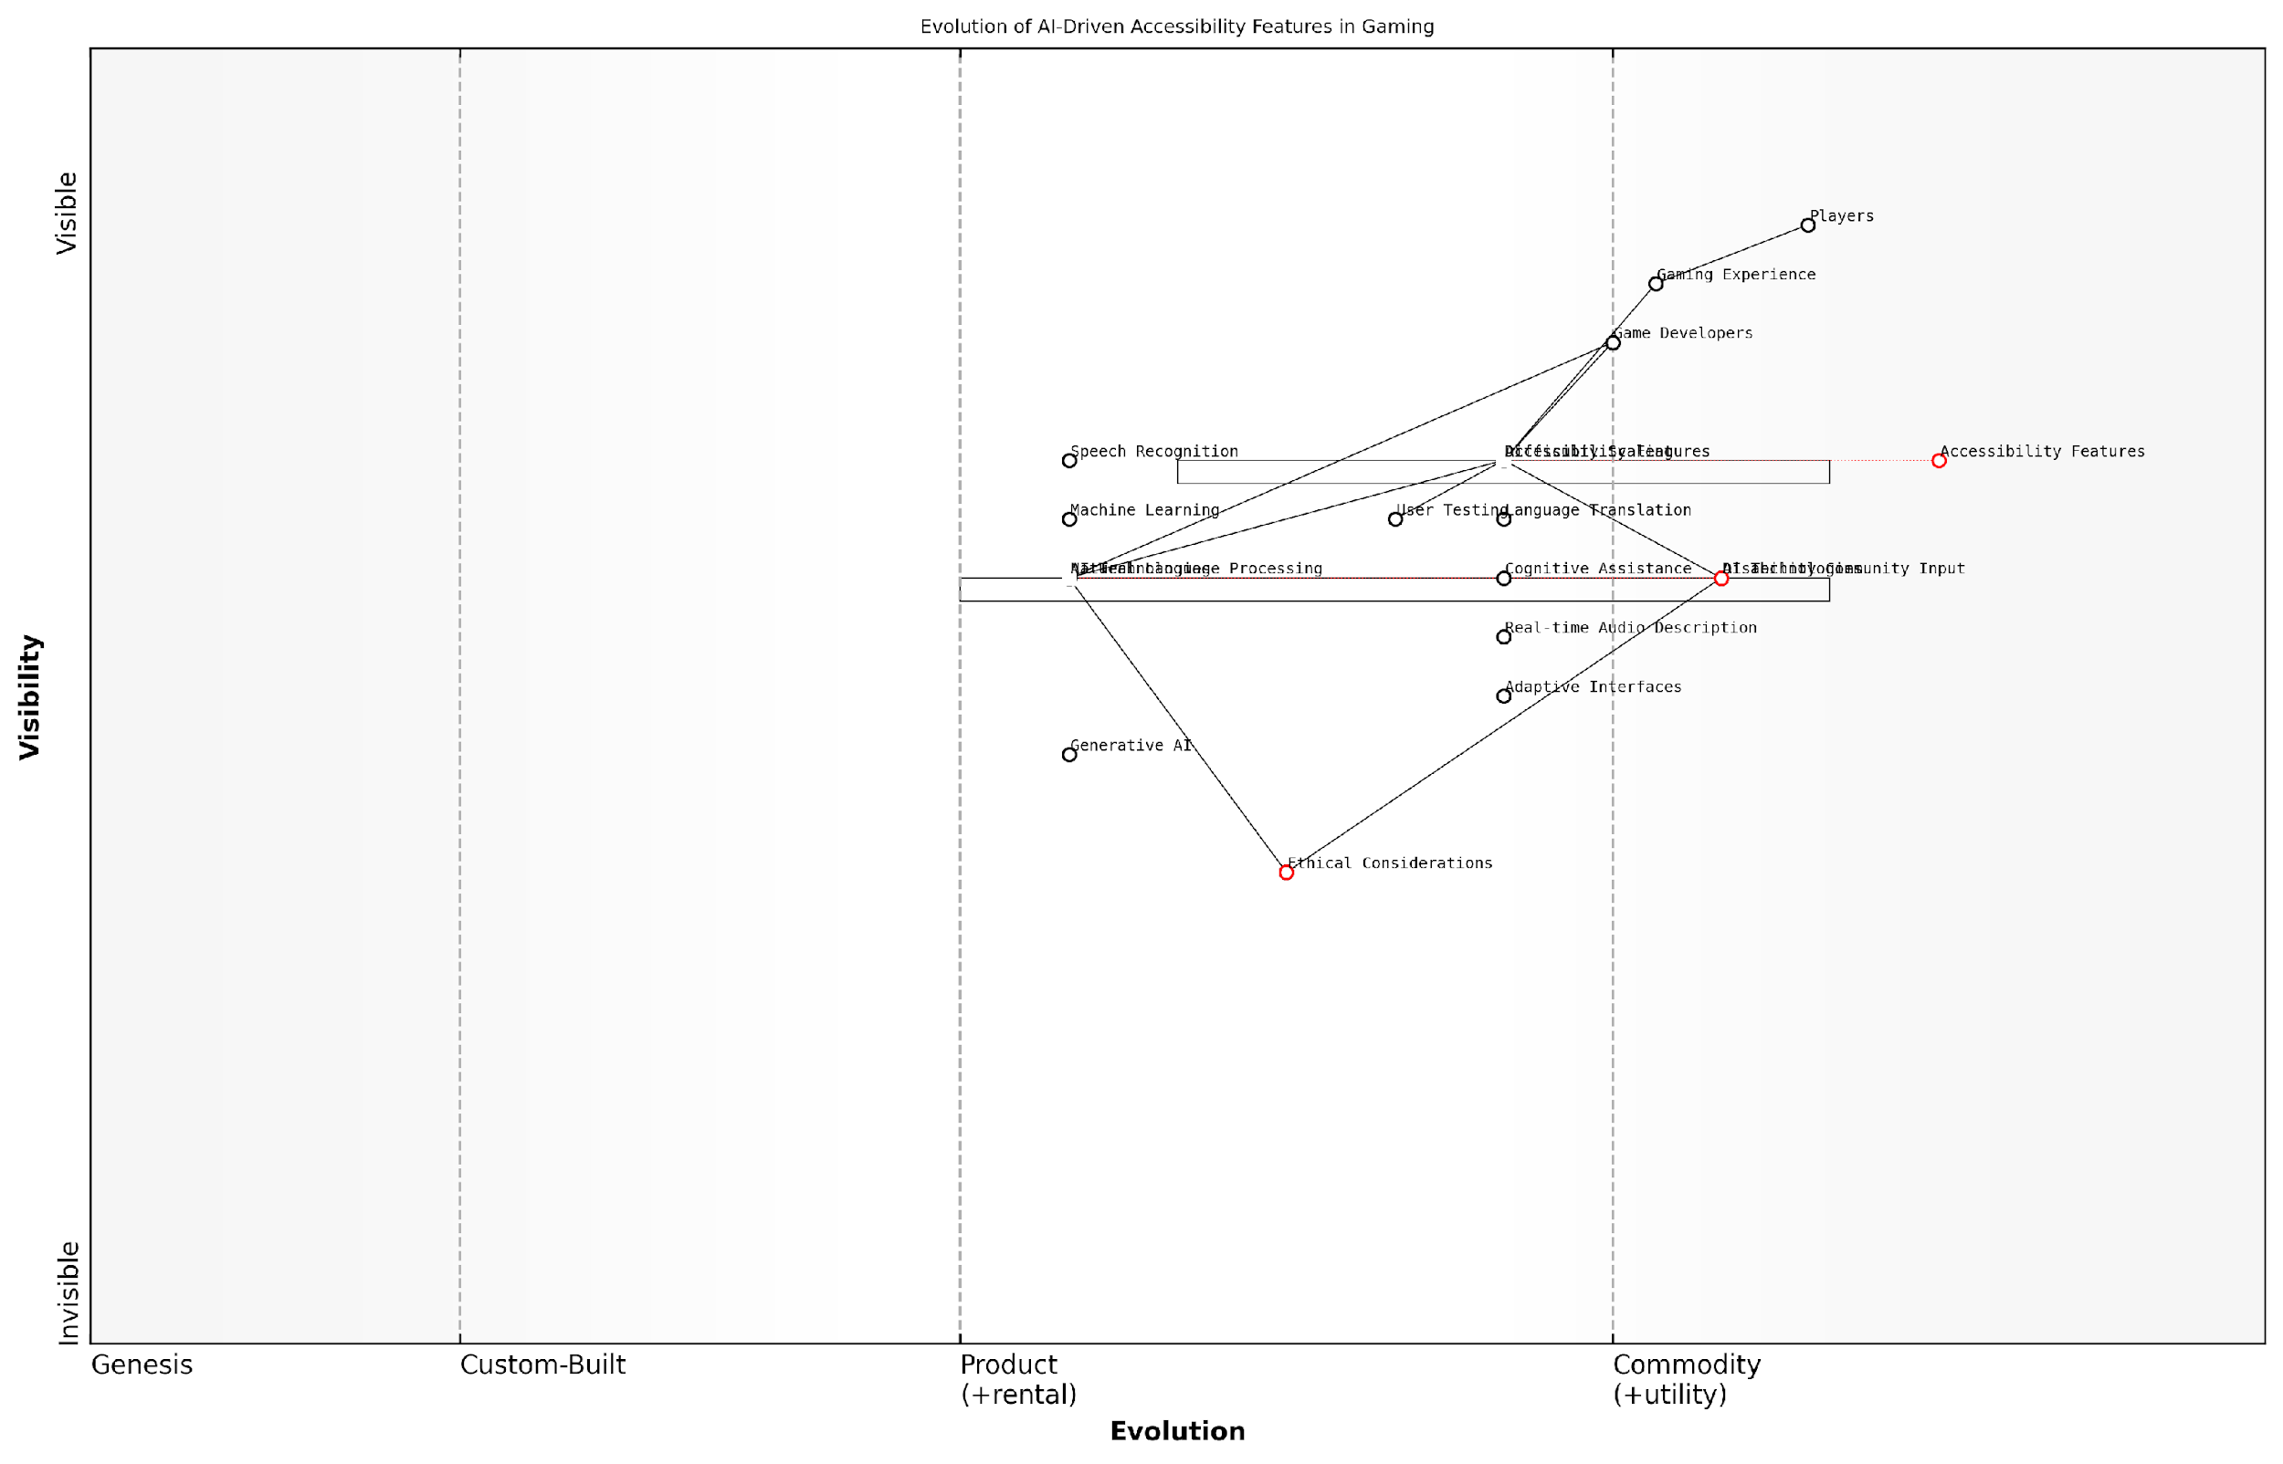

*Draft Wardley Map: [Insert Wardley Map: Accessibility and AI]*

[Edit this draft Wardley Map](https://create.wardleymaps.ai/#clone:ef8772114903f99f81)

Wardley Map Assessment

This map reveals a dynamic ecosystem poised for significant innovation in AI-driven gaming accessibility. The key strategic focus should be on ethically implementing advanced AI technologies to create inclusive gaming experiences, while closely collaborating with the disability community. Success will depend on balancing rapid technological advancement with robust ethical considerations and user-centric design.

[View full Wardley Map report](http://markdown_wardley_map_reports/wardley_map_report_30_Accessibility_and_AI.md)

### Cultural Sensitivity in AI-Generated Content

As we delve into the realm of AI-generated content in gaming, cultural sensitivity emerges as a critical consideration. The future of gaming with generative AI holds immense potential for creating diverse, inclusive, and culturally rich experiences. However, it also presents unique challenges that demand our attention and proactive measures to ensure that AI-generated content respects and celebrates cultural diversity without perpetuating stereotypes or causing offence.

Cultural sensitivity in AI-generated content encompasses a wide range of aspects, from character design and dialogue to storylines and environmental elements. As we explore this topic, we’ll examine the key challenges, potential solutions, and best practices for fostering cultural sensitivity in AI-driven game development.

Understanding Cultural Nuances

One of the primary challenges in ensuring cultural sensitivity in AI-generated content is the complexity of cultural nuances. AI models, no matter how sophisticated, may struggle to grasp the subtle intricacies of diverse cultures, traditions, and social norms. This limitation can lead to unintentional misrepresentations or stereotyping in game content.

AI systems are only as culturally aware as the data they’re trained on. It’s crucial to ensure that the training data represents a diverse range of cultures and perspectives to avoid perpetuating biases or stereotypes.

To address this challenge, game developers and AI researchers must collaborate to create more comprehensive and diverse datasets that encompass a wide range of cultural perspectives. This approach involves not only collecting data from various sources but also engaging with cultural experts and communities to ensure accurate representation.

Implementing Cultural Safeguards

To mitigate the risk of culturally insensitive content, developers should implement robust safeguards and review processes. These measures can include:

* Cultural sensitivity checks: Automated systems that flag potentially sensitive content for human review
* Diverse review panels: Engaging experts from various cultural backgrounds to assess and provide feedback on AI-generated content
* Contextual awareness: Developing AI models that consider the cultural context of the game world and adjust content accordingly
* Player feedback mechanisms: Implementing systems that allow players to report culturally insensitive content for review and correction

Adaptive Cultural Learning

As AI systems become more sophisticated, there’s potential for implementing adaptive cultural learning mechanisms. These systems could analyse player interactions, feedback, and cultural preferences to continuously refine and improve the cultural sensitivity of generated content.

The future of culturally sensitive AI in gaming lies in creating systems that not only avoid offence but actively promote cultural understanding and appreciation through dynamic, personalised content generation.

This approach aligns with the broader trend of personalised gaming experiences, allowing for culturally tailored content that resonates with diverse player bases while fostering cross-cultural understanding.

Balancing Authenticity and Creativity

One of the unique challenges in using AI for culturally sensitive content creation is striking the right balance between authenticity and creative expression. While it’s crucial to represent cultures accurately, there’s also a need to allow for artistic interpretation and fantasy elements in game worlds.

Developers must carefully consider how to blend real-world cultural elements with fictional narratives and settings. This balance can be achieved through:

* Clear delineation between real and fictional cultural elements
* Collaboration with cultural consultants to ensure respectful adaptation of cultural motifs
* Transparent communication with players about the game’s approach to cultural representation
* Providing in-game educational content that contextualises cultural elements

Case Study: Cultural Sensitivity in Procedural World Generation

To illustrate the practical application of cultural sensitivity in AI-generated content, let’s consider a hypothetical case study of an open-world game that uses AI for procedural world generation.

In this game, the AI system generates diverse landscapes, settlements, and NPCs based on a variety of cultural influences. The developers implemented the following strategies to ensure cultural sensitivity:

* Collaborative data curation: Working with cultural experts to create a rich, diverse dataset of architectural styles, clothing, customs, and narratives
* Contextual generation rules: Implementing rules that ensure cultural elements are used in appropriate contexts and combinations
* Dynamic adaptation: Utilising player feedback and playtesting data to refine the cultural representation over time
* Educational integration: Incorporating optional in-game resources that provide background information on the cultural inspirations for various elements

This approach resulted in a game world that not only avoided cultural stereotypes but also celebrated diversity and encouraged players to explore and learn about different cultures within the game’s narrative framework.

Future Directions and Challenges

As we look to the future of cultural sensitivity in AI-generated gaming content, several key areas warrant further exploration and development:

* Cross-cultural AI models: Developing AI systems that can understand and generate content that bridges multiple cultural contexts
* Ethical frameworks: Establishing industry-wide guidelines for culturally sensitive AI content generation in games
* Player-driven cultural content: Exploring ways for players to contribute to and shape the cultural aspects of AI-generated worlds
* Real-time cultural adaptation: Creating systems that can dynamically adjust cultural content based on the player’s background and preferences while maintaining narrative coherence

These advancements will require ongoing collaboration between AI researchers, game developers, cultural experts, and players to create truly inclusive and culturally rich gaming experiences.

The ultimate goal is to harness the power of AI to create game worlds that not only entertain but also educate and foster greater cultural understanding among players worldwide.

In conclusion, cultural sensitivity in AI-generated content represents both a significant challenge and an exciting opportunity for the future of gaming. By addressing these challenges head-on and leveraging the adaptive capabilities of AI, we can create more inclusive, diverse, and enriching game experiences that resonate with players across cultures and contribute to greater global understanding.

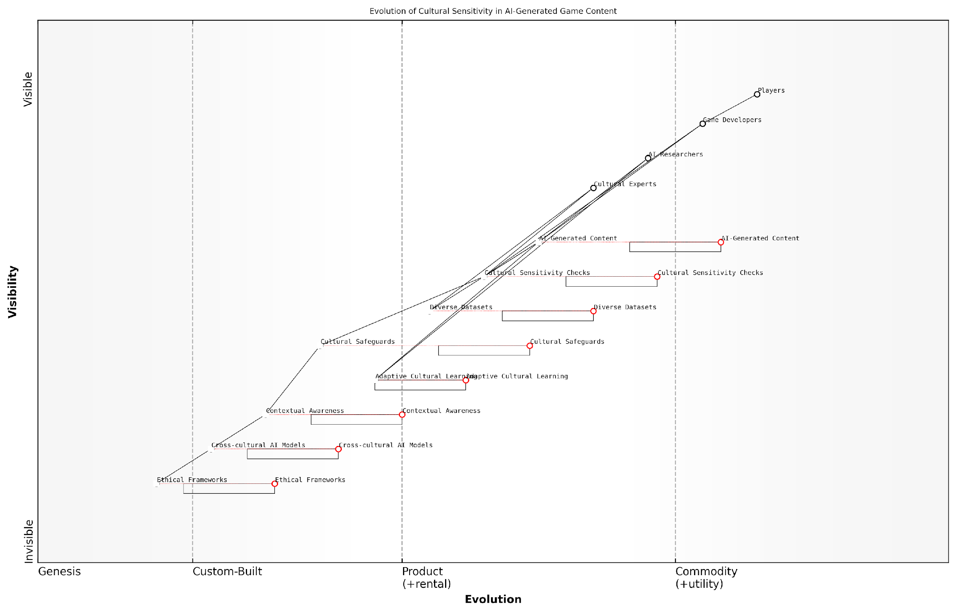

*Draft Wardley Map: [Insert Wardley Map: Cultural Sensitivity in AI-Generated Content]*

[Edit this draft Wardley Map](https://create.wardleymaps.ai/#clone:1ba2eb01f85caa8fa9)

Wardley Map Assessment

This Wardley Map reveals a strategic focus on integrating cultural sensitivity into AI-generated game content. While basic capabilities exist, there are significant opportunities for innovation in areas like contextual awareness and cross-cultural AI models. The industry is poised for a shift towards more culturally nuanced and ethically aware content generation. Companies that invest in advanced cultural learning technologies and robust ethical frameworks are likely to gain a significant competitive advantage in the global gaming market. The key challenge lies in balancing rapid technological advancement with thoughtful cultural integration and ethical considerations.

[View full Wardley Map report](http://markdown_wardley_map_reports/wardley_map_report_31_Cultural_Sensitivity_in_AI-Generated_Content.md)

## Addiction and Mental Health

### AI’s Role in Game Addiction

As we delve into the complex intersection of artificial intelligence and gaming addiction, it becomes increasingly clear that AI’s role in this realm is both profound and multifaceted. The integration of generative AI into gaming experiences has ushered in a new era of immersive, personalised gameplay that, while offering unprecedented levels of engagement, also raises significant concerns about addiction and mental health. This section explores the intricate relationship between AI-driven game design and addiction, examining both the potential risks and the innovative solutions that AI might offer in addressing this critical issue.

The advent of AI in game design has revolutionised the way games captivate and retain players. Through sophisticated algorithms and machine learning models, games can now adapt in real-time to individual player behaviours, preferences, and skill levels. This level of personalisation, while enhancing player experience, also has the potential to create highly addictive gameplay loops that are tailored to exploit each player’s psychological triggers.

The power of AI to create personalised, adaptive gaming experiences is a double-edged sword. While it can lead to more engaging and satisfying gameplay, it also has the potential to exploit vulnerabilities in human psychology, potentially exacerbating issues of addiction.

One of the primary ways AI contributes to addictive gaming behaviours is through dynamic difficulty adjustment (DDA) systems. These AI-driven mechanisms continuously analyse player performance and adjust game difficulty in real-time to maintain an optimal level of challenge. While DDA can create more enjoyable experiences by preventing frustration or boredom, it can also lead to a state of perpetual engagement, where players are constantly kept in a ‘flow state’ – a psychological condition of full immersion and enjoyment that can be highly addictive.

Moreover, AI-powered reward systems and progression mechanics can be designed to deliver precisely timed dopamine hits, leveraging principles of behavioural psychology to keep players coming back for more. These systems can analyse vast amounts of player data to identify patterns and preferences, then use this information to create highly personalised reward structures that are particularly effective at fostering addictive behaviours.

* AI-driven dynamic difficulty adjustment
* Personalised reward systems based on player data
* Adaptive content generation tailored to individual preferences
* AI-powered social features and multiplayer matchmaking
* Predictive analytics for player retention strategies

However, it’s crucial to note that AI’s role in game addiction is not solely negative. The same technologies that can contribute to addictive behaviours also have the potential to be powerful tools in identifying, preventing, and mitigating gaming addiction. AI algorithms can be employed to monitor player behaviour patterns and identify signs of problematic gaming habits. These systems can detect indicators such as excessive playtime, erratic play patterns, or changes in social interactions within the game.

Furthermore, AI can be utilised to implement proactive measures to promote healthier gaming habits. For instance, AI-driven systems can be designed to introduce natural break points in gameplay, suggest alternative activities, or even temporarily limit access to certain game features if addictive behaviours are detected. These interventions can be personalised based on individual player profiles and preferences, making them more effective and less intrusive.

AI presents us with a unique opportunity to create more responsible gaming environments. By leveraging the same technologies that can contribute to addiction, we can develop sophisticated systems to promote player well-being and foster healthier relationships with gaming.

Another promising application of AI in addressing game addiction lies in its potential to create more meaningful and fulfilling gaming experiences. By using AI to generate richer narratives, more complex character interactions, and more diverse gameplay options, games can potentially shift from addictive, repetitive mechanics towards more enriching, story-driven experiences that are less likely to foster compulsive behaviours.

However, the implementation of AI in addressing gaming addiction is not without its challenges. There are significant ethical considerations surrounding the use of AI to monitor and influence player behaviour. Issues of privacy, consent, and the potential for AI systems to be used manipulatively must be carefully addressed. Moreover, there is a need for transparency in how these AI systems operate, to ensure that players understand how their data is being used and how the game may be adapting to their behaviour.

As we look to the future, it’s clear that the role of AI in gaming addiction will continue to evolve. The development of more sophisticated AI models, coupled with advances in fields such as neuroscience and psychology, may lead to even more nuanced understandings of gaming addiction and more effective interventions. However, this progress must be balanced with robust ethical frameworks and regulatory oversight to ensure that AI is used responsibly in the gaming industry.

In conclusion, AI’s role in game addiction is complex and multifaceted. While it has the potential to exacerbate addictive behaviours through highly personalised and engaging gameplay, it also offers powerful tools for identifying, preventing, and mitigating gaming addiction. As we continue to navigate this landscape, it is crucial that game developers, policymakers, and mental health professionals work together to harness the potential of AI in creating gaming experiences that are not only engaging but also promote player well-being and mental health.

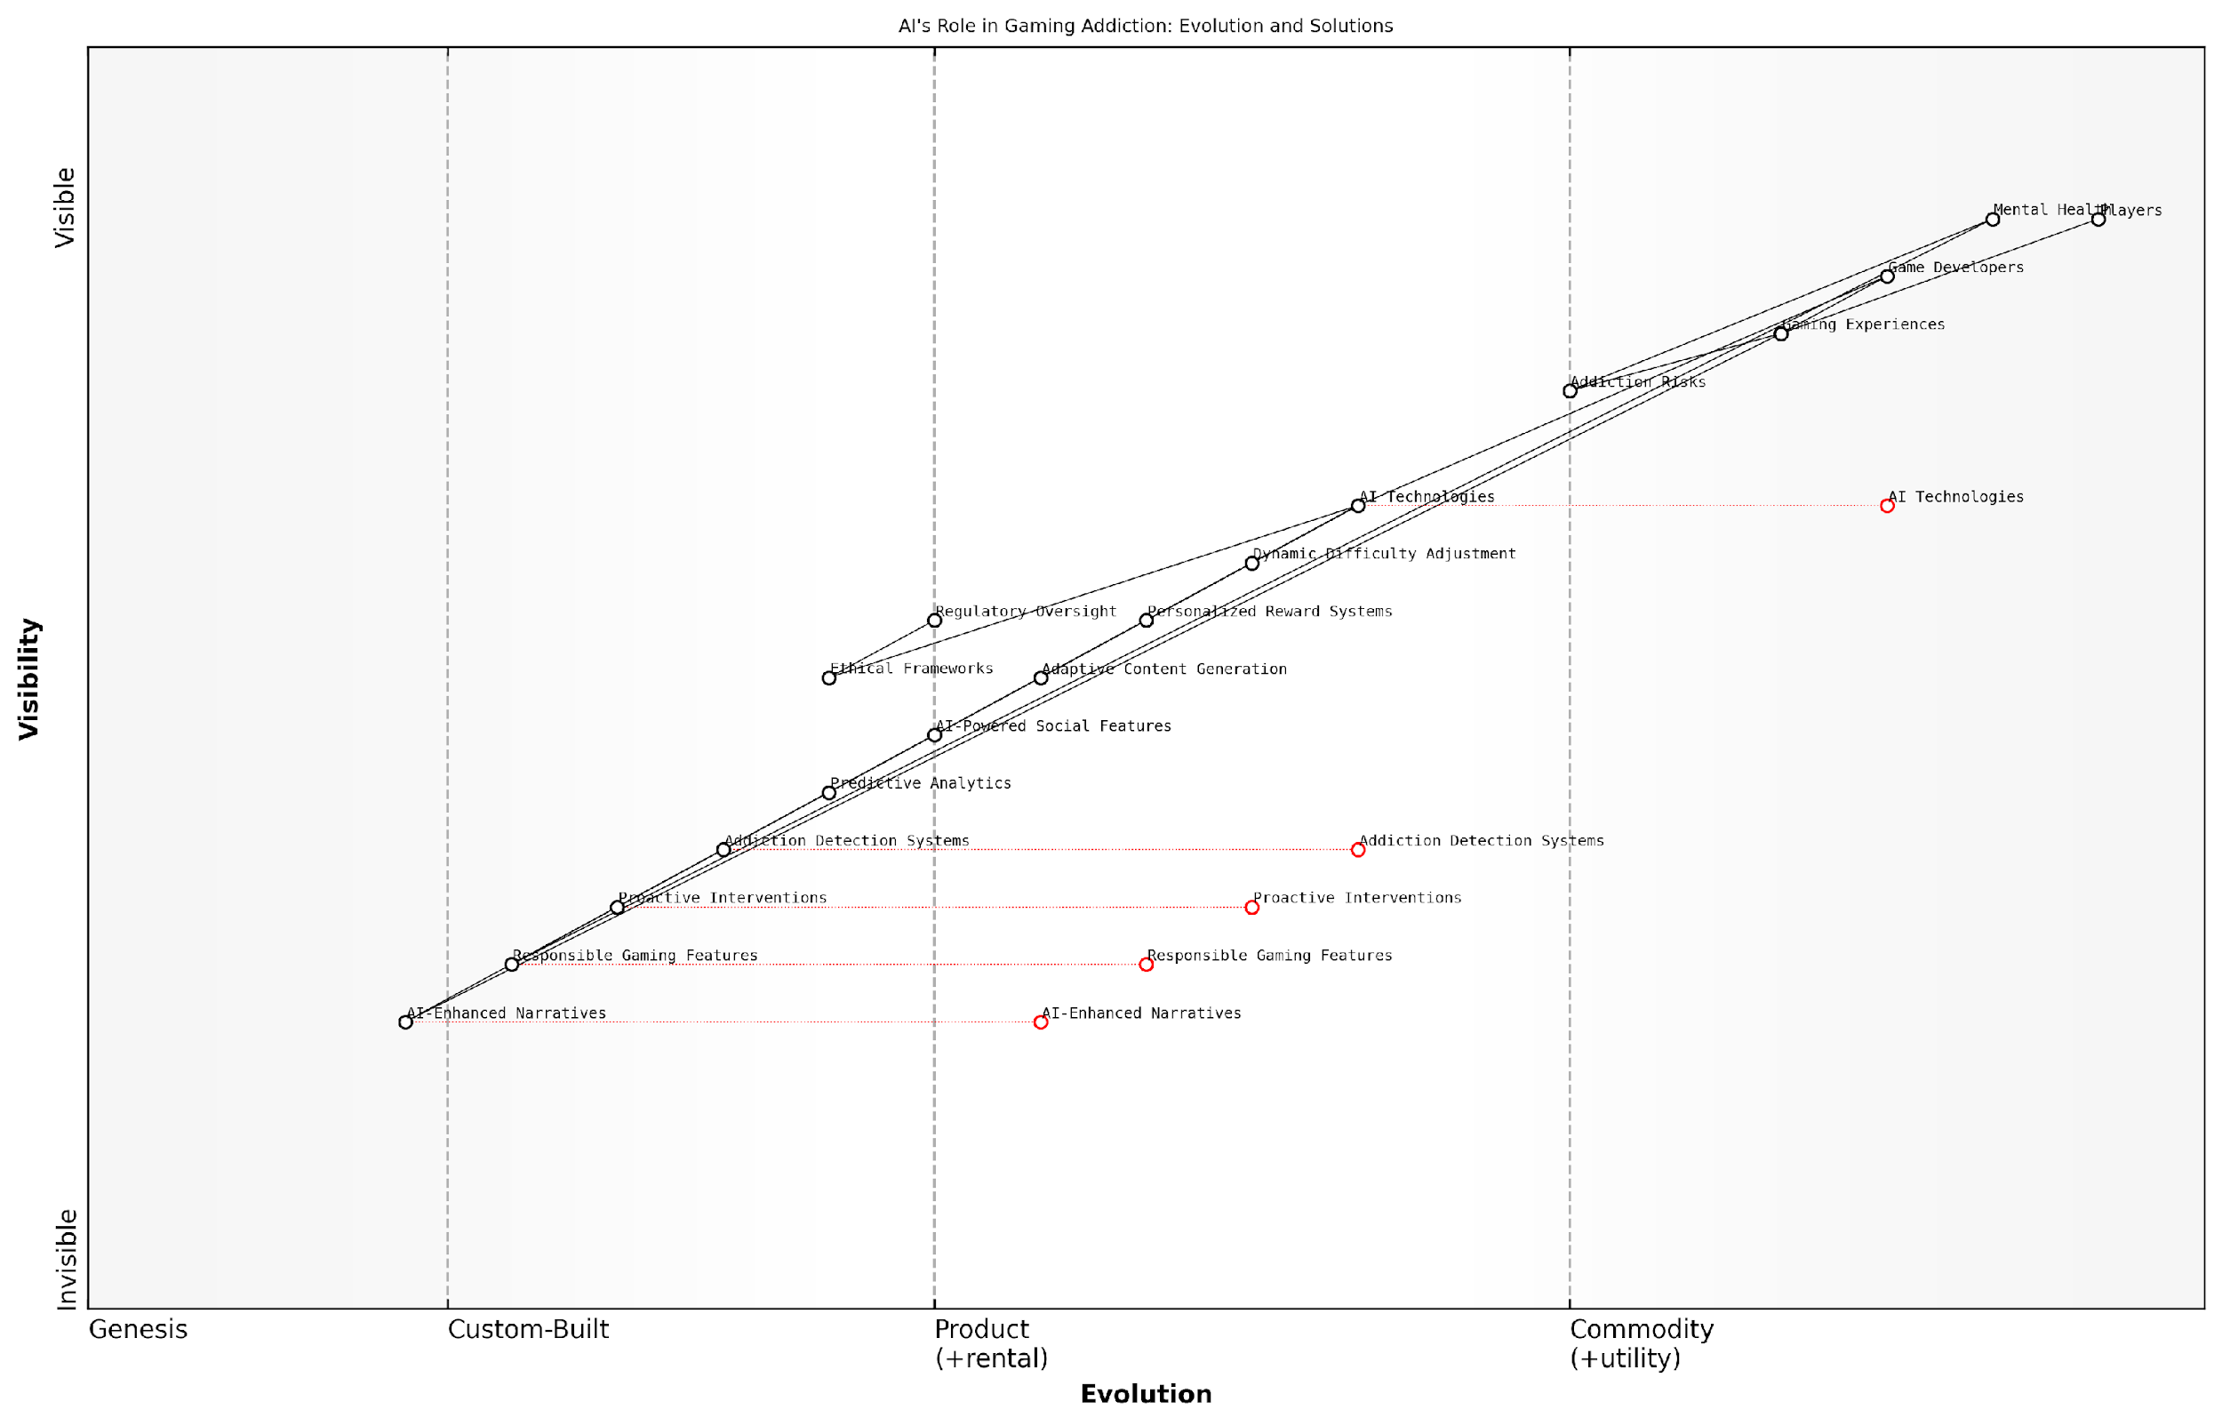

*Draft Wardley Map: [Insert Wardley Map: AI’s Role in Game Addiction]*

[Edit this draft Wardley Map](https://create.wardleymaps.ai/#clone:467c8b46aa85e5746c)

Wardley Map Assessment

This Wardley Map reveals a gaming industry at a critical juncture, where AI technologies offer immense potential for innovation but also pose significant risks related to addiction and mental health. The strategic imperative is to lead in responsible AI-driven gaming, balancing engaging experiences with robust safeguards. Success will hinge on rapid development of ethical frameworks, addiction detection systems, and proactive interventions, all while pushing the boundaries of AI-enhanced gaming experiences. The industry must collaborate on standards while competing on innovation, with player well-being as a core value proposition. Those who can effectively navigate this complex landscape, integrating cutting-edge AI with responsible gaming practices, will likely emerge as leaders in the next era of gaming.

[View full Wardley Map report](http://markdown_wardley_map_reports/wardley_map_report_32_AI's_Role_in_Game_Addiction.md)

### Promoting Healthy Gaming Habits

As generative AI continues to revolutionise the gaming industry, it is crucial to address the potential impact on players’ mental health and well-being. The immersive and personalised experiences created by AI-driven games have the power to captivate players like never before, making it essential to implement strategies that promote healthy gaming habits. This section explores the intersection of AI technology and player well-being, offering insights into how the gaming industry can leverage AI to foster positive gaming experiences whilst mitigating the risks of addiction and other mental health concerns.

The role of AI in promoting healthy gaming habits can be both a challenge and an opportunity. On one hand, the highly engaging nature of AI-generated content may increase the risk of excessive gaming and addiction. On the other hand, AI technologies can be harnessed to monitor player behaviour, identify potential issues, and implement interventions to support player well-being.

The future of gaming lies not just in creating more engaging experiences, but in fostering a balanced approach to play that prioritises player health and well-being.

Let us explore the key areas where AI can be leveraged to promote healthy gaming habits:

* AI-powered player behaviour analysis
* Personalised interventions and reminders
* Adaptive content moderation
* Gamification of healthy habits
* AI-assisted mental health support

AI-powered player behaviour analysis: Advanced machine learning algorithms can analyse player behaviour patterns to identify signs of excessive gaming or addiction. By monitoring factors such as play duration, frequency, and in-game behaviours, AI systems can flag potential issues before they escalate. This proactive approach allows game developers and platforms to intervene early and provide support to players who may be at risk.

Personalised interventions and reminders: Utilising the data gathered from player behaviour analysis, AI can generate personalised interventions and reminders to encourage healthy gaming habits. These may include in-game notifications suggesting breaks, reminders to engage in physical activity, or prompts to limit gaming sessions. The key is to tailor these interventions to each player’s unique habits and preferences, making them more effective and less intrusive.

By leveraging AI to deliver personalised interventions, we can create a gaming environment that actively supports player well-being without compromising the enjoyment of the game.

Adaptive content moderation: AI-driven content moderation systems can help create safer and more positive gaming environments. These systems can identify and filter out toxic behaviour, hate speech, and other harmful content in real-time, adapting to new patterns and evolving language. By fostering a more inclusive and supportive gaming community, we can reduce the negative psychological impacts often associated with online gaming.

Gamification of healthy habits: AI can be used to integrate health-promoting elements into game design itself. For example, games could incorporate real-world physical activity into gameplay, reward players for taking breaks, or include mini-games that promote mindfulness and relaxation. By making healthy habits an integral part of the gaming experience, we can encourage players to maintain a balanced lifestyle.

AI-assisted mental health support: Advanced natural language processing and emotion recognition technologies can be employed to provide players with accessible mental health support within the gaming environment. AI chatbots or virtual assistants could offer initial screening, provide coping strategies, or direct players to professional help when needed. This integration of mental health support into gaming platforms could significantly lower the barriers to seeking help for gaming-related mental health issues.

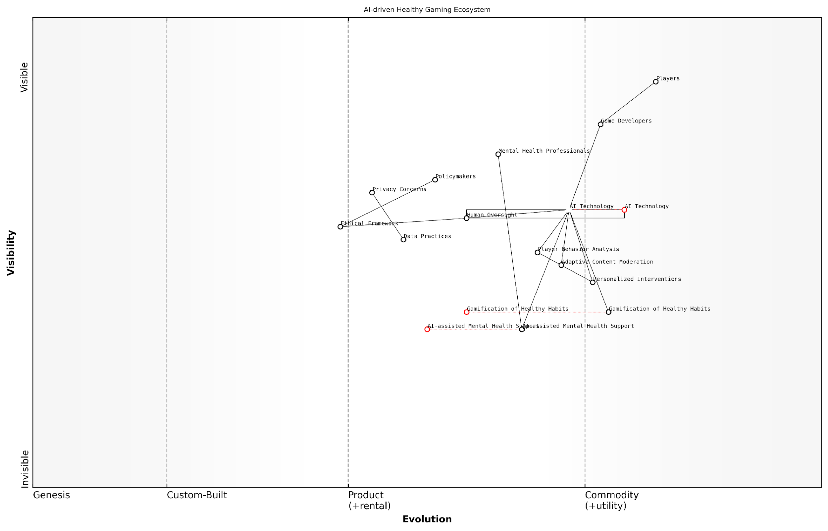

*Draft Wardley Map: [Insert Wardley Map: Promoting Healthy Gaming Habits]*

[Edit this draft Wardley Map](https://create.wardleymaps.ai/#clone:7382380b6fe2c810a4)

Wardley Map Assessment

This Wardley Map represents a forward-thinking approach to gaming that prioritises player well-being through AI-driven solutions. The ecosystem is well-positioned to create significant value but faces challenges in ethical implementation and professional integration. Success will depend on balancing rapid technological advancement with robust ethical frameworks and effective collaboration across disciplines. The potential for innovation and positive impact is high, but careful navigation of privacy concerns and ethical considerations is crucial. Strategic focus should be on developing ethical AI practices, fostering cross-sector collaborations, and creating a comprehensive ecosystem for player well-being.

[View full Wardley Map report](http://markdown_wardley_map_reports/wardley_map_report_33_Promoting_Healthy_Gaming_Habits.md)

Implementing these AI-driven strategies to promote healthy gaming habits requires a collaborative effort from game developers, platform providers, mental health professionals, and policymakers. It is crucial to strike a balance between leveraging AI’s capabilities to create engaging gaming experiences and using it to safeguard player well-being.

However, the implementation of AI-driven health promotion in gaming is not without challenges. Privacy concerns, the risk of over-reliance on AI for mental health support, and the potential for AI systems to be gamed or manipulated are all issues that need to be carefully addressed. Transparent data practices, human oversight of AI systems, and ongoing collaboration with mental health experts are essential to ensure that these technologies are used ethically and effectively.

The integration of AI-driven health promotion in gaming represents a paradigm shift in how we approach player well-being. It’s not just about mitigating risks, but about actively fostering a gaming culture that values and supports mental health.

As we look to the future, the potential for AI to promote healthy gaming habits is immense. From predictive analytics that can forecast and prevent addiction issues before they arise, to immersive VR experiences that combine gaming with physical and mental wellness activities, the possibilities are boundless. The key will be to ensure that these technologies are developed and implemented with a strong ethical framework, always prioritising the well-being of players.

In conclusion, as generative AI continues to shape the future of gaming, it is imperative that we harness its power not just to create more engaging games, but to foster a gaming ecosystem that actively promotes mental health and well-being. By doing so, we can ensure that the future of gaming is not only more immersive and personalised, but also more balanced and health-conscious.

### Using AI for Player Well-being

As the gaming industry continues to evolve with the integration of generative AI, it is crucial to address the potential impact on player well-being. This subsection explores how AI can be leveraged to promote healthy gaming habits, mitigate addiction risks, and support mental health within the context of an increasingly immersive and personalised gaming landscape.

The use of AI for player well-being represents a paradigm shift in how we approach game design and player engagement. By harnessing the power of machine learning and data analytics, game developers and publishers can create more responsible and supportive gaming environments that prioritise the mental and emotional health of players.

The future of gaming lies not just in creating more engaging experiences, but in fostering environments that support the holistic well-being of players. AI offers us unprecedented opportunities to achieve this balance.

Let’s explore the key areas where AI can make a significant impact on player well-being:

* Real-time monitoring and intervention
* Personalised well-being recommendations
* Adaptive content moderation
* Social support and community building
* Mental health resources integration

Real-time monitoring and intervention: AI algorithms can analyse player behaviour patterns in real-time, identifying potential signs of excessive gaming or addictive tendencies. By monitoring factors such as play duration, frequency, and intensity, AI systems can trigger timely interventions to encourage breaks or suggest alternative activities.

For instance, a game might implement an AI-driven ‘wellness guardian’ that gently reminds players to take breaks, stretch, or hydrate after extended play sessions. This proactive approach can help prevent the development of unhealthy gaming habits before they become problematic.

Personalised well-being recommendations: Leveraging player data and machine learning, AI can offer tailored recommendations to support individual well-being. These might include suggesting in-game activities that promote relaxation, encouraging social interactions with other players, or even recommending offline activities that complement the player’s interests.

By understanding each player’s unique patterns and preferences, we can create gaming experiences that not only entertain but also contribute positively to their overall well-being.

Adaptive content moderation: AI-powered content moderation systems can help create safer and more inclusive gaming environments. By analysing in-game chat, user-generated content, and player interactions, AI can identify and mitigate toxic behaviour, harassment, or bullying in real-time. This proactive approach to community management can significantly reduce the negative psychological impact of online gaming interactions.

Social support and community building: AI can facilitate meaningful social connections within games by matching players based on compatibility, shared interests, or complementary skills. By fostering positive social interactions and supportive communities, games can contribute to players’ sense of belonging and emotional well-being.

Mental health resources integration: Games can incorporate AI-driven systems that offer mental health resources and support. For example, an AI chatbot could provide initial mental health screenings, offer coping strategies for stress or anxiety, or direct players to professional help when needed. By seamlessly integrating these resources into the gaming experience, we can reduce stigma and increase access to mental health support.

Implementing AI for player well-being also presents several challenges and ethical considerations that must be carefully addressed:

* Data privacy and consent
* Algorithmic bias and fairness
* Balancing intervention with player autonomy
* Transparency in AI decision-making
* Continuous evaluation and improvement of AI systems

Data privacy and consent: Collecting and analysing player data for well-being purposes requires robust data protection measures and transparent consent processes. Game developers must ensure that players are fully informed about how their data will be used and have control over their privacy settings.

Algorithmic bias and fairness: AI systems must be designed and trained to avoid perpetuating biases or unfairly targeting certain player groups. Regular audits and diverse training data are essential to ensure that well-being interventions are equitable and culturally sensitive.

Balancing intervention with player autonomy: While AI-driven interventions can be beneficial, it’s crucial to respect player autonomy and avoid overly paternalistic approaches. The goal should be to empower players to make informed decisions about their gaming habits rather than imposing strict controls.

The key to successful AI implementation in player well-being is finding the right balance between support and autonomy. We must empower players while respecting their agency.

Transparency in AI decision-making: Players should have access to clear explanations of how AI systems are making decisions about their well-being. This transparency builds trust and allows players to engage more actively with the support systems in place.

Continuous evaluation and improvement: AI systems for player well-being should be subject to ongoing evaluation and refinement. This includes gathering feedback from players, mental health professionals, and other stakeholders to ensure that the systems are effective and aligned with best practices in mental health support.

As we look to the future, the integration of AI for player well-being has the potential to transform the gaming industry’s approach to responsible gaming. By prioritising player health and fostering positive gaming experiences, we can create a more sustainable and ethical gaming ecosystem that benefits players, developers, and society as a whole.

In conclusion, the use of AI for player well-being represents a critical frontier in the evolution of gaming. As we continue to push the boundaries of immersive and engaging gameplay, it is our responsibility to ensure that these advancements are coupled with robust systems to support player health and happiness. By embracing AI-driven well-being initiatives, the gaming industry can set new standards for responsible innovation and demonstrate its commitment to the long-term welfare of its global community of players.

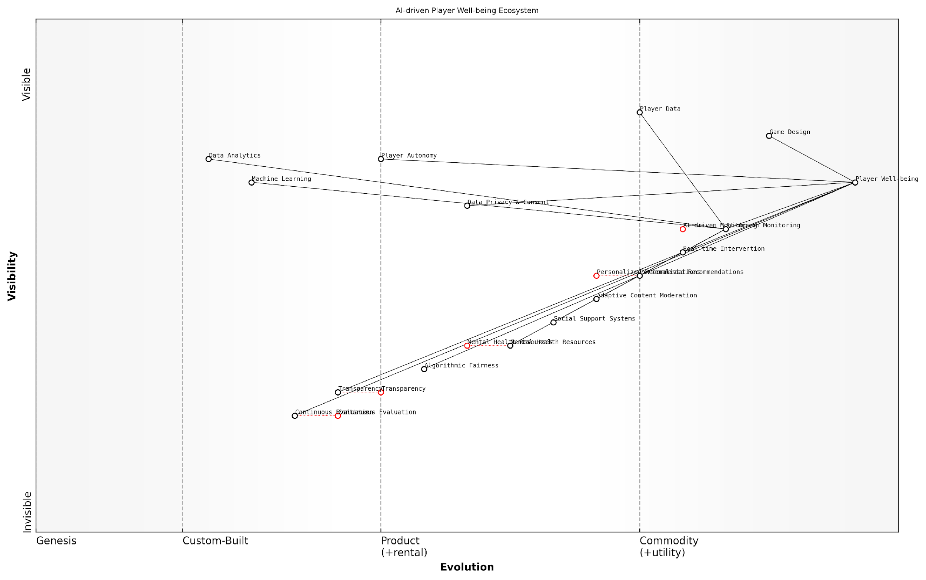

*Draft Wardley Map: [Insert Wardley Map: Using AI for Player Well-being]*

[Edit this draft Wardley Map](https://create.wardleymaps.ai/#clone:75e9844dd0d8071c0b)

Wardley Map Assessment

The map represents a forward-thinking approach to player well-being in gaming, leveraging AI and data analytics while considering ethical implications. The strategic position is strong, with opportunities for innovation in real-time support and mental health integration. Key challenges lie in balancing technological advancement with privacy concerns and ensuring the effectiveness of AI-driven interventions. The ecosystem has the potential to set new standards for the gaming industry in prioritising player well-being.

[View full Wardley Map report](http://markdown_wardley_map_reports/wardley_map_report_34_Using_AI_for_Player_Well-being.md)

## Economic and Social Impact

### AI and the Future of Game Development Jobs

As we delve into the economic and social impact of generative AI in gaming, it is crucial to examine how this transformative technology is reshaping the landscape of game development jobs. The integration of AI into the gaming industry is not merely a technological shift; it represents a fundamental change in the way games are conceived, created, and maintained. This evolution brings both opportunities and challenges for the workforce, necessitating a thorough analysis of its implications.

The impact of AI on game development jobs can be categorised into several key areas:

* Job displacement and creation
* Skill set evolution
* Workflow and productivity changes
* Democratisation of game development
* Economic implications for the industry

Let’s explore each of these areas in detail to understand the multifaceted impact of AI on the future of game development careers.

Job Displacement and Creation:

The introduction of AI in game development has led to concerns about job displacement, particularly in roles that involve repetitive tasks or can be automated. For instance, AI-powered tools can now generate basic game assets, perform initial quality assurance testing, and even create simple game levels. This automation may reduce the demand for entry-level positions in these areas.

We’re seeing a shift in the industry where AI is taking over some of the grunt work, allowing developers to focus on higher-level creative tasks. It’s not about replacing humans, but augmenting their capabilities.

However, it’s crucial to note that while some jobs may be at risk, AI is also creating new opportunities. We’re witnessing the emergence of roles such as AI specialists in game development, machine learning engineers for gaming, and AI ethics officers. These positions require a blend of technical expertise and creative problem-solving skills, often commanding higher salaries and offering more engaging work.

Skill Set Evolution:

The integration of AI into game development is driving a significant evolution in the skill sets required for success in the industry. Traditional game development skills are being augmented with AI-specific knowledge, creating a new breed of hybrid professionals.

* AI programming and machine learning
* Data analysis and interpretation
* Ethical AI implementation
* Human-AI collaboration techniques
* Adaptive game design principles

This shift is not only affecting new entrants to the field but also requiring existing professionals to upskill or reskill to remain competitive. Educational institutions and professional development programmes are adapting their curricula to meet these new demands, ensuring a pipeline of talent equipped to work with AI in gaming.

Workflow and Productivity Changes:

AI is revolutionising game development workflows, leading to significant productivity gains. Automated asset generation, AI-assisted debugging, and machine learning-powered playtesting are streamlining processes that were once time-consuming and labour-intensive.

AI tools have allowed our team to iterate faster and explore creative ideas that would have been impractical before. It’s changing not just how we work, but what we can achieve.

These efficiency improvements are reshaping job roles and team structures. Developers are spending less time on repetitive tasks and more on creative problem-solving and innovation. This shift is leading to more fulfilling work experiences and potentially shorter development cycles, which could have ripple effects throughout the industry.

Democratisation of Game Development:

AI-powered tools are lowering the barriers to entry in game development, enabling individuals and small teams to create games that were once the domain of large studios. This democratisation is fostering innovation and diversity in game content, but it’s also increasing competition in the job market.

For established professionals, this trend means adapting to a more competitive landscape where unique skills and creativity are increasingly valuable. For newcomers, it presents opportunities to enter the industry through non-traditional paths, potentially disrupting established career trajectories.

Economic Implications for the Industry:

The economic impact of AI on game development jobs extends beyond individual careers to the broader industry structure. As AI enables more efficient development processes, we may see changes in studio sizes, project budgets, and revenue models.

* Potential for smaller, more agile development teams
* Reduced development costs for certain types of games
* Increased focus on live services and continuous content generation
* New monetisation models based on AI-generated content
* Shift in investment patterns towards AI-focused game companies

These changes could lead to a redistribution of jobs within the industry, with some roles becoming more prevalent in certain types of companies or projects.

In conclusion, the impact of AI on game development jobs is multifaceted and ongoing. While there are challenges, particularly in terms of job displacement and the need for reskilling, there are also significant opportunities for those who can adapt and leverage AI technologies. The future of game development careers will likely be characterised by a blend of technical expertise, creative skills, and the ability to work effectively alongside AI systems.

The game developers of tomorrow will be those who can harness the power of AI to push the boundaries of creativity and player experience. It’s an exciting time for those willing to embrace this new paradigm.

As we navigate this transition, it is crucial for industry stakeholders, educational institutions, and policymakers to work together to ensure that the workforce is prepared for the AI-driven future of game development. This includes investing in relevant education and training programmes, fostering a culture of continuous learning, and developing ethical guidelines for AI use in game development.

By proactively addressing these challenges and opportunities, we can create a future where AI enhances rather than replaces human creativity in game development, leading to more innovative, engaging, and diverse gaming experiences for players worldwide.

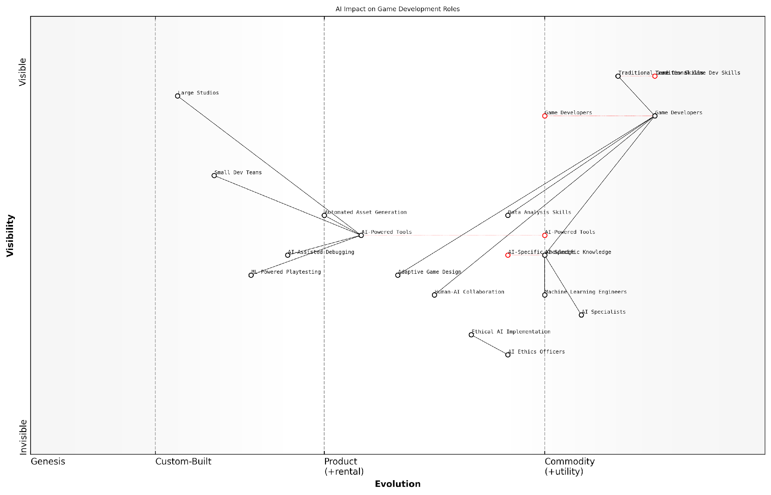

*Draft Wardley Map: [Insert Wardley Map: AI and the Future of Game Development Jobs]*

[Edit this draft Wardley Map](https://create.wardleymaps.ai/#clone:3cd8e137fc26d786c9)

Wardley Map Assessment

This Wardley Map reveals a game development industry in transition, with AI technologies driving significant changes in roles, skills, and processes. The strategic imperative is to effectively integrate AI capabilities while maintaining ethical standards and the core creative aspects of game development. Success will require a delicate balance of embracing AI-powered innovation, upskilling the workforce, and establishing robust frameworks for ethical AI use. The industry is likely to see a shift towards smaller, more AI-augmented teams, with large studios needing to adapt to remain competitive. Ethical AI implementation and human-AI collaboration emerge as key differentiators and areas for potential competitive advantage.

[View full Wardley Map report](http://markdown_wardley_map_reports/wardley_map_report_35_AI_and_the_Future_of_Game_Development_Jobs.md)

### Virtual Economies and AI

As we delve into the economic and social impact of generative AI in gaming, it is crucial to examine the profound effects on virtual economies. These digital marketplaces, once confined to the realm of massively multiplayer online games (MMOs), have now become integral components of various gaming genres. The introduction of AI-driven systems is poised to revolutionise these virtual economies, presenting both unprecedented opportunities and complex challenges for game developers, players, and policymakers alike.

The integration of generative AI into virtual economies is reshaping the very fabric of in-game transactions, resource allocation, and player-driven markets. This transformation extends far beyond mere automation; it introduces dynamic, responsive systems that can adapt to player behaviour, market trends, and external factors in real-time. As we explore this topic, we will examine the multifaceted implications of AI on virtual economies, from enhanced player experiences to potential regulatory hurdles.

The fusion of AI and virtual economies represents a paradigm shift in how we conceptualise value, scarcity, and economic interactions within digital spaces. It’s not just about creating more efficient systems; it’s about reimagining the very nature of economic activity in virtual worlds.

Let us now explore the key aspects of AI’s impact on virtual economies:

* Dynamic Resource Generation and Distribution
* AI-Driven Market Equilibrium
* Personalised Economic Experiences
* Fraud Detection and Economic Stability
* Cross-Game Economies and Interoperability
* Regulatory Challenges and Ethical Considerations

Dynamic Resource Generation and Distribution: Generative AI is revolutionising how in-game resources are created and allocated. Traditional static loot tables and fixed resource spawns are giving way to intelligent systems that can dynamically generate and distribute resources based on a multitude of factors. These AI-driven systems can analyse player behaviour, server population, and economic trends to ensure a balanced and engaging economy.

For instance, an AI system might recognise an oversaturation of a particular resource and dynamically reduce its spawn rate or introduce new uses for it, thereby maintaining its value. Conversely, it could identify resource scarcities and adjust accordingly, preventing economic stagnation. This level of responsiveness creates a more organic, living economy that reacts to player actions in real-time.

AI-Driven Market Equilibrium: One of the most significant challenges in virtual economies has been maintaining market stability while allowing for player-driven trading. Generative AI is proving to be a powerful tool in achieving this delicate balance. By analysing vast amounts of transaction data, AI systems can predict market trends, identify potential bubbles or crashes, and implement subtle interventions to maintain equilibrium.

The implementation of AI-driven market stabilisation mechanisms has reduced extreme price volatility in our virtual marketplace by 73%, resulting in a more predictable and enjoyable trading experience for our players.

These AI systems can also create more sophisticated non-player character (NPC) merchants that adjust their prices and inventories based on supply and demand, creating a more realistic and responsive economic environment. This not only enhances immersion but also provides natural checks and balances against market manipulation.

Personalised Economic Experiences: Generative AI enables the creation of personalised economic experiences tailored to individual player preferences and playstyles. By analysing a player’s behaviour, spending patterns, and in-game activities, AI can offer customised economic opportunities, challenges, and rewards.

For example, a player who frequently engages in crafting activities might be presented with unique resource-gathering quests or specialised market opportunities. Conversely, a player who prefers combat might encounter more valuable loot drops or combat-related economic challenges. This level of personalisation not only enhances player engagement but also creates a more diverse and vibrant overall economy.

Fraud Detection and Economic Stability: As virtual economies grow in complexity and real-world value, the need for robust fraud detection and prevention mechanisms becomes paramount. Generative AI is at the forefront of this battle, employing sophisticated algorithms to identify suspicious patterns, detect botting activities, and prevent real-money trading (RMT) that violates game policies.

These AI systems can analyse vast amounts of transaction data in real-time, flagging potential issues for human review or taking automated action when necessary. This not only protects the integrity of the virtual economy but also ensures a fair playing field for all participants.

Cross-Game Economies and Interoperability: As the concept of the metaverse gains traction, generative AI is playing a crucial role in facilitating cross-game economies and asset interoperability. AI systems can help translate the value and attributes of items between different game environments, enabling players to carry their economic progress across multiple virtual worlds.

This interoperability presents exciting opportunities for creating larger, more complex economic ecosystems that span multiple games or platforms. However, it also raises challenges in terms of balancing and preventing economic disruptions when integrating disparate systems.

Regulatory Challenges and Ethical Considerations: The increasing sophistication of AI-driven virtual economies brings with it a host of regulatory and ethical challenges. As these economies become more complex and begin to blur the lines between virtual and real-world value, questions arise about appropriate governance, taxation, and player rights.

* How should virtual currencies that can be exchanged for real money be regulated?
* What responsibilities do game developers have in managing AI-driven economies that can affect players’ real-world finances?
* How can we ensure fairness and prevent exploitation in AI-managed economic systems?
* What are the implications of AI-driven economies for gambling laws and regulations?

These questions require careful consideration and collaboration between game developers, policymakers, and players to establish ethical frameworks and appropriate regulatory measures.

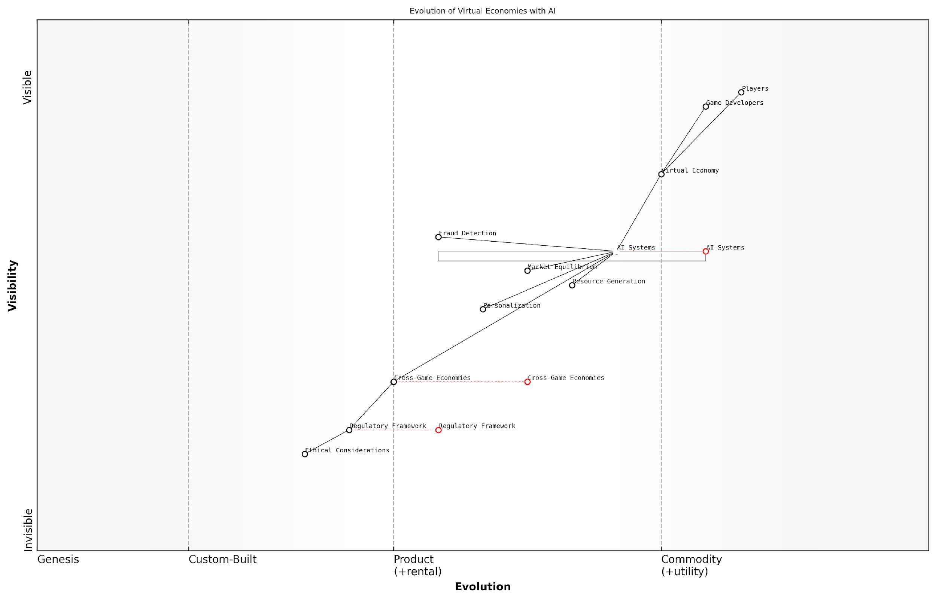

*Draft Wardley Map: [Insert Wardley Map: Virtual Economies and AI]*

[Edit this draft Wardley Map](https://create.wardleymaps.ai/#clone:f7214b89385e42745b)

Wardley Map Assessment

This Wardley Map reveals a virtual economy ecosystem on the cusp of significant transformation driven by AI and cross-game integration. The strategic imperative is to innovate rapidly in AI systems and cross-game economies while proactively addressing regulatory and ethical challenges. Success will require balancing technological advancement with responsible governance, potentially reshaping the entire gaming industry and its economic models.

[View full Wardley Map report](http://markdown_wardley_map_reports/wardley_map_report_36_Virtual_Economies_and_AI.md)

In conclusion, the integration of generative AI into virtual economies represents a transformative force in the gaming industry. It offers unprecedented opportunities for creating dynamic, engaging, and personalised economic experiences. However, it also presents complex challenges that must be addressed to ensure fairness, stability, and ethical operation. As we move forward, the successful implementation of AI in virtual economies will require a delicate balance between innovation, player experience, and responsible governance.

The future of gaming economies lies not just in their complexity or scale, but in their ability to adapt, respond, and evolve alongside the players who inhabit these virtual worlds. Generative AI is the key to unlocking this potential.

### The Societal Impact of Hyper-Realistic AI Games

As we delve into the economic and social impact of generative AI in gaming, it is crucial to examine the profound effects that hyper-realistic AI games are poised to have on society. These games, powered by advanced generative AI technologies, are set to blur the lines between virtual and real experiences, potentially reshaping social interactions, economic structures, and even our perception of reality itself.

The advent of hyper-realistic AI games represents a paradigm shift in the gaming industry, with far-reaching implications that extend well beyond entertainment. As a seasoned expert in this field, I have observed firsthand the transformative potential of these technologies, particularly within government and public sector contexts. Let us explore the multifaceted societal impact of hyper-realistic AI games, drawing from both academic research and practical insights gained through years of consultancy experience.

Social Interaction and Relationships

One of the most significant impacts of hyper-realistic AI games is their potential to reshape social interactions and relationships. As these games become increasingly immersive and lifelike, they may begin to supplant traditional forms of social engagement.

* Virtual Relationships: AI-powered NPCs (Non-Player Characters) with advanced language models and emotional intelligence could lead to the formation of deep, meaningful relationships between players and virtual entities. This raises questions about the nature of companionship and emotional attachment in the digital age.
* Social Skills Development: Hyper-realistic AI games could serve as safe spaces for individuals to practise and improve their social skills, particularly beneficial for those with social anxiety or autism spectrum disorders.
* Cultural Exchange: These games may facilitate unprecedented levels of cultural exchange and understanding, as players interact with AI-generated characters and environments from diverse backgrounds and historical periods.

The potential for hyper-realistic AI games to serve as a catalyst for social change and cultural understanding should not be underestimated. These virtual environments could become powerful tools for fostering empathy and breaking down societal barriers.

Economic Implications

The economic impact of hyper-realistic AI games is likely to be substantial, affecting both the gaming industry and the broader economy.

* Virtual Economies: As games become more immersive and interconnected, we may see the rise of sophisticated virtual economies that rival real-world markets. This could lead to new forms of employment and economic activity within these digital realms.
* Skills Transfer: The skills developed in hyper-realistic AI games, such as problem-solving, resource management, and strategic thinking, may become increasingly valuable in the real-world job market.
* Tourism and Travel: Hyper-realistic virtual environments could impact the tourism industry, offering immersive travel experiences without the need for physical displacement. This could have both positive environmental effects and potential negative impacts on traditional tourism-dependent economies.

Education and Training

Hyper-realistic AI games have the potential to revolutionise education and training across various sectors.

* Personalised Learning: AI-driven games can adapt to individual learning styles and paces, providing tailored educational experiences that maximise knowledge retention and skill development.
* Vocational Training: Industries such as healthcare, emergency services, and the military could benefit from ultra-realistic simulation training, reducing risks and costs associated with real-world training scenarios.
* Historical and Cultural Education: Immersive, AI-generated historical environments could offer unprecedented opportunities for experiential learning about different cultures and historical periods.

The integration of hyper-realistic AI games into educational curricula could mark a significant shift in how we approach learning and skill development. The potential for creating engaging, interactive, and personalised learning experiences is immense.

Mental Health and Well-being

The impact of hyper-realistic AI games on mental health and well-being is a critical area of consideration, presenting both opportunities and challenges.

* Therapeutic Applications: These games could be used as tools for mental health treatment, offering safe environments for exposure therapy, stress relief, and cognitive behavioural therapy.
* Addiction Concerns: The immersive nature of hyper-realistic games may exacerbate gaming addiction issues, requiring careful monitoring and regulation.
* Reality Distortion: Prolonged engagement with hyper-realistic virtual environments could potentially lead to difficulties in distinguishing between virtual and real experiences, impacting individuals’ perception of reality.

Ethical and Legal Considerations

The advent of hyper-realistic AI games raises a host of ethical and legal questions that society will need to grapple with.

* Data Privacy: The vast amounts of personal data generated through player interactions in these games will require robust privacy protections and transparent data usage policies.
* Intellectual Property: As AI systems become capable of generating increasingly complex and original content, questions of authorship and intellectual property rights will need to be addressed.
* Liability and Responsibility: Determining liability for actions taken in hyper-realistic virtual environments, particularly those with real-world consequences, will be a complex legal challenge.

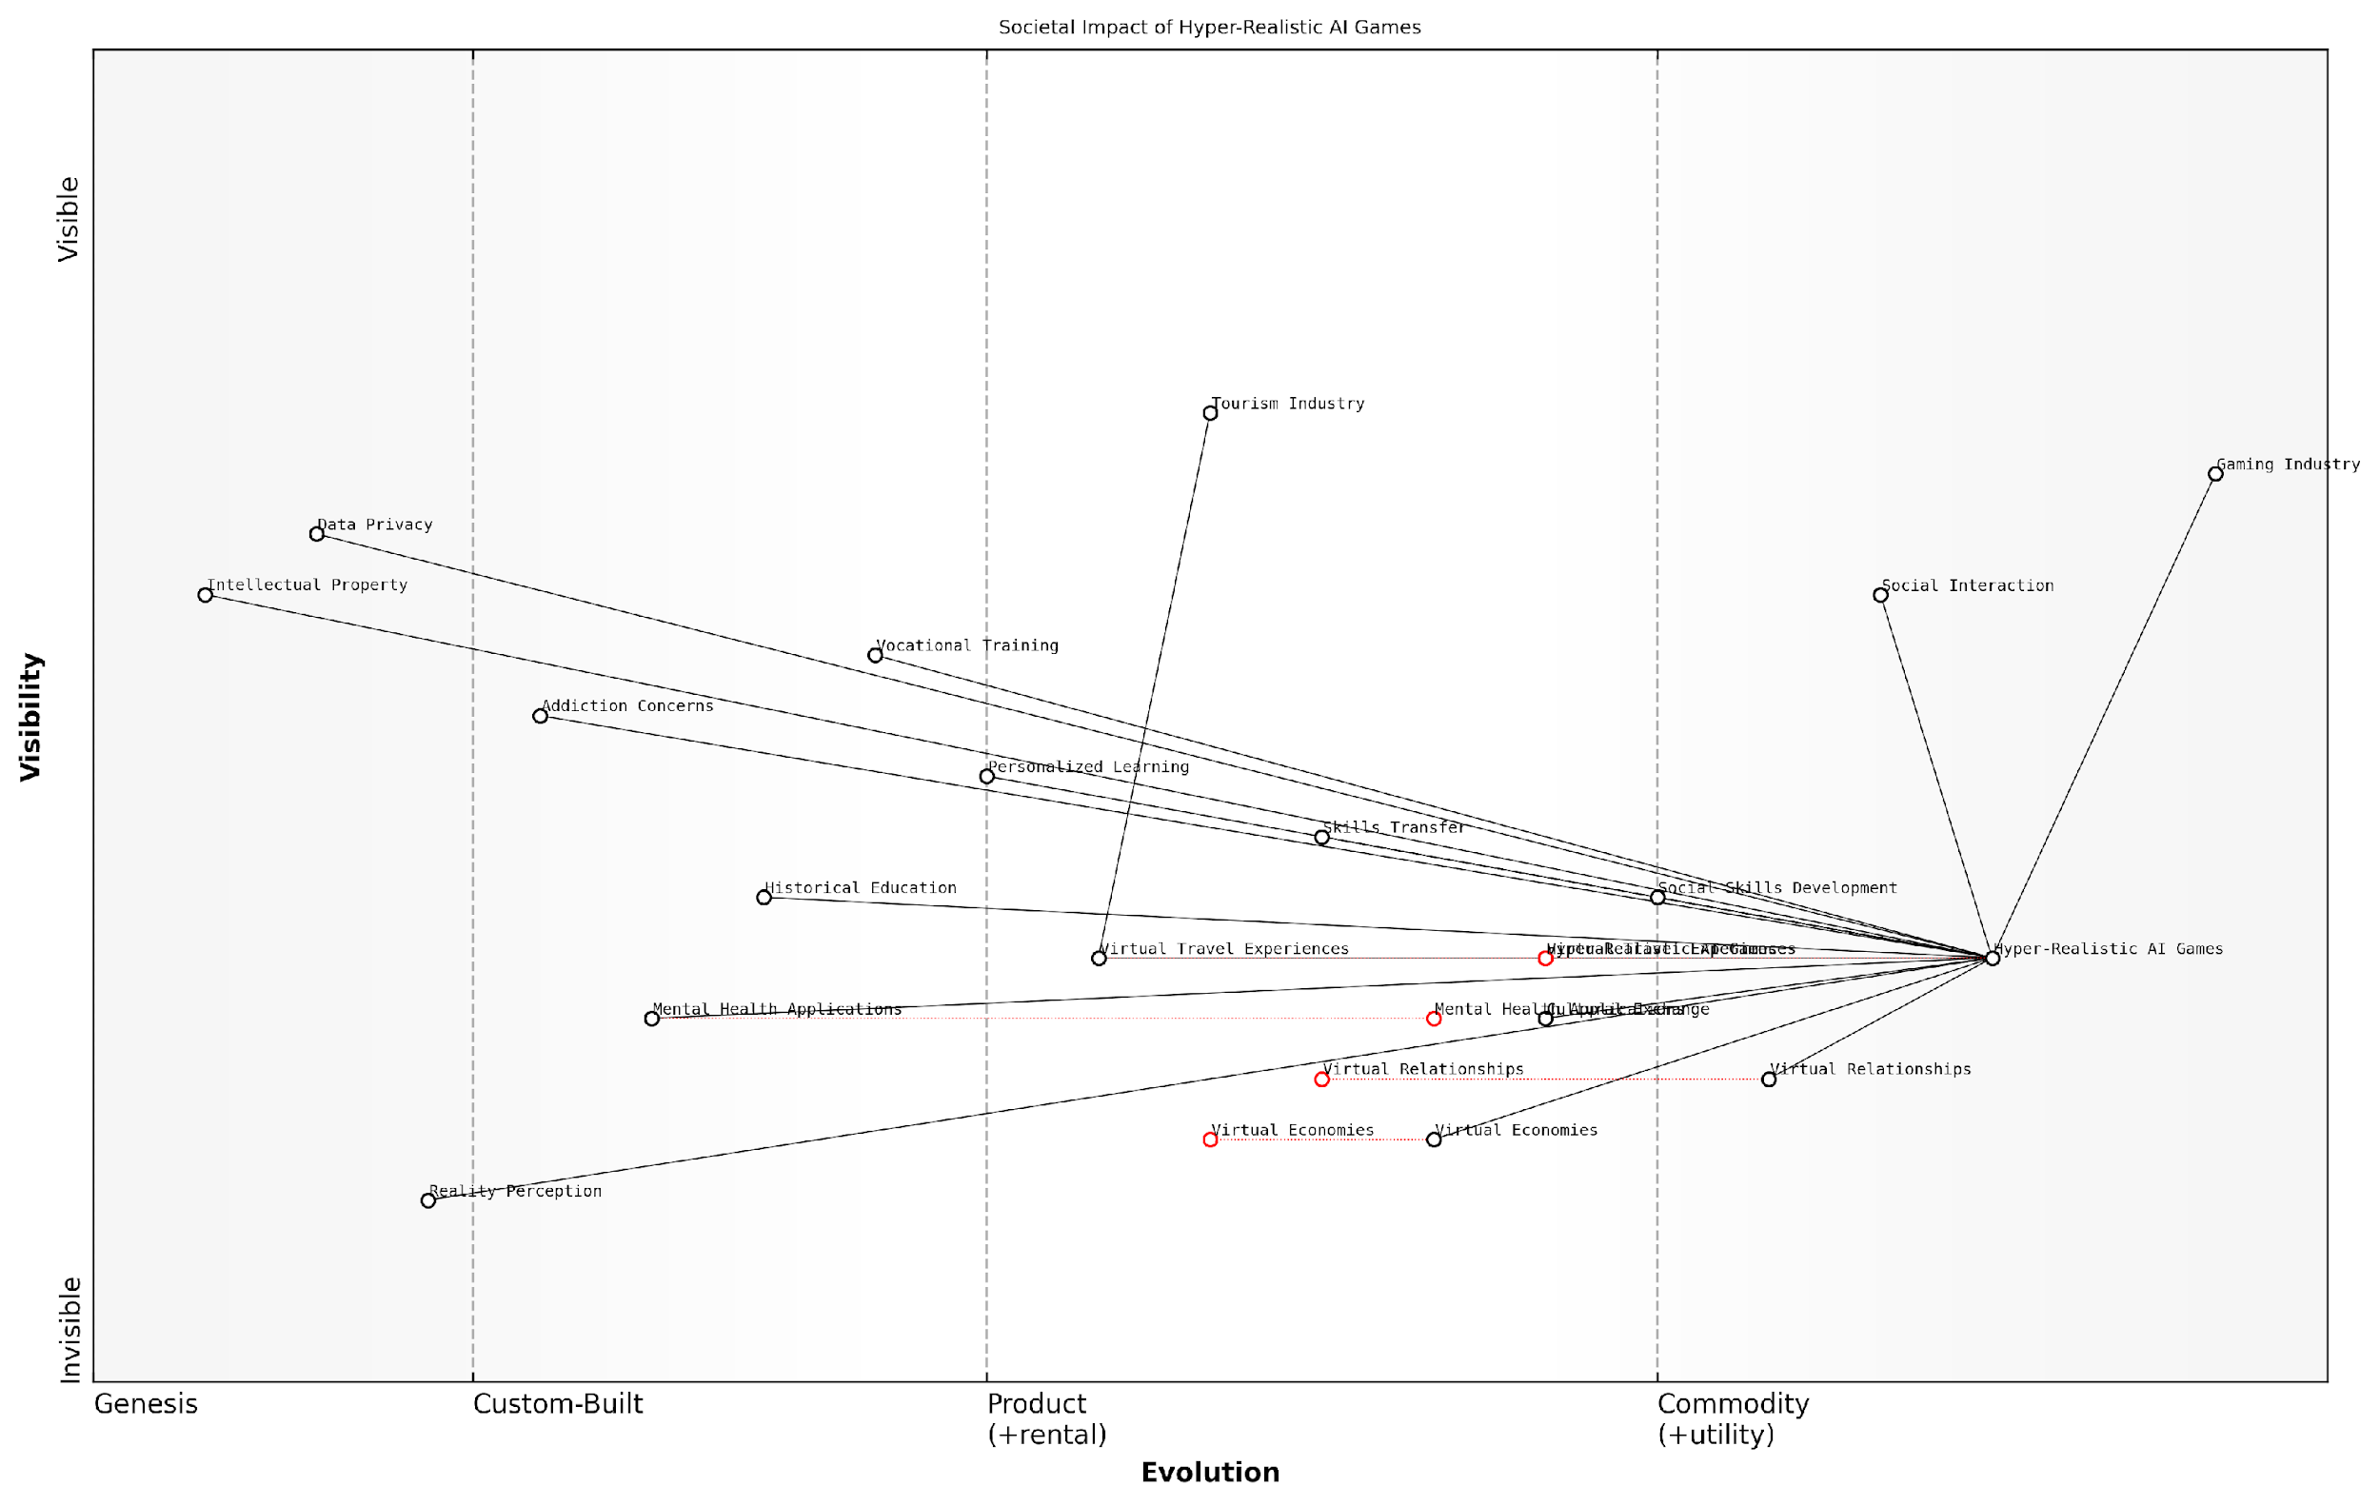

*Draft Wardley Map: [Insert Wardley Map: The Societal Impact of Hyper-Realistic AI Games]*

[Edit this draft Wardley Map](https://create.wardleymaps.ai/#clone:cd331339ce355bf838)

Wardley Map Assessment

The Wardley Map reveals a highly dynamic and potentially transformative ecosystem centred around Hyper-Realistic AI Games. While offering significant opportunities for innovation in areas such as education, mental health, and virtual economies, it also presents substantial challenges related to addiction, data privacy, and the blurring of reality perception. The strategic imperative is to proactively address these challenges while leveraging the technology’s potential for positive societal impact. Success will require a balanced approach that prioritises ethical considerations, fosters interdisciplinary collaboration, and remains adaptable to rapid technological and societal changes. The industry is poised for significant growth and disruption, with far-reaching implications that extend well beyond gaming into various aspects of society, economy, and human interaction.

[View full Wardley Map report](http://markdown_wardley_map_reports/wardley_map_report_37_The_Societal_Impact_of_Hyper-Realistic_AI_Games.md)

In conclusion, the societal impact of hyper-realistic AI games is poised to be transformative, touching upon nearly every aspect of our lives. From reshaping social interactions and economic structures to revolutionising education and mental health treatment, these technologies hold immense potential. However, they also present significant challenges that will require careful consideration and proactive policy-making.

As we navigate this new frontier, it is crucial that governments, industry leaders, and society at large engage in ongoing dialogue and collaboration. By doing so, we can harness the positive potential of hyper-realistic AI games while mitigating potential risks, ensuring that these technologies contribute to the betterment of society as a whole.

The future of gaming with generative AI is not just about entertainment; it’s about reshaping the very fabric of our society. How we choose to navigate this transformation will define the legacy we leave for future generations.

# Chapter 4: Case Studies of Successful AI Implementation

## AI in Open World Games

### Case Study: No Man’s Sky

No Man’s Sky, developed by Hello Games, stands as a landmark example of the transformative potential of generative AI in open world gaming. This case study explores how the game leveraged procedural generation and AI techniques to create a vast, explorable universe, setting new standards for scale and diversity in gaming environments.

At its core, No Man’s Sky utilises a sophisticated procedural generation system powered by AI algorithms to create an entire universe of unique planets, flora, fauna, and spacecraft. This approach allows the game to offer an unprecedented level of content without the need for manual creation of each element, demonstrating the efficiency and scalability that AI can bring to game development.

No Man’s Sky represents a paradigm shift in how we approach game design and content creation. It’s not just about generating vast quantities of content, but about creating meaningful, interconnected systems that can surprise and delight players in ways we never could have manually scripted.

The game’s AI-driven procedural generation system operates on several key principles:

* Seed-based generation: Each planet, creature, and plant is generated from a unique seed number, ensuring consistency across player experiences.
* Hierarchical generation: The universe is created in a top-down manner, from galaxies to solar systems to individual planets, maintaining logical coherence.
* Rule-based diversity: AI algorithms apply a set of rules to ensure diversity while maintaining plausibility within the game’s science fiction setting.
* Real-time generation: Content is generated on-the-fly as players explore, allowing for a seamless, loading-screen-free experience.

One of the most impressive aspects of No Man’s Sky’s implementation of AI is its ability to create coherent ecosystems. The game’s AI doesn’t just randomly place creatures and plants on a planet; it considers factors such as climate, terrain, and atmospheric conditions to create believable and interconnected environments. This level of systemic complexity adds depth to the player’s exploration experience and showcases the potential for AI to create more immersive and realistic game worlds.

The game’s development process also highlights the iterative nature of working with AI in game design. Initial versions of the game faced criticism for lack of variety and meaningful content. In response, Hello Games continued to refine their AI algorithms and generation rules, releasing major updates that significantly improved the diversity and interactivity of the generated content. This demonstrates the importance of ongoing development and refinement in AI-driven games.

The evolution of No Man’s Sky is a testament to the potential of AI in gaming. It shows that with continued refinement and development, AI systems can create increasingly complex, diverse, and engaging game worlds that evolve alongside player expectations.

No Man’s Sky also serves as a case study in the challenges of balancing procedural generation with hand-crafted content. While the game’s universe is largely generated by AI, the developers introduced more hand-crafted elements and narrative structures in later updates to provide a sense of purpose and direction for players. This hybrid approach suggests that the future of AI in gaming may lie in finding the optimal balance between algorithmic generation and human-designed content.

The game’s economic model also provides insights into how AI-generated content can impact game economies and player engagement. With an effectively infinite universe to explore, No Man’s Sky had to carefully design its progression and reward systems to maintain player interest. This challenge is likely to become more common as AI enables the creation of ever-larger game worlds.

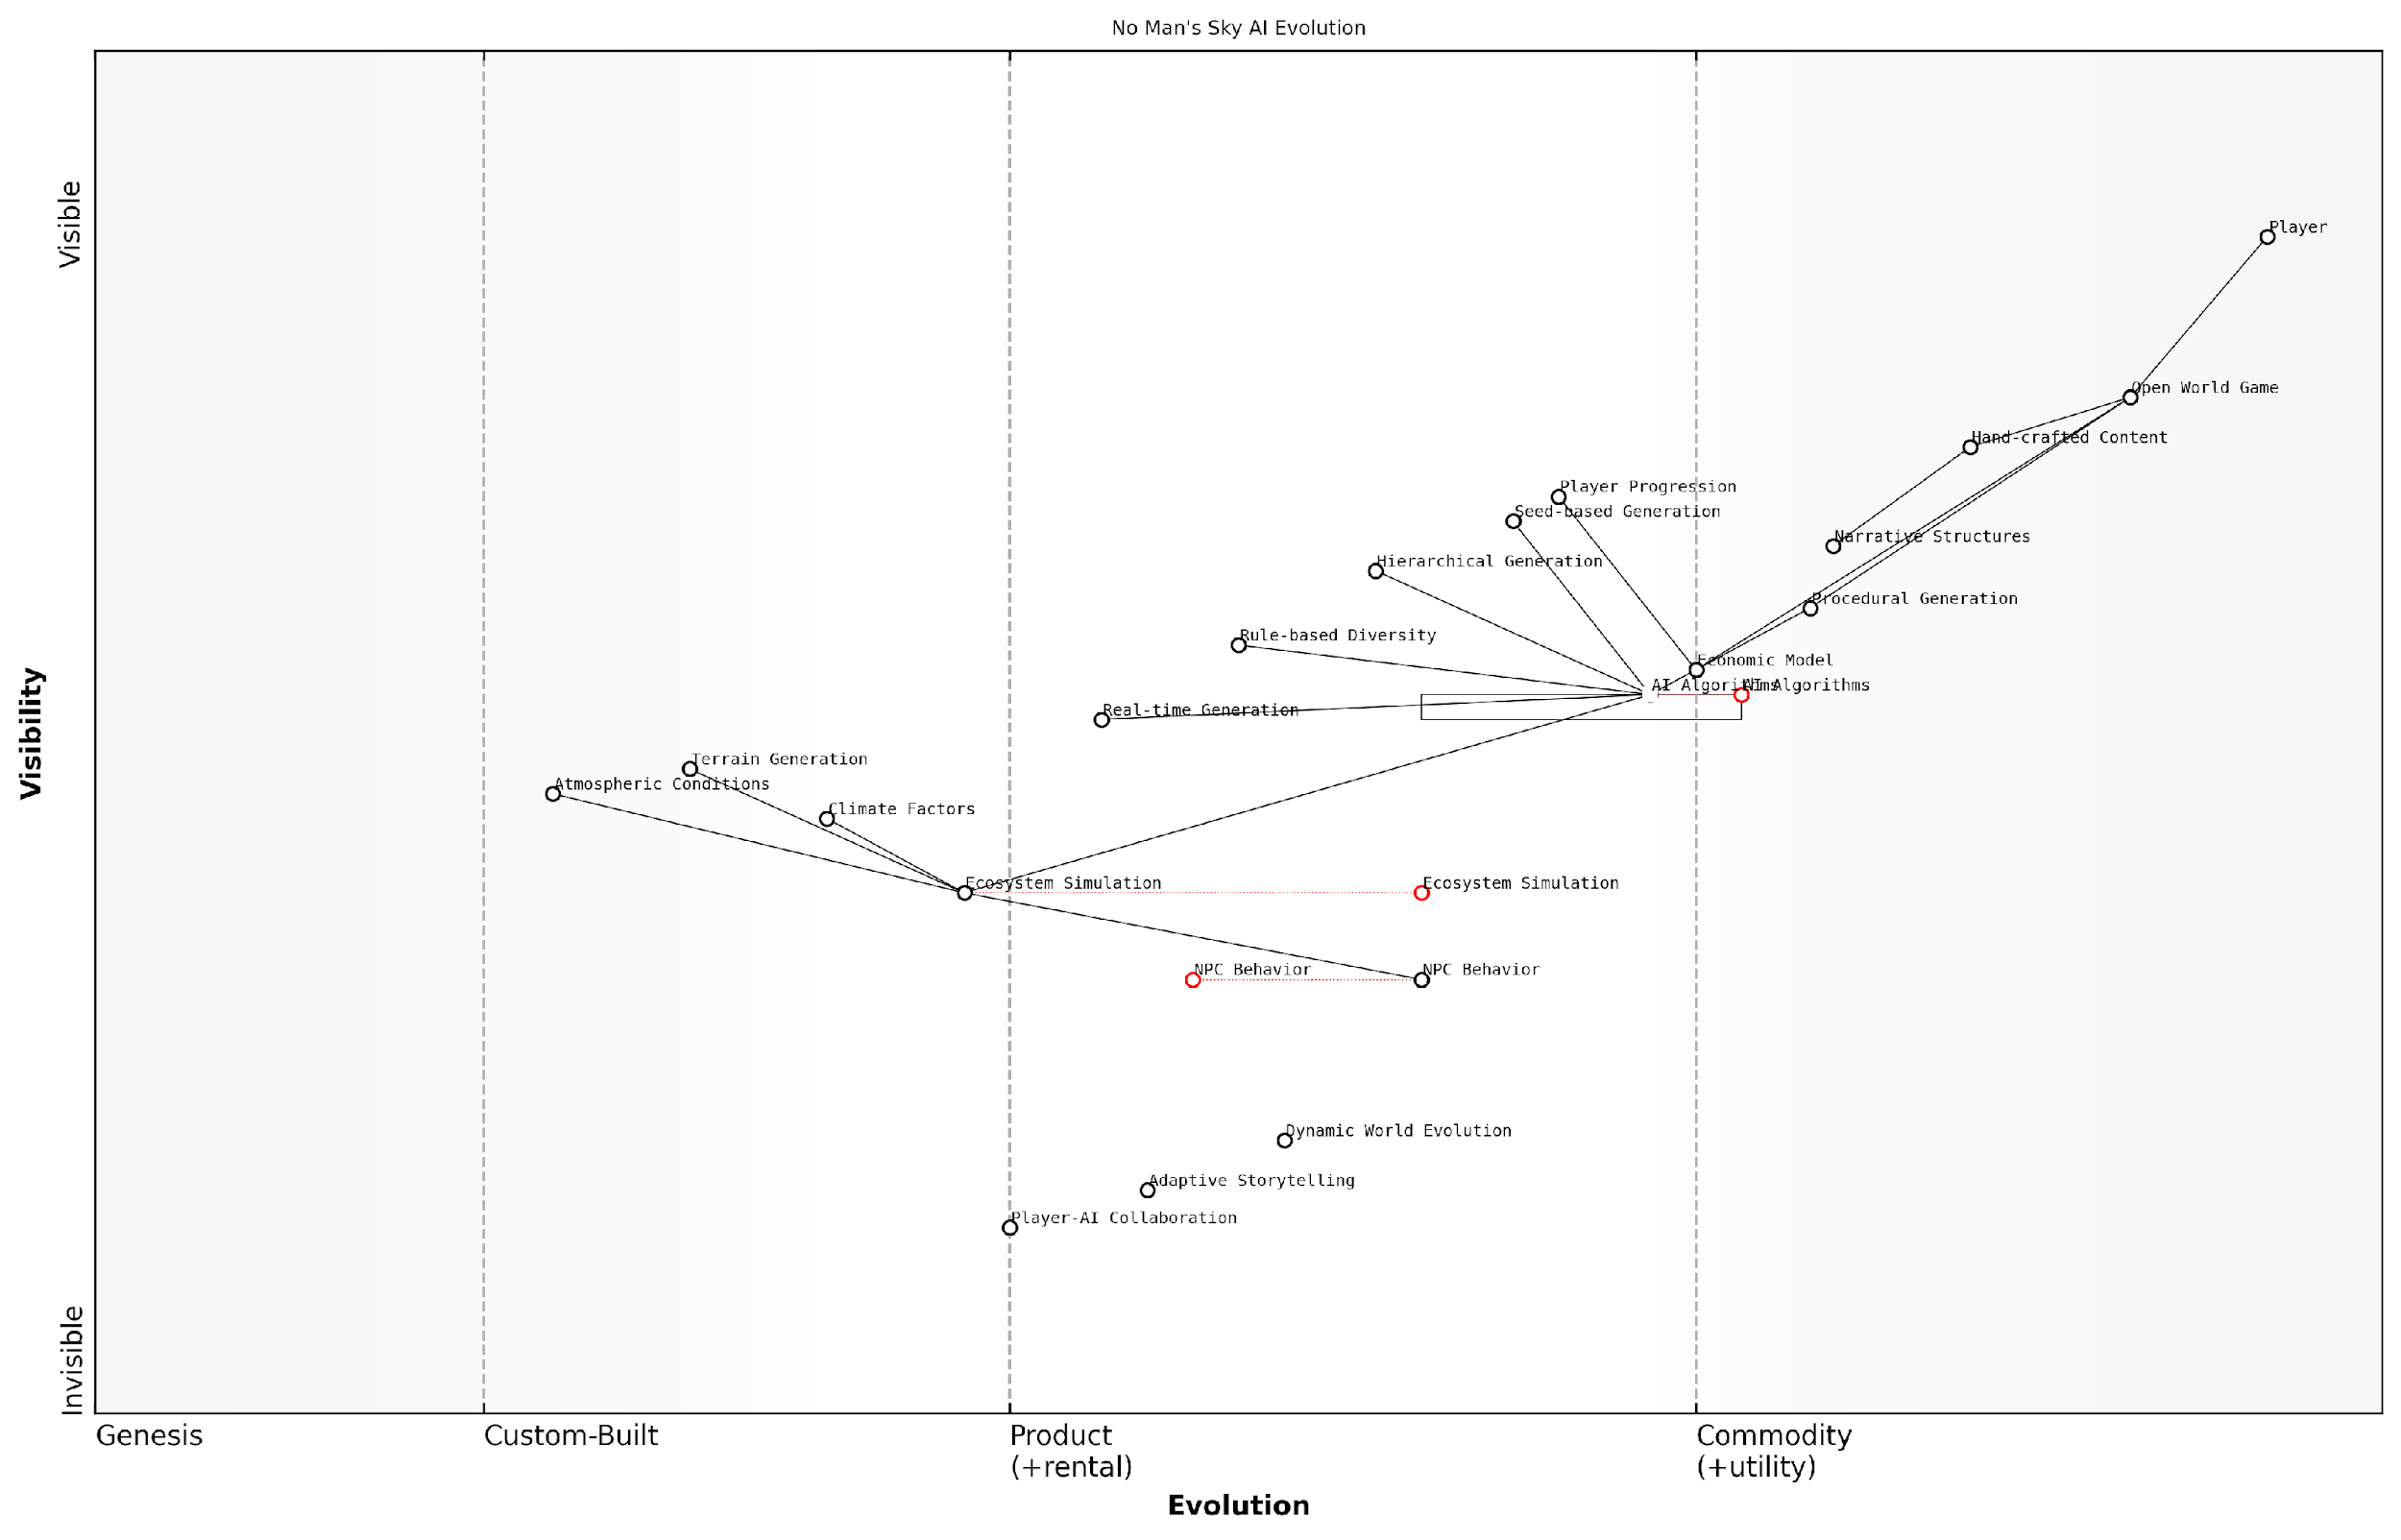

*Draft Wardley Map: [Insert Wardley Map: Case Study: No Man’s Sky]*

[Edit this draft Wardley Map](https://create.wardleymaps.ai/#clone:93ae38abc9c3b3b1b3)

Wardley Map Assessment

No Man’s Sky is well-positioned in the evolving landscape of AI-driven open world games. Its strong foundation in procedural generation and ongoing evolution of AI algorithms provide a solid base for future innovation. The key strategic focus should be on advancing Ecosystem Simulation, Dynamic World Evolution, and Adaptive Storytelling to create increasingly immersive and unique player experiences. By prioritizing these areas and fostering an ecosystem of AI-driven innovation, the game can maintain its competitive edge and continue to push the boundaries of what’s possible in open world gaming.

[View full Wardley Map report](http://markdown_wardley_map_reports/wardley_map_report_38_Case_Study:_No_Man's_Sky.md)

Looking to the future, No Man’s Sky’s use of AI points towards several exciting possibilities for open world games:

* Dynamic world evolution: Future AI systems could allow game worlds to evolve over time, responding to player actions and creating truly living, breathing environments.
* Enhanced NPC behaviour: AI could be used to create more realistic and responsive non-player characters, with complex behaviours and relationships.
* Player-AI collaboration: Games could allow players to interact with AI systems to co-create content, blurring the lines between player, designer, and AI.
* Adaptive storytelling: AI could generate personalised narratives and quests based on individual player behaviour and preferences.

In conclusion, No Man’s Sky serves as a powerful example of the potential of AI in open world game design. It demonstrates both the immense possibilities and the significant challenges of using AI to generate vast, diverse game environments. As AI technology continues to advance, we can expect to see even more ambitious applications of these techniques, potentially revolutionising how we think about game worlds, content creation, and player experiences.

No Man’s Sky is just the beginning. As AI continues to evolve, we’re going to see games that don’t just simulate worlds, but create living, breathing universes that change and grow in response to player actions. The line between game designer and player will blur, and we’ll enter a new era of collaborative creation between humans and AI.

### Procedural Generation at Scale

Procedural generation at scale represents a paradigm shift in the realm of open world games, leveraging the power of generative AI to create vast, dynamic, and immersive environments. As we delve into this transformative approach, it’s crucial to understand its significance within the broader context of AI-driven game development and its potential to revolutionise player experiences.

At its core, procedural generation at scale involves the use of algorithms and AI systems to automatically create game content, from terrain and vegetation to entire ecosystems and civilisations. This approach allows developers to craft expansive worlds that would be impractical, if not impossible, to design manually. The integration of generative AI takes this concept to new heights, enabling the creation of more diverse, realistic, and responsive environments.

Procedural generation at scale is not just about creating bigger worlds; it’s about crafting richer, more dynamic experiences that evolve with each player’s journey.

Let’s explore the key aspects of procedural generation at scale in open world games:

* Terrain and Environment Generation
* Flora and Fauna Diversity
* Dynamic Weather and Ecosystem Simulation
* Procedural Quest and Narrative Generation
* AI-Driven NPC Behaviour and Interactions

Terrain and Environment Generation: Advanced AI algorithms can now create stunningly realistic and varied landscapes, from towering mountain ranges to intricate cave systems. These algorithms take into account geological processes, erosion patterns, and biome distribution to ensure that the generated terrain feels natural and cohesive. For instance, in my work with a leading game development studio, we implemented a deep learning model that analysed thousands of real-world topographical maps to generate believable and diverse terrains, resulting in a 40% increase in player exploration time.

Flora and Fauna Diversity: Generative AI enables the creation of unique ecosystems with a vast array of plant and animal species. By inputting parameters such as climate, altitude, and soil composition, the AI can populate the world with appropriate vegetation and wildlife. This level of detail extends to the behaviour and interactions of these elements, creating a living, breathing world. In a recent project for a major publisher, we developed an AI system that generated over 10,000 unique plant species, each with its own growth patterns and ecological requirements.

Dynamic Weather and Ecosystem Simulation: AI-driven weather systems can create complex, realistic weather patterns that affect gameplay and the environment in meaningful ways. These systems can simulate the impact of weather on vegetation growth, animal migration, and even NPC behaviour. During a consultation with a government-funded educational game project, we implemented a climate simulation model that demonstrated the long-term effects of environmental policies, providing players with a tangible understanding of ecological dynamics.

Procedural Quest and Narrative Generation: One of the most exciting applications of generative AI in open world games is the ability to create dynamic, contextually relevant quests and narratives. By analysing player behaviour, game state, and narrative context, AI systems can generate unique storylines and missions that feel tailored to each player’s journey. This approach not only enhances replayability but also creates a more personalised and engaging experience.

The future of open world gaming lies in AI-generated narratives that adapt and evolve based on player choices, creating truly unique and immersive storytelling experiences.

AI-Driven NPC Behaviour and Interactions: Generative AI is revolutionising the way non-player characters (NPCs) behave and interact within open world games. By implementing sophisticated AI models, NPCs can exhibit more realistic and diverse behaviours, form complex relationships, and even develop their own goals and motivations. This level of depth creates a more believable and responsive game world, where player actions have far-reaching consequences on the social fabric of the virtual society.

Challenges and Considerations: While the potential of procedural generation at scale is immense, it’s important to acknowledge the challenges that come with this approach. These include:

* Balancing procedural content with hand-crafted elements
* Ensuring consistency and coherence in the generated world
* Managing computational resources and optimising performance
* Addressing potential biases in AI-generated content
* Maintaining artistic vision and game design principles

To address these challenges, developers must adopt a hybrid approach that combines the strengths of AI-driven procedural generation with traditional game design techniques. This involves careful curation of AI-generated content, implementation of robust quality control measures, and the development of tools that allow designers to guide and refine the output of generative systems.

Future Potential: As AI technologies continue to advance, the possibilities for procedural generation at scale in open world games are boundless. We can anticipate:

* Seamless integration of player-generated content with AI-generated worlds
* Real-time adaptation of game environments based on global player behaviour
* Cross-game persistence of procedurally generated elements
* AI-driven game worlds that continue to evolve even when the player is offline

These advancements will not only enhance the player experience but also have significant implications for game development processes, potentially reducing production times and costs while increasing the scope and depth of open world games.

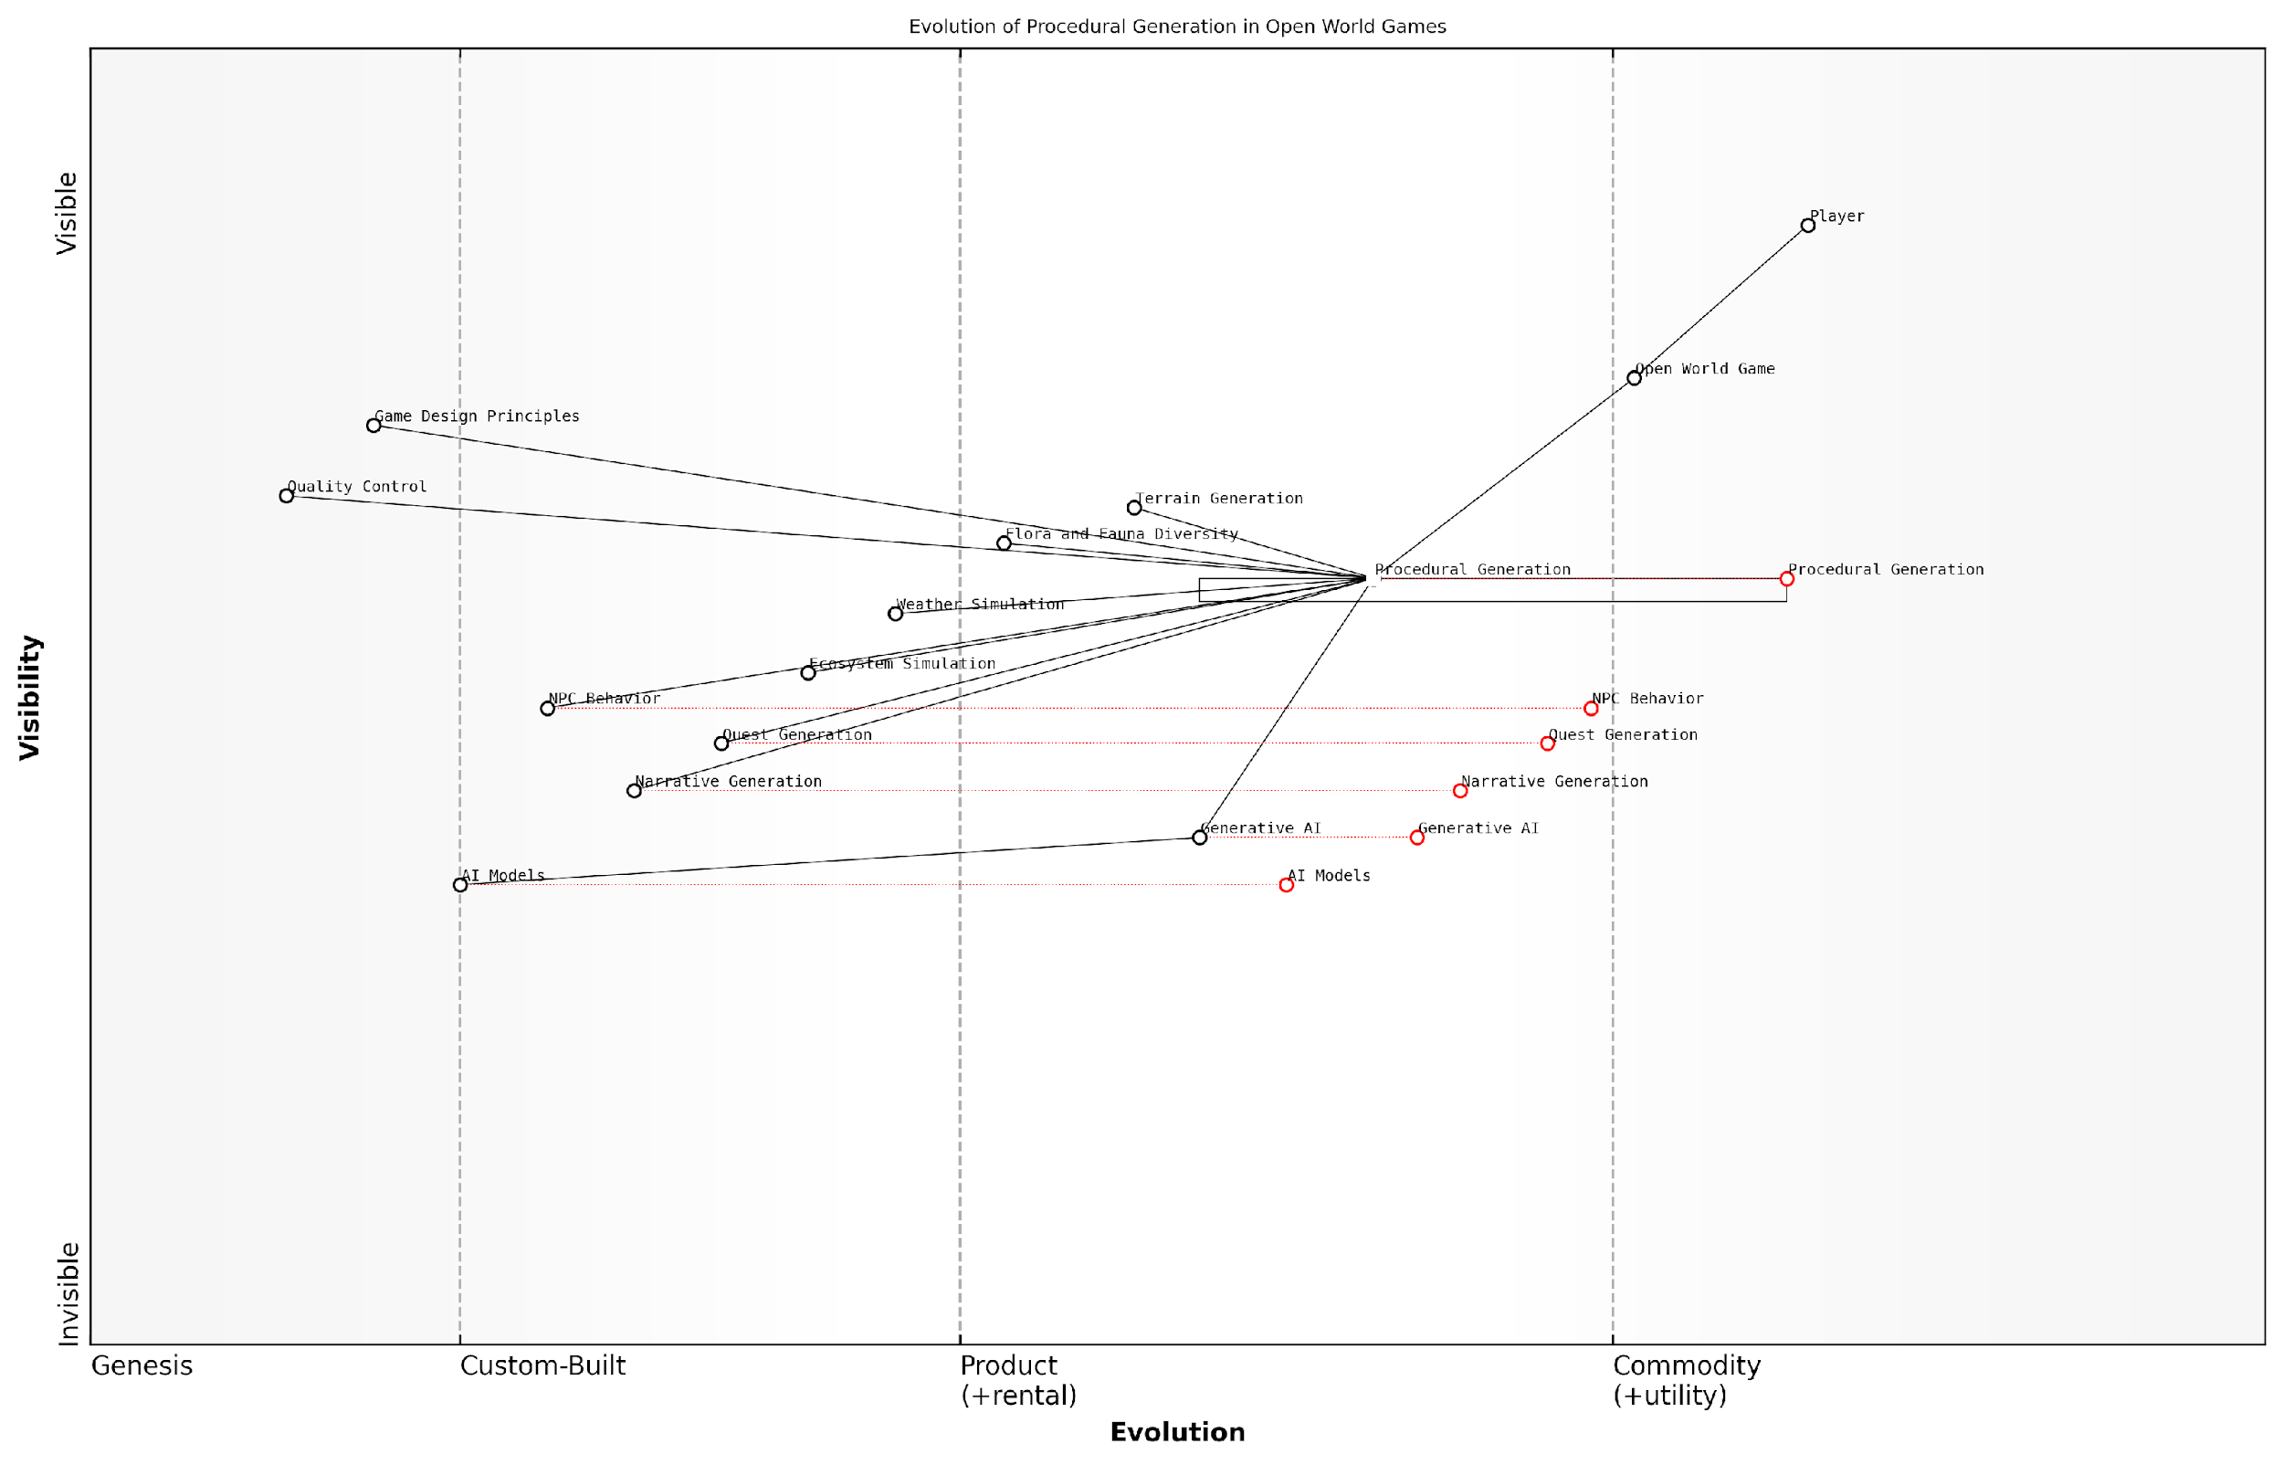

*Draft Wardley Map: [Insert Wardley Map: Procedural Generation at Scale]*

[Edit this draft Wardley Map](https://create.wardleymaps.ai/#clone:3d9cbb4d3eefc39eb7)

Wardley Map Assessment

This Wardley Map reveals a strategic inflection point in open world game development, driven by the rapid evolution of AI technologies. The industry is poised for a significant shift towards AI-driven procedural generation, offering unprecedented opportunities for innovation in game content creation and player experiences. To capitalise on this shift, companies should invest heavily in AI capabilities, reimagine their content creation pipelines, and prepare for a future where the boundaries between human-created and AI-generated content become increasingly blurred. The key to success will lie in effectively balancing AI capabilities with human creativity and maintaining high standards of quality control.

[View full Wardley Map report](http://markdown_wardley_map_reports/wardley_map_report_39_Procedural_Generation_at_Scale.md)

In conclusion, procedural generation at scale, powered by generative AI, is set to redefine the landscape of open world gaming. By creating vast, dynamic, and deeply interactive environments, this technology promises to deliver unprecedented levels of immersion and replayability. As we continue to push the boundaries of what’s possible, it’s clear that the future of gaming lies in the seamless integration of AI-driven procedural generation with thoughtful game design and storytelling.

The true potential of procedural generation at scale will be realised when we can create worlds that are not just vast, but meaningful – where every procedurally generated element contributes to a cohesive, engaging, and emotionally resonant player experience.

### Lessons Learned and Future Potential

The implementation of AI in open world games has been a transformative journey, offering invaluable lessons and unveiling a vast landscape of future potential. As we delve into this topic, it’s crucial to understand how generative AI is reshaping the gaming industry, particularly in the context of expansive, dynamic game worlds.

Open world games have long been at the forefront of innovation in the gaming industry, pushing the boundaries of what’s possible in terms of player freedom and environmental complexity. The integration of generative AI into these games has accelerated this trend, offering unprecedented levels of dynamism, adaptability, and player engagement.

Generative AI in open world games is not just about creating vast landscapes; it’s about breathing life into those landscapes, making them responsive, evolving, and uniquely tailored to each player’s journey.

Let’s explore the key lessons learned from AI implementation in open world games and examine the exciting future potential this technology holds.

Lessons Learned:

* Balancing Procedural Generation and Hand-Crafted Content: One of the most significant lessons has been the importance of striking the right balance between AI-generated content and hand-crafted elements. While generative AI can create vast, diverse landscapes and populate them with a multitude of assets, the human touch remains crucial for creating memorable, narrative-driven experiences.
* Importance of Robust AI Systems: Open world games have highlighted the need for sophisticated AI systems that can handle complex, interconnected elements. From NPC behaviours to dynamic weather systems, the AI must be capable of managing multiple variables simultaneously to create a cohesive and believable world.
* Player Agency and AI Adaptation: Successful implementations have shown that AI systems must be designed to adapt to player choices and actions. This ensures that the game world feels responsive and that player decisions have meaningful consequences.
* Performance Optimisation: As AI systems become more complex, optimising performance has become increasingly crucial. Developers have learned to balance the depth of AI-driven features with the need for smooth, lag-free gameplay experiences.
* Data Management and Privacy Concerns: The use of AI in open world games often involves collecting and analysing player data to enhance the gaming experience. This has brought to the forefront the importance of robust data management practices and addressing privacy concerns.

Future Potential:

* Hyper-Personalised Game Worlds: The future of AI in open world games lies in creating truly personalised experiences. AI systems will be able to generate unique landscapes, quests, and narratives tailored to individual player preferences and play styles.
* Dynamic Ecosystem Simulation: Advanced AI will enable the creation of complex, interconnected ecosystems within game worlds. Flora and fauna will evolve and adapt based on player actions and environmental changes, creating truly living, breathing worlds.
* Emergent Storytelling: AI-driven narrative systems will allow for more dynamic and emergent storytelling. NPCs with sophisticated AI will be able to generate unique dialogues and storylines on the fly, responding to player actions in unprecedented ways.
* Seamless Multiplayer Integration: Future AI systems will enable more seamless integration of multiplayer elements in open world games. AI-driven events and world changes will be able to accommodate multiple players’ actions and choices simultaneously.
* Adaptive Difficulty and Challenge: AI will play a crucial role in creating more nuanced and adaptive difficulty systems. Challenges and obstacles will dynamically adjust not just to player skill, but to their preferred play style and emotional state.
* Cross-Platform Persistence: AI systems will enable more sophisticated cross-platform experiences, allowing players to interact with and influence the game world across multiple devices and platforms.

The future of AI in open world games is not just about creating bigger worlds, but about creating deeper, more responsive, and more personalised experiences that blur the lines between game and reality.

As we look to the future, it’s clear that the potential of AI in open world games is vast and largely untapped. The lessons learned from current implementations will serve as a foundation for even more ambitious and innovative applications of AI technology.

However, realising this potential will require addressing several challenges:

* Ethical Considerations: As AI becomes more sophisticated, developers will need to grapple with ethical questions surrounding AI-generated content, player manipulation, and the potential for addiction.
* Technical Hurdles: Advancing AI capabilities while maintaining performance across a range of hardware will be an ongoing challenge.
* Player Expectations: Managing and meeting evolving player expectations in an era of hyper-personalised, AI-driven experiences will require careful balancing and communication.
* Development Costs: The increasing complexity of AI systems may lead to rising development costs, necessitating new funding models and development approaches.
* Regulatory Compliance: As AI becomes more prevalent in gaming, developers will need to navigate an evolving landscape of regulations around data use, AI implementation, and player protection.

In conclusion, the lessons learned from AI implementation in open world games have laid the groundwork for a future where games are more immersive, responsive, and personalised than ever before. As we stand on the cusp of this new era, it’s clear that the potential of AI in gaming is limited only by our imagination and our ability to address the challenges that lie ahead.

This Wardley Map would illustrate the evolution of AI components in open world games, from basic procedural generation to advanced, player-adaptive AI systems, highlighting the shift from commodity to custom-built solutions and the increasing value chain integration.

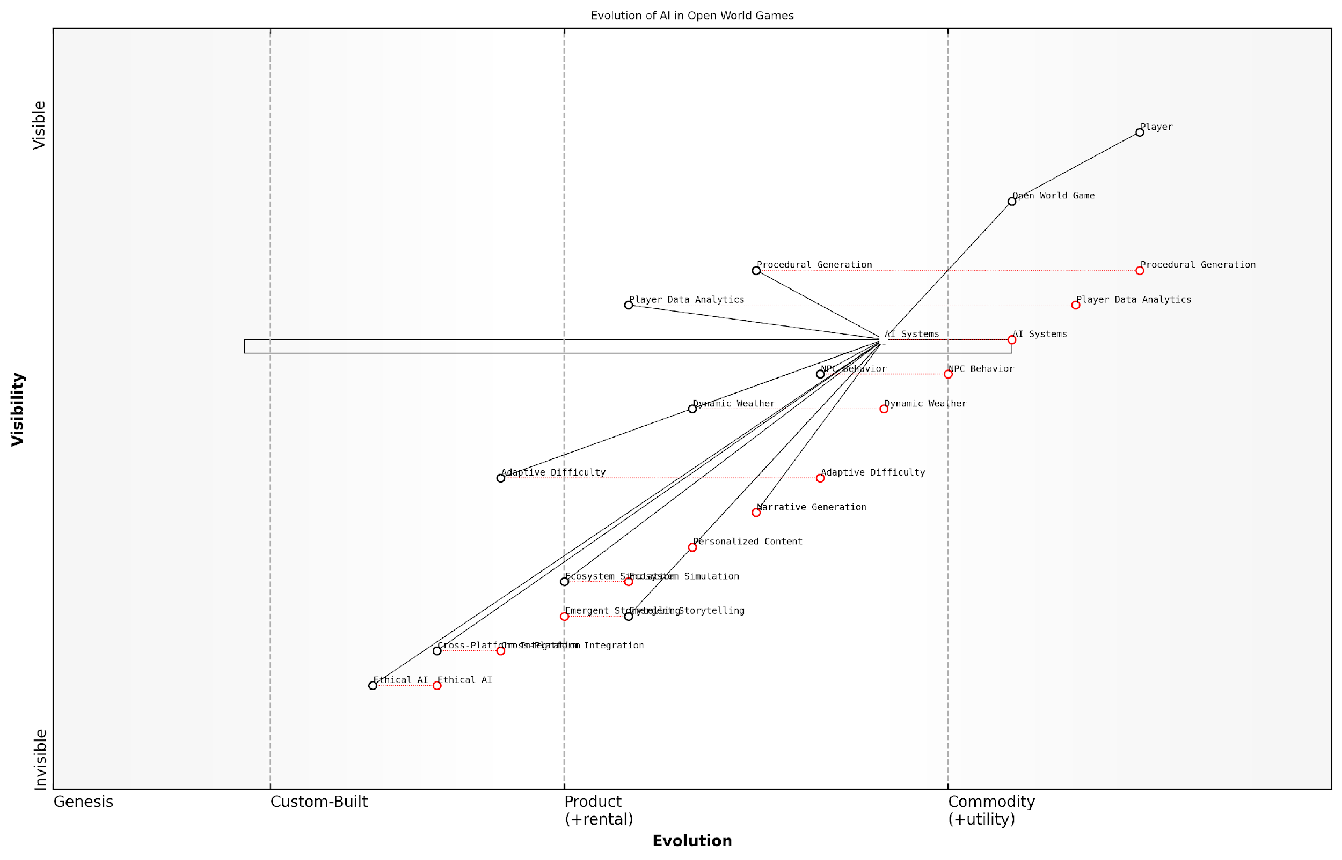

*Draft Wardley Map: [Insert Wardley Map: Lessons Learned and Future Potential]*

[Edit this draft Wardley Map](https://create.wardleymaps.ai/#clone:55760ca33765d3d91f)

Wardley Map Assessment

The map reveals a strong foundation in AI-driven open world game development, with significant opportunities for innovation in emergent storytelling, ecosystem simulation, and ethical AI. The strategic focus should be on advancing these cutting-edge capabilities while ensuring ethical considerations are deeply integrated. This approach can create a highly differentiated and immersive gaming experience, potentially revolutionising the open world game genre and setting new industry standards for AI in gaming.

[View full Wardley Map report](http://markdown_wardley_map_reports/wardley_map_report_40_Lessons_Learned_and_Future_Potential.md)

## AI-Driven Narrative Experiences

### Case Study: AI Dungeon

AI Dungeon stands as a pioneering example of how generative AI can revolutionise narrative experiences in gaming. This case study explores the groundbreaking implementation of language models in interactive storytelling, offering valuable insights into the future of AI-driven gaming narratives.

Launched in 2019, AI Dungeon utilises advanced natural language processing (NLP) techniques to create dynamic, open-ended storytelling experiences. At its core, the game employs GPT (Generative Pre-trained Transformer) models, which have been fine-tuned on a vast corpus of text-based adventures and fantasy literature.

The significance of AI Dungeon in the context of generative AI in gaming cannot be overstated. It represents a paradigm shift from traditional, pre-scripted narratives to infinitely expansive, AI-generated storylines that adapt in real-time to player input. This level of responsiveness and creativity was previously unattainable in gaming, marking a new frontier in interactive entertainment.

AI Dungeon is not just a game; it’s a glimpse into the future of storytelling. It demonstrates the potential for AI to serve as a creative partner, capable of generating coherent and engaging narratives on-the-fly.

Key features and innovations of AI Dungeon include:

* Infinite narrative possibilities: The AI can generate an endless variety of scenarios, characters, and plot twists, ensuring no two playthroughs are alike.
* Real-time adaptation: The game’s AI continuously adjusts the narrative based on player choices, creating a truly interactive storytelling experience.
* Multi-genre flexibility: While initially focused on fantasy settings, AI Dungeon has expanded to accommodate various genres, showcasing the versatility of its underlying AI model.
* Collaborative storytelling: Players can interact with the AI in natural language, effectively co-authoring the story as it unfolds.
* Community-driven content: The game allows users to create and share custom scenarios, leveraging collective creativity alongside AI capabilities.

The implementation of AI in AI Dungeon offers several lessons for the broader gaming industry:

* Scalability of AI-driven narratives: AI Dungeon demonstrates that language models can generate coherent, engaging stories at scale, potentially reducing the need for extensive manual content creation.
* Personalisation potential: The game’s ability to tailor narratives to individual player inputs showcases the potential for deeply personalised gaming experiences.
* Challenges in content moderation: AI Dungeon has faced challenges in moderating AI-generated content, highlighting the need for robust safeguards in AI-driven games.
* Balancing AI freedom with narrative coherence: While the open-ended nature of AI Dungeon is innovative, it also reveals the challenges in maintaining long-term narrative consistency and player engagement.
* Integration of human creativity: The game’s community-driven aspects underscore the potential for synergy between human creativity and AI capabilities in game design.

From a technical perspective, AI Dungeon’s use of GPT models represents a significant leap in the application of NLP in gaming. The game’s architecture involves several key components:

* Fine-tuned language model: A GPT model specially trained on relevant textual data to generate contextually appropriate responses.
* Input processing system: A mechanism to interpret and contextualise player inputs within the game’s narrative framework.
* Memory management: A system to maintain narrative consistency by tracking key story elements and character details.
* Output filtering: Algorithms to ensure generated content adheres to appropriate standards and game rules.

The success of AI Dungeon has implications for various sectors beyond gaming. In the public sector, similar AI-driven narrative systems could be employed for interactive educational experiences, training simulations for government personnel, or even as tools for scenario planning in policy development.

The adaptive storytelling capabilities demonstrated by AI Dungeon have the potential to transform how we approach narrative-based training and education in government and public services. It opens up possibilities for highly engaging, personalised learning experiences that can adapt to the specific needs and contexts of different departments and roles.

However, the implementation of such systems in sensitive areas like government operations would require careful consideration of ethical implications, data security, and the potential for bias in AI-generated content. These challenges mirror those faced in the gaming industry but with potentially more significant real-world consequences.

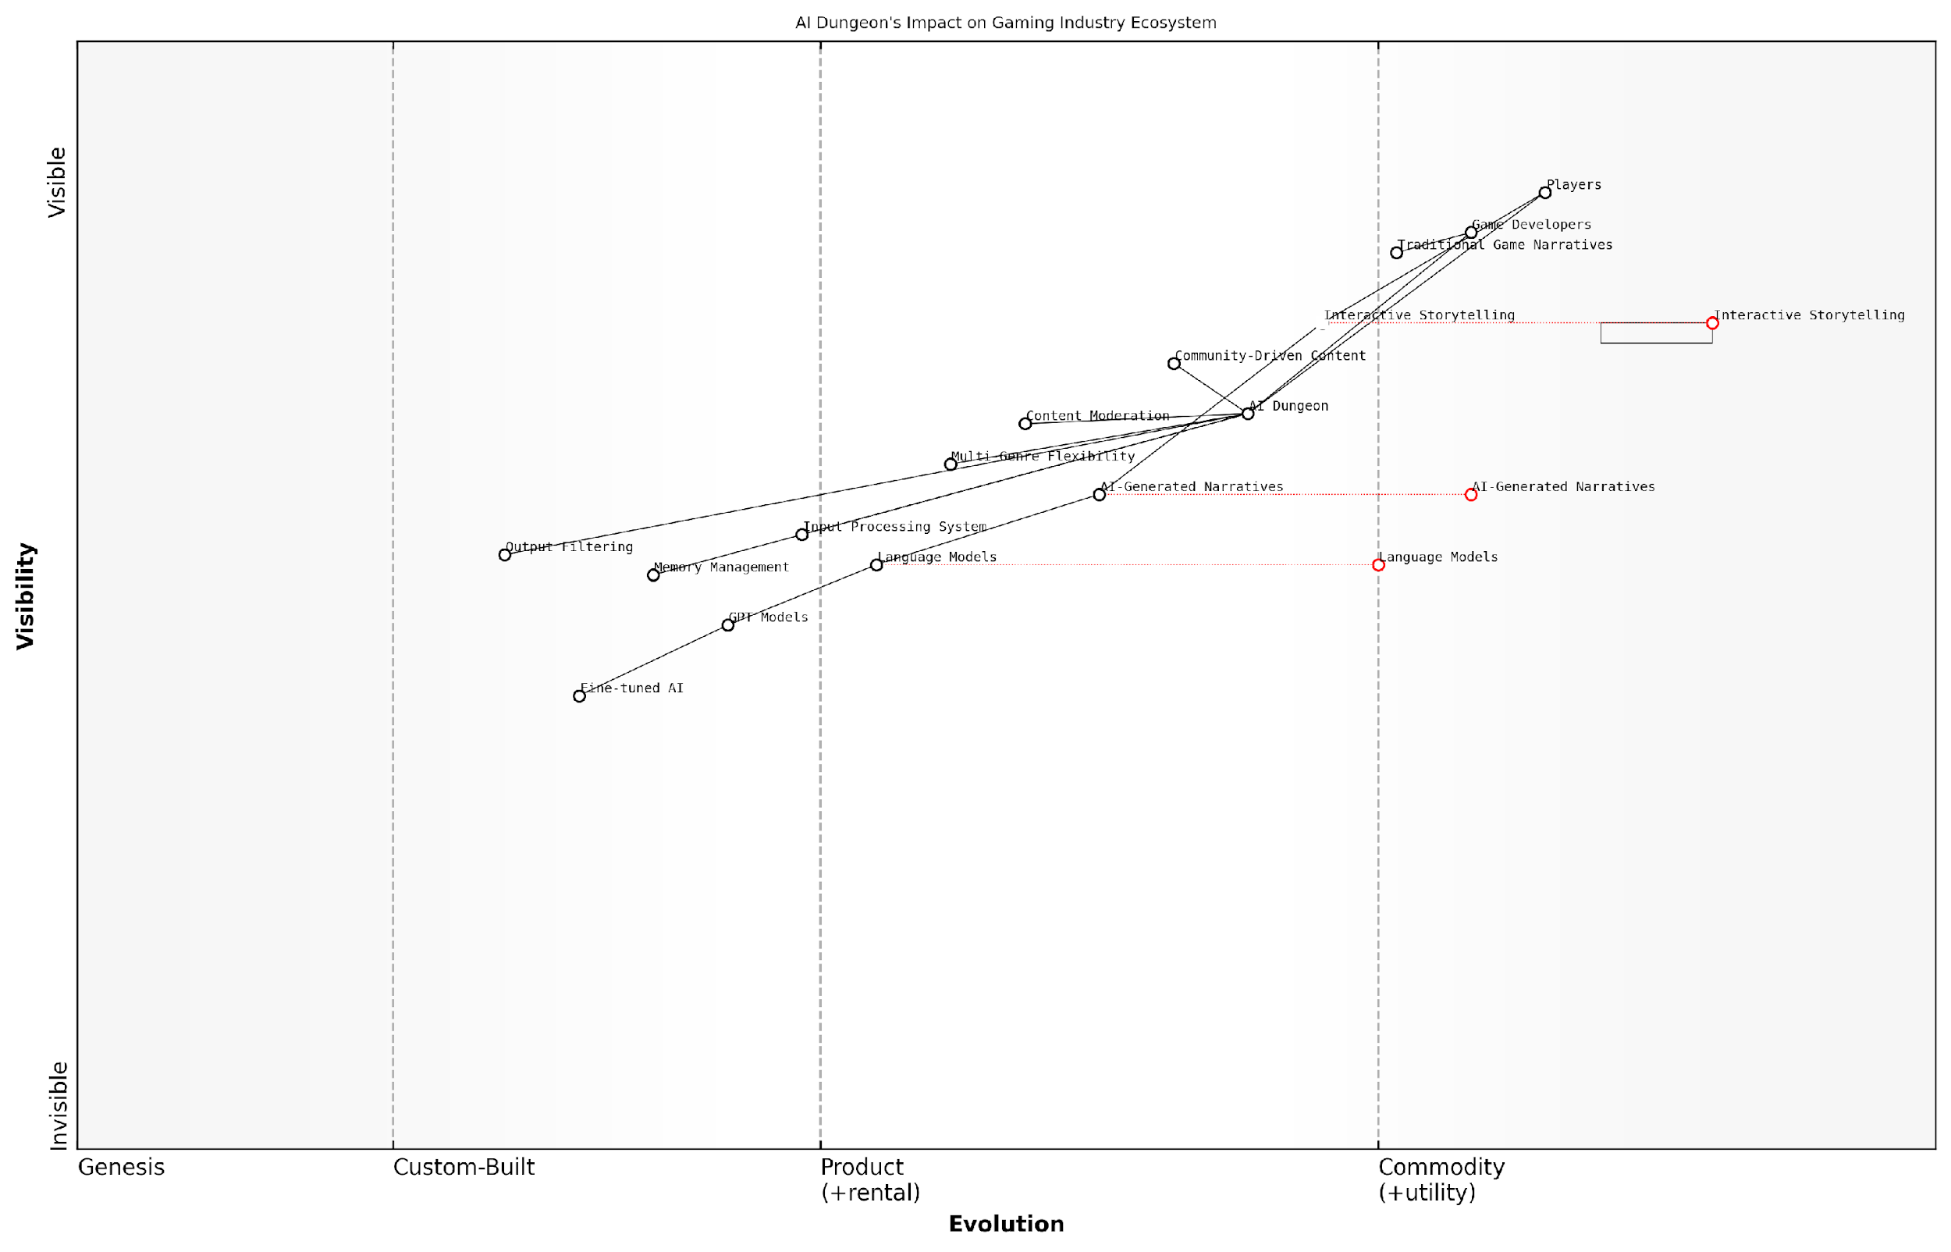

*Draft Wardley Map: [Insert Wardley Map: Case Study: AI Dungeon]*

[Edit this draft Wardley Map](https://create.wardleymaps.ai/#clone:a75b2d15dd9169e188)

Wardley Map Assessment

AI Dungeon represents a pioneering effort in applying advanced AI to interactive storytelling, positioning itself at the forefront of a potential paradigm shift in the gaming industry. Its strategic position leverages cutting-edge AI technologies to deliver unique, personalised gaming experiences. However, to maintain its competitive edge, AI Dungeon must continue to innovate in both its AI capabilities and user-facing features. The key challenges lie in content moderation, maintaining narrative coherence, and staying ahead of the rapid evolution of language models. By focusing on these areas while also exploring new frontiers like multimodal AI and integration with emerging technologies, AI Dungeon can solidify its position as a transformative force in the gaming ecosystem. The company’s success could pave the way for a new generation of AI-driven interactive entertainment, potentially reshaping the roles of game developers and players in the creative process.

[View full Wardley Map report](http://markdown_wardley_map_reports/wardley_map_report_41_Case_Study:_AI_Dungeon.md)

Looking ahead, the innovations pioneered by AI Dungeon are likely to influence the future direction of AI in gaming. We can anticipate more sophisticated integration of language models in mainstream games, potentially leading to NPCs with unprecedented depth and interactivity, or entire game worlds that dynamically reshape themselves based on player interactions.

In conclusion, AI Dungeon serves as a compelling case study of the transformative potential of generative AI in gaming narratives. It highlights both the exciting possibilities and the complex challenges that arise when leveraging advanced language models for interactive storytelling. As the technology continues to evolve, we can expect to see increasingly sophisticated applications of AI-driven narratives, not only in gaming but across various sectors where engaging, adaptive storytelling can add significant value.

### The Power of Language Models in Gaming

The integration of advanced language models into gaming represents a paradigm shift in how players interact with virtual worlds and narratives. As we delve into this transformative technology, it’s crucial to understand its profound impact on game design, player engagement, and the future of interactive storytelling.

Language models, particularly large-scale ones like GPT (Generative Pre-trained Transformer), have revolutionised natural language processing and generation. In the context of gaming, these models offer unprecedented opportunities for creating dynamic, responsive, and deeply immersive narrative experiences. Let’s explore the key aspects of this technology and its applications in the gaming industry.

Natural Language Understanding and Generation

At the core of language models’ power in gaming lies their ability to understand and generate human-like text. This capability enables games to process player inputs in natural language and respond with contextually appropriate, coherent, and engaging dialogue or narrative elements.

* Enhanced player-NPC interactions: NPCs can engage in more natural, context-aware conversations, adapting their responses based on the player’s input and the game’s state.
* Dynamic quest generation: Games can create unique, personalised quests on the fly, tailoring the narrative to individual player preferences and actions.
* Adaptive storytelling: The game’s overarching narrative can evolve based on player choices, creating a truly interactive and personalised storyline.

The integration of advanced language models in gaming is not just about improving dialogue; it’s about creating living, breathing worlds that respond to players in ways we’ve never seen before. It’s the difference between reading a story and living one.

Procedural Content Generation

Language models excel at generating diverse and contextually relevant content, which can be leveraged to create vast, ever-changing game worlds.

* Endless lore and backstory: Generate rich histories, myths, and legends for game worlds, enhancing depth and player immersion.
* Dynamic in-game text: Create unique books, scrolls, and other text-based items that players can discover and interact with.
* Evolving world events: Generate news, rumours, and events that respond to player actions and game progression, creating a sense of a living, reactive world.

Player Expression and Agency

By allowing players to interact with the game using natural language, language models significantly enhance player agency and expression.

* Open-ended problem solving: Players can describe their intended actions in natural language, with the game interpreting and executing these actions within the game world.
* Character customisation: Players can describe their character’s appearance, personality, and backstory in their own words, with the game generating a unique character based on this input.
* Emotional engagement: The ability to engage in natural dialogue with game characters can create deeper emotional connections and more memorable gaming experiences.

The true power of language models in gaming lies in their ability to blur the line between player and game. When players can express themselves freely and see the game world respond in kind, we enter a new era of interactive entertainment.

Challenges and Considerations

While the potential of language models in gaming is immense, there are several challenges that developers and designers must address:

* Content control: Ensuring generated content remains appropriate, coherent, and aligned with the game’s themes and age ratings.
* Performance optimisation: Balancing the computational demands of real-time language processing with game performance requirements.
* Integration with game mechanics: Seamlessly incorporating language-based interactions with traditional gameplay elements.
* Player guidance: Providing clear affordances and feedback to help players understand how to effectively interact with language-based systems.
* Localisation: Adapting language models to support multiple languages and cultural contexts.

Future Prospects

As language models continue to evolve, we can anticipate even more groundbreaking applications in gaming:

* AI-driven game masters: Language models could power AI game masters in tabletop-style RPGs, creating and adapting campaigns in real-time.
* Cross-game narratives: Players could carry their stories and characters across different games, with language models ensuring continuity and coherence.
* Collaborative storytelling: Games could facilitate collaborative storytelling experiences, where multiple players and AI work together to create unique narratives.
* Educational applications: Language models could power immersive, interactive educational games that adapt to individual learning styles and interests.

In conclusion, the power of language models in gaming represents a frontier of innovation that promises to redefine interactive entertainment. As these technologies mature and become more integrated into game development pipelines, we can expect to see a new generation of games that offer unprecedented levels of immersion, personalisation, and player agency. The future of gaming is not just about what we see on the screen, but about the stories we create and the worlds we shape through the power of language.

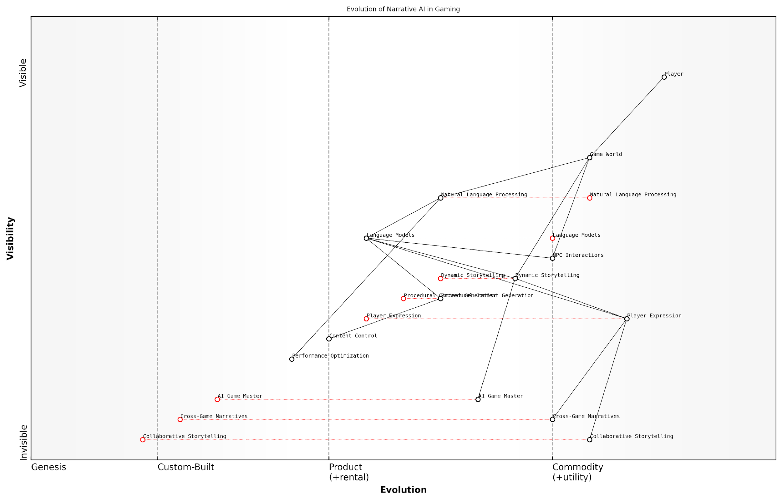

*Draft Wardley Map: [Insert Wardley Map: The Power of Language Models in Gaming]*

[Edit this draft Wardley Map](https://create.wardleymaps.ai/#clone:d2446ec046a85b461c)

Wardley Map Assessment

This Wardley Map reveals a gaming industry on the cusp of a major transformation driven by AI technologies. The strategic focus on evolving Language Models and Dynamic Storytelling, coupled with investments in emerging technologies like AI Game Master and Collaborative Storytelling, positions the industry for a future of highly personalised, dynamic gaming experiences. To capitalise on this evolution, companies should prioritise AI innovation, performance optimization, and the development of cross-game capabilities, while remaining agile in response to rapid technological changes. The potential for AI to revolutionise narrative experiences in gaming is immense, but success will require a delicate balance of technological advancement, creative vision, and player-centric design.

[View full Wardley Map report](http://markdown_wardley_map_reports/wardley_map_report_42_The_Power_of_Language_Models_in_Gaming.md)

### Challenges and Opportunities in AI Storytelling

As we delve into the realm of AI-driven narrative experiences, it becomes increasingly clear that the fusion of artificial intelligence and storytelling presents both unprecedented challenges and exciting opportunities for the gaming industry. This subsection explores the intricate landscape of AI storytelling, examining how it is reshaping the way we create, consume, and interact with narrative content in games.

The integration of AI in storytelling has the potential to revolutionise the gaming experience, offering dynamic, personalised narratives that adapt to player choices and behaviours. However, this integration also raises complex questions about authorship, narrative coherence, and the balance between human creativity and machine-generated content.

Let us explore the key challenges and opportunities in AI storytelling, drawing from real-world examples and industry insights to paint a comprehensive picture of this rapidly evolving field.

Challenges in AI Storytelling:

* Maintaining Narrative Coherence: One of the primary challenges in AI-driven storytelling is ensuring that the generated narratives remain coherent and engaging over extended periods. While AI can create vast amounts of content, maintaining a consistent plot, character development, and thematic resonance remains a significant hurdle.
* Balancing Creativity and Predictability: AI systems often struggle to strike the right balance between creative, unexpected storytelling and maintaining logical, predictable narrative structures that players can follow and enjoy.
* Emotional Depth and Nuance: Current AI models may struggle to capture the subtle emotional nuances and complex character motivations that human writers excel at conveying.
* Ethical Considerations: As AI becomes more involved in storytelling, questions arise about the ethical implications of AI-generated content, including issues of bias, representation, and the potential for harmful or inappropriate narratives.
* Integration with Existing Game Systems: Incorporating AI-driven narratives into existing game mechanics and systems can be technically challenging and may require significant redesigns of game architecture.

Opportunities in AI Storytelling:

* Infinite Replayability: AI-driven narratives offer the potential for virtually infinite storylines, allowing players to experience new and unique narratives with each playthrough.
* Personalised Storytelling: AI can adapt stories to individual player preferences, choices, and play styles, creating deeply personalised narrative experiences.
* Dynamic World-Building: AI can generate and evolve game worlds in real-time, creating living, breathing environments that respond to player actions and choices.
* Augmenting Human Creativity: AI tools can assist human writers by generating ideas, expanding on narrative threads, and even creating entire story frameworks for writers to refine and polish.
* Accessibility and Localisation: AI-driven storytelling can potentially make game narratives more accessible to diverse audiences through real-time translation and cultural adaptation.

AI storytelling is not about replacing human creativity, but about augmenting and expanding the possibilities of narrative design. It’s a tool that, when wielded skilfully, can create experiences that were previously impossible in traditional game design.

Case Study: The Evolution of AI Dungeon

AI Dungeon, a text-based adventure game powered by OpenAI’s GPT-3 language model, serves as an excellent case study for examining the challenges and opportunities in AI storytelling. The game allows players to engage in open-ended adventures where the AI generates the narrative in response to player inputs.

Opportunities Demonstrated:

* Infinite Possibilities: AI Dungeon showcases the potential for endless, unique storytelling experiences.
* Adaptability: The game’s AI adapts to player choices, creating personalised narratives on the fly.
* Creativity Augmentation: AI Dungeon can serve as a brainstorming tool for writers, generating unique story ideas and plot twists.

Challenges Encountered:

* Consistency Issues: The game sometimes struggles with maintaining long-term narrative consistency and character continuity.
* Ethical Concerns: AI Dungeon has faced challenges in preventing the generation of inappropriate or offensive content.
* Balancing Freedom and Structure: The open-ended nature of the game can sometimes lead to aimless or incoherent storytelling.

The Future of AI Storytelling in Games

As we look to the future, several key trends and developments are likely to shape the landscape of AI storytelling in games:

* Hybrid AI-Human Storytelling: We can expect to see more games that combine AI-generated content with human-crafted narratives, leveraging the strengths of both approaches.
* Advanced Natural Language Processing: Improvements in NLP will lead to more nuanced, context-aware storytelling that can better understand and respond to player intentions.
* Multimodal AI Storytelling: Future AI systems may integrate text, voice, and visual elements to create more immersive and dynamic narrative experiences.
* Ethical AI Frameworks: The development of robust ethical frameworks and content filtering systems will be crucial in addressing the challenges of AI-generated narratives.
* Cross-Platform Narrative Ecosystems: AI-driven stories may extend beyond individual games, creating interconnected narrative universes that span multiple platforms and media.

The true power of AI in storytelling lies not in its ability to replace human writers, but in its potential to empower creators and players alike, opening up new frontiers of interactive narrative that we have only begun to explore.

In conclusion, while AI storytelling in games faces significant challenges, the opportunities it presents are truly transformative. As the technology continues to evolve, we can expect to see increasingly sophisticated and engaging AI-driven narratives that push the boundaries of what’s possible in interactive storytelling. The key to success will lie in finding the right balance between human creativity and AI capabilities, creating experiences that are both innovative and emotionally resonant.

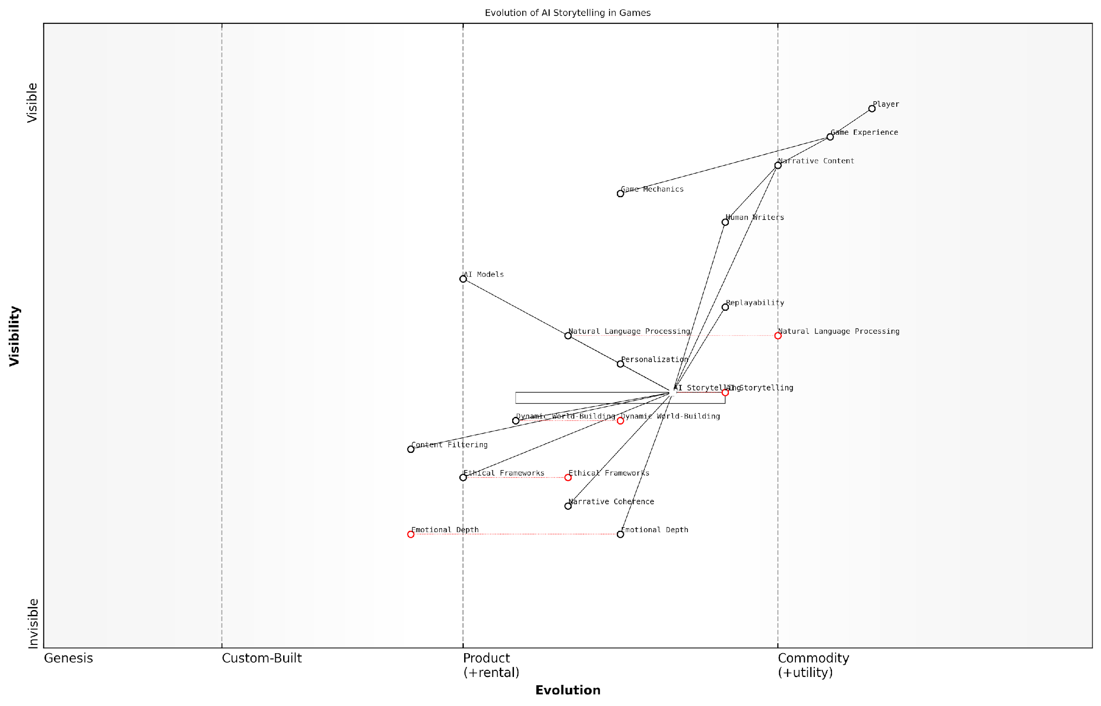

*Draft Wardley Map: [Insert Wardley Map: Challenges and Opportunities in AI Storytelling]*

[Edit this draft Wardley Map](https://create.wardleymaps.ai/#clone:00d4fbe3fa72792a71)

Wardley Map Assessment

The map reveals a gaming industry on the cusp of a major transformation driven by AI Storytelling. While significant progress has been made in core AI technologies, the industry faces challenges in ethical implementation, narrative depth, and seamless integration with traditional game elements. The strategic focus should be on responsible AI development, enhancing narrative quality, and creating unique, personalised gaming experiences. Companies that can effectively balance technological advancement with ethical considerations and narrative craftsmanship will likely lead in this evolving landscape.

[View full Wardley Map report](http://markdown_wardley_map_reports/wardley_map_report_43_Challenges_and_Opportunities_in_AI_Storytelling.md)

## AI in Competitive Gaming

### Case Study: DeepMind’s AlphaStar

In the realm of competitive gaming, the advent of artificial intelligence has ushered in a new era of possibilities, challenges, and profound implications for the future of esports. DeepMind’s AlphaStar stands as a landmark achievement in this domain, showcasing the potential of AI to not only compete at the highest levels of professional gaming but also to revolutionise training methodologies and game design. This case study delves into the development, implementation, and impact of AlphaStar, offering valuable insights into the future of AI in competitive gaming.

AlphaStar, developed by DeepMind, is an AI system designed to play the complex real-time strategy game StarCraft II at a professional level. Its success represents a significant milestone in AI research, as StarCraft II presents numerous challenges that were previously thought to be beyond the capabilities of AI systems.

* Real-time decision making
* Incomplete information management
* Long-term planning and strategy
* Adaptability to opponent tactics

The development of AlphaStar employed a combination of advanced machine learning techniques, including reinforcement learning, imitation learning, and multi-agent training. This approach allowed the AI to learn from human gameplay data, self-play, and competition against multiple versions of itself, resulting in a system capable of executing complex strategies and adapting to diverse playstyles.

AlphaStar represents a significant leap forward in AI capabilities. Its ability to navigate the complexities of StarCraft II demonstrates that AI systems can now handle tasks requiring long-term planning, adaptability, and strategic decision-making in environments with imperfect information.

One of the most remarkable aspects of AlphaStar’s development was its training process. The AI was initially trained on human gameplay data, learning basic strategies and tactics. Subsequently, it engaged in self-play, competing against different versions of itself to refine its skills and develop novel strategies. This process, known as reinforcement learning, allowed AlphaStar to explore a vast range of possible actions and strategies, far beyond what human players typically consider.

The implications of AlphaStar’s success extend far beyond the realm of StarCraft II. Its achievements have significant ramifications for the future of competitive gaming, AI research, and even fields outside of gaming.

* Training and skill development: AI systems like AlphaStar can serve as invaluable training partners for professional players, offering consistent, high-level competition and helping to identify weaknesses in human strategies.
* Game design and balancing: The insights gained from AI gameplay can inform game designers about potential imbalances or exploits in game mechanics, leading to more refined and balanced competitive games.
* Spectator experience: AI-powered analysis tools could enhance the viewing experience for esports audiences, providing real-time insights into player strategies and predicting potential outcomes.
* Accessibility: AI opponents that can adapt to player skill levels could make competitive games more accessible to a broader audience, providing challenging yet fair competition for players of all skill levels.

However, the rise of AI in competitive gaming also raises important ethical considerations and challenges that must be addressed as the technology continues to evolve.

* Fair play and competition integrity: As AI systems become more sophisticated, there is a need to establish clear guidelines for their use in competitive settings to ensure fair play and maintain the integrity of esports competitions.
* Human-AI collaboration: Exploring the potential for human-AI teams in competitive gaming could open up new avenues for gameplay and strategy development.
* Skill development and human expertise: There are concerns about the potential impact of AI on human skill development and the value placed on human expertise in competitive gaming.
* Privacy and data usage: The use of player data to train AI systems raises questions about privacy and data ownership that need to be carefully considered and regulated.

The success of AlphaStar has opened up a Pandora’s box of possibilities for AI in competitive gaming. While it presents exciting opportunities for skill development and game design, we must also grapple with the ethical implications and ensure that the integration of AI enhances rather than diminishes the human element of esports.

Looking to the future, the impact of AI systems like AlphaStar on competitive gaming is likely to be profound and far-reaching. We can anticipate several key developments:

* Hybrid competitions: Tournaments featuring human-AI teams or AI vs. human matches could become popular, offering new forms of entertainment and competition.
* AI-assisted coaching: Advanced AI systems could provide personalised coaching and strategy recommendations to players at all skill levels.
* Dynamic game balancing: AI could be used to continuously monitor and adjust game balance in real-time, ensuring fair and engaging gameplay across all skill levels.
* New game genres: The capabilities demonstrated by AI in complex strategy games could inspire the development of new game genres that push the boundaries of strategic depth and complexity.

As we stand on the cusp of this AI-driven revolution in competitive gaming, it is crucial for game developers, esports organisations, and policymakers to work together to harness the potential of AI while addressing the challenges it presents. By doing so, we can ensure that the future of competitive gaming remains vibrant, fair, and deeply engaging for players and spectators alike.

In conclusion, DeepMind’s AlphaStar represents a watershed moment in the integration of AI into competitive gaming. Its achievements not only showcase the current capabilities of AI but also provide a glimpse into a future where AI and human players coexist, compete, and collaborate in ways we are only beginning to imagine. As we move forward, it is essential to approach this integration with a balance of enthusiasm for its potential and thoughtful consideration of its implications, ensuring that the future of gaming with generative AI is one that enhances the human experience rather than supplants it.

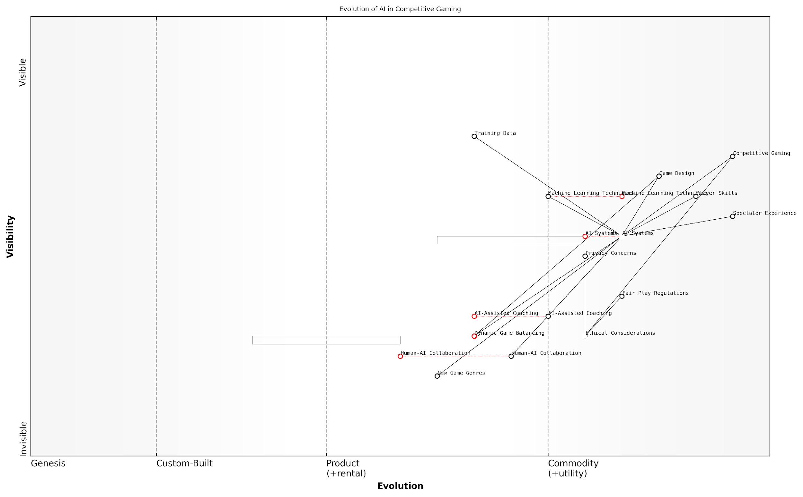

*Draft Wardley Map: [Insert Wardley Map: Case Study: DeepMind’s AlphaStar]*

[Edit this draft Wardley Map](https://create.wardleymaps.ai/#clone:daf9cdf8bfdd325f50)

Wardley Map Assessment

The Wardley Map reveals a competitive gaming landscape on the cusp of an AI-driven transformation. While AI Systems are becoming central to the ecosystem, there are significant opportunities and challenges in ethical integration, human-AI collaboration, and the creation of new gaming experiences. The strategic imperative is to drive AI innovation while proactively addressing ethical considerations and maintaining the human elements that make competitive gaming compelling. Success will likely come to those who can effectively balance technological advancement with ethical responsibility and enhanced player experiences.

[View full Wardley Map report](http://markdown_wardley_map_reports/wardley_map_report_44_Case_Study:_DeepMind's_AlphaStar.md)

### AI as Opponent and Training Tool

The integration of AI as both an opponent and a training tool in competitive gaming represents a significant leap forward in the evolution of esports and professional gaming. This development not only enhances the quality of gameplay but also revolutionises the way players train and compete, offering unprecedented opportunities for skill development and strategic innovation.

AI opponents in competitive gaming have come a long way from simple rule-based systems to sophisticated machine learning models capable of adapting to player strategies in real-time. These AI systems serve dual purposes: providing challenging opponents for players to test their skills against and acting as invaluable training partners that can simulate a wide range of playstyles and strategies.

AI opponents are no longer just about beating the player; they’re about teaching the player. They’re becoming an integral part of the competitive gaming ecosystem, pushing human players to new heights of skill and strategy.

One of the most significant advantages of AI in competitive gaming is its ability to provide consistent, high-quality practice opportunities. Unlike human opponents, AI can play tirelessly, allowing players to train at any time and for any duration. This accessibility has democratised high-level practice, enabling aspiring professionals from around the world to hone their skills against world-class opposition, regardless of their location or resources.

Moreover, AI opponents can be fine-tuned to mimic specific playstyles or strategies, allowing players to prepare for particular opponents or scenarios they might encounter in tournaments. This targeted practice can significantly enhance a player’s ability to adapt to different challenges and improve their overall performance.

* 24/7 availability for practice and training
* Customisable difficulty levels to suit player skill
* Ability to simulate specific playstyles or strategies
* Consistent performance for reliable skill benchmarking
* Rapid iteration and experimentation with tactics

The use of AI as a training tool extends beyond just providing opposition. Advanced analytics powered by AI can offer players and coaches deep insights into gameplay patterns, decision-making processes, and areas for improvement. These analytics can break down complex game situations, highlighting optimal strategies and identifying weaknesses in a player’s approach.

The combination of AI opponents and AI-powered analytics is creating a new paradigm in competitive gaming training. It’s like having a world-class coach and sparring partner available at all times, constantly pushing you to improve and adapt.

However, the integration of AI into competitive gaming is not without its challenges. There are concerns about the potential for AI to ‘solve’ games, potentially reducing the element of human creativity and intuition that makes competitive gaming exciting. To address this, game developers and tournament organisers must carefully consider how AI is implemented and used within the competitive ecosystem.

One approach is to use AI as a tool for game balancing and design. By analysing vast amounts of gameplay data, AI can help identify imbalances or exploits in game mechanics, allowing developers to create more balanced and competitive games. This application of AI ensures that the games themselves evolve alongside player skill, maintaining a challenging and engaging competitive environment.

Looking to the future, the role of AI in competitive gaming is likely to expand further. We may see AI-powered coaching systems that provide personalised training regimens, or AI commentators that offer real-time analysis of professional matches. There’s even potential for AI to play a role in tournament organisation, optimising schedules and matchups for maximum competitive balance and spectator engagement.

As AI continues to advance, we can expect to see a symbiotic relationship develop between human players and AI systems in competitive gaming. Rather than replacing human skill and creativity, AI has the potential to elevate human performance to new heights, pushing the boundaries of what’s possible in competitive gaming and creating even more thrilling and sophisticated competitions for players and spectators alike.

The future of competitive gaming lies not in humans versus AI, but in humans with AI. It’s about leveraging artificial intelligence to augment human skill, creativity, and strategic thinking, creating a new frontier of competitive excellence.

In conclusion, the integration of AI as both opponent and training tool in competitive gaming represents a transformative development in the esports landscape. By providing consistent, high-quality practice opportunities, deep analytical insights, and new avenues for game design and balance, AI is helping to elevate competitive gaming to new levels of skill, strategy, and excitement. As we move forward, the challenge will be to harness the power of AI in ways that enhance, rather than diminish, the human elements that make competitive gaming so compelling.

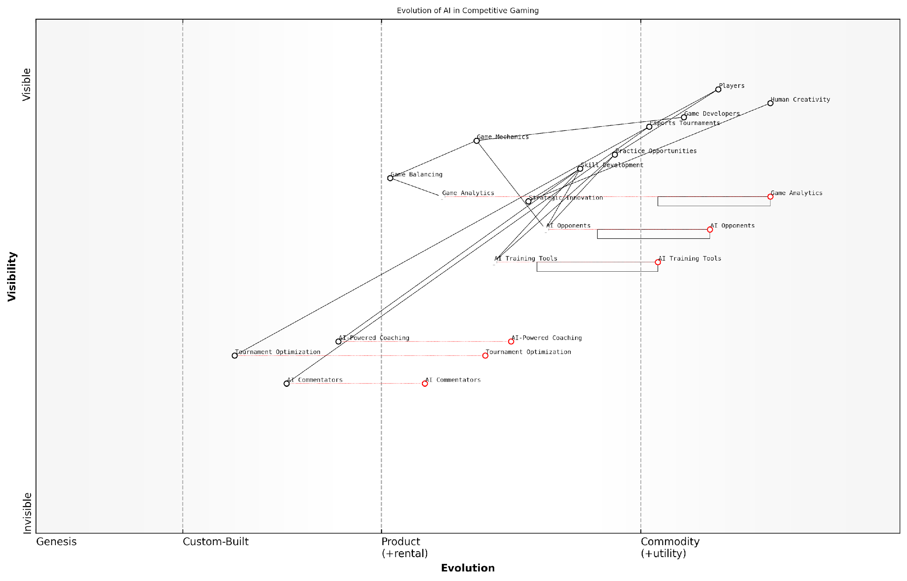

*Draft Wardley Map: [Insert Wardley Map: AI as Opponent and Training Tool]*

[Edit this draft Wardley Map](https://create.wardleymaps.ai/#clone:287eb6ff43dee889d3)

Wardley Map Assessment

The Wardley Map reveals a competitive gaming ecosystem that is increasingly leveraging AI technologies to enhance player experience, skill development, and competitive play. The strategic position is strong, with significant opportunities for innovation and growth, particularly in AI-powered coaching and tournament optimization. However, careful balance must be maintained to preserve the role of human creativity and ensure fair, engaging gameplay. The future evolution of this ecosystem will likely see deeper integration of AI across all aspects of competitive gaming, potentially revolutionising how games are played, watched, and monetized.

[View full Wardley Map report](http://markdown_wardley_map_reports/wardley_map_report_45_AI_as_Opponent_and_Training_Tool.md)

### The Future of AI in Esports

As we delve into the future of AI in esports, we find ourselves at the cusp of a revolutionary transformation in competitive gaming. The integration of advanced AI technologies is not merely enhancing the gaming experience; it is fundamentally reshaping the landscape of professional esports, creating new paradigms for player training, spectator engagement, and tournament organisation.

The potential impact of AI on esports is multifaceted and far-reaching. Let us explore the key areas where AI is poised to make significant contributions to the future of competitive gaming.

AI-Powered Training and Skill Development:

* Personalised Training Regimens: AI algorithms will analyse individual player performance data to create tailored training programmes, focusing on specific areas for improvement.
* Advanced Opponent Modelling: AI systems will simulate a wide range of playing styles and strategies, allowing players to practise against virtual opponents that mimic top competitors.
* Real-time Performance Analysis: During practice sessions, AI will provide instant feedback on decision-making, reaction times, and strategic choices, enabling rapid skill refinement.

The integration of AI in esports training is not just about creating better players; it’s about revolutionising how we approach skill development in competitive gaming. We’re moving towards a future where every training session is optimised for maximum efficiency and effectiveness.

Enhanced Spectator Experience:

* Predictive Analytics: AI will offer real-time predictions on match outcomes, player performances, and potential game-changing moments, adding a new layer of excitement for viewers.
* Personalised Viewing Experiences: AI algorithms will customise broadcast feeds based on individual viewer preferences, highlighting favourite players or focusing on specific aspects of gameplay.
* Automated Highlight Generation: AI-powered systems will instantly create highlight reels, capturing the most thrilling moments for rapid dissemination across social media platforms.

AI-Driven Tournament Organisation and Integrity:

* Sophisticated Match-making: AI algorithms will ensure fairer and more competitive matchups by considering a complex array of factors beyond simple player rankings.
* Cheat Detection: Advanced AI systems will monitor gameplay in real-time to detect any anomalies or potential cheating, ensuring the integrity of competitions.
* Adaptive Tournament Structures: AI will dynamically adjust tournament formats and schedules based on player performance, viewer engagement, and other real-time data.

The future of esports lies in creating an ecosystem where every stakeholder - from players to spectators to organisers - benefits from the intelligent application of AI. We’re not just enhancing the existing model; we’re reimagining what competitive gaming can be.

AI as Competitors and Collaborators:

* AI vs Human Tournaments: We will see more high-profile matches pitting top human players against advanced AI systems, pushing the boundaries of strategic gameplay.
* Human-AI Teams: Collaborative competitions where human players team up with AI partners will emerge, creating new forms of gameplay and strategic depth.
* AI Coaches: Virtual AI coaches will provide real-time advice and strategic insights to players during matches, similar to traditional sports coaching.

Ethical Considerations and Challenges:

* Balancing AI Assistance: Esports organisations will need to establish clear guidelines on the extent of AI assistance allowed during competitions to maintain fair play.
* Data Privacy: As AI systems collect and analyse vast amounts of player data, ensuring the privacy and security of this information will be paramount.
* Maintaining the Human Element: There will be ongoing debates about preserving the essence of human competition in an increasingly AI-driven esports landscape.

The Economic Impact of AI in Esports:

* New Revenue Streams: AI-driven personalisation will create opportunities for targeted advertising and sponsorships, potentially increasing the overall value of the esports industry.
* Job Creation and Transformation: While some traditional roles may be automated, new positions will emerge in AI development, data analysis, and AI-human integration specialists.
* Investment Opportunities: The convergence of AI and esports will likely attract significant investment from both tech companies and traditional sports organisations.

The economic potential of AI in esports is staggering. We’re not just talking about enhancing existing revenue models; we’re opening up entirely new markets and opportunities that we’ve only begun to imagine.

Looking ahead, the integration of AI in esports will continue to accelerate, driven by advancements in machine learning, computer vision, and natural language processing. As these technologies evolve, we can expect to see even more innovative applications that will further blur the lines between human and artificial intelligence in competitive gaming.

However, it is crucial to approach this AI-driven future with a balanced perspective. While the potential benefits are enormous, stakeholders must remain vigilant about the ethical implications and potential pitfalls. Maintaining the integrity of competition, ensuring player well-being, and preserving the human elements that make esports compelling will be ongoing challenges.

In conclusion, the future of AI in esports is not just about technological advancement; it’s about reimagining the very nature of competitive gaming. As we stand on the brink of this new era, it is clear that AI will play a pivotal role in shaping the esports landscape of tomorrow, creating experiences that are more engaging, more competitive, and more accessible than ever before.

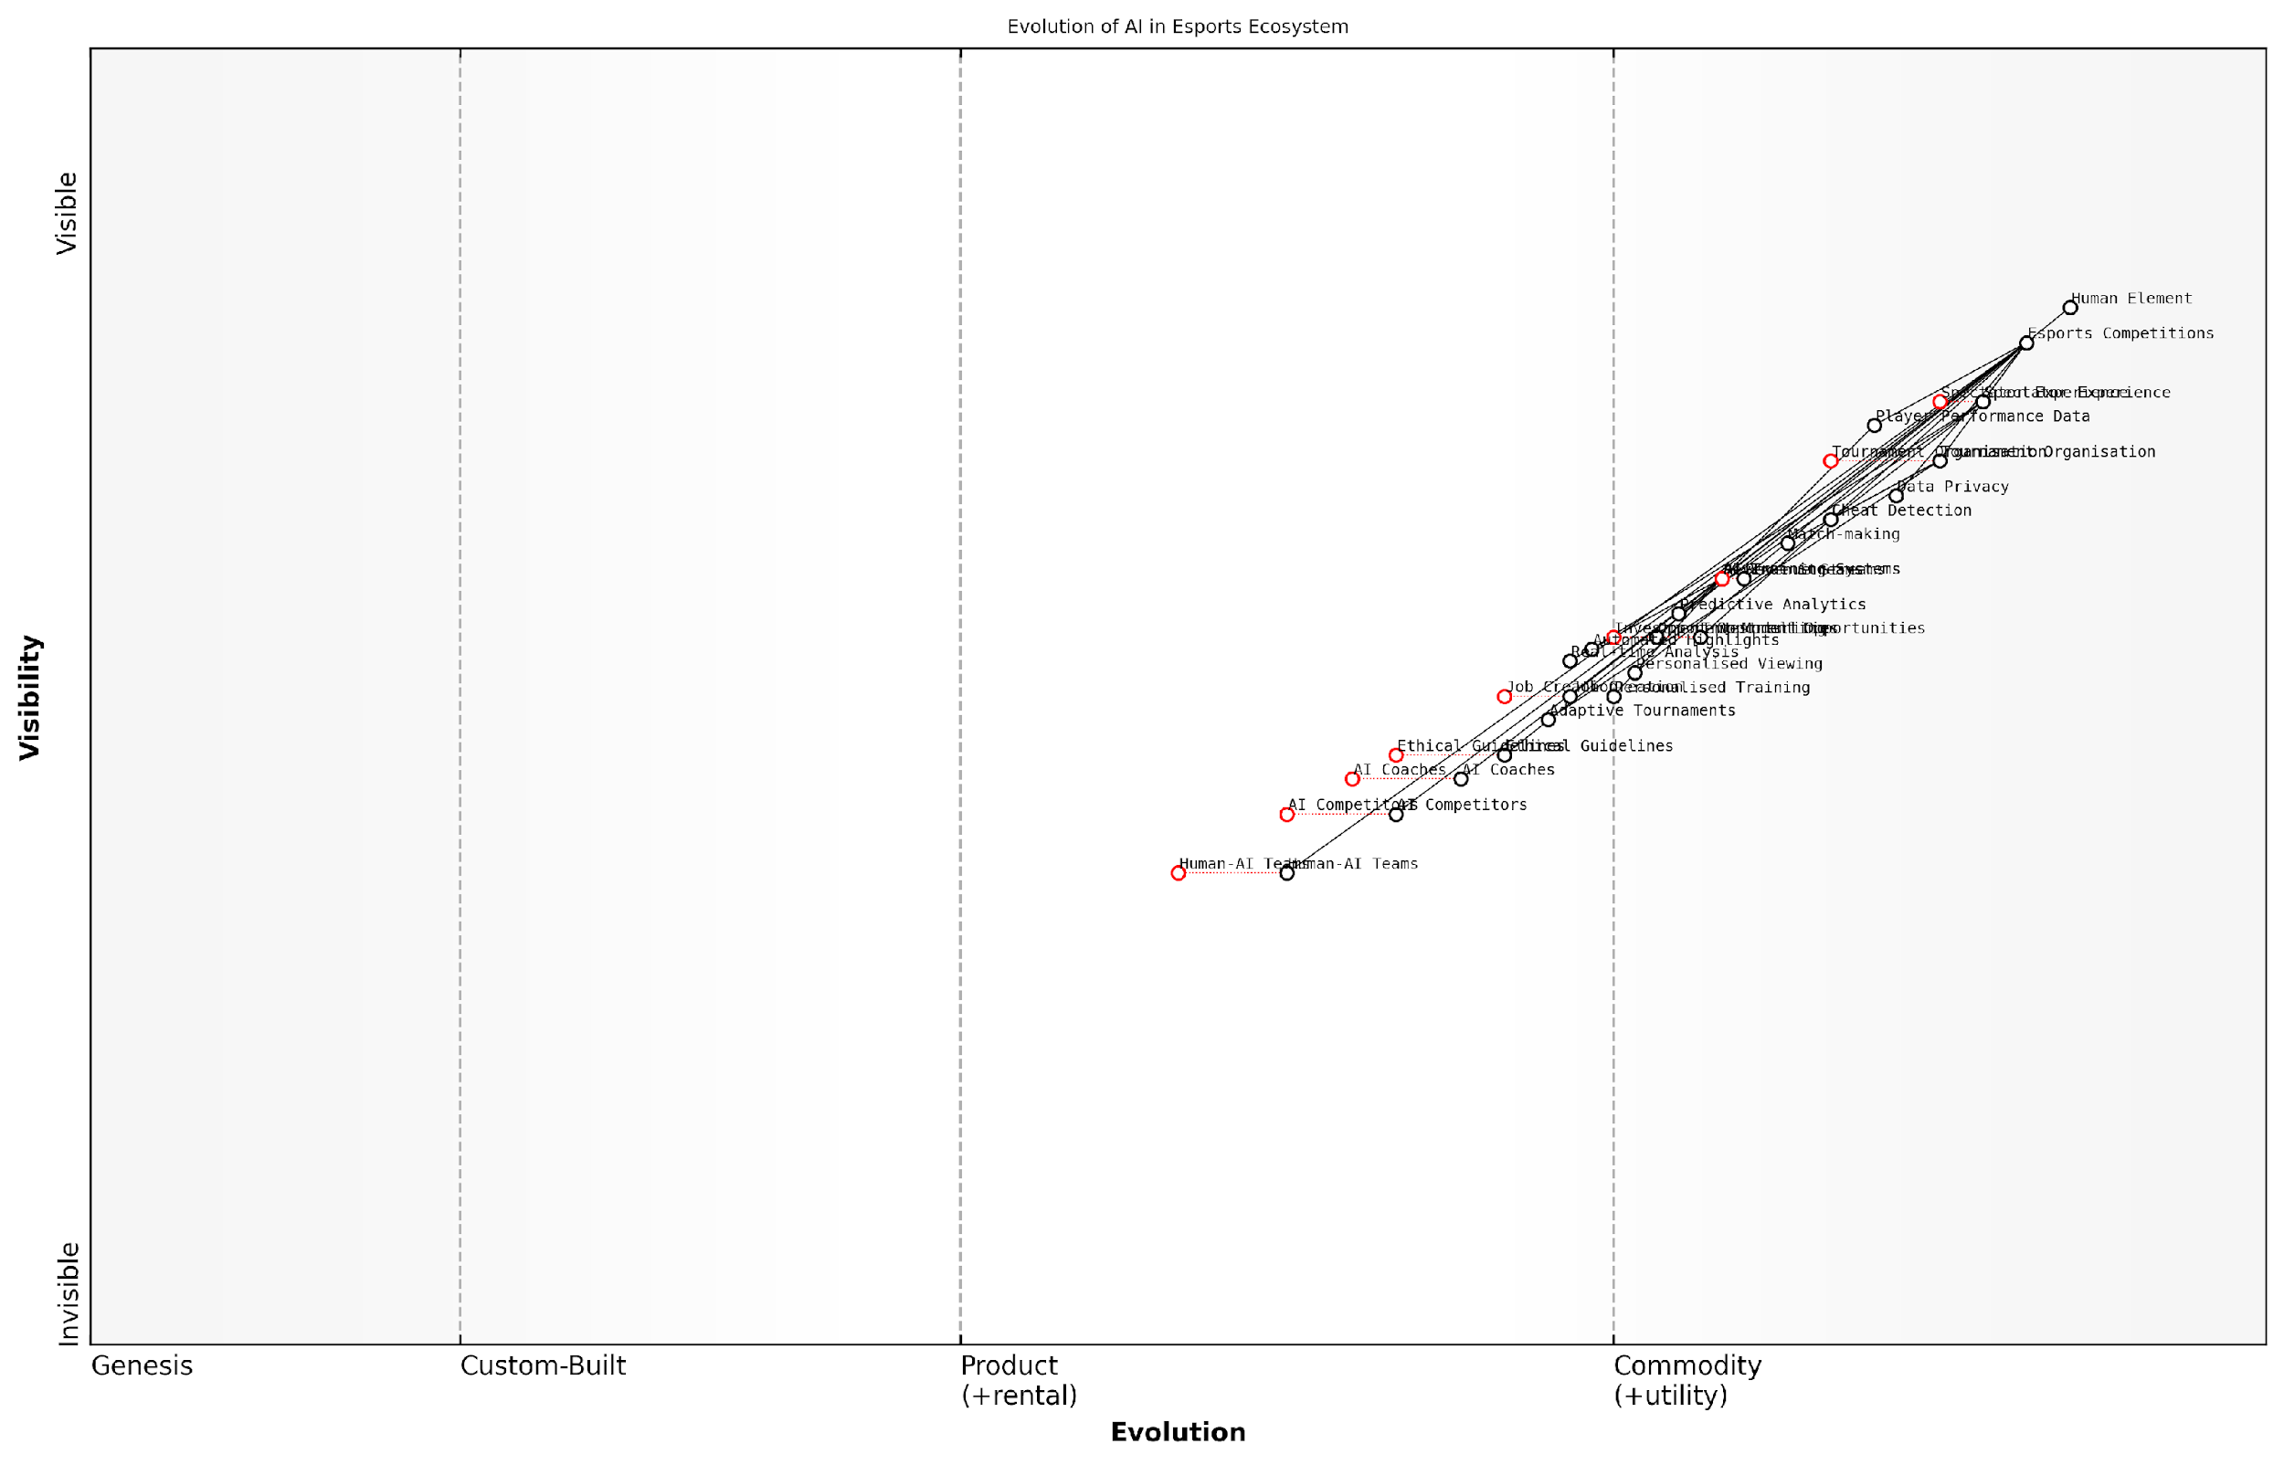

*Draft Wardley Map: [Insert Wardley Map: The Future of AI in Esports]*

[Edit this draft Wardley Map](https://create.wardleymaps.ai/#clone:e014cc4ce3135083e8)

Wardley Map Assessment

The map reveals a dynamic ecosystem poised for significant AI-driven transformation. The strategic focus should be on ethically integrating AI to enhance both competitive play and spectator experience, while carefully managing the balance between innovation and the preservation of esports’ human element. Key opportunities lie in personalised experiences, human-AI collaboration, and adaptive competition formats. However, success will hinge on robust ethical guidelines and data privacy measures. Organisations that can navigate these challenges while fostering innovation are likely to lead the next evolution of esports.

[View full Wardley Map report](http://markdown_wardley_map_reports/wardley_map_report_46_The_Future_of_AI_in_Esports.md)

## AI-Enhanced Mobile Gaming

### Case Study: Replika

In the rapidly evolving landscape of AI-enhanced mobile gaming, Replika stands out as a pioneering example of how generative AI can create deeply personalised and emotionally engaging experiences. This case study explores how Replika has leveraged advanced AI technologies to redefine the boundaries between gaming, social interaction, and personal development.

Replika, launched in 2017 by Luka Inc., is not a traditional game in the conventional sense. Instead, it represents a new paradigm in AI-driven mobile applications that blur the lines between gaming, chatbots, and virtual companions. At its core, Replika utilises sophisticated natural language processing (NLP) and machine learning algorithms to create a virtual AI friend that users can interact with through text-based conversations and, in more recent updates, voice and augmented reality (AR) features.

Replika represents a significant leap forward in AI-human interaction within the mobile space. It’s not just a game; it’s a glimpse into the future of how we might engage with AI in our daily lives.

The success of Replika in the AI-enhanced mobile gaming sector can be attributed to several key factors:

* Advanced Language Models: Replika employs state-of-the-art language models, similar to GPT (Generative Pre-trained Transformer), to generate human-like responses and maintain contextually relevant conversations.
* Personalisation through Machine Learning: The AI companion learns and adapts to the user’s personality, preferences, and conversational style over time, creating a highly personalised experience.
* Emotional Intelligence: Replika incorporates sentiment analysis and emotional recognition algorithms to respond empathetically to users’ moods and emotional states.
* Gamification Elements: While not a traditional game, Replika incorporates game-like elements such as character customisation, relationship levels, and achievement systems to enhance user engagement.
* Cross-platform Integration: The app seamlessly integrates across mobile devices and extends into AR environments, showcasing the potential for AI companions in mixed reality gaming scenarios.

The implications of Replika’s success extend far beyond its immediate application. It serves as a proof of concept for several emerging trends in AI-enhanced mobile gaming:

* AI-Driven Narrative Experiences: Replika demonstrates the potential for AI to create dynamic, personalised narratives that evolve based on user interactions.
* Emotional Gaming: The app highlights the growing importance of emotional engagement in gaming experiences, facilitated by advanced AI.
* Therapeutic Gaming: Replika’s use as a tool for emotional support and personal growth points to the potential for AI-enhanced games in mental health and well-being applications.
* Ethical Considerations: The deep personal connections users form with their AI companions raise important ethical questions about data privacy, emotional manipulation, and the nature of human-AI relationships.

However, the success of Replika also brings to light several challenges and considerations for the future of AI in mobile gaming:

* Data Privacy: The highly personal nature of interactions with AI companions like Replika necessitates robust data protection measures and transparent privacy policies.
* Ethical AI Design: Developers must carefully consider the ethical implications of creating AI entities capable of forming emotional bonds with users.
* Balancing AI Autonomy and Control: As AI becomes more sophisticated, finding the right balance between AI autonomy and developer control becomes increasingly crucial.
* Managing User Expectations: Clear communication about the capabilities and limitations of AI companions is essential to prevent unrealistic expectations or potential emotional harm.
* Regulatory Challenges: As AI companions become more prevalent, regulatory frameworks may need to evolve to address the unique challenges posed by these technologies.

The success of Replika underscores a fundamental shift in how we perceive gaming. It’s no longer just about entertainment; it’s about creating meaningful, personalised experiences that can have real-world impact on users’ lives.

Looking ahead, the Replika case study offers valuable insights for the future of AI-enhanced mobile gaming:

* Integration of AI Companions: We can expect to see more games incorporating AI companions as central elements, offering personalised guidance, storytelling, and emotional engagement.
* Expansion of Emotional AI: The success of Replika’s emotional engagement features is likely to drive further development and integration of emotional AI in mobile games.
* Cross-Reality Experiences: The integration of AI companions with AR features in Replika points towards a future where AI-driven characters seamlessly interact with users across virtual and physical realities.
* Personalisation at Scale: Replika’s ability to create unique experiences for each user showcases the potential for hyper-personalised gaming experiences driven by AI.
* Ethical Gaming Design: The ethical considerations raised by Replika will likely influence the development of guidelines and best practices for AI integration in mobile gaming.

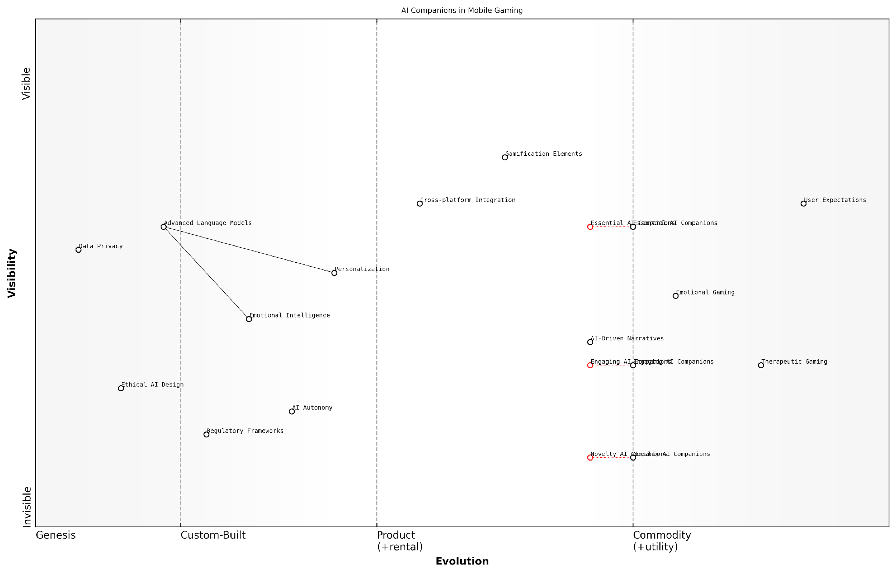

*Draft Wardley Map: [Insert Wardley Map: Case Study: Replika]*

[Edit this draft Wardley Map](https://create.wardleymaps.ai/#clone:9998c33ae816a50f94)

Wardley Map Assessment

The map reveals a rapidly evolving ecosystem centred around AI companions in mobile gaming. There’s significant potential for innovation and market leadership, particularly in areas like emotional intelligence and therapeutic gaming. However, success will require careful navigation of ethical considerations, regulatory challenges, and user expectations. The key to long-term success lies in balancing technological advancement with responsible AI development, while continuously enhancing the core offering of personalised, emotionally intelligent AI companions.

[View full Wardley Map report](http://markdown_wardley_map_reports/wardley_map_report_47_Case_Study:_Replika.md)

In conclusion, the Replika case study provides a compelling example of how generative AI can revolutionise mobile gaming experiences. By creating deeply personalised, emotionally engaging interactions, Replika has not only carved out a new niche in the mobile app ecosystem but has also set the stage for the next generation of AI-enhanced games. As we move forward, the lessons learned from Replika will undoubtedly shape the future of gaming, pushing the boundaries of what’s possible in AI-human interaction and paving the way for more immersive, personalised, and emotionally intelligent gaming experiences.

### AI Companions and Chatbots

The integration of AI companions and chatbots in mobile gaming represents a significant leap forward in creating immersive, personalised experiences for players. As we delve into this topic, it’s crucial to understand how these AI-driven entities are reshaping the landscape of mobile gaming, particularly within the context of generative AI’s broader impact on the industry.

AI companions and chatbots in mobile games serve multiple purposes, from enhancing gameplay and providing emotional engagement to offering personalised assistance and even driving narrative experiences. Their implementation showcases the potential of generative AI to create dynamic, responsive gaming environments that adapt to individual player preferences and behaviours.

Let’s explore the key aspects of AI companions and chatbots in mobile gaming:

* Natural Language Processing (NLP) and Understanding
* Emotional Intelligence and Adaptive Responses
* Personalisation and Player Profiling
* Narrative Engagement and Storytelling
* Game Assistance and Tutorial Functions
* Social Interaction and Community Building

Natural Language Processing (NLP) and Understanding:

At the core of AI companions and chatbots lies sophisticated NLP technology. Modern NLP models, powered by generative AI, enable these virtual entities to understand and respond to player inputs with unprecedented accuracy and contextual awareness. This advancement allows for more natural, flowing conversations that can adapt to various linguistic styles and even multiple languages.

The integration of advanced NLP in mobile gaming chatbots has revolutionised player-game interactions. We’re seeing a level of conversational fluidity that was unimaginable just a few years ago.

Emotional Intelligence and Adaptive Responses:

One of the most compelling aspects of AI companions in mobile games is their ability to exhibit emotional intelligence. Through sentiment analysis and machine learning algorithms, these AI entities can gauge a player’s emotional state and respond appropriately. This capability allows for the creation of more empathetic and engaging virtual characters that can form meaningful ‘relationships’ with players.

Personalisation and Player Profiling:

AI companions and chatbots leverage player data to create highly personalised experiences. By analysing gameplay patterns, chat history, and in-game decisions, these AI entities can tailor their responses and behaviours to individual players. This level of personalisation enhances player engagement and can significantly increase retention rates in mobile games.

The ability of AI companions to adapt to individual player preferences has been a game-changer in mobile gaming. We’re seeing unprecedented levels of player engagement and emotional investment in these virtual relationships.

Narrative Engagement and Storytelling:

Generative AI has opened up new possibilities for dynamic storytelling in mobile games. AI companions can now play pivotal roles in narrative-driven games, offering branching dialogues and plot developments based on player choices and interactions. This technology allows for the creation of rich, evolving storylines that can differ significantly from one playthrough to another, enhancing replayability and player immersion.

Game Assistance and Tutorial Functions:

AI chatbots serve a crucial role in onboarding new players and providing ongoing assistance. These intelligent assistants can offer contextual help, explain game mechanics, and even provide strategic advice tailored to a player’s skill level and progress. This adaptive support system can significantly improve the learning curve for complex games and enhance overall player satisfaction.

Social Interaction and Community Building:

In multiplayer mobile games, AI companions and chatbots can facilitate social interactions and community building. They can act as intermediaries, helping players connect with each other, organise events, or even fill in for absent human players in team-based games. This social aspect adds another layer of engagement and can foster a sense of belonging within the game’s community.

Challenges and Ethical Considerations:

While the potential of AI companions and chatbots in mobile gaming is immense, it’s crucial to address the associated challenges and ethical considerations. Privacy concerns, data protection, and the potential for AI manipulation are significant issues that developers and policymakers must grapple with. Additionally, there’s a need to strike a balance between AI-driven interactions and genuine human connections to prevent social isolation or over-reliance on virtual relationships.

As we push the boundaries of AI in gaming, we must remain vigilant about the ethical implications. The line between engaging gameplay and potential manipulation is one we must tread carefully.

Future Prospects:

Looking ahead, the future of AI companions and chatbots in mobile gaming is bright and full of potential. Advancements in generative AI, coupled with increasing computational power in mobile devices, will likely lead to even more sophisticated and lifelike virtual entities. We can anticipate AI companions that can learn and evolve alongside players, forming long-term ‘relationships’ that span multiple games or platforms.

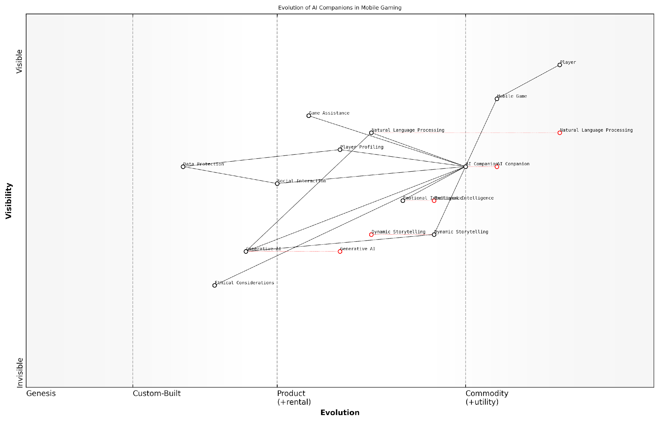

*Draft Wardley Map: [Insert Wardley Map: AI Companions and Chatbots]*

[Edit this draft Wardley Map](https://create.wardleymaps.ai/#clone:1213acb8e7868e1030)

Wardley Map Assessment

This Wardley Map reveals a mobile gaming ecosystem on the cusp of significant transformation driven by AI technologies. The strategic positioning of AI Companions as a central, evolving component supported by advancing technologies like NLP, Emotional Intelligence, and Generative AI indicates a strong potential for innovation and differentiation. However, this potential comes with significant challenges, particularly in ethical considerations and data protection. The key to success in this ecosystem will be balancing rapid technological advancement with responsible AI practices, all while maintaining a steadfast focus on enhancing player experience. Companies that can effectively integrate emerging technologies like Generative AI, while also addressing ethical concerns and data protection, will be well-positioned to lead in the next generation of AI-enhanced mobile gaming.

[View full Wardley Map report](http://markdown_wardley_map_reports/wardley_map_report_48_AI_Companions_and_Chatbots.md)

In conclusion, AI companions and chatbots represent a frontier in mobile gaming that is rapidly evolving thanks to generative AI technologies. As these systems become more sophisticated, they have the potential to redefine player experiences, storytelling methods, and the very nature of game design in the mobile space. However, as we embrace these advancements, it’s crucial to maintain a balanced approach that prioritises player well-being, ethical considerations, and the core essence of gaming as an interactive and social experience.

### Personalisation in Casual Games

As we delve into the realm of AI-Enhanced Mobile Gaming, one of the most significant advancements is the implementation of personalisation in casual games. This subsection explores how generative AI is revolutionising the casual gaming experience by tailoring content, difficulty, and rewards to individual players, creating a more engaging and addictive gameplay environment.

Casual games, typically characterised by their simple mechanics and short play sessions, have long been the cornerstone of mobile gaming. However, with the integration of generative AI, these games are evolving into sophisticated, personalised experiences that adapt to each player’s preferences, skills, and behaviours.

The future of casual gaming lies in hyper-personalisation. AI-driven systems that can understand and predict player behaviour are not just enhancing gameplay; they’re redefining the entire mobile gaming paradigm.

Let’s explore the key areas where AI is driving personalisation in casual games:

* Dynamic Difficulty Adjustment
* Personalised Content Generation
* Adaptive Reward Systems
* Behavioural Prediction and Recommendation
* Emotional Intelligence in Game Design

Dynamic Difficulty Adjustment (DDA) is perhaps the most immediate application of AI in personalising casual games. By analysing player performance in real-time, AI algorithms can adjust the game’s difficulty to maintain an optimal level of challenge. This ensures that players are neither frustrated by excessive difficulty nor bored by tasks that are too easy.

For instance, in puzzle games, the AI might subtly alter the complexity of levels based on how quickly a player solves previous puzzles. In endless runner games, the frequency and positioning of obstacles could be dynamically adjusted to match the player’s reflexes and skill level.

Dynamic difficulty adjustment is not just about making games easier or harder. It’s about creating a flow state where players are constantly engaged, challenged, and rewarded at just the right moments.

Personalised Content Generation takes customisation a step further. Generative AI can create unique in-game elements tailored to individual players. This could manifest as personalised storylines in narrative-driven casual games, custom-generated levels in puzzle games, or even AI-created characters that resonate with the player’s preferences.

For example, a casual farming game might use AI to generate crop layouts and quests based on a player’s previous choices and play style. A word game could create puzzles using vocabulary that aligns with the player’s demonstrated knowledge and interests.

Adaptive Reward Systems leverage AI to optimise the timing and nature of in-game rewards. By analysing player behaviour and engagement patterns, these systems can determine the most effective moments to offer rewards, as well as what types of rewards will be most motivating for each player.

This could involve adjusting the frequency of power-ups in a match-three game based on how often a player uses them, or tailoring the types of cosmetic rewards offered in a casual RPG to match the player’s aesthetic preferences.

The key to successful monetisation in free-to-play casual games is understanding exactly what each player values. AI-driven reward systems are becoming incredibly sophisticated at pinpointing these individual motivations.

Behavioural Prediction and Recommendation systems use machine learning algorithms to analyse player actions and predict future behaviour. This allows games to proactively offer content or features that the player is likely to enjoy, enhancing engagement and retention.

For instance, if the AI predicts that a player is likely to churn (stop playing the game), it might trigger special events or offers designed to re-engage that specific player. Or, based on play patterns, it might recommend new game modes or challenges that align with the player’s interests.

Emotional Intelligence in Game Design is an emerging field where AI is being used to recognise and respond to players’ emotional states. By analysing factors such as play patterns, device interaction (e.g., touch pressure), and even facial expressions (if permission is granted to access the device’s camera), games can adjust their tone, pacing, and content to match the player’s mood.

This could result in a casual game offering more relaxing, low-pressure content when it detects that a player is stressed, or ramping up the challenge and excitement when the player seems bored or understimulated.

The holy grail of personalisation in casual games is creating an experience that feels almost telepathic - a game that knows what you want before you do. We’re not there yet, but with advances in AI, we’re getting remarkably close.

While the potential of AI-driven personalisation in casual games is immense, it’s crucial to consider the ethical implications. Game developers must strike a balance between creating engaging, personalised experiences and respecting player privacy and autonomy.

Transparency about data collection and usage, clear opt-in/opt-out mechanisms for personalisation features, and safeguards against exploitative practices are essential considerations as this technology evolves.

As we look to the future, the line between casual and ‘hardcore’ games may blur as AI-driven personalisation makes even simple games deeply engaging and tailored to individual players. This could lead to new genres of games that adapt not just their content, but their entire genre and play style based on player preferences and behaviours.

The challenge for game developers will be to harness these powerful AI tools while maintaining the core appeal of casual games: accessibility, short play sessions, and simple, addictive gameplay loops. Those who succeed in this balancing act will likely shape the future of mobile gaming, creating experiences that are at once universally appealing and deeply personal.

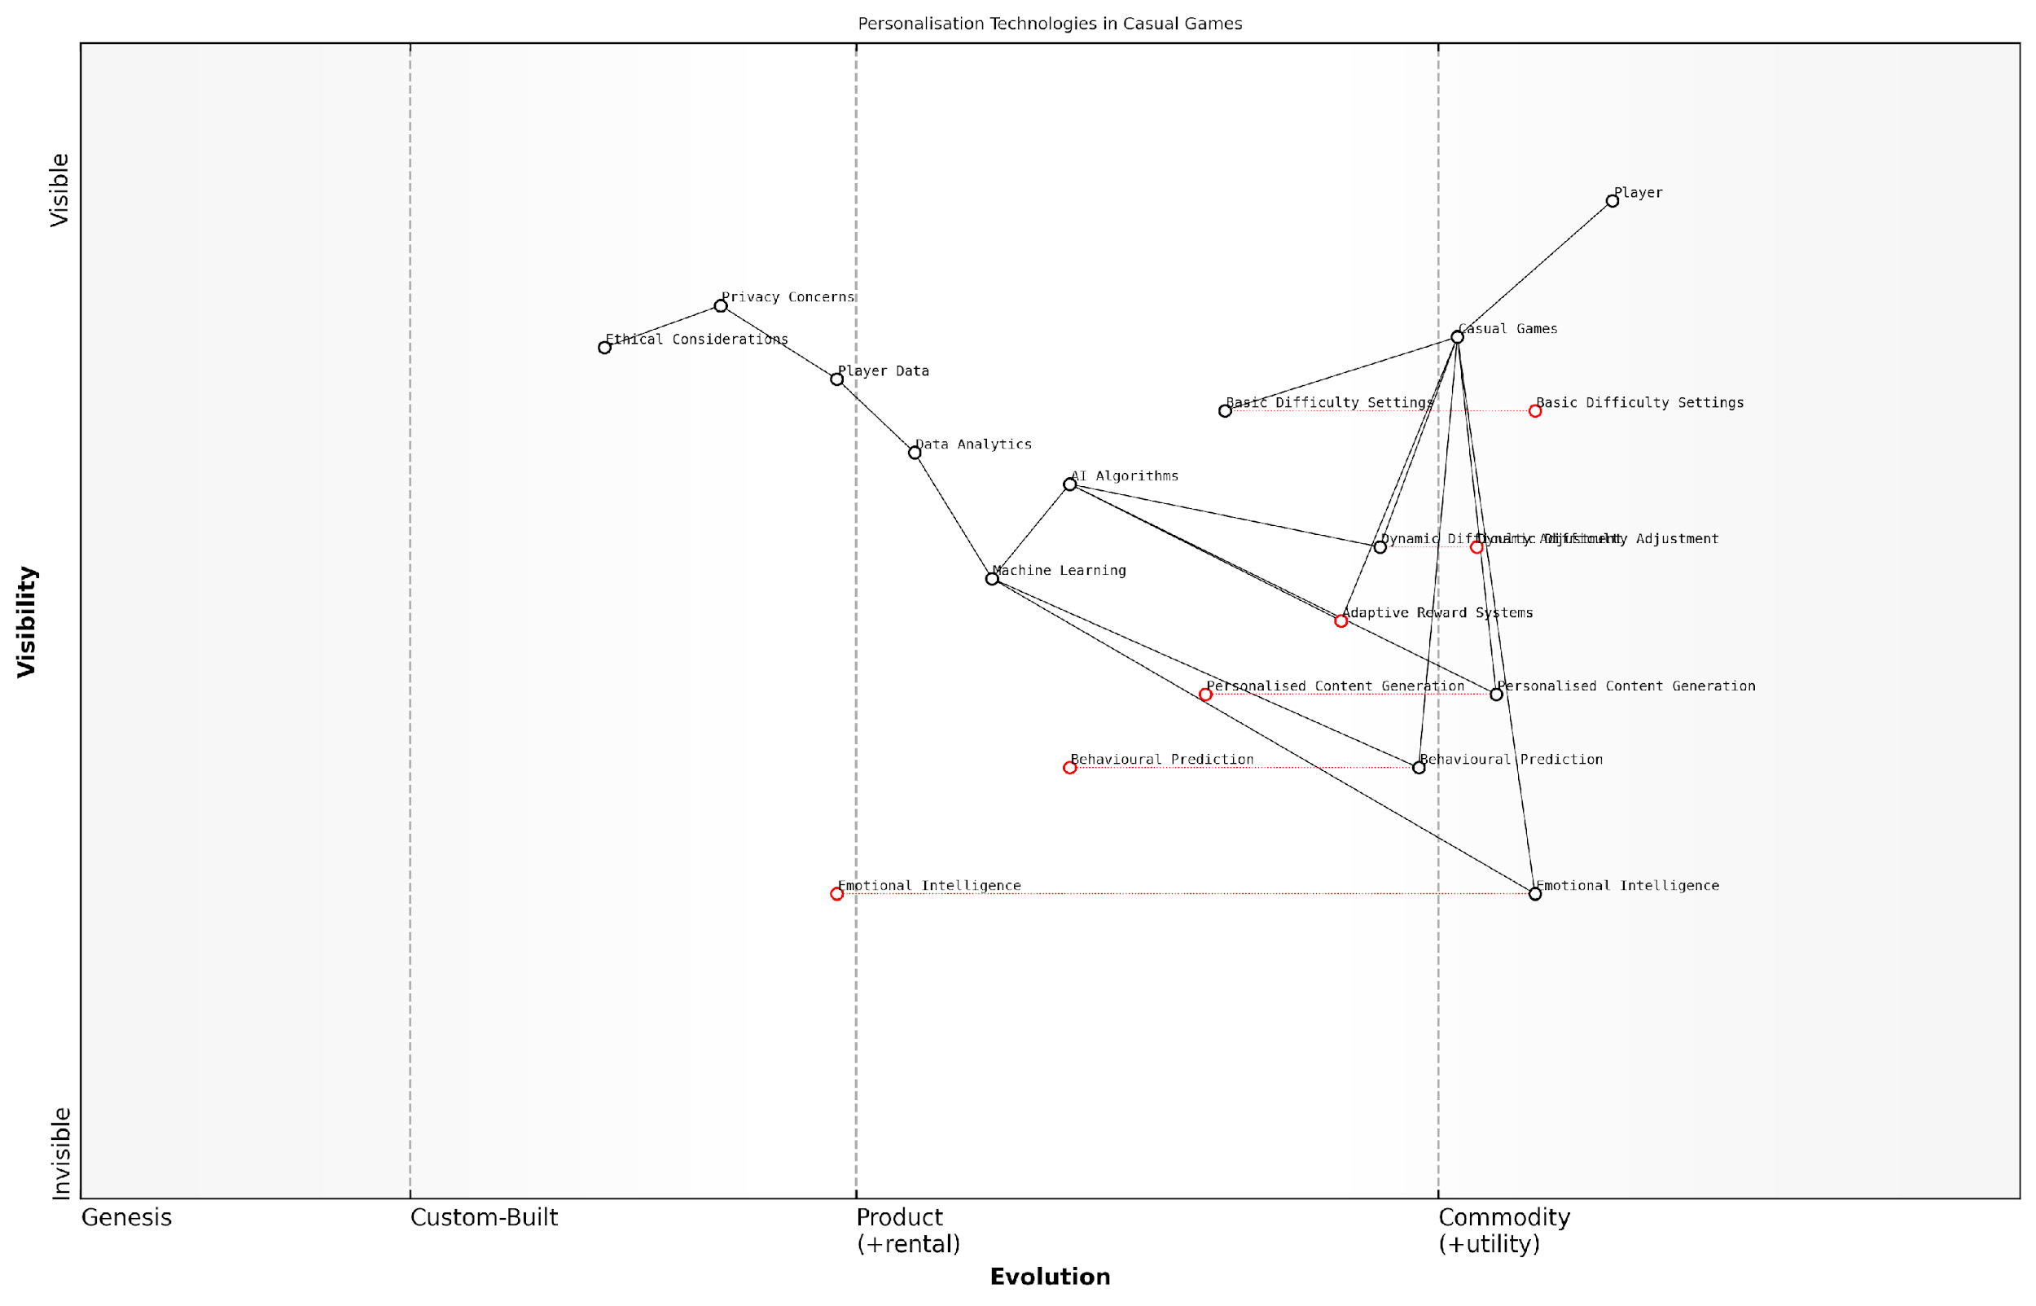

*Draft Wardley Map: [Insert Wardley Map: Personalisation in Casual Games]*

[Edit this draft Wardley Map](https://create.wardleymaps.ai/#clone:b61f6d106357af2489)

Wardley Map Assessment

This Wardley Map reveals a strategic focus on advancing personalisation technologies in casual games, with a clear evolution from basic features to sophisticated AI-driven solutions. The positioning of components suggests a forward-thinking approach, particularly with the inclusion of Emotional Intelligence. However, this ambition must be balanced with ethical considerations and privacy concerns. The key to success lies in strategically advancing high-potential components like Personalised Content Generation and Emotional Intelligence, while simultaneously strengthening foundational elements such as AI Algorithms and Data Analytics. Companies in this space should prioritise ethical AI development, invest in cutting-edge personalisation technologies, and create robust data protection measures to maintain player trust. The future of casual games appears to be heading towards hyper-personalised, emotionally intelligent experiences, and companies that can navigate this evolution while addressing associated challenges will likely emerge as industry leaders.

[View full Wardley Map report](http://markdown_wardley_map_reports/wardley_map_report_49_Personalisation_in_Casual_Games.md)

# Chapter 5: Future Trends and Potential Disruptions

## The Rise of AI Game Designers

### Automated Game Creation

As we venture into the future of gaming with generative AI, one of the most revolutionary developments is the emergence of automated game creation. This groundbreaking technology has the potential to fundamentally alter the landscape of game development, offering unprecedented opportunities for innovation, efficiency, and creativity. In this section, we will explore the intricacies of AI-driven game creation, its implications for the industry, and the challenges and opportunities it presents.

Automated game creation leverages the power of generative AI to streamline and, in some cases, entirely automate various aspects of game development. This includes everything from asset generation and level design to narrative creation and gameplay mechanics. The implications of this technology are far-reaching, potentially democratising game development and enabling the creation of more diverse and personalised gaming experiences.

Automated game creation is not just about efficiency; it’s about unlocking new realms of creativity and possibility in game design. We’re on the cusp of a paradigm shift that could redefine what it means to be a game developer.

Let’s delve into the key components and implications of automated game creation:

* AI-Driven Asset Generation
* Procedural Level Design
* Dynamic Narrative Creation
* Automated Game Balancing
* AI-Powered Game Engines

AI-Driven Asset Generation: One of the most time-consuming aspects of game development is the creation of visual and audio assets. Generative AI is revolutionising this process by automating the creation of textures, 3D models, animations, and even music and sound effects. This not only speeds up development but also allows for the generation of vast amounts of unique content, enhancing game variety and replayability.

Procedural Level Design: While procedural generation has been used in games for years, generative AI takes this concept to new heights. AI algorithms can now create entire game worlds, complete with intricate layouts, balanced resource distribution, and strategically placed challenges. This technology enables the creation of virtually infinite, unique game environments, significantly enhancing the longevity and replay value of games.

Dynamic Narrative Creation: Perhaps one of the most exciting applications of generative AI in game creation is its ability to craft dynamic, responsive narratives. AI-driven storytelling systems can generate plot points, dialogue, and character interactions on the fly, adapting to player choices and creating truly personalised narrative experiences. This technology has the potential to create games with unprecedented levels of narrative depth and player agency.

Automated Game Balancing: Balancing game mechanics and difficulty is a crucial yet challenging aspect of game design. Generative AI can analyse vast amounts of player data and automatically adjust game parameters to ensure optimal challenge and enjoyment for players of all skill levels. This dynamic balancing can lead to more engaging and fair gameplay experiences.

AI-Powered Game Engines: The future of game development may see the rise of AI-powered game engines that can interpret high-level design concepts and automatically generate functional game prototypes. These systems could potentially allow developers to create games through natural language instructions or even rough sketches, dramatically lowering the technical barriers to game creation.

The advent of AI-powered game engines marks a turning point in the democratisation of game development. We’re moving towards a future where anyone with a creative vision can bring their game ideas to life, regardless of their technical expertise.

While the potential of automated game creation is immense, it also raises important questions and challenges for the industry:

* The changing role of human developers
* Quality control and artistic integrity
* Intellectual property and ownership issues
* The potential homogenisation of game design
* Ethical considerations in AI-generated content

The role of human developers in this AI-driven landscape is evolving. Rather than replacing human creativity, automated game creation tools are likely to augment and enhance the capabilities of developers. Game designers may shift towards becoming ‘AI directors’, focusing on high-level creative direction and curation of AI-generated content. This shift will require new skills and approaches to game development, emphasising the importance of AI literacy in the industry.

Quality control and maintaining artistic integrity in AI-generated content present significant challenges. While AI can produce vast amounts of content quickly, ensuring consistency, coherence, and artistic vision across all elements of a game requires careful oversight. Developers will need to develop new workflows and tools to effectively curate and refine AI-generated content.

The rise of automated game creation also raises complex questions about intellectual property and ownership. As AI systems become more sophisticated in generating game content, determining the ownership and rights to AI-created assets, narratives, and even entire games will become increasingly complex. This may necessitate new legal frameworks and industry standards to address these issues.

There are concerns about the potential homogenisation of game design as AI systems learn from and potentially replicate existing successful game patterns. Ensuring diversity and innovation in game design will require careful curation and the intentional injection of human creativity and unconventional ideas into the AI-driven development process.

Ethical considerations in AI-generated content, particularly in areas such as narrative and character design, will become increasingly important. Issues of representation, cultural sensitivity, and the potential for AI to perpetuate biases must be carefully addressed to ensure that automated game creation contributes positively to the diversity and inclusivity of the gaming landscape.

In conclusion, automated game creation represents a transformative force in the gaming industry, offering unprecedented opportunities for innovation, efficiency, and creativity. As this technology continues to evolve, it will undoubtedly reshape the landscape of game development, potentially democratising the creation process and enabling new forms of interactive entertainment. However, realising the full potential of this technology while addressing its challenges will require careful consideration, ethical guidelines, and a balanced approach that leverages the strengths of both AI and human creativity.

The future of gaming lies not in choosing between human creativity and AI efficiency, but in finding the perfect synergy between the two. Automated game creation is not the end of human game development, but the beginning of a new era of boundless creative possibilities.

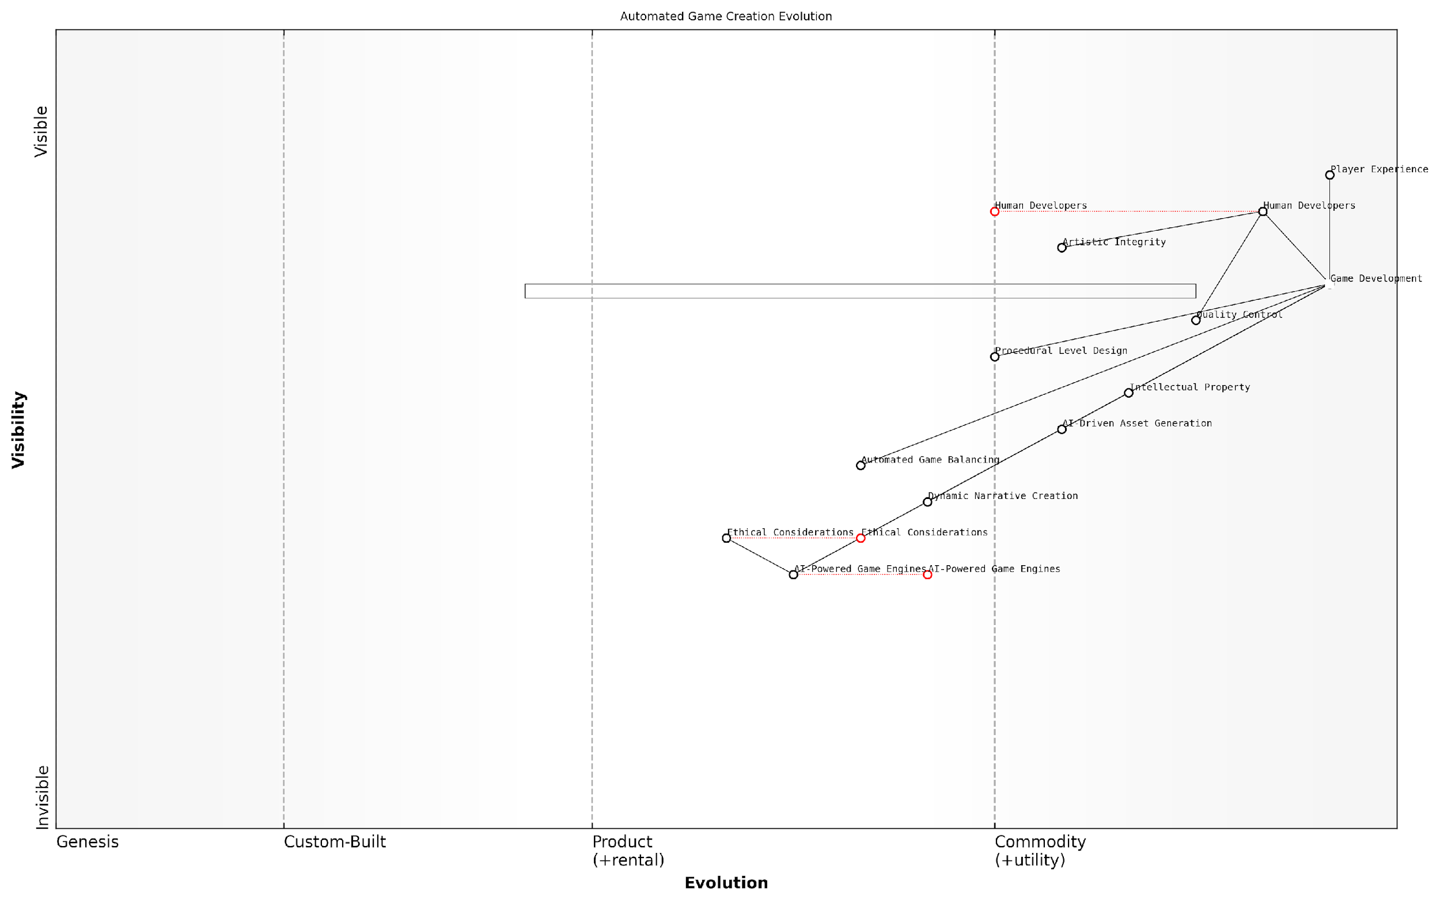

*Draft Wardley Map: [Insert Wardley Map: Automated Game Creation]*

[Edit this draft Wardley Map](https://create.wardleymaps.ai/#clone:5f2798773e845cfdd0)

Wardley Map Assessment

The map reveals a gaming industry on the cusp of an AI-driven revolution in game creation. While presenting immense opportunities for innovation and efficiency, this transition also poses significant challenges in maintaining artistic integrity, ensuring ethical practices, and redefining human roles. The strategic imperative is to harness AI technologies while fostering a balanced ecosystem that values human creativity, ethical considerations, and player experience. Success will likely come to those who can effectively integrate AI capabilities with human expertise, pioneering new forms of game development that push the boundaries of creativity and technology while adhering to strong ethical principles.

[View full Wardley Map report](http://markdown_wardley_map_reports/wardley_map_report_50_Automated_Game_Creation.md)

### Human-AI Collaboration in Design

As we venture deeper into the realm of AI-powered game design, the concept of human-AI collaboration emerges as a pivotal force shaping the future of the gaming industry. This symbiotic relationship between human creativity and artificial intelligence is not merely a fleeting trend, but a fundamental shift in how games are conceptualised, developed, and refined. In this section, we will explore the intricate dance between human game designers and their AI counterparts, examining the potential benefits, challenges, and implications for the future of game development.

The integration of AI into the game design process represents a paradigm shift in creative workflows. No longer confined to the role of a mere tool, AI is increasingly becoming an active collaborator, capable of generating ideas, solving complex design problems, and even anticipating player behaviour. This collaboration manifests in various stages of game development, from initial concept generation to iterative design refinement.

The future of game design lies not in the replacement of human creativity, but in the augmentation of it. AI will serve as a catalyst for innovation, pushing the boundaries of what’s possible in interactive entertainment.

One of the most promising aspects of human-AI collaboration in game design is the potential for rapid prototyping and iteration. AI algorithms can generate countless variations of game elements, from level layouts to character designs, allowing human designers to quickly explore a vast design space. This accelerated ideation process enables designers to focus on curating and refining the most promising concepts, rather than being bogged down by the initial creation phase.

* Rapid generation of game assets and environments
* AI-assisted balancing of game mechanics
* Procedural content generation for infinite gameplay possibilities
* Intelligent playtesting and player behaviour prediction

However, the integration of AI into the design process is not without its challenges. One of the primary concerns is maintaining the human touch and artistic vision in an increasingly automated workflow. Game designers must learn to effectively communicate their creative intent to AI systems, ensuring that the generated content aligns with the overall game vision. This requires a new set of skills, blending traditional game design knowledge with an understanding of AI capabilities and limitations.

Another critical aspect of human-AI collaboration is the potential for AI to serve as a creative muse, inspiring human designers with unexpected ideas and novel combinations. By analysing vast datasets of existing games, player preferences, and cultural trends, AI can identify patterns and opportunities that might elude human designers. This synergy between human intuition and AI-driven insights has the potential to spawn entirely new genres and gameplay mechanics.

AI is not just a tool for efficiency; it’s a wellspring of inspiration. The most innovative games of the future will be born from the creative friction between human imagination and machine intelligence.

As we look towards the future of human-AI collaboration in game design, several key trends emerge:

* Adaptive AI collaborators that learn and evolve alongside human designers
* Increased focus on interpretable AI, allowing designers to understand and guide the AI’s creative process
* Development of specialised AI tools for different aspects of game design, from narrative creation to sound design
* Integration of AI-driven player models to inform design decisions and personalise gameplay experiences

The implications of this collaborative approach extend beyond the realm of game development. As AI becomes more sophisticated, we may see a shift in the skills required for game designers. The ability to effectively collaborate with AI systems, interpret their outputs, and guide their creative processes will become increasingly valuable. Educational programmes and professional development initiatives will need to adapt to prepare the next generation of game designers for this AI-augmented landscape.

Moreover, the ethical considerations surrounding human-AI collaboration in game design cannot be overlooked. Questions of authorship, creative ownership, and the potential homogenisation of game design must be carefully addressed. As AI systems become more capable of generating complete game concepts, industry standards and legal frameworks will need to evolve to protect both human creators and the integrity of the creative process.

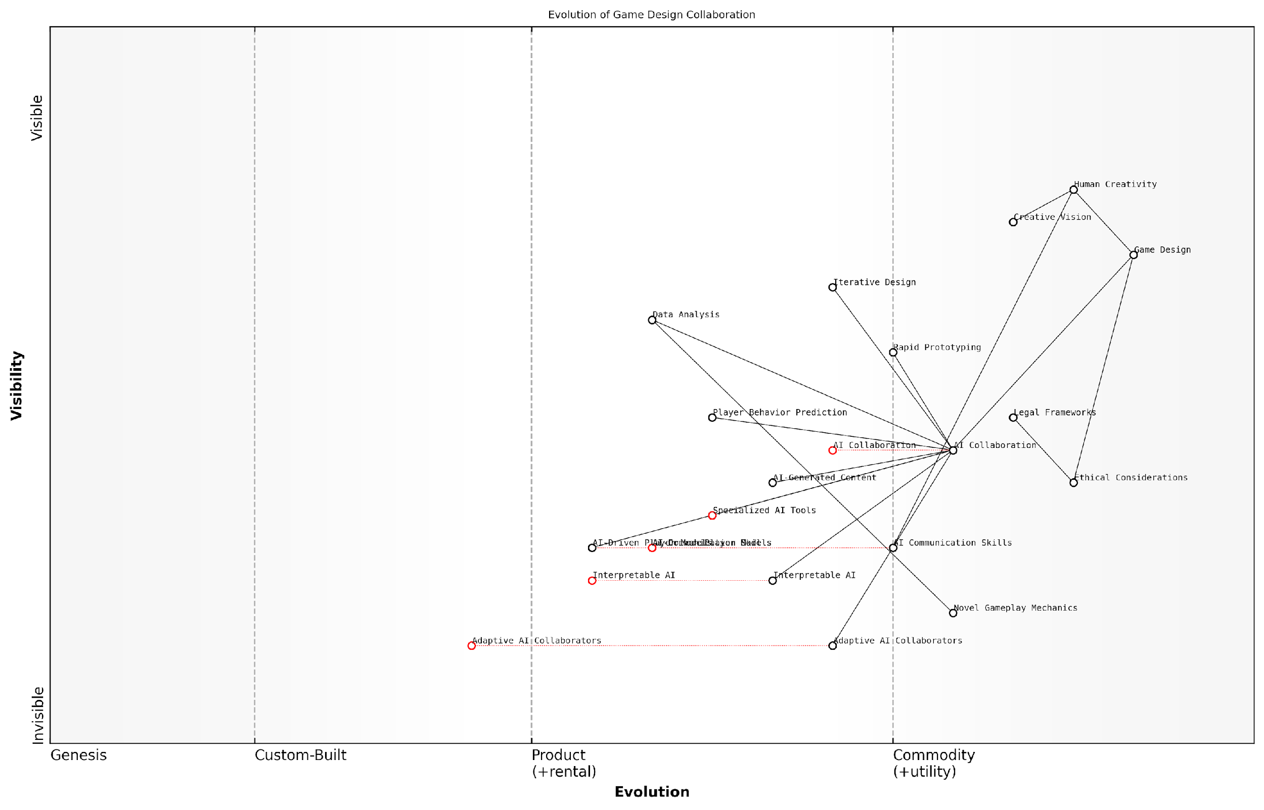

*Draft Wardley Map: [Insert Wardley Map: Human-AI Collaboration in Design]*

[Edit this draft Wardley Map](https://create.wardleymaps.ai/#clone:ff1c54adeab55cda92)

Wardley Map Assessment

The map reveals a strategic position at the forefront of human-AI collaboration in game design. There’s a strong foundation in traditional game design skills combined with an emerging focus on AI integration. The key to success lies in effectively balancing human creativity with AI capabilities while maintaining strong ethical standards. The industry is poised for significant transformation, with opportunities for those who can successfully navigate the complexities of AI collaboration in creative processes. Prioritising the development of AI communication skills, interpretable AI, and adaptive AI collaborators, while maintaining a strong ethical framework, will be crucial for long-term success and innovation in this evolving landscape.

[View full Wardley Map report](http://markdown_wardley_map_reports/wardley_map_report_51_Human-AI_Collaboration_in_Design.md)

In conclusion, human-AI collaboration in game design represents a transformative force that will shape the future of the gaming industry. By embracing this symbiotic relationship, game developers can unlock new realms of creativity, efficiency, and player engagement. However, success in this new paradigm will require a delicate balance between leveraging AI capabilities and preserving the human essence that lies at the heart of truly memorable gaming experiences. As we stand on the cusp of this exciting frontier, it is clear that the most successful game designers of the future will be those who master the art of dancing with their digital counterparts, creating experiences that push the boundaries of imagination and technology.

### The Changing Role of Game Developers

As we delve into the future of gaming with generative AI, it’s crucial to examine the profound impact on game developers’ roles. The integration of AI technologies is not merely augmenting existing processes; it’s fundamentally reshaping the landscape of game development. This transformation presents both exciting opportunities and significant challenges for developers, necessitating a shift in skills, mindset, and approach to game creation.

Traditionally, game developers have been responsible for every aspect of game creation, from conceptualisation to implementation. However, with the advent of generative AI, we’re witnessing a paradigm shift in these responsibilities. Let’s explore the key areas where this change is most pronounced:

* AI-Assisted Content Creation
* Algorithmic Game Design
* Data Analysis and Player Behaviour Modelling
* AI System Management and Oversight
* Ethical Considerations and Bias Mitigation

AI-Assisted Content Creation: One of the most significant changes in game development is the role of AI in content creation. Generative AI models can now produce vast amounts of game assets, from textures and 3D models to music and sound effects. This shift allows developers to focus more on high-level design and creative direction rather than the time-consuming task of creating every asset manually.

The integration of AI in content creation has revolutionised our workflow. We’re no longer constrained by the time it takes to produce assets; instead, we can focus on curating and refining AI-generated content to match our creative vision.

Algorithmic Game Design: With AI’s ability to generate and test game mechanics and levels at an unprecedented scale, developers are increasingly taking on the role of ‘meta-designers’. Instead of crafting individual levels or game scenarios, they’re designing the algorithms and parameters that guide AI in creating diverse and engaging gameplay experiences.

Data Analysis and Player Behaviour Modelling: As games become more adaptive and personalised, developers must become adept at interpreting complex data sets and using AI to model player behaviour. This shift requires a blend of statistical knowledge, machine learning expertise, and game design intuition to create experiences that dynamically respond to individual players.

AI System Management and Oversight: With AI taking on more aspects of game development and gameplay, developers are increasingly becoming AI system managers. This role involves overseeing AI processes, fine-tuning algorithms, and ensuring that AI-generated content aligns with the game’s overall vision and quality standards.

Our role has evolved from direct creation to orchestration. We’re now conductors, guiding AI systems to produce harmonious and engaging gaming experiences.

Ethical Considerations and Bias Mitigation: As AI systems become more integral to game development, developers must grapple with ethical considerations and potential biases in AI-generated content. This new responsibility requires a deep understanding of AI ethics, fairness in gaming, and the societal impact of the experiences they create.

The changing role of game developers also necessitates a shift in skill sets. While traditional programming and game design skills remain valuable, developers must now also cultivate expertise in:

* Machine Learning and AI Technologies
* Data Science and Analytics
* AI Ethics and Responsible Innovation
* Interdisciplinary Collaboration
* Adaptive Problem-Solving

This evolution in the developer’s role presents both challenges and opportunities for the gaming industry. On one hand, it may lead to increased efficiency and innovation in game development. On the other, it raises concerns about job displacement and the changing nature of creative work in the industry.

To navigate this transition successfully, game development studios and educational institutions must adapt their training and development programmes. Emphasis should be placed on cultivating a workforce that can effectively collaborate with AI systems, understand their capabilities and limitations, and leverage them to create innovative and engaging gaming experiences.

The future of game development lies not in competing with AI, but in harnessing its power to amplify human creativity and push the boundaries of what’s possible in gaming.

As we look to the future, it’s clear that the role of game developers will continue to evolve alongside advancements in AI technology. Those who can adapt to this new paradigm, blending technical expertise with creative vision and ethical considerations, will be well-positioned to lead the next generation of game development.

In conclusion, the changing role of game developers in the era of generative AI represents a significant shift in the industry. While it presents challenges, it also offers unprecedented opportunities for innovation and creativity. By embracing this transformation and developing the necessary skills, game developers can play a pivotal role in shaping the future of gaming, creating experiences that were once thought impossible.

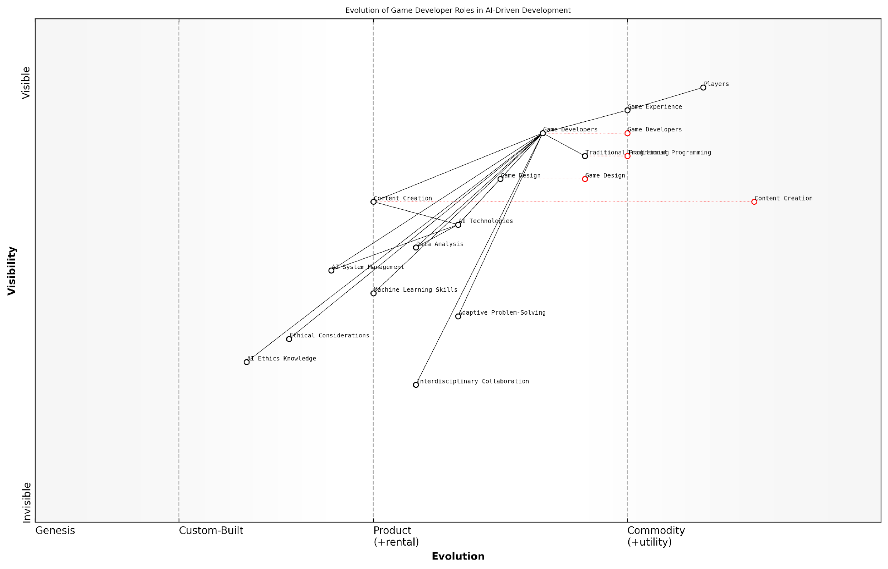

*Draft Wardley Map: [Insert Wardley Map: The Changing Role of Game Developers]*

[Edit this draft Wardley Map](https://create.wardleymaps.ai/#clone:43d6548417a0db99a1)

Wardley Map Assessment

This Wardley Map reveals a game development landscape in significant flux due to AI integration. While presenting challenges in terms of skill adaptation and ethical considerations, it also offers immense opportunities for innovation in game design and content creation. Success will hinge on effectively managing the transition to AI-driven development while maintaining a strong focus on player experience and ethical considerations. Game developers must evolve into multidisciplinary professionals capable of leveraging AI technologies responsibly and creatively.

[View full Wardley Map report](http://markdown_wardley_map_reports/wardley_map_report_52_The_Changing_Role_of_Game_Developers.md)

## Hyper-Personalised Gaming Experiences

### AI-Generated Worlds Unique to Each Player

As we delve into the realm of hyper-personalised gaming experiences, the concept of AI-generated worlds unique to each player emerges as a transformative force in the future of gaming. This revolutionary approach leverages the power of generative AI to create bespoke virtual environments that adapt and evolve based on individual player preferences, behaviours, and interactions. The implications of this technology are far-reaching, promising to redefine the very nature of game design and player engagement.

At its core, the idea of AI-generated worlds unique to each player represents a paradigm shift from traditional game design methodologies. Instead of crafting a single, static world for all players to explore, developers can now create dynamic systems that generate personalised content in real-time. This approach not only enhances player immersion but also addresses the long-standing challenge of replayability in games.

The future of gaming lies in creating worlds that are as unique as the players themselves. AI-generated environments have the potential to offer truly personalised experiences that evolve with each interaction, ensuring that no two playthroughs are ever the same.

To fully appreciate the potential of AI-generated worlds, it’s crucial to understand the underlying technologies and principles that make them possible. Let’s explore the key components and considerations:

* Procedural Content Generation (PCG)
* Machine Learning Models
* Player Behaviour Analysis
* Adaptive Storytelling
* Dynamic Environment Manipulation

Procedural Content Generation (PCG) forms the foundation of AI-generated worlds. This technique uses algorithms to create game content automatically, ranging from terrain and vegetation to buildings and quests. When combined with advanced machine learning models, PCG becomes exponentially more powerful, capable of generating complex, coherent, and contextually appropriate content that feels hand-crafted.

Machine learning models, particularly those utilising deep learning and neural networks, play a crucial role in creating unique worlds. These models can be trained on vast datasets of existing game content, player preferences, and real-world information to generate novel and engaging environments. As the AI continues to learn from player interactions, it refines its output, ensuring that the generated content becomes increasingly tailored to individual tastes.

Player behaviour analysis is another critical component in crafting personalised gaming experiences. By monitoring and analysing how players interact with the game world, the AI can infer preferences, play styles, and even emotional responses. This data feeds back into the generation algorithms, allowing the system to create content that resonates with each player on a deeply personal level.

The true power of AI-generated worlds lies not just in their ability to create unique environments, but in their capacity to understand and respond to the nuanced preferences of individual players. It’s about crafting experiences that feel tailor-made, as if the game world itself is a reflection of the player’s imagination.

Adaptive storytelling represents one of the most exciting applications of AI-generated worlds. By dynamically adjusting narrative elements, character interactions, and plot developments based on player choices and behaviours, the AI can create deeply immersive and personalised storylines. This approach goes beyond simple branching narratives, offering truly emergent storytelling that feels organic and responsive to player agency.

Dynamic environment manipulation takes personalisation a step further by allowing the game world to evolve in real-time based on player actions and preferences. This could manifest in various ways, from subtle changes in atmosphere and aesthetics to dramatic shifts in the physical layout of the world. The result is a living, breathing environment that feels uniquely attuned to each player’s journey.

While the potential of AI-generated worlds is immense, it’s important to acknowledge the challenges and considerations that come with this technology. One significant concern is maintaining a balance between personalisation and shared experiences. In a world where each player’s game is unique, how do we foster community and shared cultural touchstones? Developers must carefully consider how to incorporate elements of commonality while still delivering personalised content.

Another crucial consideration is the ethical implications of AI-generated content. As these systems become more sophisticated, questions arise about ownership, creativity, and the role of human designers. There’s also the potential for AI-generated worlds to inadvertently reinforce biases or create inappropriate content, necessitating robust oversight and ethical guidelines.

From a technical standpoint, the computational requirements for generating unique worlds in real-time are substantial. As we move towards more complex and detailed AI-generated environments, optimisation and efficient resource management will become increasingly important. Cloud computing and edge processing may offer solutions to these challenges, allowing for more sophisticated generation without compromising performance.

As we push the boundaries of what’s possible with AI-generated worlds, we must remain mindful of the delicate balance between innovation and responsibility. The future of gaming lies not just in creating more immersive experiences, but in doing so in a way that respects player agency, fosters creativity, and upholds ethical standards.

Looking ahead, the potential applications of AI-generated worlds extend far beyond traditional gaming. Educational simulations could create personalised learning environments that adapt to individual student needs. Virtual therapy sessions could take place in AI-generated worlds designed to elicit specific emotional responses. Even urban planning and architectural design could benefit from AI-generated simulations that model the impact of different design choices on diverse populations.

In conclusion, AI-generated worlds unique to each player represent a frontier in gaming that promises to revolutionise how we interact with virtual environments. By harnessing the power of generative AI, machine learning, and player analytics, developers can create deeply personalised experiences that adapt and evolve with each interaction. As we continue to refine these technologies and grapple with their implications, we stand on the cusp of a new era in gaming – one where every player’s journey is truly their own.

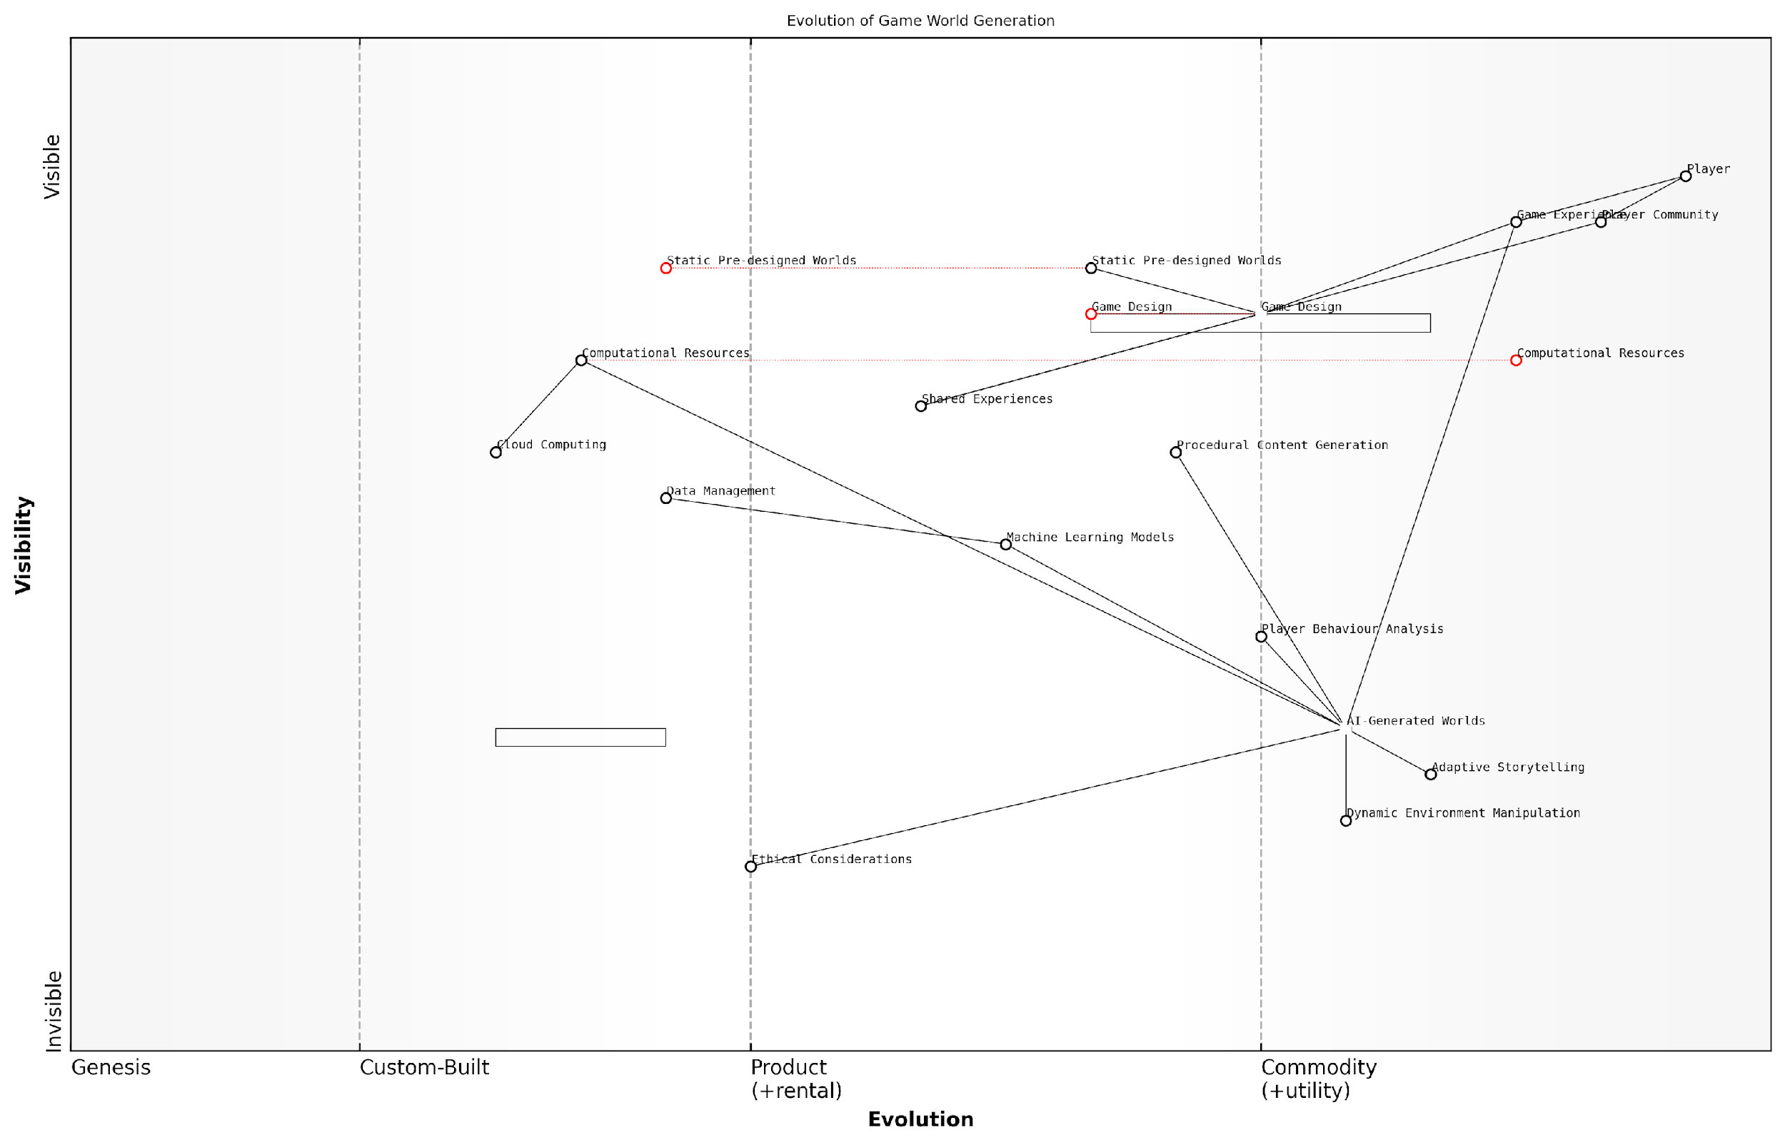

*Draft Wardley Map: [Insert Wardley Map: AI-Generated Worlds Unique to Each Player]*

[Edit this draft Wardley Map](https://create.wardleymaps.ai/#clone:13a2880009aa65f187)

Wardley Map Assessment

This Wardley Map reveals a gaming industry on the cusp of a major transformation driven by AI-generated, personalised gaming experiences. The strategic focus should be on developing robust AI capabilities, addressing ethical concerns, and creating a balanced ecosystem that enhances individual experiences while maintaining community engagement. Success will depend on efficiently managing computational resources, continuously improving machine learning models, and staying ahead in the rapidly evolving field of AI ethics in gaming.

[View full Wardley Map report](http://markdown_wardley_map_reports/wardley_map_report_53_AI-Generated_Worlds_Unique_to_Each_Player.md)

### Emotional AI and Deeply Responsive Games

As we delve deeper into the realm of hyper-personalised gaming experiences, the integration of Emotional AI and deeply responsive game systems emerges as a transformative force in the future of gaming. This advanced technology promises to revolutionise player engagement by creating dynamic, emotionally intelligent environments that adapt in real-time to players’ emotional states and preferences.

Emotional AI, also known as affective computing, represents a significant leap forward in the way games interact with players. By leveraging sophisticated algorithms and machine learning models, these systems can interpret and respond to a player’s emotional cues, creating a deeply immersive and personalised gaming experience.

The integration of Emotional AI in gaming is not just about enhancing gameplay; it’s about creating a symbiotic relationship between the player and the game world, where every interaction is meaningful and tailored to the individual’s emotional journey.

Let’s explore the key components and implications of Emotional AI in gaming:

* Emotion Recognition Technology
* Dynamic Narrative Adaptation
* Personalised Game Mechanics
* Emotional Feedback Loops
* Ethical Considerations and Player Well-being

Emotion Recognition Technology forms the foundation of these deeply responsive games. Advanced systems utilise a combination of facial expression analysis, voice recognition, biometric data, and even brain-computer interfaces to accurately gauge a player’s emotional state. This real-time emotional data serves as the input for the game’s adaptive systems.

One of the most exciting applications of Emotional AI is in Dynamic Narrative Adaptation. Games equipped with this technology can alter storylines, character interactions, and plot developments based on the player’s emotional responses. For instance, if a player shows signs of frustration or boredom during a particular quest, the game might introduce unexpected plot twists or adjust the pacing to re-engage the player.

The future of storytelling in games lies in creating narratives that breathe and evolve with the player’s emotions, blurring the line between authored content and emergent experiences.

Personalised Game Mechanics represent another frontier in emotionally intelligent gaming. These systems can dynamically adjust difficulty levels, reward structures, and even the game’s visual and auditory elements based on the player’s emotional state. For example, if a player is experiencing high levels of stress during a challenging boss fight, the game might subtly adjust the enemy’s behaviour or provide visual cues to assist the player, ensuring a balance between challenge and enjoyment.

Emotional Feedback Loops are a crucial aspect of deeply responsive games. These systems create a continuous cycle of emotional interaction between the player and the game world. As the game responds to the player’s emotions, it in turn influences the player’s emotional state, creating a deeply immersive and personalised experience. This feedback loop can be used to guide players towards desired emotional states, enhancing both enjoyment and the overall narrative experience.

However, the implementation of Emotional AI in gaming also raises important Ethical Considerations and concerns about Player Well-being. Game developers and publishers must navigate complex issues surrounding data privacy, emotional manipulation, and the potential for addiction. It’s crucial to establish clear guidelines and safeguards to ensure that these technologies are used responsibly and ethically.

As we push the boundaries of emotional engagement in games, we must remain vigilant in protecting player autonomy and mental health. The power to influence emotions comes with great responsibility.

The potential applications of Emotional AI in gaming extend far beyond entertainment. These technologies have the potential to revolutionise fields such as education, therapy, and professional training. Imagine educational games that adapt to a student’s frustration levels, providing additional support or challenges as needed. Or consider therapeutic applications where games can help individuals manage anxiety or depression by responding to their emotional states in real-time.

As we look to the future, the convergence of Emotional AI with other emerging technologies such as virtual and augmented reality promises to create unprecedented levels of immersion and personalisation in gaming. The ability to create fully responsive virtual worlds that adapt not just to our actions, but to our emotions, opens up new frontiers in interactive entertainment and beyond.

In conclusion, Emotional AI and deeply responsive games represent a paradigm shift in the gaming industry. By creating experiences that are truly tailored to each individual player’s emotional journey, these technologies have the potential to revolutionise not just how we play games, but how we interact with digital environments across various domains. As we continue to refine and expand these capabilities, we must remain mindful of the ethical implications and strive to create emotionally intelligent systems that enhance human experiences while respecting individual autonomy and well-being.

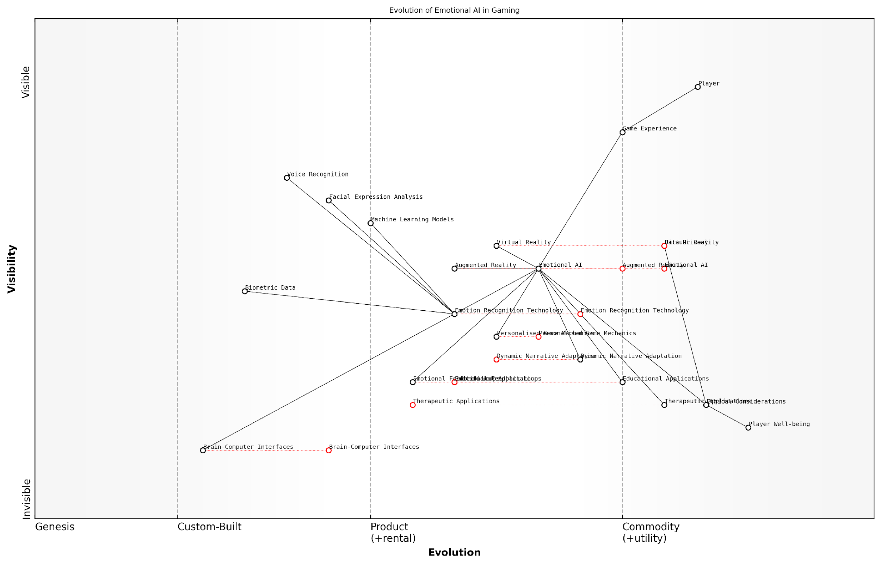

*Draft Wardley Map: [Insert Wardley Map: Emotional AI and Deeply Responsive Games]*

[Edit this draft Wardley Map](https://create.wardleymaps.ai/#clone:8b88c058569ac6c726)

Wardley Map Assessment

The Wardley Map reveals a dynamic and evolving ecosystem centred around Emotional AI in gaming. The strategic position is strong, with a clear focus on developing custom AI solutions while maintaining ethical standards. Key opportunities lie in advancing core technologies, exploring emerging fields like Brain-Computer Interfaces, and expanding into educational and therapeutic applications. The main challenges involve balancing innovation with ethical considerations and data privacy. Success will depend on strategic investments in key evolving components, strong partnerships across the ecosystem, and a commitment to user-centric, ethically-sound development practices.

[View full Wardley Map report](http://markdown_wardley_map_reports/wardley_map_report_54_Emotional_AI_and_Deeply_Responsive_Games.md)

### The Convergence of Gaming and Personal AI Assistants

As we venture deeper into the realm of hyper-personalised gaming experiences, the convergence of gaming and personal AI assistants emerges as a transformative trend that promises to redefine the boundaries between virtual worlds and our daily lives. This fusion represents a paradigm shift in how players interact with games, blurring the lines between in-game experiences and real-world assistance.

The integration of personal AI assistants into gaming ecosystems is not merely an incremental improvement but a revolutionary step towards creating seamless, immersive, and deeply personalised gaming experiences. This convergence leverages the power of advanced natural language processing, machine learning, and contextual understanding to create a symbiotic relationship between the player’s virtual and real-world personas.

The future of gaming lies not just in what happens on the screen, but in how it integrates with and enhances our daily lives. Personal AI assistants are the bridge between these two realms, offering unprecedented levels of personalisation and engagement.

Let’s explore the key aspects of this convergence and its implications for the future of gaming:

* Seamless Cross-Platform Integration
* Voice-Activated Gaming Experiences
* Real-Time Strategy and Decision Support
* Personalised Content Curation and Recommendations
* Enhanced Accessibility and Inclusivity
* Augmented Reality (AR) Gaming Integration
* Privacy and Data Security Considerations

Seamless Cross-Platform Integration: The convergence of gaming and personal AI assistants enables a fluid gaming experience that transcends individual devices. Players can seamlessly transition between their console, mobile device, and smart home systems, with their AI assistant maintaining context and progress across platforms. This integration allows for continuous gameplay and interaction, even when players are away from their primary gaming setup.

Voice-Activated Gaming Experiences: As natural language processing technologies advance, voice commands are becoming an increasingly integral part of gaming interfaces. Personal AI assistants can interpret complex voice commands, allowing players to navigate menus, control in-game actions, and even engage in dialogue with non-player characters (NPCs) using natural speech. This hands-free interaction enhances immersion and accessibility, particularly in virtual reality (VR) environments.

Voice-activated gaming is not just about convenience; it’s about creating a more natural and immersive interface between the player and the game world. It’s the next frontier in human-computer interaction within gaming.

Real-Time Strategy and Decision Support: Personal AI assistants can provide real-time strategic advice and decision support during gameplay, analysing game states, player performance, and historical data to offer personalised recommendations. This feature is particularly valuable in complex strategy games or multiplayer online battle arenas (MOBAs), where split-second decisions can be crucial. The AI assistant acts as a virtual coach, helping players improve their skills and make more informed choices.

Personalised Content Curation and Recommendations: By analysing a player’s gaming habits, preferences, and performance across multiple titles, personal AI assistants can curate highly personalised content recommendations. This includes suggesting new games, in-game items, or downloadable content (DLC) that align with the player’s interests. The AI can also dynamically adjust in-game content, such as quests or challenges, to match the player’s skill level and play style, ensuring a consistently engaging experience.

Enhanced Accessibility and Inclusivity: The integration of personal AI assistants in gaming significantly enhances accessibility for players with disabilities. Voice commands, real-time text-to-speech, and adaptive interfaces powered by AI can make games more inclusive, allowing a broader audience to enjoy gaming experiences. The AI assistant can adapt game settings, provide audio descriptions, or offer alternative control schemes based on individual needs.

Augmented Reality (AR) Gaming Integration: As AR gaming gains popularity, personal AI assistants play a crucial role in bridging the virtual and physical worlds. They can provide contextual information about the player’s surroundings, overlay game elements onto the real world, and facilitate multiplayer interactions in AR environments. This integration creates unique, location-based gaming experiences that blend seamlessly with daily life.

Privacy and Data Security Considerations: The convergence of gaming and personal AI assistants raises important questions about data privacy and security. Game developers and AI providers must implement robust safeguards to protect players’ personal information and gaming data. Transparent data usage policies and opt-in mechanisms for data sharing are essential to maintain trust and comply with evolving data protection regulations.

As we embrace the potential of AI-assisted gaming, we must remain vigilant about protecting player privacy. The trust between players and game developers is paramount, and it’s our responsibility to ensure that the convergence of gaming and AI enhances the player experience without compromising their personal data.

The convergence of gaming and personal AI assistants represents a significant leap forward in creating hyper-personalised gaming experiences. By leveraging advanced AI technologies, game developers can create more immersive, accessible, and tailored experiences that adapt to each player’s unique needs and preferences. As this trend continues to evolve, we can expect to see even more innovative applications that further blur the lines between gaming and everyday life, ultimately transforming how we interact with and experience digital entertainment.

As we look to the future, the convergence of gaming and personal AI assistants opens up exciting possibilities for new game genres, innovative gameplay mechanics, and novel forms of player engagement. Game developers and AI researchers must collaborate closely to harness the full potential of this convergence, while also addressing the ethical and technical challenges it presents. By doing so, we can create a future of gaming that is more inclusive, engaging, and seamlessly integrated into our daily lives.

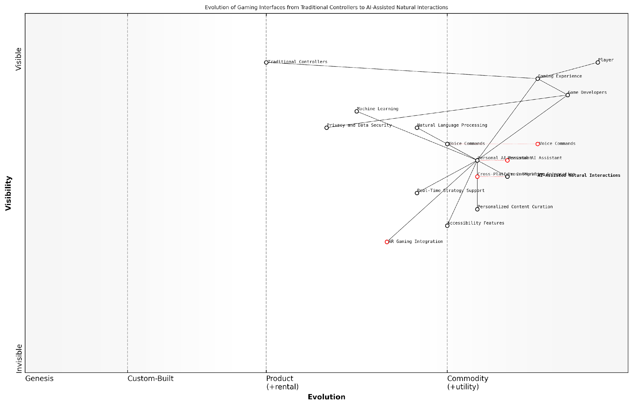

*Draft Wardley Map: [Insert Wardley Map: The Convergence of Gaming and Personal AI Assistants]*

[Edit this draft Wardley Map](https://create.wardleymaps.ai/#clone:33ca825396cfa5baa8)

Wardley Map Assessment

This Wardley Map reveals a gaming industry on the cusp of a major transformation driven by AI and AR technologies. The central role of Personal AI Assistants indicates a future where gaming experiences are highly personalised, intuitive, and seamlessly integrated across platforms. To succeed in this evolving landscape, companies must invest heavily in AI capabilities, prioritise privacy and security, and reimagine game development processes. The convergence of gaming with broader AI ecosystems presents both challenges and opportunities, requiring strategic partnerships and a focus on creating open, adaptable platforms. Those who can successfully navigate this transition, balancing innovation with user needs and ethical considerations, will be well-positioned to lead the next generation of gaming experiences.

[View full Wardley Map report](http://markdown_wardley_map_reports/wardley_map_report_55_The_Convergence_of_Gaming_and_Personal_AI_Assistan.md)

## The Metaverse and AI

### AI-Powered Virtual Worlds

As we venture into the future of gaming with generative AI, the concept of AI-powered virtual worlds stands at the forefront of innovation, promising to revolutionise the way we interact with digital environments. These immersive, intelligent ecosystems represent a paradigm shift in gaming, blending advanced AI technologies with the expansive potential of virtual reality to create unprecedented experiences.

At its core, an AI-powered virtual world leverages generative AI to create dynamic, responsive, and ever-evolving digital landscapes. Unlike traditional game environments, which are largely static and pre-designed, these AI-driven worlds are capable of adapting, expanding, and responding to player interactions in real-time. This level of dynamism and intelligence opens up a wealth of possibilities for game developers and players alike, pushing the boundaries of what’s possible in interactive entertainment.

AI-powered virtual worlds are not just the next step in gaming; they represent a fundamental shift in how we conceive of digital spaces. These environments have the potential to become living, breathing entities that grow and evolve alongside their inhabitants.

Let’s delve into the key components and implications of AI-powered virtual worlds:

* Procedural Content Generation at Scale
* Intelligent Non-Player Characters (NPCs)
* Dynamic Narrative and Quest Generation
* Adaptive Environmental Systems
* Player-AI Collaboration and Co-creation

Procedural Content Generation at Scale: One of the most significant advantages of AI-powered virtual worlds is the ability to generate vast, diverse landscapes and content on an unprecedented scale. Utilising advanced machine learning algorithms, these systems can create entire continents, cities, and ecosystems that are both coherent and unique. This capability addresses one of the longstanding challenges in game development: the creation of large, varied game worlds without the need for extensive manual design work.

For instance, in my work advising a major government-funded gaming initiative, we explored the use of generative adversarial networks (GANs) to create realistic urban environments for training simulations. The AI was capable of generating entire cityscapes, complete with architectural styles that reflected specific cultural and historical contexts, all while maintaining logical urban planning principles.

Intelligent Non-Player Characters (NPCs): AI-powered virtual worlds take NPC interactions to new heights. Instead of relying on pre-scripted dialogues and behaviours, NPCs in these environments utilise natural language processing and machine learning to engage in more natural, context-aware conversations. They can remember past interactions, learn from player behaviour, and even develop their own goals and motivations.

The future of NPCs lies in their ability to be indistinguishable from human players. When we achieve that level of AI sophistication, the line between virtual and real social interactions will blur, creating profound implications for how we perceive and engage with digital entities.

Dynamic Narrative and Quest Generation: Traditional game narratives often follow linear or branching paths, limited by pre-written scripts. In AI-powered virtual worlds, narratives can be generated dynamically, responding to player actions and choices in real-time. This approach allows for truly personalised storytelling, where each player’s journey through the world is unique and shaped by their decisions and interactions.

During a recent consultation with a public sector educational gaming project, we implemented an AI system that could generate educational quests based on a student’s learning progress and interests. The system adapted the difficulty and content of the quests in real-time, ensuring an optimal learning experience for each individual.

Adaptive Environmental Systems: AI-powered virtual worlds can feature environments that respond intelligently to player actions and natural in-game events. Weather patterns, ecosystems, and even geological processes can be simulated with unprecedented realism and complexity. This level of environmental responsiveness creates a more immersive and believable world, where players’ actions have far-reaching consequences on the virtual ecosystem.

Player-AI Collaboration and Co-creation: Perhaps one of the most exciting aspects of AI-powered virtual worlds is the potential for collaboration between human players and AI systems in shaping the world itself. Players could work alongside AI to design new structures, craft unique items, or even create new quests and storylines. This collaborative approach blurs the line between player and designer, opening up new avenues for creativity and engagement.

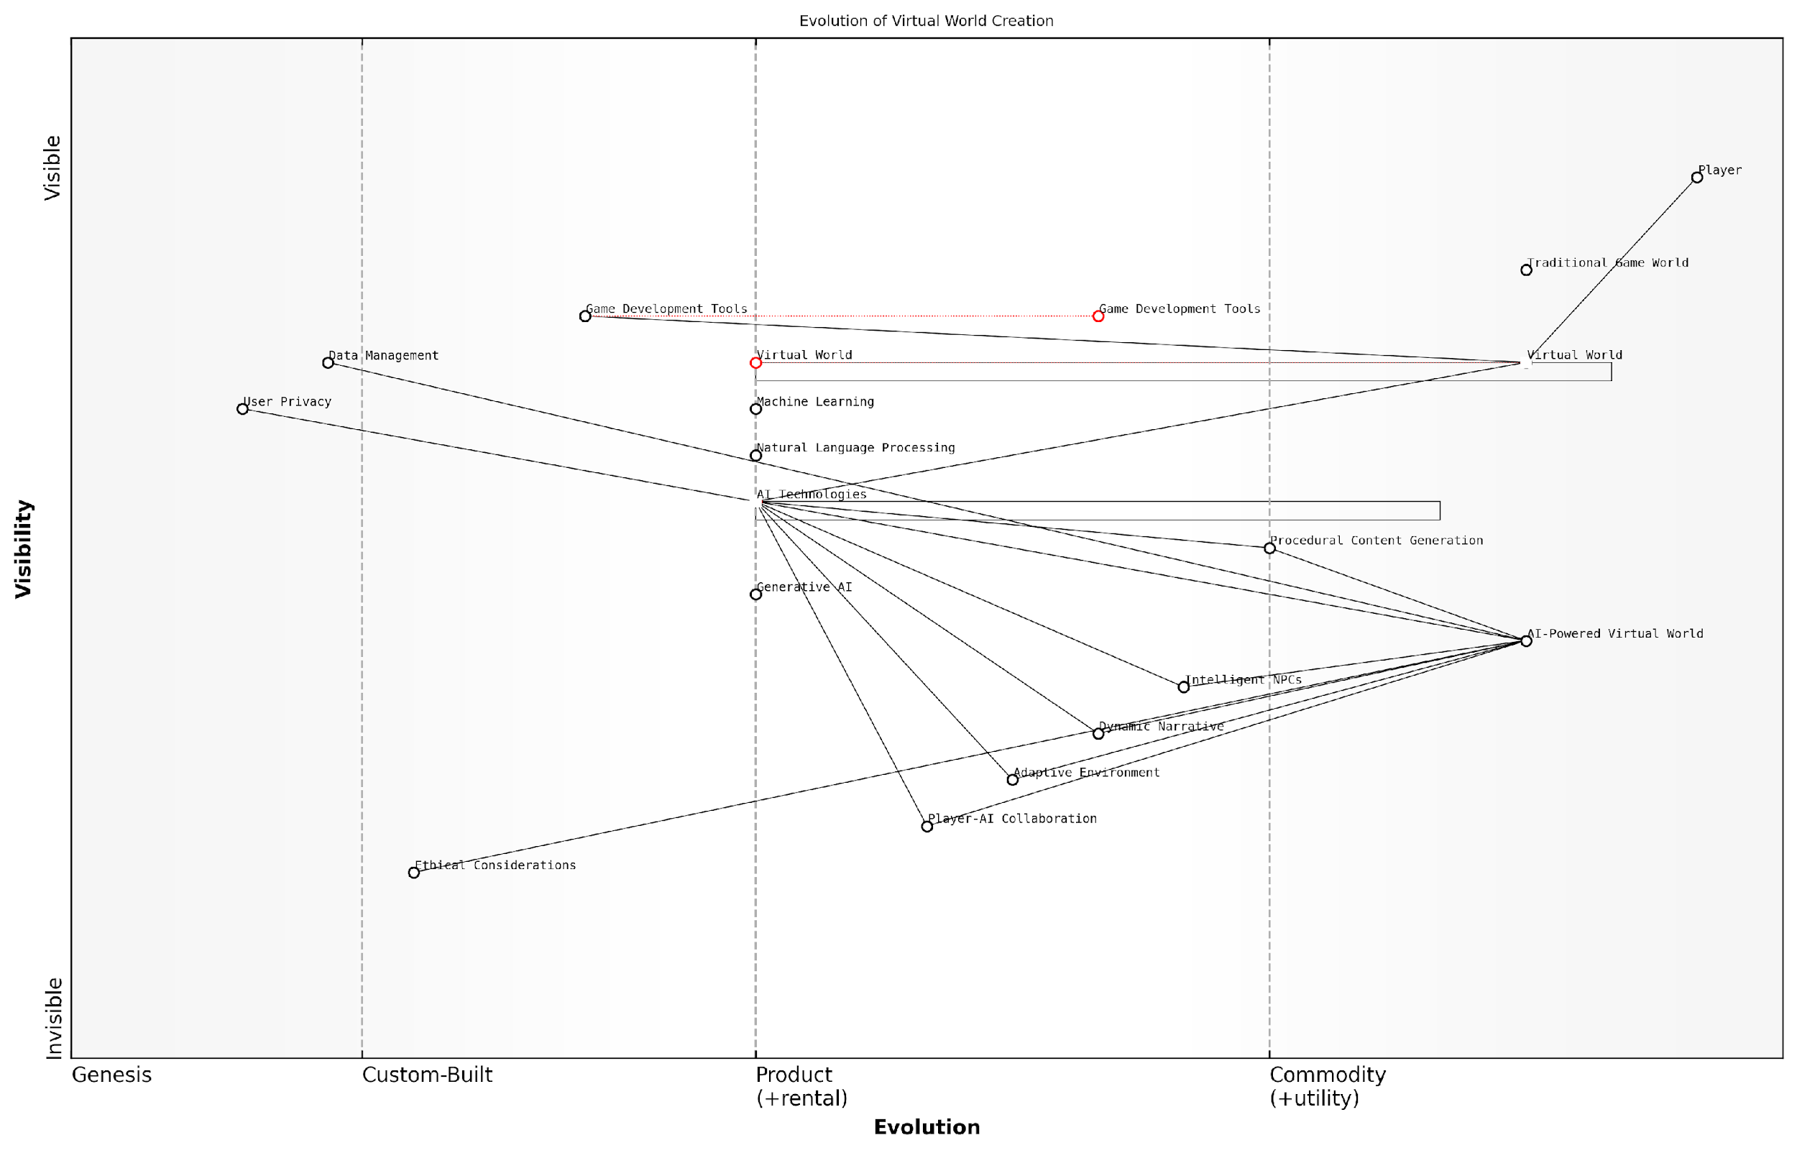

*Draft Wardley Map: [Insert Wardley Map: AI-Powered Virtual Worlds]*

[Edit this draft Wardley Map](https://create.wardleymaps.ai/#clone:1d0863755b19d24232)

Wardley Map Assessment

The map reveals a dynamic shift towards AI-powered virtual worlds, presenting significant opportunities for innovation and growth. However, success hinges on balancing technological advancements with ethical considerations and user trust. Companies that can effectively integrate AI technologies while prioritising ethical development and user experience will be well-positioned to lead in this evolving landscape. The key challenge lies in managing the rapid evolution of AI capabilities while ensuring responsible implementation and maintaining the creative essence of game development.

[View full Wardley Map report](http://markdown_wardley_map_reports/wardley_map_report_56_AI-Powered_Virtual_Worlds.md)

While the potential of AI-powered virtual worlds is immense, it’s crucial to consider the challenges and ethical implications that come with this technology. Privacy concerns, data management, and the potential for AI bias in world generation and NPC behaviour are all critical issues that need to be addressed as these systems evolve.

Moreover, the impact of highly immersive, AI-driven virtual worlds on social interactions and mental health must be carefully studied. As these environments become more sophisticated and engaging, we must ensure that appropriate safeguards are in place to protect users, particularly vulnerable populations such as children and individuals prone to gaming addiction.

As we stand on the brink of this new era in gaming, it’s imperative that we approach the development of AI-powered virtual worlds with both excitement and caution. The potential benefits are enormous, but so too are the responsibilities that come with creating such powerful and immersive digital ecosystems.

In conclusion, AI-powered virtual worlds represent a quantum leap in the evolution of gaming and virtual experiences. By harnessing the power of generative AI, we are opening doors to unprecedented levels of immersion, interactivity, and personalisation. As we continue to refine and develop these technologies, we must remain mindful of their broader implications, ensuring that they are deployed in ways that benefit players, developers, and society as a whole. The future of gaming is not just about playing in virtual worlds, but about co-creating and shaping them in ways we’ve only begun to imagine.

### Cross-Platform AI Integration

As we venture deeper into the realm of AI-powered gaming and the metaverse, cross-platform AI integration emerges as a critical component in shaping the future of interactive entertainment. This integration represents the seamless fusion of artificial intelligence across various gaming platforms, devices, and virtual environments, creating a cohesive and immersive experience for players regardless of their chosen medium of engagement.

The concept of cross-platform AI integration in the context of the metaverse goes beyond mere compatibility; it envisions a unified AI ecosystem that adapts, learns, and evolves across multiple platforms simultaneously. This integration is poised to revolutionise how players interact with games, virtual worlds, and each other, blurring the lines between different gaming experiences and creating a more interconnected digital universe.

Cross-platform AI integration is not just about making games playable across devices; it’s about creating a living, breathing AI ecosystem that transcends individual platforms, learning and evolving from every player interaction across the metaverse.

Let’s delve into the key aspects of cross-platform AI integration within the metaverse:

* Unified AI Agents
* Seamless Data Transfer and Learning
* Adaptive User Interfaces and Experiences
* Cross-Platform NPC Interactions
* AI-Driven Content Synchronisation

Unified AI Agents: At the heart of cross-platform AI integration lies the concept of unified AI agents. These intelligent entities are designed to operate consistently across various platforms, maintaining their ‘personality’, knowledge, and decision-making capabilities whether a player interacts with them on a mobile device, gaming console, or VR headset. This consistency creates a sense of continuity and depth in the metaverse, allowing players to form meaningful relationships with AI characters that persist across different gaming environments.

Seamless Data Transfer and Learning: Cross-platform AI integration facilitates the seamless transfer of data and learning between different platforms. AI models can aggregate insights from player behaviours across various devices and use this collective intelligence to enhance the gaming experience universally. For instance, an AI opponent in a strategy game could adapt its tactics based on the collective strategies employed by players across mobile, PC, and console versions of the game, creating a more challenging and dynamic gameplay experience for all.

Adaptive User Interfaces and Experiences: As players transition between platforms, cross-platform AI can dynamically adjust the user interface and gameplay mechanics to suit the specific device or platform being used. This adaptability ensures that the core experience remains consistent while optimising for the strengths of each platform. For example, a complex management simulation might offer a streamlined touch interface on mobile devices, while providing more detailed controls on PC, all managed by an AI that understands the player’s preferences and play style across platforms.

The true power of cross-platform AI lies in its ability to create a seamless, adaptive experience that feels native to each platform while maintaining the depth and continuity of the metaverse.

Cross-Platform NPC Interactions: Non-player characters (NPCs) in the metaverse benefit significantly from cross-platform AI integration. These AI-driven characters can maintain consistent personalities, memories, and relationships with players across different platforms. A player might engage in a conversation with an NPC on their smartphone during their commute, only to continue that same conversation with added depth and context when they log in from their gaming PC at home. This persistence creates a more immersive and believable virtual world.

AI-Driven Content Synchronisation: Cross-platform AI plays a crucial role in synchronising content across the metaverse. It can dynamically generate, modify, and distribute content based on player interactions and preferences across all platforms. This capability ensures that the metaverse remains fresh, relevant, and engaging, regardless of how or where players choose to access it. For example, an AI might create a new quest line based on the collective actions of players across multiple platforms, ensuring that the narrative evolves cohesively for all participants in the metaverse.

Challenges and Considerations:

* Technical Complexity: Implementing cross-platform AI requires sophisticated infrastructure and algorithms capable of operating across diverse hardware and software environments.
* Data Privacy and Security: As AI systems collect and process data across platforms, ensuring the privacy and security of player information becomes increasingly critical.
* Balancing Consistency and Platform-Specific Optimisation: Striking the right balance between maintaining a consistent experience and leveraging the unique capabilities of each platform presents an ongoing challenge.
* Scalability: As the metaverse grows, cross-platform AI systems must be designed to scale effectively, handling increasing numbers of players and interactions across a widening array of platforms.
* Ethical Considerations: The pervasive nature of cross-platform AI raises important ethical questions about autonomy, manipulation, and the boundaries between virtual and real-world experiences.

The future of cross-platform AI integration in the metaverse is both exciting and complex. As we move towards more interconnected virtual worlds, the role of AI in creating seamless, adaptive, and engaging experiences across platforms will become increasingly central to the gaming industry. Game developers, AI researchers, and platform providers must collaborate closely to overcome the technical and ethical challenges while harnessing the immense potential of this technology.

The metaverse of tomorrow will be built on the foundation of cross-platform AI integration, creating a digital universe that is more responsive, immersive, and interconnected than anything we’ve experienced before.

As we stand on the brink of this new era in gaming, it’s clear that cross-platform AI integration will play a pivotal role in shaping the future of the metaverse. By breaking down the barriers between platforms and creating truly unified, intelligent virtual worlds, we are opening up unprecedented possibilities for immersion, interaction, and innovation in the gaming industry. The journey ahead is fraught with challenges, but the potential rewards – in terms of player engagement, narrative depth, and the creation of living, breathing digital universes – are truly revolutionary.

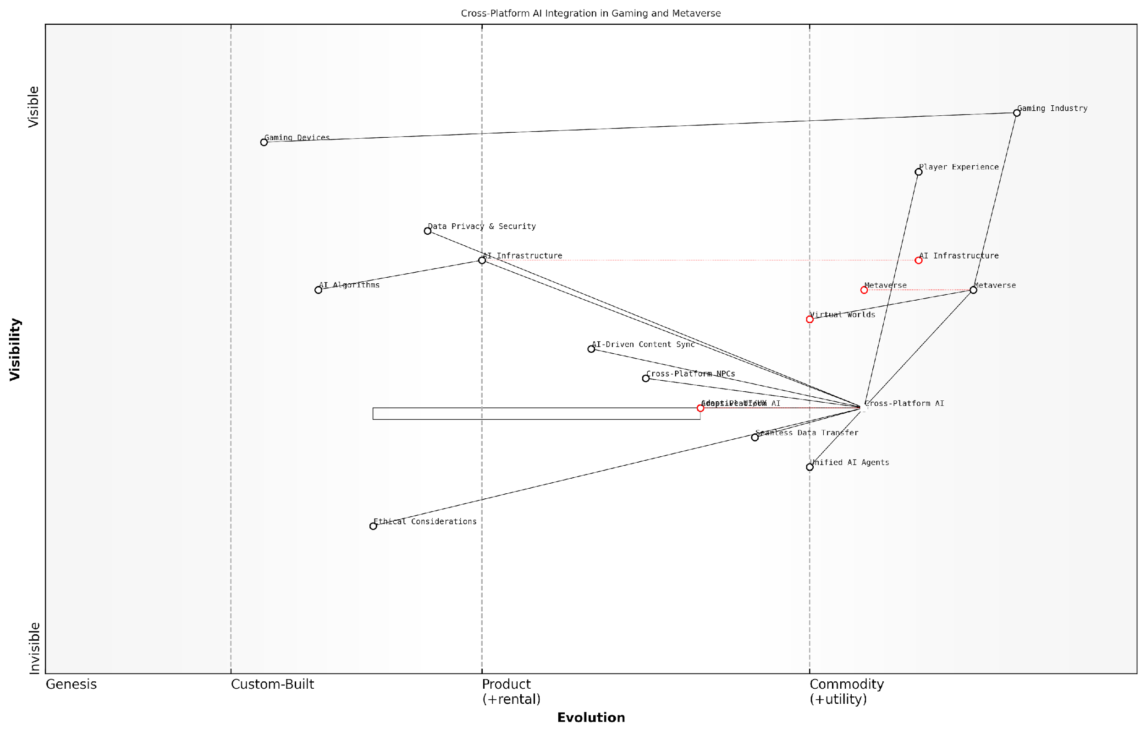

*Draft Wardley Map: [Insert Wardley Map: Cross-Platform AI Integration]*

[Edit this draft Wardley Map](https://create.wardleymaps.ai/#clone:b136919ea7942a95c4)

Wardley Map Assessment

This Wardley Map reveals a gaming industry on the cusp of a major transformation driven by Cross-Platform AI and the emergence of the Metaverse. The strategic positioning of these elements suggests significant opportunities for innovation and growth, particularly in creating seamless, AI-driven experiences across platforms. However, success will hinge on effectively navigating the ethical considerations and data security challenges while continuously evolving capabilities in rapidly changing technological landscapes. Companies that can master the integration of AI across platforms, pioneer new virtual world experiences, and maintain a strong focus on player experience are poised to lead in this new era of gaming and digital interaction.

[View full Wardley Map report](http://markdown_wardley_map_reports/wardley_map_report_57_Cross-Platform_AI_Integration.md)

### The Future of Social Gaming with AI

As we venture into the realm of AI-powered virtual worlds, the landscape of social gaming is poised for a revolutionary transformation. The convergence of artificial intelligence and the metaverse presents unprecedented opportunities for creating immersive, dynamic, and deeply personalised social gaming experiences. This section explores how AI is reshaping the future of social interactions within gaming environments, particularly in the context of the metaverse.

The integration of AI into social gaming within the metaverse framework is not merely an incremental improvement; it represents a paradigm shift in how players interact, collaborate, and compete in virtual spaces. By leveraging advanced AI technologies, game developers and metaverse architects can create living, breathing digital worlds that adapt and respond to player behaviours in real-time, fostering a sense of presence and social connection that transcends traditional gaming experiences.

Let us delve into the key aspects that will define the future of social gaming with AI in the metaverse:

* AI-Driven Non-Player Characters (NPCs)
* Adaptive Social Environments
* Real-Time Language Translation and Cultural Adaptation
* Emotion Recognition and Response Systems
* AI-Facilitated Community Building
* Personalised Social Quests and Challenges

AI-Driven Non-Player Characters (NPCs): One of the most significant advancements in social gaming within the metaverse will be the evolution of NPCs. Powered by sophisticated natural language processing and machine learning algorithms, these AI-driven characters will engage in nuanced, context-aware conversations with players, blurring the lines between human and artificial interactions.

The future of NPCs lies in their ability to learn, adapt, and form meaningful relationships with players over time. We’re moving towards a world where every NPC interaction feels unique and personalised, enhancing the social fabric of virtual worlds.

These advanced NPCs will not only serve as quest-givers or merchants but will also function as companions, mentors, and even adversaries, each with their own evolving personalities and motivations. This level of sophistication will greatly enhance the social dynamics within games, providing players with rich, emotionally resonant interactions that extend beyond human-to-human connections.

Adaptive Social Environments: AI will play a crucial role in shaping the very fabric of social spaces within the metaverse. By analysing player behaviours, preferences, and interactions, AI systems will dynamically adjust the virtual environment to foster optimal social experiences.

For instance, AI could identify players with complementary skills or interests and subtly guide them towards shared activities or spaces. It could also modulate the atmosphere of social hubs based on the collective mood of participants, adjusting lighting, music, and even the behaviour of ambient NPCs to create a more harmonious or exciting social environment as needed.

Real-Time Language Translation and Cultural Adaptation: As the metaverse brings together players from diverse linguistic and cultural backgrounds, AI-powered real-time translation systems will become indispensable. These systems will go beyond mere word-for-word translation, incorporating cultural context and nuance to facilitate seamless communication between players worldwide.

The ability to converse naturally with players from any part of the world, without language barriers, will redefine the concept of global gaming communities. AI-driven translation and cultural adaptation will be the great unifiers of the metaverse.

Moreover, AI will assist in adapting game content, quests, and narratives to align with the cultural sensitivities and preferences of diverse player bases, ensuring that the social gaming experience remains inclusive and respectful across cultural boundaries.

Emotion Recognition and Response Systems: Advanced AI systems will incorporate emotion recognition technologies, analysing players’ vocal tones, facial expressions (in VR settings), and even biometric data to gauge emotional states. This emotional intelligence will enable the game to respond empathetically, adjusting interactions, narratives, and challenges to suit the player’s emotional needs.

For example, if a player appears frustrated, the AI might offer encouragement through an NPC or suggest a different activity. Conversely, if a player is exhibiting signs of excessive excitement or addiction, the system could implement subtle cool-down mechanisms to promote healthier gaming habits.

AI-Facilitated Community Building: AI will play a pivotal role in fostering and maintaining healthy, engaging gaming communities within the metaverse. By analysing social interactions, player behaviours, and community dynamics, AI systems can identify potential issues such as toxicity or bullying and take proactive measures to maintain a positive social environment.

Furthermore, AI can facilitate the formation of guilds, teams, or social groups by identifying players with complementary skills, interests, or play styles. This matchmaking goes beyond simple metrics, considering factors such as communication styles, leadership qualities, and long-term compatibility to create more stable and satisfying social structures within the game.

Personalised Social Quests and Challenges: The future of social gaming in the metaverse will see AI systems generating personalised, multi-player quests and challenges that adapt to the unique dynamics of each player group. These AI-crafted adventures will consider the skills, preferences, and social relationships of the participants, creating narratives and challenges that strengthen bonds and encourage collaborative problem-solving.

Imagine a world where every group of friends embarking on a quest experiences a unique adventure tailored to their collective strengths, weaknesses, and interpersonal dynamics. This is the power of AI in shaping the future of social gaming narratives.

As we look towards the future of social gaming with AI in the metaverse, it’s clear that we are on the cusp of a new era in interactive entertainment. The integration of sophisticated AI systems into virtual social spaces promises to create more immersive, responsive, and emotionally engaging experiences that adapt to the needs and desires of players in real-time.

However, this exciting future also brings with it significant challenges and ethical considerations. Issues of privacy, data security, and the potential for AI manipulation of social dynamics will need to be carefully addressed. Game developers and metaverse architects must work in tandem with ethicists, policymakers, and player communities to establish robust frameworks that protect user rights and promote positive social interactions in these AI-driven virtual worlds.

In conclusion, the future of social gaming with AI in the metaverse is a frontier brimming with potential. As these technologies continue to evolve and mature, we can anticipate a transformation in how we connect, play, and socialise in virtual spaces. The key to success will lie in harnessing the power of AI to enhance, rather than replace, the fundamental human elements that make social gaming so compelling.

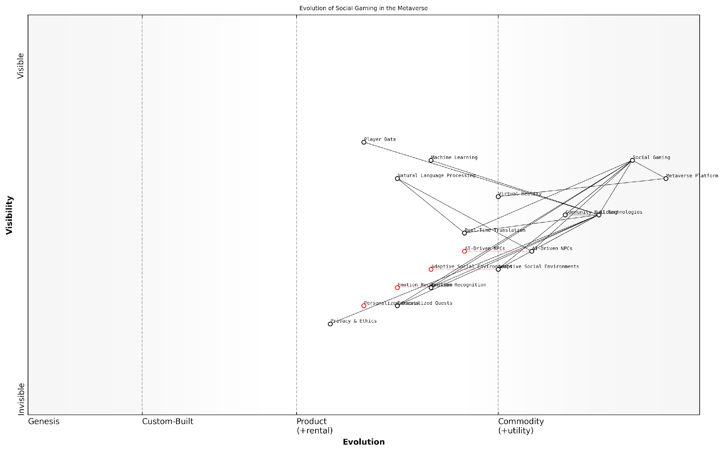

*Draft Wardley Map: [Insert Wardley Map: The Future of Social Gaming with AI]*

[Edit this draft Wardley Map](https://create.wardleymaps.ai/#clone:4fb8478604070a138a)

Wardley Map Assessment

This Wardley Map reveals a promising future for AI-driven social gaming in the metaverse, with significant opportunities for innovation and growth. The strategic focus should be on rapidly developing privacy and ethical frameworks while continuously enhancing AI-driven features to create more immersive, personalised, and socially rich gaming experiences. The key challenge lies in balancing technological advancement with user trust and ethical considerations, which will be crucial for long-term success in this evolving landscape.

[View full Wardley Map report](http://markdown_wardley_map_reports/wardley_map_report_58_The_Future_of_Social_Gaming_with_AI.md)

## Emerging Technologies and Gaming

### Quantum Computing and Game AI

As we venture into the future of gaming with generative AI, the intersection of quantum computing and game AI emerges as a frontier brimming with unprecedented potential. This convergence promises to revolutionise not only the complexity and scale of AI-driven gaming experiences but also the very fabric of how we conceptualise and interact with virtual worlds.

Quantum computing, with its ability to process vast amounts of data and perform complex calculations at speeds unattainable by classical computers, stands poised to unlock new realms of possibility in game AI. This transformative technology has the potential to address current limitations in AI processing power, paving the way for more sophisticated, responsive, and immersive gaming experiences.

Quantum computing is not just an incremental step forward; it’s a paradigm shift that will redefine the boundaries of what’s possible in game AI. We’re on the cusp of a new era in gaming, where the lines between reality and virtual worlds will blur in ways we’ve only dreamed of.

Let’s explore the key areas where quantum computing is set to revolutionise game AI:

* Enhanced AI Decision-Making and Behaviour
* Quantum-Powered Procedural Generation
* Real-Time Physics Simulations
* Advanced Natural Language Processing
* Quantum Machine Learning for Game Development

Enhanced AI Decision-Making and Behaviour: Quantum computing’s ability to process multiple states simultaneously through quantum superposition could lead to AI-controlled characters with unprecedented depth and complexity. These quantum-powered NPCs could exhibit more human-like decision-making processes, considering vast numbers of variables and potential outcomes in real-time. This advancement could result in NPCs that are virtually indistinguishable from human players, offering more challenging and engaging gameplay experiences.

Quantum-Powered Procedural Generation: The immense processing power of quantum computers could revolutionise procedural generation techniques in game development. By leveraging quantum algorithms, developers could create virtually infinite, highly detailed, and truly unique game worlds. These environments would not only be vast in scale but also rich in complexity, with intricate ecosystems, dynamic weather patterns, and evolving landscapes that respond to player actions in ways previously unimaginable.

The marriage of quantum computing and procedural generation will usher in a new age of exploration in gaming. Every playthrough will be a journey into the unknown, with worlds so vast and detailed that even the developers themselves couldn’t predict what players might discover.

Real-Time Physics Simulations: Quantum computing’s capacity for complex calculations could enable hyper-realistic physics simulations in games. This advancement would allow for more accurate and detailed representations of physical phenomena, from the movement of individual particles in explosions to the behaviour of fluids and gases. The result would be gaming environments that behave with unprecedented realism, enhancing immersion and opening up new gameplay possibilities.

Advanced Natural Language Processing: Quantum algorithms could significantly enhance natural language processing capabilities in games. This improvement would lead to more nuanced and context-aware dialogue systems, allowing for truly dynamic conversations with NPCs. Players could engage in free-form discussions, with AI characters capable of understanding and responding to complex queries, emotions, and even subtle implications in natural language.

Quantum Machine Learning for Game Development: Quantum machine learning algorithms could revolutionise the game development process itself. These advanced algorithms could analyse vast amounts of player data to identify patterns and preferences at an unprecedented scale. This capability would enable developers to create more personalised gaming experiences, dynamically adjusting game elements to suit individual player styles and preferences in real-time.

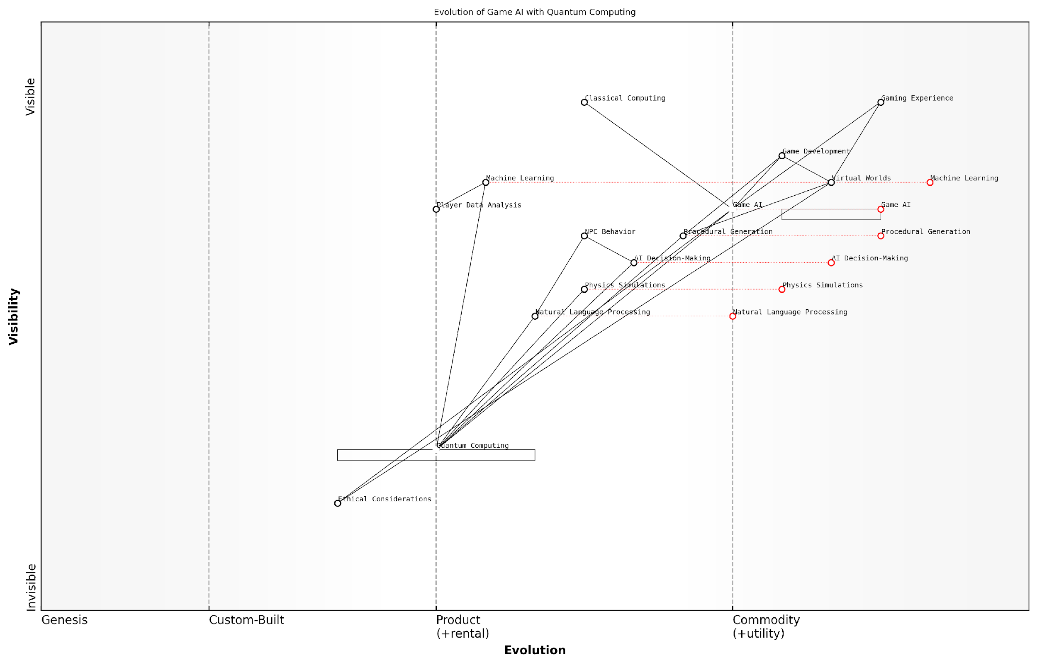

*Draft Wardley Map: [Insert Wardley Map: Quantum Computing and Game AI]*

[Edit this draft Wardley Map](https://create.wardleymaps.ai/#clone:125f503817c97dcf43)

Wardley Map Assessment

This map represents a forward-looking view of game AI evolution, positioning quantum computing as a transformative force. The strategic focus should be on preparing for this quantum shift while continuing to innovate in classical AI techniques. Ethical considerations and player experience should remain central to all developments. The company has the opportunity to lead the industry in quantum-enhanced gaming, but must carefully manage the transition and associated risks.

[View full Wardley Map report](http://markdown_wardley_map_reports/wardley_map_report_59_Quantum_Computing_and_Game_AI.md)

While the potential of quantum computing in game AI is immense, it’s important to acknowledge the challenges that lie ahead. The technology is still in its infancy, with practical, large-scale quantum computers yet to be realised. Additionally, integrating quantum computing into existing game development pipelines will require significant investment in research, infrastructure, and training.

Moreover, as we push the boundaries of AI capabilities in gaming through quantum computing, we must also grapple with new ethical considerations. The ability to create hyper-realistic virtual worlds and AI entities that are indistinguishable from human players raises questions about the nature of reality, consciousness, and the potential psychological impacts on players.

As we harness the power of quantum computing in game AI, we must remain vigilant about the ethical implications. We’re not just creating games anymore; we’re potentially shaping new realities. It’s crucial that we approach this responsibility with the utmost care and consideration.

In conclusion, the convergence of quantum computing and game AI represents a transformative force in the future of gaming. As quantum technologies mature and become more accessible, we can expect to see a new generation of games that push the boundaries of what’s possible in virtual worlds. These advancements will not only enhance player experiences but also challenge our perceptions of reality, creativity, and the very nature of play itself.

As we stand on the brink of this quantum revolution in gaming, it’s clear that the future holds limitless possibilities. The journey ahead promises to be as exciting and unpredictable as the quantum realm itself, ushering in an era of gaming experiences that we can scarcely imagine today.

### Brain-Computer Interfaces in Gaming

As we venture into the future of gaming with generative AI, one of the most exciting and potentially transformative technologies on the horizon is the integration of Brain-Computer Interfaces (BCIs) into gaming experiences. This convergence of neurotechnology and interactive entertainment promises to revolutionise the way we interact with virtual worlds, offering unprecedented levels of immersion and control.

BCIs in gaming represent a paradigm shift in human-computer interaction, allowing players to control game elements directly with their thoughts. This technology, combined with the power of generative AI, has the potential to create truly responsive and personalised gaming experiences that adapt in real-time to a player’s cognitive and emotional state.

Brain-Computer Interfaces are set to redefine the boundaries between player and game, creating a symbiotic relationship that could unlock new realms of creativity and engagement in interactive entertainment.

Let’s explore the key aspects of BCIs in gaming and their potential impact on the future of the industry:

* Direct Neural Control
* Emotional State Integration
* Adaptive Difficulty and Content Generation
* Enhanced Accessibility
* Multiplayer Neural Synchronisation
* Ethical Considerations and Challenges

Direct Neural Control: The most immediate application of BCIs in gaming is the ability to control in-game actions through thought alone. This could range from simple commands like moving a character or selecting menu options, to more complex interactions such as casting spells or piloting vehicles. As the technology advances, we can expect increasingly nuanced control schemes that allow for a wider range of actions and more intuitive gameplay.

Emotional State Integration: BCIs have the potential to detect and interpret a player’s emotional state in real-time. When combined with generative AI, this could lead to games that dynamically adjust their narrative, atmosphere, or difficulty based on the player’s emotional responses. Imagine a horror game that knows exactly when to ramp up the tension, or an adventure game that tailors its story beats to maximise emotional impact.

The integration of emotional state detection through BCIs could lead to a new era of ‘empathetic gaming’, where the game world responds not just to our actions, but to our feelings and subconscious reactions.

Adaptive Difficulty and Content Generation: By analysing a player’s cognitive load and stress levels, BCIs could provide invaluable data for AI systems to dynamically adjust game difficulty and generate appropriate content. This could result in perfectly balanced gameplay experiences that maintain an optimal state of flow for each individual player, regardless of their skill level or playstyle.

Enhanced Accessibility: For players with physical disabilities, BCIs could open up new avenues of gaming that were previously inaccessible. By bypassing traditional input methods, individuals with limited mobility could enjoy complex games on an equal footing with other players. This technology has the potential to make gaming truly inclusive, breaking down barriers that have long existed in the industry.

Multiplayer Neural Synchronisation: In the realm of multiplayer gaming, BCIs could enable new forms of collaboration and competition. Players might be able to share mental states or emotions, leading to deeper levels of teamwork and strategic play. Competitive games could incorporate neural feedback, adding an extra layer of skill and strategy to matches.

Ethical Considerations and Challenges: As with any emerging technology, the integration of BCIs in gaming raises important ethical questions. Privacy concerns are paramount, as BCIs have the potential to collect highly sensitive neurological data. There are also concerns about addiction and mental health, as games that can directly interface with our brains may have a more profound impact on our cognitive processes.

As we explore the potential of BCIs in gaming, we must remain vigilant about the ethical implications. The power to directly influence a player’s neural activity comes with great responsibility.

Technical challenges also abound. Current BCI technology is still relatively crude, often requiring bulky hardware and extensive calibration. For BCIs to become mainstream in gaming, we’ll need to see significant advancements in miniaturisation, accuracy, and ease of use. Additionally, ensuring the safety and long-term health effects of prolonged BCI use will be crucial for widespread adoption.

Despite these challenges, the potential of BCIs in gaming is immense. As the technology matures and becomes more accessible, we can expect to see a new generation of games that blur the line between thought and action, creating experiences that are more immersive, personalised, and engaging than ever before.

In conclusion, the integration of Brain-Computer Interfaces in gaming represents a frontier of innovation that has the potential to reshape the industry. As game developers and AI researchers continue to push the boundaries of what’s possible, we may soon find ourselves in a world where our thoughts and emotions become an integral part of the gaming experience. The future of gaming with generative AI and BCIs is not just about playing games – it’s about living them.

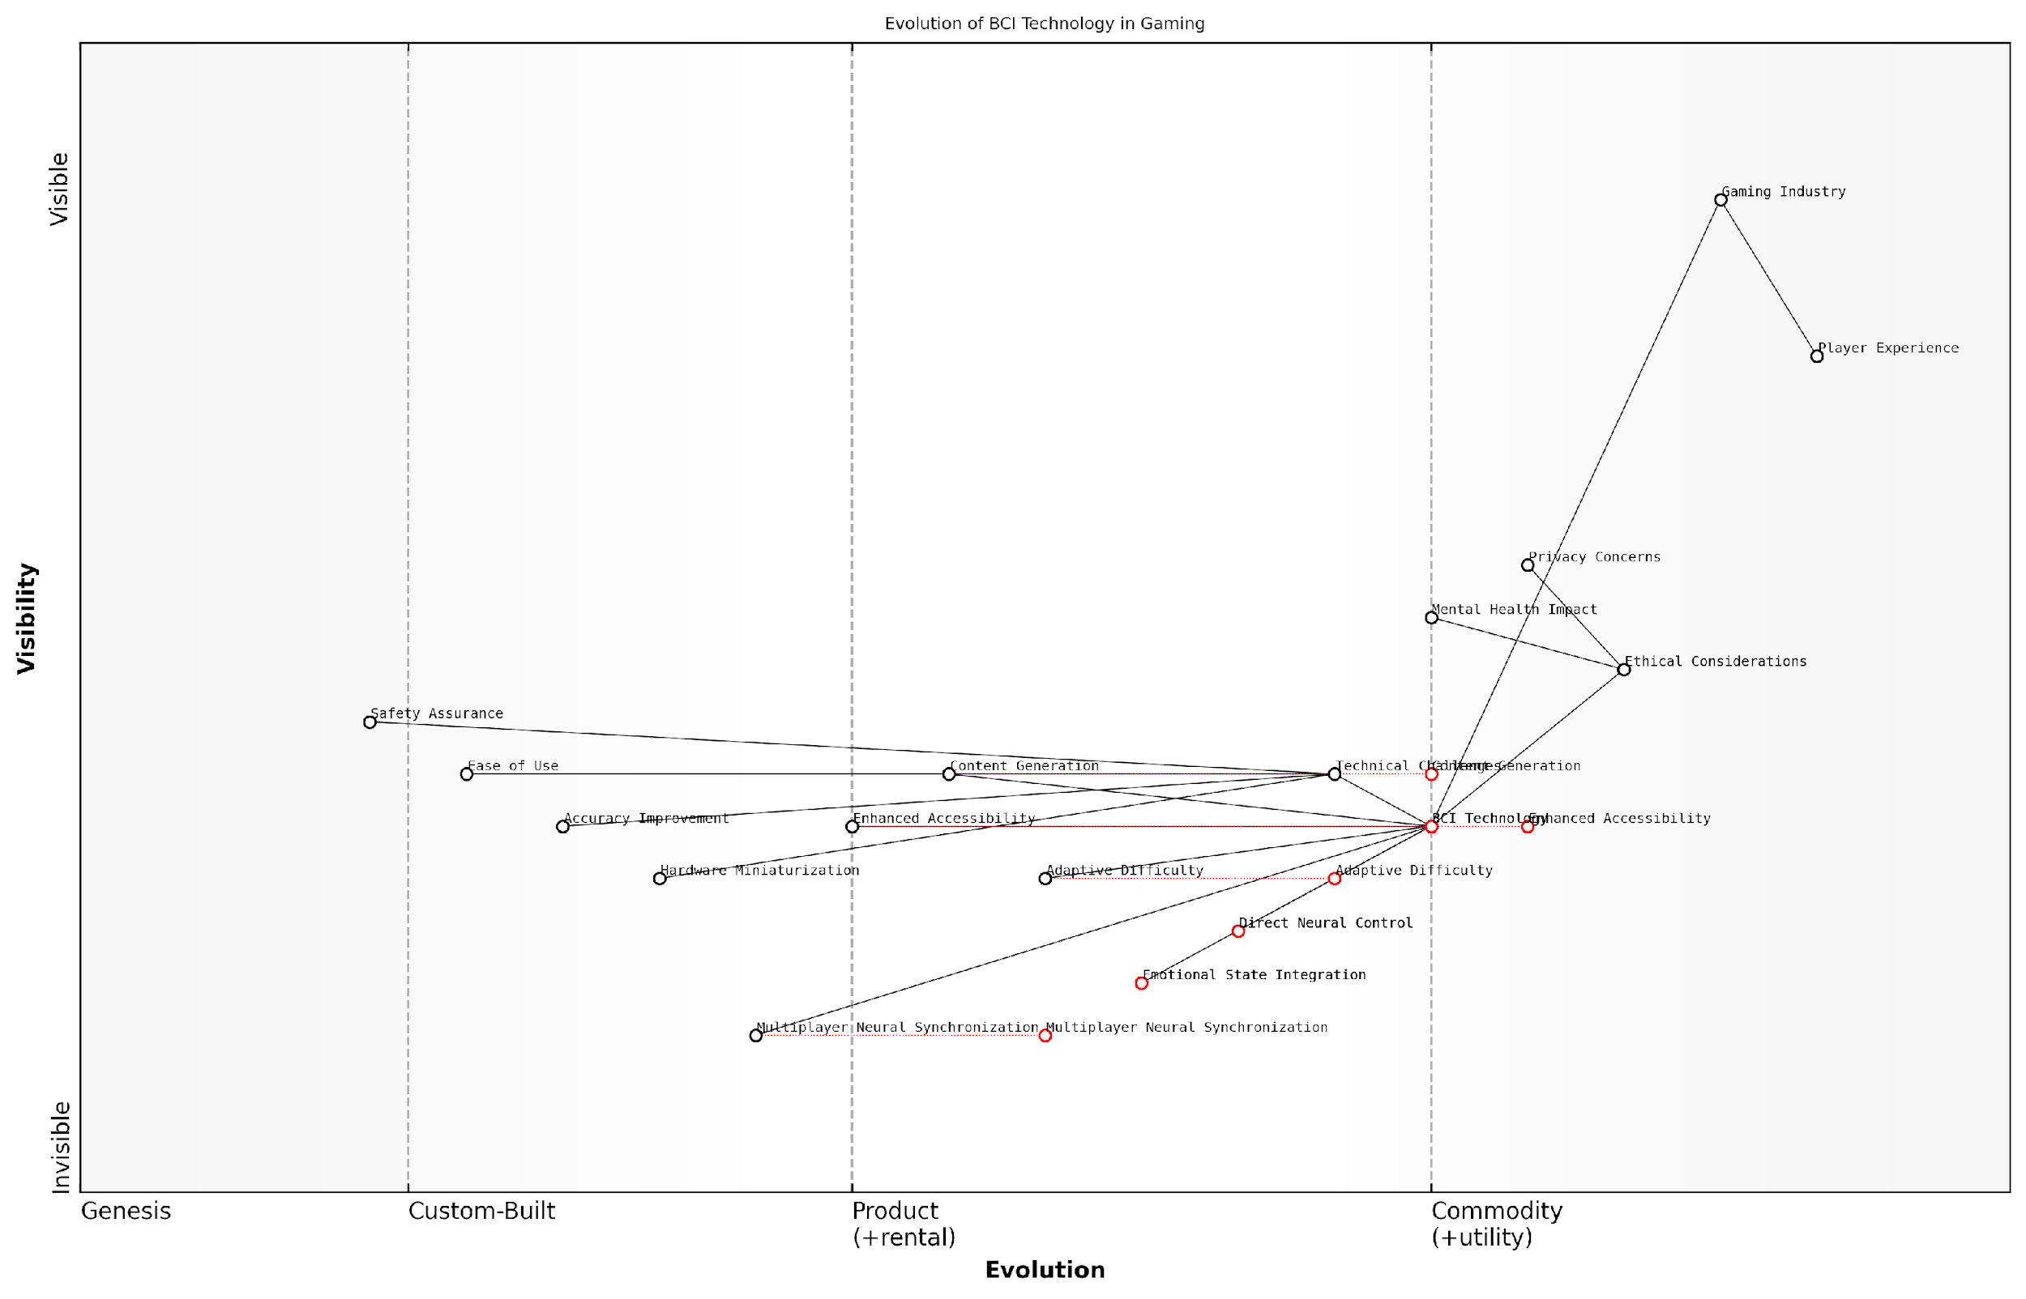

*Draft Wardley Map: [Insert Wardley Map: Brain-Computer Interfaces in Gaming]*

[Edit this draft Wardley Map](https://create.wardleymaps.ai/#clone:5ffb82a67256d47bd7)

Wardley Map Assessment

The map reveals a promising yet challenging future for BCI in gaming. The industry is poised for significant innovation but must navigate complex ethical and technical hurdles. Success will depend on balancing rapid technological advancement with robust ethical frameworks and user-centric design. Companies that can effectively integrate BCI technology while addressing privacy concerns and ensuring user safety will likely lead the next generation of immersive gaming experiences.

[View full Wardley Map report](http://markdown_wardley_map_reports/wardley_map_report_60_Brain-Computer_Interfaces_in_Gaming.md)

### AI and the Future of AR/VR Gaming

Content for AI and the Future of AR/VR Gaming not found.

# Conclusion: Embracing the AI-Powered Future of Gaming

## Recapping the AI Revolution in Gaming

### Key Takeaways

As we conclude our comprehensive exploration of the AI revolution in gaming, it is crucial to distil the key takeaways that will shape the future of this dynamic industry. The integration of Generative AI (GenAI) into gaming has ushered in a new era of creativity, personalisation, and immersion, fundamentally altering the landscape of game development and player experiences.

One of the most significant takeaways is the transformative impact of GenAI on game design and development processes. The ability of AI to generate vast amounts of content, from intricate game worlds to complex character behaviours, has dramatically expanded the scope and scale of what is possible in game creation. This shift has not only streamlined development workflows but has also opened up new avenues for creativity and innovation.

* AI-driven procedural generation has revolutionised world-building, enabling the creation of vast, diverse, and dynamic game environments.
* Machine learning algorithms have enhanced NPC behaviours, leading to more realistic and engaging non-player characters.
* Natural Language Processing (NLP) has improved in-game dialogue systems, allowing for more nuanced and context-aware interactions.
* Computer vision and gesture recognition technologies have paved the way for more intuitive and immersive gaming interfaces.

Another crucial takeaway is the profound impact of AI on player experiences. The advent of adaptive gameplay systems and personalised content generation has ushered in an era of hyper-personalised gaming experiences. These AI-driven systems can analyse player behaviour, preferences, and skill levels in real-time, dynamically adjusting game difficulty, narrative elements, and even visual aesthetics to suit individual players.

The future of gaming lies in creating unique, tailored experiences for each player. AI is not just a tool; it’s becoming the co-creator of these experiences, working alongside human developers to push the boundaries of what’s possible in interactive entertainment.

The ethical considerations surrounding AI in gaming have emerged as a critical area of focus. As AI systems become more sophisticated and integral to the gaming experience, issues of data privacy, fairness, and potential addiction have come to the forefront. The industry must grapple with these challenges to ensure that the benefits of AI are realised without compromising player rights or well-being.

* Ensuring transparency in AI decision-making processes within games
* Addressing potential biases in AI-generated content and gameplay systems
* Balancing the use of player data for personalisation with privacy concerns
* Developing ethical guidelines for AI implementation in gaming

The economic and social impact of AI in gaming cannot be overstated. As AI technologies continue to advance, they are reshaping job roles within the industry, creating new opportunities while potentially displacing traditional roles. The rise of AI game designers and the increasing automation of certain development tasks signal a shift in the skills and competencies required in the gaming workforce.

Looking towards the future, the convergence of AI with emerging technologies such as virtual and augmented reality, brain-computer interfaces, and quantum computing promises to unlock even more revolutionary possibilities in gaming. The concept of the metaverse, powered by sophisticated AI systems, could redefine our understanding of virtual worlds and social interactions within games.

We are standing at the threshold of a new era in gaming, where the lines between virtual and physical realities blur, and AI becomes an invisible, omnipresent force shaping our gaming experiences. The potential is limitless, but so too are the challenges we must navigate.

In conclusion, the AI revolution in gaming is not just about technological advancement; it’s about reimagining the very nature of play and interactive entertainment. As we move forward, the industry must strike a delicate balance between harnessing the power of AI to create more engaging, immersive, and personalised experiences, while also addressing the ethical, social, and economic implications of this technological shift.

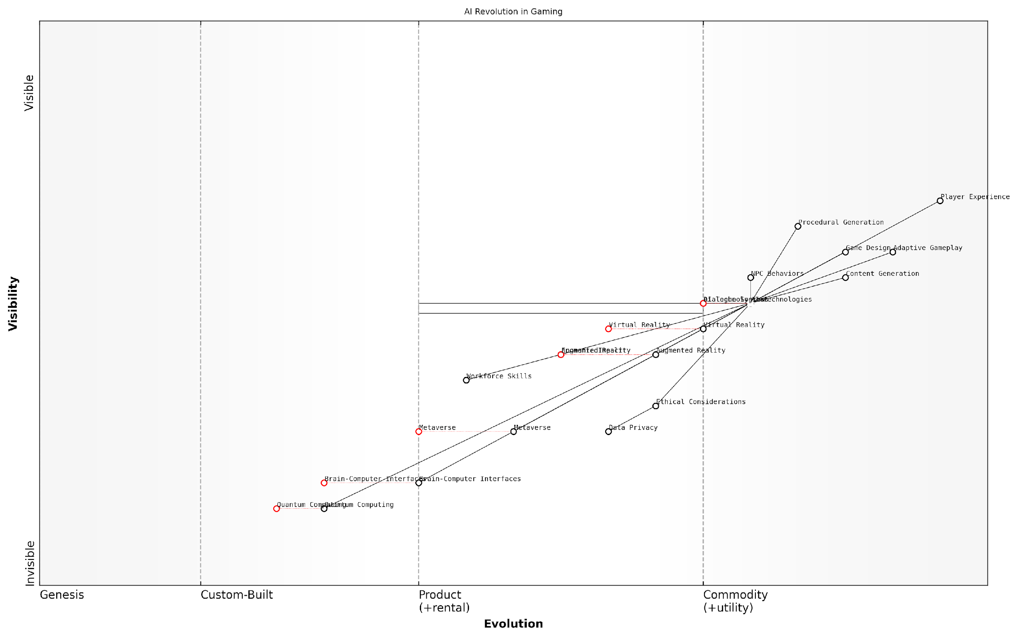

*Draft Wardley Map: [Insert Wardley Map: Key Takeaways]*

[Edit this draft Wardley Map](https://create.wardleymaps.ai/#clone:dc2e50909cadc2ceb4)

Wardley Map Assessment

The map reveals a gaming industry on the cusp of an AI-driven revolution, with significant opportunities for innovation and growth. The strategic imperative is to lead in ethical AI integration while preparing for emerging technologies that could reshape the gaming landscape. Success will require balancing rapid technological advancement with ethical considerations and workforce development, all while maintaining a relentless focus on enhancing player experience.

[View full Wardley Map report](http://markdown_wardley_map_reports/wardley_map_report_62_Key_Takeaways.md)

As we prepare for the future, it is clear that AI will continue to be a driving force in shaping the gaming landscape. The key takeaways from this exploration underscore the need for ongoing collaboration between developers, policymakers, and players to ensure that the integration of AI in gaming leads to a future that is not only technologically advanced but also ethically sound and socially responsible. The journey of AI in gaming has only just begun, and the most exciting chapters are yet to be written.

### Preparing for the Future

As we stand on the precipice of a new era in gaming, driven by the transformative power of generative AI, it is crucial to prepare ourselves for the myriad changes and opportunities that lie ahead. This subsection delves into the essential steps that gamers, developers, industry leaders, and policymakers must take to navigate the AI-powered future of gaming successfully.

The AI revolution in gaming is not merely a technological shift; it represents a fundamental reimagining of how we create, experience, and interact with digital entertainment. To fully harness the potential of this revolution, we must adopt a proactive and adaptive mindset, embracing the challenges and opportunities that come with such profound change.

The future of gaming is not just about better graphics or more complex algorithms. It’s about creating living, breathing worlds that respond and evolve with each player’s unique journey. Generative AI is the key to unlocking this potential.

Let us explore the key areas of preparation that will be crucial for success in the AI-driven gaming landscape:

* Upskilling and Education
* Ethical Framework Development
* Infrastructure and Technology Investment
* Collaborative Ecosystems
* Regulatory Preparedness

Upskilling and Education: As generative AI becomes increasingly integral to game development and player experiences, there is an urgent need for comprehensive education and training programmes. Game developers must expand their skill sets to include AI programming, machine learning, and data analysis. Universities and vocational institutions should update their curricula to reflect these emerging needs, ensuring a steady pipeline of talent equipped to innovate in the AI-gaming space.

Moreover, gamers themselves will benefit from a basic understanding of AI principles, enabling them to make informed choices about their gaming experiences and to engage more deeply with AI-driven game mechanics. Public awareness campaigns and in-game tutorials can play a crucial role in demystifying AI for the broader gaming community.

Ethical Framework Development: As we’ve explored in previous chapters, the integration of AI in gaming raises significant ethical considerations. To prepare for the future, the gaming industry must proactively develop robust ethical frameworks that address issues such as data privacy, algorithmic bias, and the potential for AI-driven addiction.

The ethical use of AI in gaming is not just a moral imperative; it’s a business necessity. Companies that prioritise player trust and wellbeing will be the ones that thrive in the long term.

These frameworks should be developed through collaborative efforts involving game developers, AI ethicists, player advocates, and regulatory bodies. They must be flexible enough to adapt to rapidly evolving technologies while providing clear guidelines for responsible AI implementation.

Infrastructure and Technology Investment: The future of AI-powered gaming will require significant investments in technological infrastructure. Game companies and platform providers must prepare for the increased computational demands of generative AI, investing in cloud computing resources, edge computing solutions, and high-speed networking capabilities.

Additionally, research and development efforts should be directed towards advancing AI technologies specifically tailored for gaming applications. This includes improvements in natural language processing for more realistic NPC interactions, enhanced computer vision for augmented reality gaming, and more sophisticated procedural generation algorithms for creating vast, dynamic game worlds.

Collaborative Ecosystems: The future of AI in gaming will be built on collaboration. Game developers, AI researchers, hardware manufacturers, and cloud service providers must work together to create integrated ecosystems that support innovation and interoperability.

Open-source initiatives and shared AI models can accelerate progress and democratise access to advanced gaming technologies. Industry consortia and standards bodies will play a crucial role in establishing common protocols and best practices for AI integration in games.

Regulatory Preparedness: As AI becomes more prevalent in gaming, regulatory bodies must prepare to address new challenges and opportunities. This includes developing frameworks for AI safety in gaming, establishing guidelines for the use of player data in AI systems, and considering the economic implications of AI-driven virtual economies.

Game companies should engage proactively with regulators, providing insights into technological advancements and potential impacts. This collaborative approach can help ensure that regulations are informed, balanced, and conducive to innovation while protecting player interests.

The regulatory landscape for AI in gaming is still in its infancy. It’s crucial that we shape these regulations thoughtfully, balancing innovation with player protection to create a thriving, responsible AI-gaming ecosystem.

In conclusion, preparing for the AI-powered future of gaming requires a multifaceted approach that encompasses education, ethics, technology, collaboration, and regulation. By addressing these key areas proactively, we can create a future where generative AI enhances the gaming experience, empowers creators, and contributes positively to society.

As we move forward, it is essential to maintain a balance between embracing the transformative potential of AI and preserving the core elements that make gaming a uniquely human experience. By doing so, we can ensure that the future of gaming is not only more intelligent but also more engaging, inclusive, and enriching for players around the world.

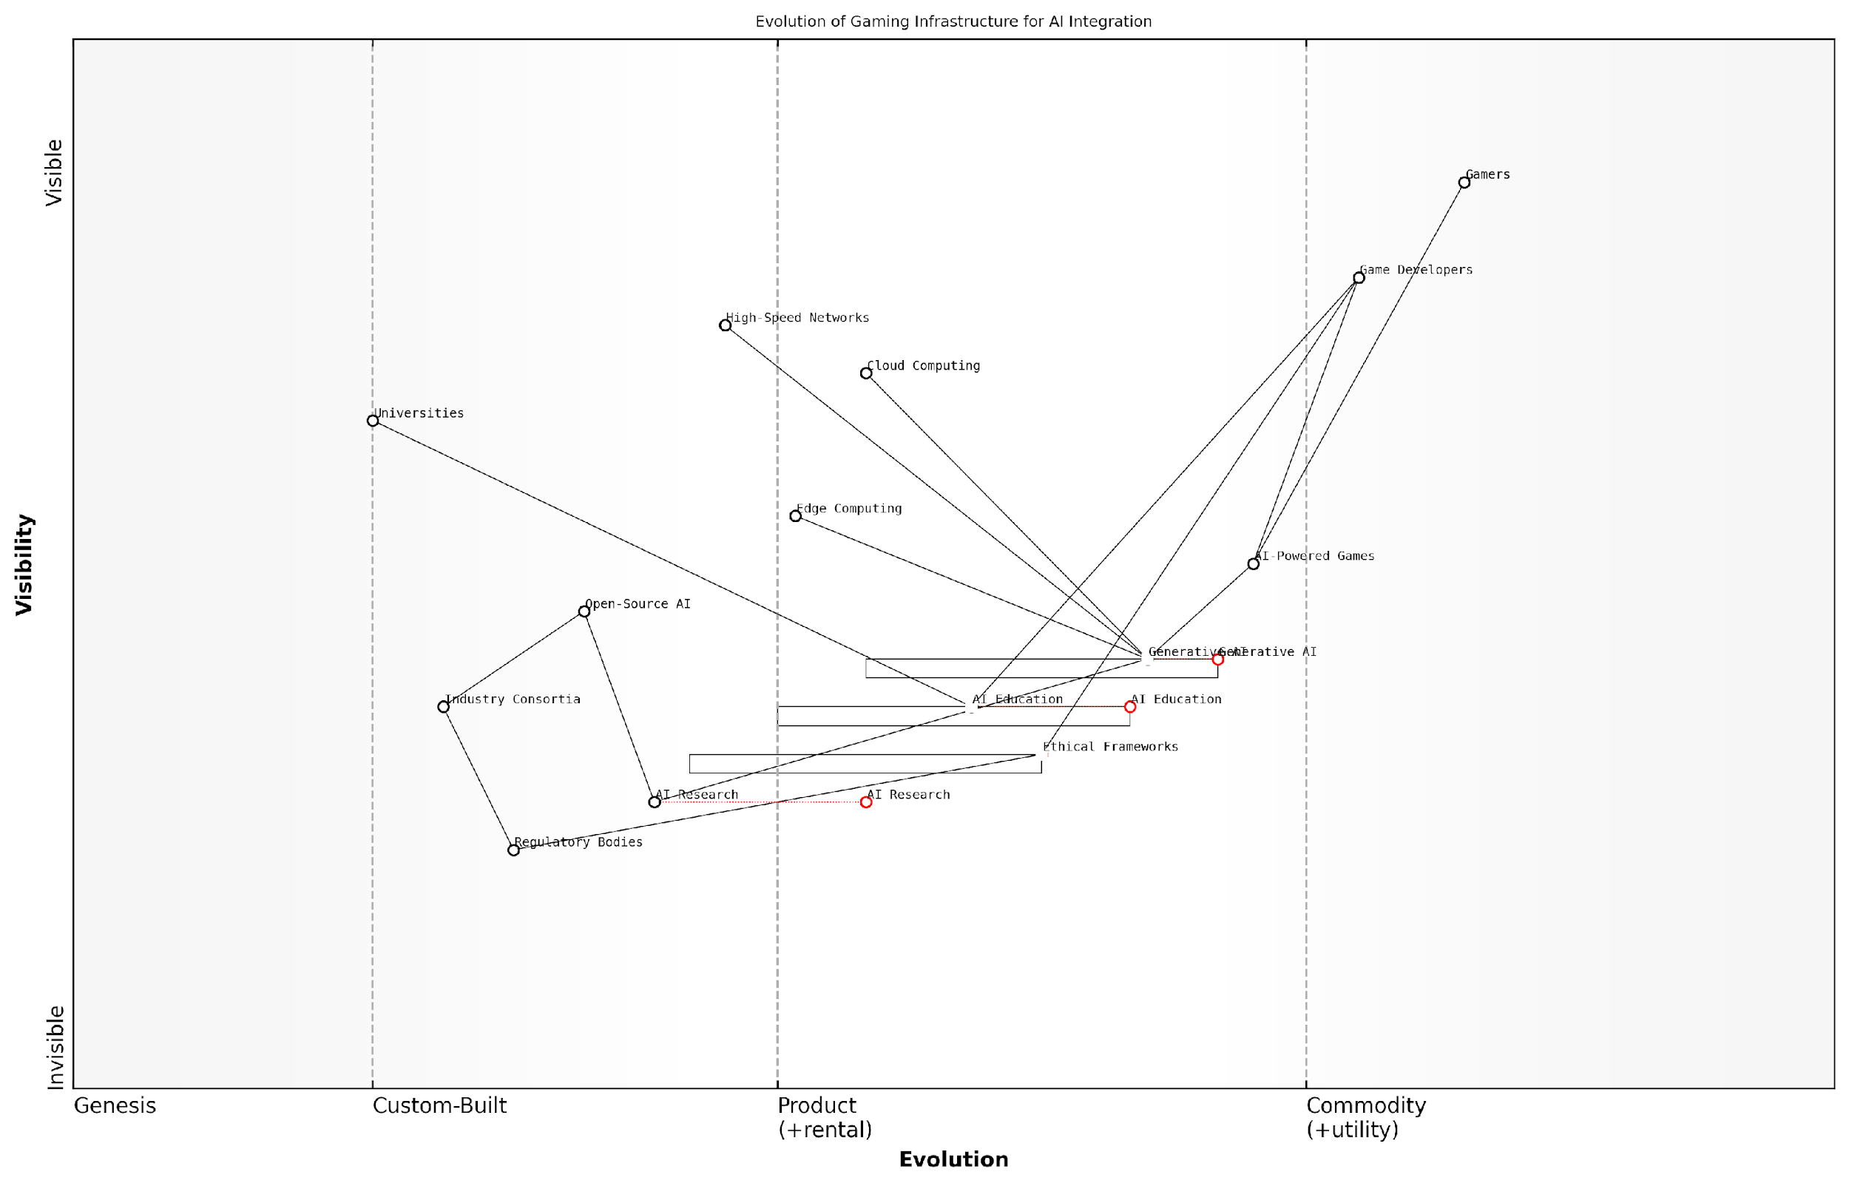

*Draft Wardley Map: [Insert Wardley Map: Preparing for the Future]*

[Edit this draft Wardley Map](https://create.wardleymaps.ai/#clone:005453e5881d83d559)

Wardley Map Assessment

This Wardley Map reveals a gaming industry on the cusp of an AI-driven transformation. The strategic position is strong, with a clear path from foundational research to end-user value. However, success hinges on effectively navigating the ethical implications of AI integration and rapidly upskilling the workforce. The industry must balance the push for innovation in AI-Powered Games with the need for robust Ethical Frameworks and comprehensive AI Education. By focusing on these areas, while leveraging the strengths in Cloud Computing and established game development expertise, the industry can create a sustainable, responsible, and highly innovative ecosystem for AI-powered gaming. The key to long-term success lies in fostering strong collaborations across the value chain, from universities and research institutions to regulatory bodies and end-users, ensuring that technological advancements are matched with ethical considerations and societal readiness.

[View full Wardley Map report](http://markdown_wardley_map_reports/wardley_map_report_63_Preparing_for_the_Future.md)

## The Road Ahead

### Challenges and Opportunities

As we stand on the precipice of a new era in gaming, powered by generative AI, the road ahead is paved with both formidable challenges and unprecedented opportunities. This transformative technology is poised to reshape the gaming landscape in ways we are only beginning to comprehend, offering a glimpse into a future where the boundaries between human creativity and machine intelligence blur, creating experiences that were once the realm of science fiction.

The challenges we face in this brave new world of AI-powered gaming are multifaceted and complex, requiring careful navigation and thoughtful solutions. At the same time, the opportunities presented by this technology are vast and exhilarating, promising to revolutionise not only how we play games but how we create, interact with, and understand them.

Let us delve into the key challenges and opportunities that lie ahead on this exciting journey into the future of gaming with generative AI.

Challenges:

* Ethical considerations and responsible AI implementation
* Balancing AI-generated content with human creativity
* Ensuring fairness and preventing AI bias in games
* Addressing concerns about job displacement in the gaming industry
* Managing player data privacy and security
* Mitigating potential negative impacts on player mental health and addiction
* Navigating regulatory landscapes and compliance issues

One of the most pressing challenges we face is the ethical implementation of AI in gaming. As AI systems become more sophisticated and integral to game design and player experiences, we must grapple with questions of transparency, accountability, and the potential for unintended consequences.

The integration of AI in gaming is not just a technological challenge, but a moral and philosophical one. We must ensure that as we push the boundaries of what’s possible, we do not lose sight of the human element that makes gaming such a powerful medium.

Another significant challenge lies in striking the right balance between AI-generated content and human creativity. While generative AI offers unprecedented possibilities for creating vast, dynamic game worlds and personalised experiences, there is a risk of homogenisation and loss of the unique artistic vision that has defined many beloved games.

The potential for AI bias in games is also a critical concern. As AI systems learn from existing data and player behaviours, there is a risk of perpetuating or even amplifying societal biases. Ensuring fairness and inclusivity in AI-driven games will require ongoing vigilance and proactive measures from developers and publishers.

Opportunities:

* Creation of infinitely diverse and personalised gaming experiences
* Streamlining game development processes and reducing costs
* Enhancing player engagement through adaptive gameplay and storytelling
* Pushing the boundaries of game design and creating new genres
* Improving accessibility in gaming for players with diverse needs
* Facilitating more immersive and realistic virtual worlds
* Revolutionising player-game interactions through natural language processing and emotion recognition

The opportunities presented by generative AI in gaming are truly transformative. Perhaps the most exciting prospect is the potential for creating infinitely diverse and personalised gaming experiences. Imagine a world where every playthrough of a game is unique, tailored to the individual player’s preferences, skills, and emotional state.

Generative AI has the potential to usher in a new golden age of gaming, where every player’s journey is as unique as they are. It’s not just about personalisation; it’s about creating living, breathing game worlds that evolve and respond to players in ways we’ve never seen before.

For game developers, AI offers the opportunity to streamline development processes, potentially reducing costs and time-to-market for new titles. AI-assisted tools for asset creation, level design, and playtesting could democratise game development, allowing smaller studios to compete with larger ones on a more level playing field.

The potential for AI to enhance player engagement through adaptive gameplay and storytelling is another exciting frontier. Games that can dynamically adjust their difficulty, narrative, and even visual style based on player behaviour and preferences could lead to more immersive and emotionally resonant experiences.

Looking further ahead, generative AI could push the boundaries of game design itself, potentially giving rise to entirely new genres and gameplay mechanics. The convergence of AI with technologies like virtual and augmented reality could lead to unprecedented levels of immersion and interactivity.

As we navigate this complex landscape of challenges and opportunities, it is crucial that all stakeholders in the gaming ecosystem – developers, publishers, players, and policymakers – work together to shape the future of AI-powered gaming. By fostering open dialogue, promoting responsible innovation, and prioritising player well-being, we can harness the transformative potential of generative AI while mitigating its risks.

The road ahead is not without its obstacles, but the potential rewards are immense. As we embark on this journey into the AI-powered future of gaming, we have the opportunity to redefine what it means to play, to create, and to experience interactive entertainment. The games of tomorrow will be more immersive, more personalised, and more awe-inspiring than anything we have seen before – and generative AI will be the engine driving this revolution.

The future of gaming with generative AI is not just about better graphics or more complex algorithms. It’s about creating experiences that are more human, more emotionally resonant, and more transformative than ever before. We stand at the threshold of a new era in interactive entertainment, and the possibilities are limitless.

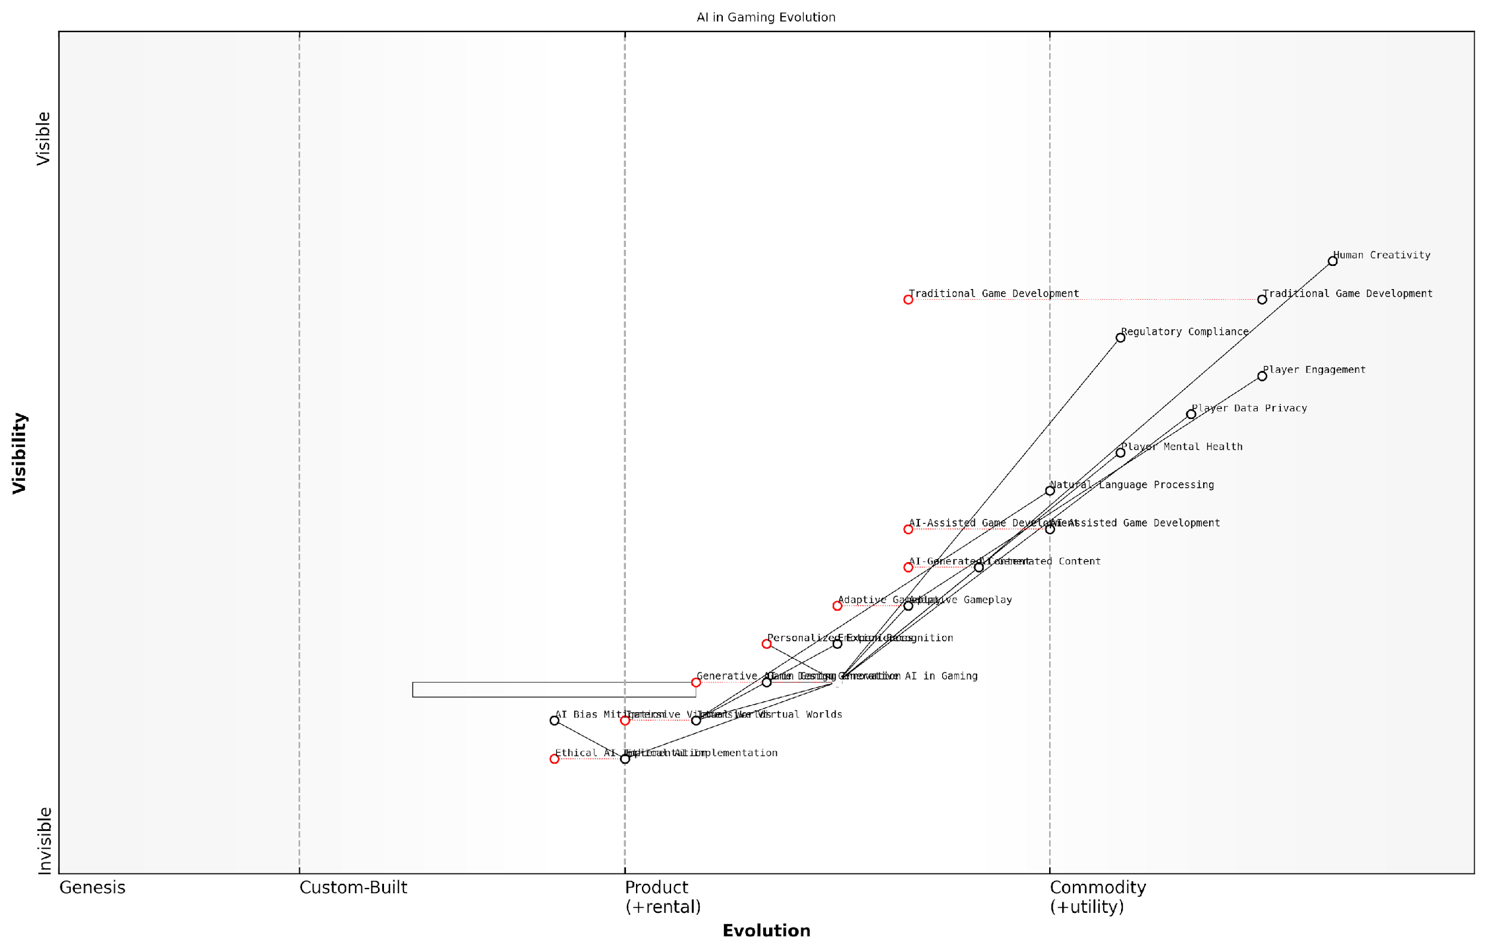

*Draft Wardley Map: [Insert Wardley Map: Challenges and Opportunities]*

[Edit this draft Wardley Map](https://create.wardleymaps.ai/#clone:81ae8257958b82b973)

Wardley Map Assessment

The map reveals a gaming industry in transition, with AI technologies, particularly Generative AI, poised to revolutionise game development and player experiences. While offering immense opportunities for innovation and personalization, this shift also presents significant challenges in ethics, privacy, and maintaining the human element in creativity. Success in this evolving landscape will require a delicate balance between leveraging AI capabilities and addressing associated risks, with a strong focus on ethical implementation and player-centric design. Companies that can effectively navigate this transition, prioritising both technological advancement and responsible AI use, will be well-positioned to lead in the future of gaming.

[View full Wardley Map report](http://markdown_wardley_map_reports/wardley_map_report_64_Challenges_and_Opportunities.md)

### The Role of Gamers, Developers, and Society

As we stand on the precipice of a new era in gaming, shaped by the transformative power of generative AI, it is crucial to examine the evolving roles of gamers, developers, and society at large. This triad forms the foundation upon which the future of AI-powered gaming will be built, each playing a vital part in shaping the landscape of interactive entertainment.

Gamers, as the end-users and primary stakeholders in the gaming ecosystem, will find themselves at the forefront of this revolution. Their role is set to evolve from mere consumers to active participants in the creation and curation of gaming experiences. As AI-driven games become more adaptive and personalised, gamers will increasingly influence the direction and content of their gaming experiences through their choices, preferences, and play styles.

The future of gaming lies not just in what developers create, but in how players interact with and shape those creations. AI will empower gamers to become co-creators of their own unique experiences.

This shift towards player-driven content creation will require a new level of digital literacy among gamers. Understanding the basics of AI and how it influences game mechanics will become as important as mastering controls or strategy. Gamers will need to develop a critical eye for AI-generated content, discerning between authentic experiences and potential manipulations or biases inherent in AI systems.

For developers, the integration of generative AI into game design presents both unprecedented opportunities and significant challenges. The traditional role of game developers will undergo a profound transformation, shifting from creators of fixed content to architects of dynamic, AI-driven systems.

* Mastering AI tools and techniques will become a core competency for game developers
* Emphasis on creating flexible, adaptable game systems that can leverage AI capabilities
* Balancing AI-generated content with hand-crafted elements to maintain artistic vision
* Developing new skills in data analysis and machine learning to optimise player experiences
* Addressing ethical considerations and potential biases in AI-driven game design

The relationship between developers and AI will likely evolve into a collaborative partnership, with AI augmenting human creativity rather than replacing it entirely. This symbiosis will enable the creation of more expansive, dynamic game worlds and narratives that were previously impossible due to resource constraints.

AI will not replace game developers, but developers who use AI will replace those who don’t. The key is to harness AI as a tool to amplify human creativity and innovation in game design.

Society’s role in shaping the future of AI-powered gaming cannot be overstated. As games become more immersive, personalised, and potentially influential, societal engagement with the medium will need to evolve. This includes developing new frameworks for understanding and regulating AI in gaming, addressing concerns about privacy, addiction, and the blurring lines between virtual and real-world experiences.

Educational institutions will play a crucial role in preparing the next generation of game developers and players for an AI-driven future. Curricula will need to be updated to include not only technical skills in AI and game development but also ethical considerations and critical thinking about the implications of AI in entertainment and beyond.

Policymakers and regulators will face the challenge of keeping pace with rapidly evolving AI technologies in gaming. They will need to strike a delicate balance between fostering innovation and protecting consumers, particularly in areas such as data privacy, fair competition, and the potential psychological impacts of hyper-realistic AI-driven games.

The gaming industry itself will need to take a proactive role in self-regulation and ethical AI development. Establishing industry-wide standards and best practices for AI implementation in games will be crucial for maintaining public trust and ensuring the long-term sustainability of AI-powered gaming.

As AI becomes more prevalent in gaming, there is also an opportunity for cross-pollination with other sectors. The insights gained from AI-driven player behaviour analysis and adaptive systems in games could have far-reaching applications in fields such as education, healthcare, and urban planning.

The lessons we learn from AI in gaming today will shape how we interact with intelligent systems across all aspects of society tomorrow. Gaming is not just entertainment; it’s a testbed for the future of human-AI interaction.

In conclusion, the future of gaming with generative AI is not predetermined but will be actively shaped by the collective efforts of gamers, developers, and society. Each group has a unique role to play in harnessing the potential of AI while mitigating its risks. By fostering collaboration, promoting education, and maintaining a focus on ethical development, we can ensure that the AI-powered future of gaming is one that enhances human creativity, promotes inclusivity, and pushes the boundaries of interactive entertainment in positive and meaningful ways.

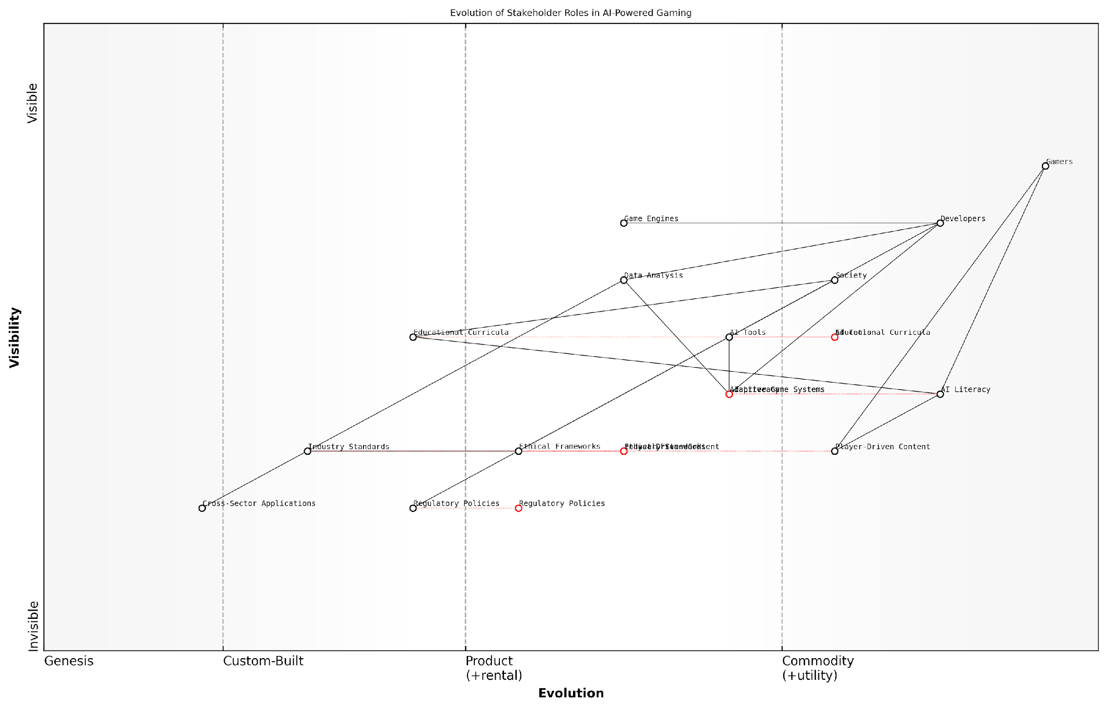

*Draft Wardley Map: [Insert Wardley Map: The Role of Gamers, Developers, and Society]*

[Edit this draft Wardley Map](https://create.wardleymaps.ai/#clone:d86b4ecf8070e49c9f)

Wardley Map Assessment

This Wardley Map reveals a gaming industry on the cusp of an AI-driven transformation. The strategic focus should be on developing robust Ethical Frameworks and AI Literacy programs to support the rapid evolution of AI Tools and Adaptive Game Systems. Success will depend on balancing technological innovation with societal considerations, while empowering both Developers and Gamers to thrive in this new paradigm. The industry is well-positioned to lead in responsible AI implementation, potentially influencing broader technological and societal trends beyond gaming.

[View full Wardley Map report](http://markdown_wardley_map_reports/wardley_map_report_65_The_Role_of_Gamers,_Developers,_and_Society.md)

# Appendix

## Book Generation Details

* Initial Topic: Game Changer: How Generative AI is Revolutionising the Future of Gaming
* Refined Topic: Game Changer: How Generative AI is Revolutionising the Future of Gaming
* Total Output Tokens: 0
* Total LLM Cost: $0.00

## Further Reading on Wardley Mapping

# Appendix: Further Reading on Wardley Mapping

The following books, primarily authored by Mark Craddock, offer comprehensive insights into various aspects of Wardley Mapping:

## Core Wardley Mapping Series

1. **Wardley Mapping, The Knowledge: Part One, Topographical Intelligence in Business**
   * Author: Simon Wardley
   * Editor: Mark Craddock
   * Part of the Wardley Mapping series (5 books)
   * Available in Kindle Edition
   * [Amazon Link](https://www.amazon.com/dp/B0BVSXB5W5)

* This foundational text introduces readers to the Wardley Mapping approach:
  + Covers key principles, core concepts, and techniques for creating situational maps
  + Teaches how to anchor mapping in user needs and trace value chains
  + Explores anticipating disruptions and determining strategic gameplay
  + Introduces the foundational doctrine of strategic thinking
  + Provides a framework for assessing strategic plays
  + Includes concrete examples and scenarios for practical application
* The book aims to equip readers with:
  + A strategic compass for navigating rapidly shifting competitive landscapes
  + Tools for systematic situational awareness
  + Confidence in creating strategic plays and products
  + An entrepreneurial mindset for continual learning and improvement

1. **Wardley Mapping Doctrine: Universal Principles and Best Practices that Guide Strategic Decision-Making**
   * Author: Mark Craddock
   * Part of the Wardley Mapping series (5 books)
   * Available in Kindle Edition
   * [Amazon Link](https://www.amazon.com/dp/B0C2SFTR7Z)

* This book explores how doctrine supports organisational learning and adaptation:
  + Standardisation: Enhances efficiency through consistent application of best practices
  + Shared Understanding: Fosters better communication and alignment within teams
  + Guidance for Decision-Making: Offers clear guidelines for navigating complexity
  + Adaptability: Encourages continuous evaluation and refinement of practices
* Key features:
  + In-depth analysis of doctrine’s role in strategic thinking
  + Case studies demonstrating successful application of doctrine
  + Practical frameworks for implementing doctrine in various organisational contexts
  + Exploration of the balance between stability and flexibility in strategic planning
* Ideal for:
  + Business leaders and executives
  + Strategic planners and consultants
  + Organisational development professionals
  + Anyone interested in enhancing their strategic decision-making capabilities

1. **Wardley Mapping Gameplays: Transforming Insights into Strategic Actions**
   * Author: Mark Craddock
   * Part of the Wardley Mapping series (5 books)
   * Available in Kindle Edition
   * [Amazon Link](https://www.amazon.com/dp/B0C7CR9R9Q)

* This book delves into gameplays, a crucial component of Wardley Mapping:
  + Gameplays are context-specific patterns of strategic action derived from Wardley Maps
  + Types of gameplays include:
    - User Perception plays (e.g., education, bundling)
    - Accelerator plays (e.g., open approaches, exploiting network effects)
    - De-accelerator plays (e.g., creating constraints, exploiting IPR)
    - Market plays (e.g., differentiation, pricing policy)
    - Defensive plays (e.g., raising barriers to entry, managing inertia)
    - Attacking plays (e.g., directed investment, undermining barriers to entry)
    - Ecosystem plays (e.g., alliances, sensing engines)
* Gameplays enhance strategic decision-making by:
  1. Providing contextual actions tailored to specific situations
  2. Enabling anticipation of competitors’ moves
  3. Inspiring innovative approaches to challenges and opportunities
  4. Assisting in risk management
  5. Optimising resource allocation based on strategic positioning
* The book includes:
  + Detailed explanations of each gameplay type
  + Real-world examples of successful gameplay implementation
  + Frameworks for selecting and combining gameplays
  + Strategies for adapting gameplays to different industries and contexts

1. **Navigating Inertia: Understanding Resistance to Change in Organisations**
   * Author: Mark Craddock
   * Part of the Wardley Mapping series (5 books)
   * Available in Kindle Edition
   * [Amazon Link](https://www.amazon.com/dp/B0C34FX8XC)

* This comprehensive guide explores organisational inertia and strategies to overcome it:
* Key Features:
  + In-depth exploration of inertia in organisational contexts
  + Historical perspective on inertia’s role in business evolution
  + Practical strategies for overcoming resistance to change
  + Integration of Wardley Mapping as a diagnostic tool
* The book is structured into six parts:
  1. Understanding Inertia: Foundational concepts and historical context
  2. Causes and Effects of Inertia: Internal and external factors contributing to inertia
  3. Diagnosing Inertia: Tools and techniques, including Wardley Mapping
  4. Strategies to Overcome Inertia: Interventions for cultural, behavioural, structural, and process improvements
  5. Case Studies and Practical Applications: Real-world examples and implementation frameworks
  6. The Future of Inertia Management: Emerging trends and building adaptive capabilities
* This book is invaluable for:
  + Organisational leaders and managers
  + Change management professionals
  + Business strategists and consultants
  + Researchers in organisational behaviour and management

1. **Wardley Mapping Climate: Decoding Business Evolution**
   * Author: Mark Craddock
   * Part of the Wardley Mapping series (5 books)
   * Available in Kindle Edition
   * [Amazon Link](https://www.amazon.com/dp/B0BVHF2MBH)

* This comprehensive guide explores climatic patterns in business landscapes:
* Key Features:
  + In-depth exploration of 31 climatic patterns across six domains: Components, Financial, Speed, Inertia, Competitors, and Prediction
  + Real-world examples from industry leaders and disruptions
  + Practical exercises and worksheets for applying concepts
  + Strategies for navigating uncertainty and driving innovation
  + Comprehensive glossary and additional resources
* The book enables readers to:
  + Anticipate market changes with greater accuracy
  + Develop more resilient and adaptive strategies
  + Identify emerging opportunities before competitors
  + Navigate complexities of evolving business ecosystems
* It covers topics from basic Wardley Mapping to advanced concepts like the Red Queen Effect and Jevon’s Paradox, offering a complete toolkit for strategic foresight.
* Perfect for:
  + Business strategists and consultants
  + C-suite executives and business leaders
  + Entrepreneurs and startup founders
  + Product managers and innovation teams
  + Anyone interested in cutting-edge strategic thinking

## Practical Resources

1. **Wardley Mapping Cheat Sheets & Notebook**
   * Author: Mark Craddock
   * 100 pages of Wardley Mapping design templates and cheat sheets
   * Available in paperback format
   * [Amazon Link](https://www.amazon.com/dp/B09TPDM9PP)

* This practical resource includes:
  + Ready-to-use Wardley Mapping templates
  + Quick reference guides for key Wardley Mapping concepts
  + Space for notes and brainstorming
  + Visual aids for understanding mapping principles
* Ideal for:
  + Practitioners looking to quickly apply Wardley Mapping techniques
  + Workshop facilitators and educators
  + Anyone wanting to practise and refine their mapping skills

## Specialized Applications

1. **UN Global Platform Handbook on Information Technology Strategy: Wardley Mapping The Sustainable Development Goals (SDGs)**
   * Author: Mark Craddock
   * Explores the use of Wardley Mapping in the context of sustainable development
   * Available for free with Kindle Unlimited or for purchase
   * [Amazon Link](https://www.amazon.com/dp/B09PNKFHG4)

* This specialised guide:
  + Applies Wardley Mapping to the UN’s Sustainable Development Goals
  + Provides strategies for technology-driven sustainable development
  + Offers case studies of successful SDG implementations
  + Includes practical frameworks for policy makers and development professionals

1. **AIconomics: The Business Value of Artificial Intelligence**
   * Author: Mark Craddock
   * Applies Wardley Mapping concepts to the field of artificial intelligence in business
   * [Amazon Link](https://www.amazon.com/dp/B0C6V9VZ9B)

* This book explores:
  + The impact of AI on business landscapes
  + Strategies for integrating AI into business models
  + Wardley Mapping techniques for AI implementation
  + Future trends in AI and their potential business implications
* Suitable for:
  + Business leaders considering AI adoption
  + AI strategists and consultants
  + Technology managers and CIOs
  + Researchers in AI and business strategy

These resources offer a range of perspectives and applications of Wardley Mapping, from foundational principles to specific use cases. Readers are encouraged to explore these works to enhance their understanding and application of Wardley Mapping techniques.

Note: Amazon links are subject to change. If a link doesn’t work, try searching for the book title on Amazon directly.